Hypnosis and imagery in the treatment of pain

Ann Williamson

Webinar 1/11/2021

I come to this from very practical point of view: I am neither a psychologist nor a neuroscientist; I was a jobbing GP for about 30 years, and I was very much into getting my patients as well as they could be without too much intervention by myself. Teaching them self-hypnosis was always very high up on my agenda, and I developed a lot of ways of doing this within a ten minute consultation. Now since retirement I have the luxury of an hour-long session. I trained in hypnosis back in the late 80’s and have been using it and teaching health professionals ever since.

What is hypnosis?

There are various definitions but my own take on this is that it is the state of mind that comes when you focus your intention and have the expectation of going into hypnosis. It is not something that is done to you; you do it for yourself. You can give suggestions to your patients which they can follow or not as they please but they have to do the putting into hypnosis themselves It is actually quite commonplace; we go into hypnotic states quite often, for instance driving along a familiar road and realizing that we have no conscious recollection of the last few miles, although we have been driving quite safely and would have reacted instantly to something unexpected. In the same way if one gets lost in a good book and someone shouts in alarm you would immediately be out of it and giving it your attention. The same thing happens with hypnosis.
It’s not like a switch: it’s a focusing of attention on a continuum from outer awareness and our normal day-to-day business of doing to an inner focus which is more a being state, in a similar way that can you can get with some medication, and there are quite a lot of parallels with the subjective feeling of being in that state. It tends to be allied with relaxation but it doesn’t have to be: of you think of Olympic athletes using intense concentration on their goal
they are far from relaxed. But a lot of our patients are anxious so going for a relaxed state is very useful.
There are two things that going into this mind state that we have labelled hypnosis does: one is to give people an enhanced ability to follow suggestions like those of calmness and comfort which can have much more effect if someone is in hypnosis rather than their normal waking state. Also you have greater access to what are normally considered unconscious processes such as involuntary muscle contractions in the gut and physiology generally. These are the two most important factors in using hypnosis for pain. Acute/ procedural pain and chronic pain are obviously very different animals, so I am going to talk about both and put my approach into context with some cases.

The slide (below) is of a very useful model which I use with patients to help them to understand how hypnosis can be useful. We know that there are two sides to the brain; (this is only a model but contains elements of truth ). The left brain is the ‘intellectualizing’ bit with ‘intentional’ memory (we think what we had for breakfast); it communicates verbally and is the operating system for our normal conscious awareness most of the time. Then there is the right side which is more to do with emotions and feelings. Its memories tend to be involuntary like the smell of baking bread that takes you back to your grandmother’s kitchen. It communicates non-verbally through body language and physiology.
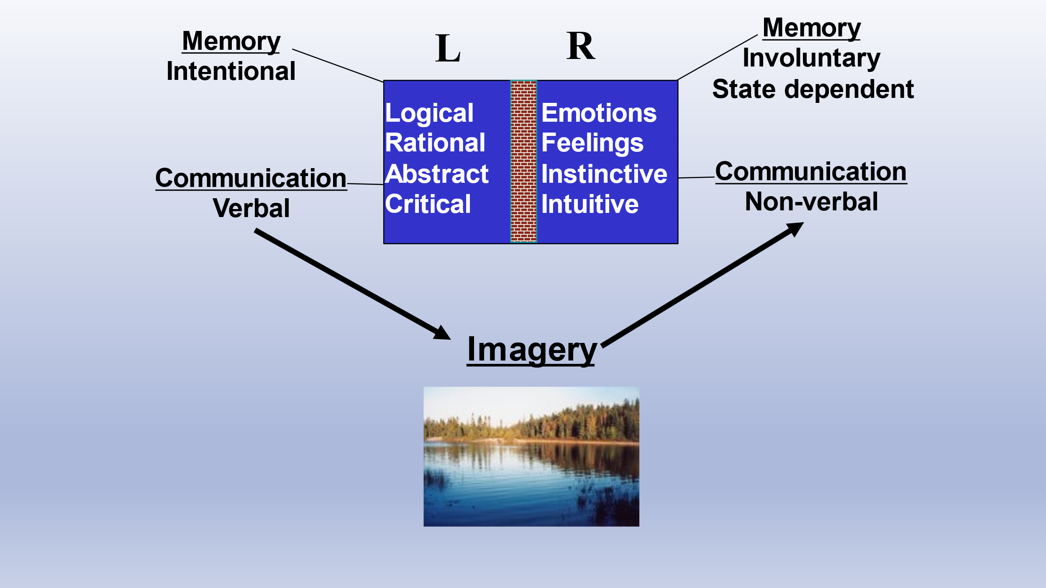

There almost seems to be a brick wall between these two types of processing. We can feel something; for instance, take someone who is afraid of spiders: they know there is no need to be frightened and they can rationalize about it for ever but this has little or no effect on what they are feeling. So there is almost a disconnect, when there is a problem, between our rational, intellectualized processing and our sensory, feeling processing. One way we can communicate between these is by using imagery. You can paint a word picture and it will talk to both types of processing. All the great teachers taught in parables and stories and this was why they were so effective. And why we use imagery so much in hypnosis.
There is a lot of relevant neuroscience to have come out over the last ten years, like when you do fMRI scans of someone who is thinking of blocks of colour, in hypnosis the ‘colour’ parts of the brain light up as if they were actually seeing colour. You can induce pain under hypnosis and the same brain areas as in ‘real’ pain light up.

Patients experiencing acute pain or facing procedural pain are often in a high state of anxiety and are operating in the right brain and not rationally. Everything they see or hear is going to be interpreted in a negative way which is how we do it as a protective thing. When they are anxious they are already in a semi-hypnotic state and you can utilize that, indeed what you say will have a much greater effect. An operating theatre may appear threatening but it can be seen as somewhere you are going to be looked after.

Many of the phrases used by health professionals might be best re-phrased, e.g. :

“Just a sharp scratch” (a nocebo!) might be better as “If you would like to make a fist with your left hand, I’ll take the blood sample” (from the right hand)
“Don’t worry, this examination isn’t painful” might be better as “most people find this examination doesn’t bother them at all” (We don’t process negatives and all they will hear is painful)
“You can have some pain-killers if you need them” might be better as “you can have something to keep you comfortable if you need”
“There is a bowl on the side in case you feel sick” might be better as “ there is a bowl on the side in case you want to rinse your mouth”

If someone is very anxious you have to work quickly to grab that focus of attention and direct it where you want it to go, for instance if it is on pain or the procedure you can utilize their desire to be anywhere else. And you can work with the tension by suggesting that one of the best ways to relax is to start to notice one’s breathing using a phrase like “Maybe you can begin to breath in calmness and out tension with each breath …” I sometimes get people to put their hands on their lower ribs and ‘breath in and out through their fingers’ which takes their focus of attention down and away from what is bothering them. At the same time you can get them to think of a time when they felt completely relaxed, may be on a holiday. You cans ask them to describe such a scene:

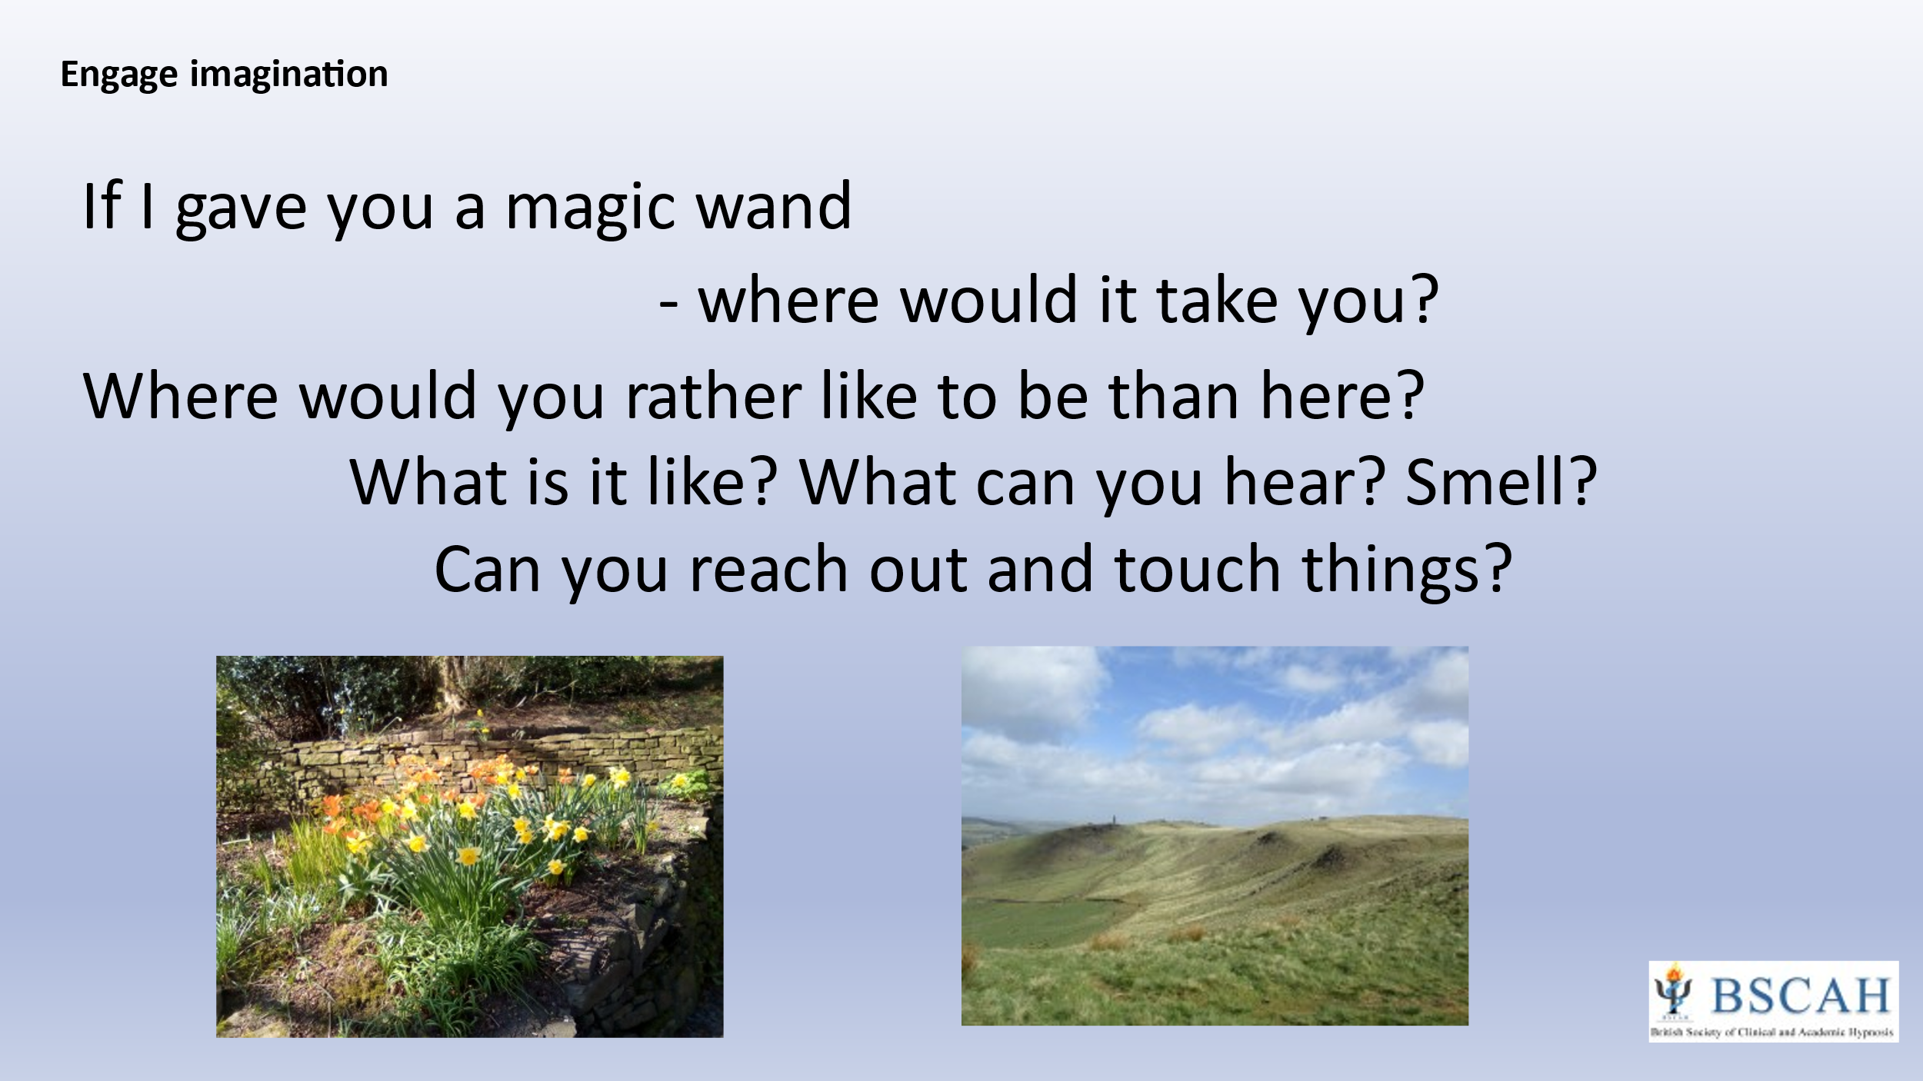

… and that will take them away from the threatening situation into a different place: instead of somewhere peaceful and calm some people might prefer something exiting; I had one patient who found it very useful to think of extreme skiing and the snow while having his burns dressed.

Again you may want to use this sort of phraseology:

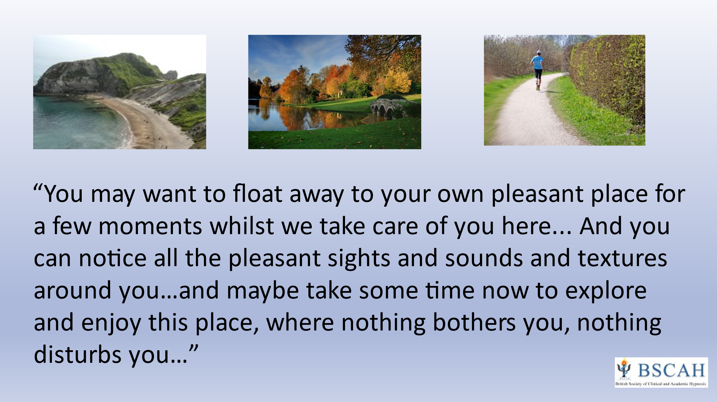

You can also get them to revivify a situation where they have done something very physically active, like swimming, skiing, cycling or horse- riding. You can ask them to let their eyes close and re -experience it. I like this for someone with a lot of pain or anxiety, and get them to do something like swimming really fast. This matches their adrenaline state so they find it relatively easy to do, and they in their own time can slow it down and stop and rest. The imagery that comes to the patient is always far more useful than anything I can suggest - I can just give them ideas they might want to pick up on.
You can work with muscle tension and get them to make a fist and direct all their pain and anxiety to it, build it up and up and then let it go, and feel how comfortable that is.

Hypnosis and pain

You can use hypnosis quite quickly and informally with someone in acute pain because they are already in a semi-hypnotic stat, e but with chronic pain it is a different ball game. You quite often have more time with the patient and have formal hypnosis sessions with the patient and can explain what it is and isn’t and disabuse them of any misperceptions they may have. The first thing I always do with them is to teach them self-hypnosis and get them to find some place in their minds, which may be real or imaginary where they ca feel calm and safe - a haven. Some people are really good at this and have wonderfully detailed pictures of their haven; for others this is just an awareness but it really doesn’t matter. But when you are using imagery in hypnosis it is important for people to use all their senses – seeing, hearing, feeling and smelling – because it will help them to develop the ability to go to their special place. When I teach self-hypnosis; it’s nice to take ten or fifteen minutes over this but this isn’t essential and it can be done quite quickly. The depth of hypnosis is determined by what the person is doing rather than anything else. It may take a bit longer for them to go deeper but that isn’t necessarily desirable. Patients, having been taught self-hypnosis, have a tool to help themselves.

Some of the classic images people can use to reduce pain include turning dials down. One I find very useful is that of the control room, which they can find in the depth of their minds, where they can sit on a chair and have all the banks of controls for turning down pain and anxiety around them; and if they have a problem with this there is someone to come up on a screen to show them what to do. Another is [?] - generated imagery where they go down and find a model or picture of what the pain looks like, thus is externalizing the pain which they then describe and think of things they can do to change it and make it more comfortable. I have seen one 50-year-old lady with persistent vulvodynia for which investigations had failed to find a cause, who when she went into hypnosis described her pain as a dark purple vortex spinning rapidly in an anticlockwise direction. So she needed to gradually slow the spin, make it spin in the opposite direction and change the colour. I don’t know what that had to do with her vulvodynia but it certainly helped it.

Sometimes there is anger associated with pain. I had one chap with a lot of anger who had a painful knee. When I was in general practice he came to me for more analgesics as my partner was away. He had had a really bad knee injury and been invalided out of the army; he became a priest until another injury disabled him even for that. He had just seen the orthopaedic surgeon who had done a knee replacement which hadn’t got rid of the pain, and who just told him it should have done. So he was very angry about this and how he had been treated in the past. So I asked him if his anger made his pain worse and he agreed that it probably did. So I offered to show him how to reduce his anger and let it go using hypnosis. I asked him if he had ever done anything in the past that had been helpful and he recollected having acupuncture for a hip pain which he had enjoyed, and his manner changed as he was talking about it. But he had had it for his knee and it didn’t work. So I got him to close his eyes and go back to the feeling had with his good experience of A/P and his special place which was fishing on the river Stour when he was a boy. I then taught him a way of using imagery to get rid of his anger, which was to take him to a quarry and select a rock, then project the anger he wanted to get rid of into the rock, look around for a sledgehammer or something and smash it into little bits. He really enjoyed this, and when had finished he went to his calm peaceful place. I then suggested he would shrink himself, go down into his knee and look around. He said: “it’s fine - it’s OK now!” I said: “that’s wonderful! - and you can keep this comfort when you come out of hypnosis.” – the post-hypnotic suggestion that it would persist

One of the metaphors I often use is that pain doesn’t need to shout at one; it can whisper and if you need to pay attention to it you can just whisper back at it. Another is of grandchildren playing in the front room and you can close the door knowing they will be safe in there and if they start screaming and yelling you know something is really wrong and you will have to go in and sort them. Acute pain can be an important message which you shouldn’t ignore but chronic pain tends not to be and has outlived its usefulness.

I often find with chronic pain that there is trauma underlying it, as in the case of Tom who had had a bad road traffic accident and still suffered with constant head and neck pain two years later despite no physical cause being found. While reviewing the accident using dissociated imagery in hypnosis Tom ‘remembered’ thinking as he was lying, trapped in his car, ‘‘My head hurts so I must be alive!’’ Working with this narrative (whether historically accurate or not is unimportant, this is what Tom’s mind ‘thought’ happened) we used imagery for Tom to update his ‘unconscious’ mind so that he truly understood that he had survived, that the accident had been in his past and he didn’t need the pain to let him know he had survived. And that worked really well for him.
Another image I use for head pain is to coalesce it into a coloured crystal and pour healing fluid over it, watching it dissolve as it increases comfort.

Sometimes with chronic pain you can use a hypnotic process known as glove anaesthesia where you get the patient to make their hand numb by a variety of means such as pouring cold water over it or immersing it in snow, putting on a magic cream or putting a thick glove on it to deprive it of external sensation. Then they can transfer that numbness to the painful part. I use it in labour pain where you transfer the numbness to the tummy. I have used it successfully in a patient with neck pain who also used the image of sitting under a waterfall with cool water flowing over her neck and shoulder.

When working with someone with chronic pain I try to build up their expectation that they can affect it. One of the ways of doing that is to explore their ability to make an arm feel light or heavy which is quite easy under hypnosis: to feel one arm heavy and sinking into their lap and the other floating up, and allowing them to explore such differences in sensation; or, for instance, difference in temperature between the hands. The implication of this is that they can also alter the sensation of pain.

Case stories

People have amazing abilities that we don’t tap into, which is a great shame. I am going to narrate a couple more cases in more detail to illustrate this.

Eric was 57 years old and attended for a review of his analgesic medication and gave a 2-year history of herpes neuralgia. He was also somewhat depressed and not sleeping very well. He described the pain ‘as if someone was rubbing salt into an open raw wound in his side’ and stated that the only time he felt easier was when he was riding his horse, which surprised me as I would have thought that the movement would have made it worse. He was interested in exploring any approach that would allow him to reduce his medication and help him feel more comfortable so we decided to have a couple of half hour sessions (I try to avoid long-term therapy for chronic pain and limit this at most to four or five visits) and see if it would help. He was directed to my website which has a lot of information on hypnosis and some self-hypnosis and general imagery tracks that can be downloaded for practice, which he did so he was already ‘primed’ before his first session, at which he scored his pain as 8/10 on both intensity and bothersomeness. Hypnosis was induced by suggesting that he close his eyes and take himself back to riding his horse, seeing, hearing, smelling (the smell of a horse is very evocative) , feeling how his muscles felt, the temperature of the air and really ‘being there’. Suggestions of calmness and comfort were given and he was asked to score his pain again , which had come down to a 5. He was asked to imagine what his neuralgia looked like, to go down into where the problem was and see what image, if any, came to mind. He said he could see red wires that were sparking as if they were short circuiting. When asked what he could do to help, to make things easier, he was silent for a while and then said he was pouring soothing fluid down the nerves to calm them down. It was suggested that he could continue to feel this comfort and that each day he could ‘go inside’ and see what needed doing to help himself, when he did his self-hypnosis.
At the second session Eric reported that he had been feeling a bit better and had certainly found that self-hypnosis had helped him to sleep better. (a common ‘side-effect’ of hypnosis) He had been using the tracks from the website but also liked his horse-riding imagery. He rated his pain at 4.
He also started talking about how he had felt when he had been made redundant 18 months previously. He felt angry at the way he had been treated and it was suggested that he could do a silent abreaction as described earlier. Hypnosis was induced as before and suggestions of calm comfort given verbally as well as Eric using imagery of his pain. This time the nerves were still red but not sparking and he felt he needed to make them paler and cooler with his healing fluid. He was also taught the ideo-motor hands exercise which can be very useful for pain, especially migraine. It is based on the premise that we all often move without being aware of it, like waving our hands around when we talk or nodding without the conscious intention. Movement associated with an idea is called ideomotor movement: it feels involuntary. A useful little exercise that I give people is to hold their hands four inches apart and ask each one if it is OK to work on the problem (in Eric’s case the herpes neuralgia) and if it is their hands will gradually move together, and if not they will stay apart. You just wait and see what happens; if they feel their hands coming together they can gather up all the information about the problem, (if they stay apart you have to respect that and perhaps leave it for another time.) Having got agreement and all the information they need, you tell them to allow one hand to fall to their lap. Then they can bring up all the unconscious resources that they need to help themselves; which could be with muscle tone, blood flow or whatever, and as their hand is coming down they can see that their mind is doing what it has been asked to. The other hand can come down as they start to use those resources. This is in itself hypnotic as it involves focusing attention and a way of gathering up a person’s unconscious resources.
I suggested that Eric might do this daily for a while. When he was seen a few weeks later he reported that his neuralgia was much improved and he was using self-hypnosis and imagery on a regular daily basis; in fact he had started a part time job and didn’t think he needed his medication anymore, apart from occasionally at night.

Peter was 68 years old and suffered with osteo-arthritis and had persistent chronic lower and upper back pain. This responded only partially to analgesic medication and he was keen to try something new. Again, by using the information and tracks on my website Peter had already started to do self-hypnosis before our first official hypnosis session and had found that he really enjoyed it and was a good hypnotic subject. (There is a bell-shaped distribution of hypnotisability in the population: about 10% are highly hypnotizable, 10% find it difficult and most of us are in the middle. Motivation has a huge amount to play). We spent the first session exploring different ways he could use to enter hypnosis, and he already had his ‘special place’ where he could feel completely calm, at peace and comfortable. While he rested there, suggestions for calm comfort were given and he was encouraged to ‘go into where the problem was’ and tell me what he saw. Peter focused on his lower lumbar spine and felt that some of the vertebrae were ‘out of alignment’ so imagined tapping them into place; higher up his spine he thought it was too red and hot so he altered it to a cooler, paler colour. When he focused on his cervical spine he imagined ‘knobbly bits protruding from the bones’ so he ‘took a file and smoothed them out’. His pain level dropped from 7 to 2. It was suggested that he could repeat this when he did his self-hypnosis practice.
At the second session Peter reported that his pain level had improved and was generally around 4 or 5. He was taught glove anaesthesia (numbing a hand in hypnosis) and transferred this numbness to his neck. In hypnosis he was reminded how we naturally only become consciously aware of a very small amount of incoming sensations, how we become so accustomed to something that we become unaware of it. (There is a lot of sensory information coming it that we don’t process – you won’t be aware of the shoe on your foot unless you draw attention to it. I had a new clock in my bedroom and I thought the ticking would drive me mad but after a week I ceased to notice it) Peter learnt how we distract ourselves and how he could become so focused on whatever he was doing or whomever he was with, that he needn’t notice his back. Suggestion was given that unless he needed to take some action to protect himself, his back needn’t shout at him – it could whisper - and that he could remain comfortable.
Peter’s third and final session was tape recorded so that he could take it home to practice with. During the session we revisited all the ways he had used hypnosis and imagery to reduce his pain so that he had a permanent reminder of how he could help himself. I find it useful when working with someone with chronic pain to spend the final session going over all the things that have helped. Nowadays with smartphones it is so easy for the patient to take a recording or record a Zoom consultation.

Discussion

I was so impressed by your presentation at Rydal that I went and did the BASCAH basic course. Having done this, working as a pain doctor in a large busy hospital I have found that there are four areas in which I have been able to use the strategies you have been talking about. The first is simply calming patients down who are in a state. As a pain doctor you often get called to a patient in ITU or HDU to people with injuries who are in extreme distress, and using hypnotic language: pacing the speech, slowing things down, can be very effective. I wish I had known about that 30 years ago – this is the sort of patient you can give so much morphine to that they stop breathing. The second group of patients is those with atypical facial pain when they have come to the end of any sensible treatment: injections, decompressions, alternative medication etc. but still have their pain. They are sort of coping but I have found hypnosis a very useful adjunct. The third area is patients with conditions such as fibromyalgia who in many cases have a history of some sort of life trauma. A question I like to ask these patients is: “How do you relax?” and it is remarkable how many look at you as if this is a bizarre question – “what do you mean, relax?” – “well, do you daydream? Do you ever ‘switch off’ and let you mind wander?” And it is remarkable how many don’t do this, and teaching them brief interventions as you have described: how to switch off with a simple self-hypnosis induction and go to somewhere pleasant, can be very rewarding. And the last thing I have learnt is to simply change the way I talk to patients: making positive suggestions without hypnosis, like: “We’ve had this discussion today and when you come back for your next appointment you’ll still have your pain but you will feel more positive about it. Some of the things we have talked about will help you to feel less distressed … “ I think it helps me as a clinician not to feel so helpless.

It's good to stimulate patients’ curiosity and encourage them to explore ways to help themselves

I have often found that people with fibromyalgia find it very difficult to express emotions. I am thinking in particular of one lady I worked with who had a very abusive marriage to an alcoholic husband whom she divorced when her daughter became a teenager. She had been diagnosed with FMS two years before I saw her and its onset seemed to date form her daughter’s emigration to Australia. When she divorced her husband the daughter went with him and was completely estranged from her mother who wasn’t even allowed to see her grandchildren, so there was a lot of suppressed anger. Our therapeutic interventions were all about allowing herself to acknowledge her feelings and use hypnosis to offload them and replace them with calmness. She did amazingly well and when I saw her a couple of years later it was about something else and no longer had her FMS.

Question from chat: How would you suggest guiding a patient who struggles to find a relaxing place and generate associated imagery and in the control room can't see or generate dials and switches or a screen?

Some people who have had a lot of trauma and a very dysfunctional background may have difficulty initially but I think everyone has at some point had a time when they are calm; it might be when they are tucked up in bed at night, or it may be that they can imagine what it would be like even if they can’t actually recall such a time. You can ask them what they would want it to be like - snuggled up in an armchair or in a beautiful garden, by a lake, up a mountain … you can give some suggestions or ideas and they can decide what they would like, use that, and then you will find that they begin to generate their own. As for the control room, they can have an awareness of it even if they can’t imagine it – perhaps adjust the dial with their hands. But if that doesn’t work for them don’t use it - there are plenty of other ways.

I’ve had one or two people who couldn’t imagine a picture but could imagine a colour and could surround themselves with a colour which they could choose

Is there anyone you would not do hypnosis with?

Yes: anyone with a history of psychosis. You should only work with patients you would be happy to work with without hypnosis. There are some people who work successfully with psychotic patients but I wouldn’t because I’m not used to that.
It used to be said that if someone was suicidally depressed you shouldn’t use hypnosis in case it tips them over into actually killing themselves, but this is true for any form of therapy; if someone who is profoundly depressed is starting to get better there is a danger that they might regain enough energy to actually do something before they start to have a more positive outlook on life. But if you are used to working with such people you know how to deal with that.

I am particularly interested in what you said about the release of emotion in people with fibromyalgia. I have recently been working with people with long Covid. It is a pilot project using a type of Tai Chi called Tai Chi movements for wellbeing. We start the class by taking them into a safe place which is a foundation - an anchor – which they can use at any point. We then progress to 15 minutes of rhythmic movement within this safe place. It is quite different from anything I have done before. You then get this tremendous release of emotion. Tears are shed at each session. I am beginning to look at this positively now as a process they need to go through. People sob, and allow themselves to sob afterwards. One or two of them have got to the stage where they can do the movements without sobbing. These are people for whom every aspect of their lives has abruptly changed and they are really struggling. I have worked a lot with people with long-term pain and have not seen this release of emotion as much.

Long Covid is more like a functional disorder – like FMS and ME - than chronic pain. There is often a lot of suppressed emotion in these. One thing I that I find a lot of patients worry about, particularly those with FMS, is that if they allow themselves to feel something the dam will burst and they will be overwhelmed. So I suggest the image of sluice gates which they can use to control this. I often use expressive art to get people to allow themselves to express how they feel in words, pictures, movement or whatever they find easiest, and then move to how they want to feel.

Some of these patients tell me that they have been ‘holding themselves tight’ in an attempt to get back to normal life; and they become aware of having tried to block off the pain or fatigue in this way.

How much time are your sessions? In a busy pain clinic, will additional time be needed to practice hypnosis?

When I was in practice as a GP I used to do short (ten minute) sessions with my patients during my surgery and sometimes half-hour sessions after this. It is also something I used to do with groups. You can teach half-a-dozen people how to do self-hypnosis and using imagery etc. as easily as one. Then you can bring them back individually to take this further. Although I now have sessions of an hour I don’t have the luxury of knowing the person, as I might have done previously, on and off for years. So I think I need a bit more time

Is the website you spoke of free for all (in which case would you mind sharing it?) or something specific that you’ve done? Are there any other free resources that people have found useful to help patients prepare/ continue afterwards?

I did have a very comprehensive website but unfortunately the lady who did it for me died and the codes died with her, so now I have a simple one: annwilliamson.co.uk. There is a lot of free material there; when Covid hit I put a lot of these resources out for people and there are a lot of recorded imagery etc. tracks on the website. We also produced a package for patients in ICU’s

I am an anaesthetist and use imagery and hypnotic language, including taking them to a safe place on induction of anaesthesia, with particular emphasis on giving the patient control in terms of being comfortable on waking. I have no idea if anaesthetising them removes the benefit of post-hypnotic suggestions made on induction without being able to take them out of hypnosis. I think it works - any idea if there is an evidence base for what I do?

I don’t see why it should remove them. There is a lot of work about perioperative practice: how you talk to your patients and the suggestions you make in the anaesthetic room etc. which seem to have a marked effect on outcome. Things like “we will take care of you and you can concentrate on healing.” There is an amazing book The Worst Is Over: What to Say When Every Moment Counts by Judith Acosta.

There are extended benefits as I tend to hypnotise my ODP or the trainee with me and they are in a better frame of mind for looking after the patient themselves!

I remember an anaesthetist friend told me that he was using hypnosis as well as anaesthesia for some sort of dental procedure and suddenly realised that he hadn’t switched the gas on!

With many forms of surgery, if you are using a sharp scalpel and not retracting tissues there is no reason why it should be perceived as extremely painful. It is the thought of it even before you have it done … And we have talked about how we can easily make pain worse just by winding people up and telling them how bad it is going to be, so with hypnosis we can turn the dial the other way. I was in Peking for a while doing acupuncture and that works very well for analgesia but I think they use hypnosis as part of that process. Before doing, for instance a thyroidectomy they have a test session showing how you get analgesia, which if successful they repeat it before the actual surgery - this is very gentle and they do use LA as well - but they are in this deep relaxed state that they attribute to AP but I think you would call hypnosis.

Can you tell us a bit more about the BSCAH training?

This is all on our website www.bscah.com Courses are ‘hybrid’ Zoom and face to face.
Module 1 of the Foundation training gives you the basic skills you need to integrate hypnotic techniques into your clinical work to help both you and your patients with anxiety and stress. You will learn about the neuroscience behind the hypnotic response and how words can influence the outcome of any interaction you have with your patients.
Modules 2 and 3 expand on this knowledge and demonstrates ways of working with patients with a variety of problems such as pain, psychosomatic problems, phobias, and past traumatic memories.
There are also various optional specialist modules that will enable you to expand your knowledge of using clinical hypnotic techniques with children, in obstetrics, PTSD, depression, grief, oncology and end of life care (according to the professional mix of delegates).
The Foundation Training follows the BSCAH Core Curriculum and can lead to BSCAH Accreditation.
We only train health professionals.

It’s unfortunate that so many people still think of hypnosis as involving taking away their control as it is a way for them to take more control of their own minds. I use metaphors like “you are the pilot and I am the navigator” . Their special place is their own and they can choose to go there or not. Nothing goes on there that they do not control. It is somewhere they can take time out from the stresses of the day.
It is very practical training. We do have a university diploma but you can leave all the theory stuff.

I can certainly recommend the BSCAH training. It is something completely different from the way I had been practicing and a very useful approach to talking to and helping people with chronic pain. One of the things that impressed me about the training was that people who are good at it are confident that they can take people along with them and instill confidence in them. I am sure that this comes with practice.

One of the things that has been recommended is to do tests of hypnotisability but I think that is useless as if you suggest that they might not be hypnotizable they won’t be!

The group of people who don’t meditate and never relax or daydream, in my experience in the pain clinic, are easy to pick out, and even within a fifteen-minute appointment you can do a very short relaxation exercise and when they come back they have been practicing it and say no-one has ever done that before.

What is the difference between relaxation training and hypnosis?

Relaxation exercises are hypnotic but hypnosis isn’t all about relaxing; hypnosis is about a lot more than that, although there is an overlap. You can be alert and do hypnosis like – someone doing it pedaling an exercise bike. You can see Olympic sportsmen going into their routine which helps them to focus, and then when they’ve got it right they will do their jump or whatever.

I have a book to recommend: Handbook of Communication in Anaesthesia and Critical Care
A practical guide to exploring the art; by Allan Cyna who is an Australian anaesthetist heavily involved in hypnosis. There is a chapter on the importance of the language one uses.

He has some interesting videos online

I think someone asked if you could do hypnosis in the street. I once very successfully did a quick induction on a young man who had fallen of his bicycle and had a compound fracture of his femur at the hip; he was sitting waiting for the ambulance. I asked his name and in my calming voice I told him to close his eyes and think of something nice. So he closed his eyes and a smile came over his face and he said: “I’m thinking of something nice – it’s a bit naughty!” – and then he was away!

When someone is in shock they are in hypnosis. Once I caught my finger in a door; the tip was hanging off and I was in shock. The colleague who was with me said “you know what to do … just [?] the pain” So I did it – I don’t know how but it didn’t hurt even when they did the ring block in casualty and debrided it etc.

