zoom_0.mp4

Webinar 12th April 2021

Poverty and Inequality in Health and Pain

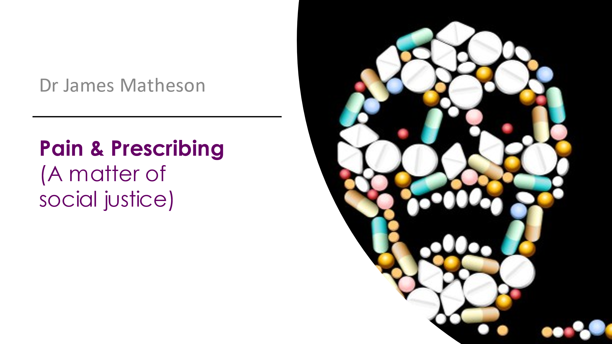

James Matheson

I am a GP who is passionate about social justice and the issues around chronic pain. I have just started working again in Cumbria, where I trained, having spent the last 5 years working with Hope Citadel Healthcare, providing primary care in disadvantaged areas in Greater Manchester, and the Shared Health Foundation and Focused Care community interest companies, which seek to reduce the impact of poverty on health and work with our patients and households with the most complex needs. I am very interested in medical education and training and working alongside our patients to support them towards better health and well-being.

Introduction

I am not an expert on pain and it is a privilege to speak to an audience from the Pain Society. However for GP’s pain features very strongly in most of our consultations. More recently I have acquired some insight into my pain patients’ experience: having been blessed with good health up until three years ago I caught typhoid which has left me with a permanent headache and joint pains So I have been on the receiving end of a lot of the issues and experience of prescribing that I am going to talk about. A lot of health professionals find ourselves in a slightly privileged position.

Of all the forms of inequality, injustice in health care is the most shocking
and Inhumane.
Martin Luther King

The first time I used that quotation in a presentation I don’t think I really understood it, but as time went on I began to see the resonance with pretty much all we do in health care. So I shall be talking today about inequality and injustice, and whether we in the healthcare professions make things worse or better in that regard. Betsan earlier sent round a tweet about the experience of a guy living on a council estate being filmed telling someone on a bus to wear their mask correctly. The story went round the estate and was related on Twitter and he was stunned to hear someone else with a similar experience who ended up with a guy with a shotgun on the doorstep and ended up homeless. And that is the reality of normal life for those of us who work in such areas - I know a GP in Darlington who found this image familiar – and for a huge number of people and patients in the UK.
And this affects our experience of pain; if you think of someone in pain sitting on a beach in Barbados sipping cocktails and compare that with the impact of pain on someone living in a cold and damp council house in the North-east of England. And it’s a relationship with pain which can go two ways:

Pain is entangled with and shaped by: social locations and identities, experiences of violence, trauma and related mental health issues, experiences of discrimination, stigma and dismissal, experiences of inadequate and ineffective health care, and the impacts of these intersecting experiences’
Wallace et al 2021

I’m going to show you some maps: I used the first in a presentation about Covid which show regional disparities in Covid deaths:

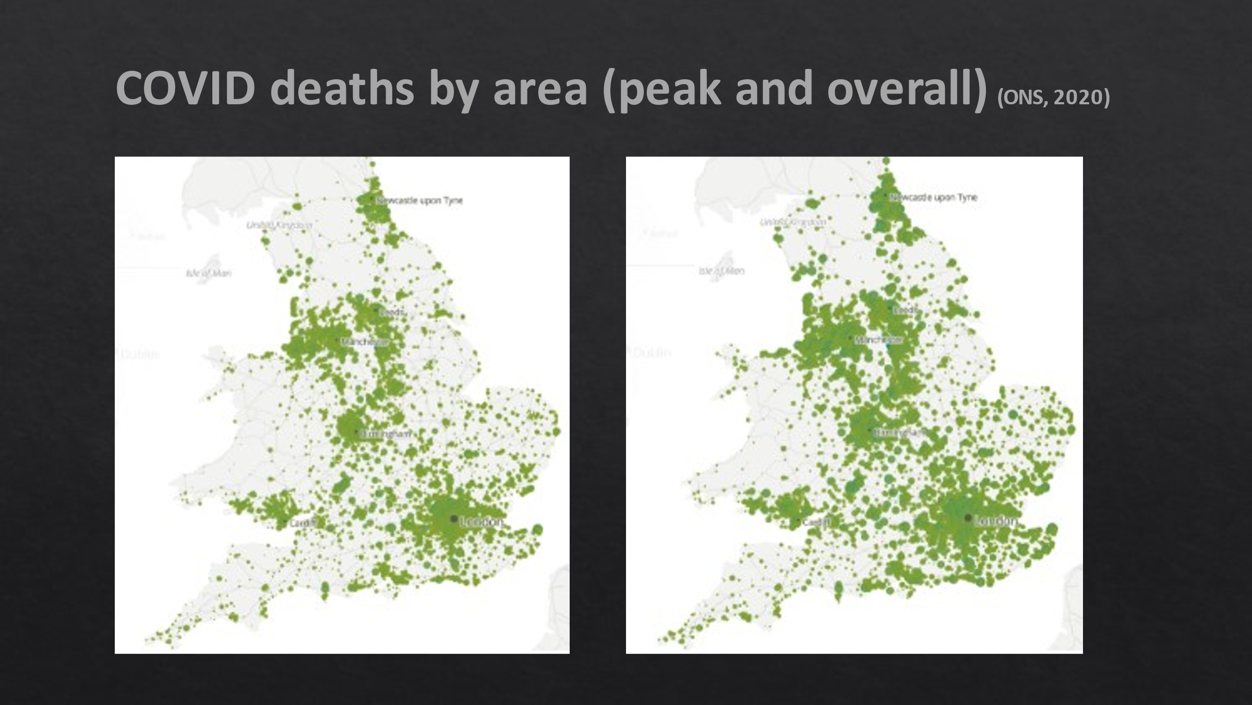

with a preponderance in the north east and north west. (this was in the early stages – now they would be a mass of green dots) .

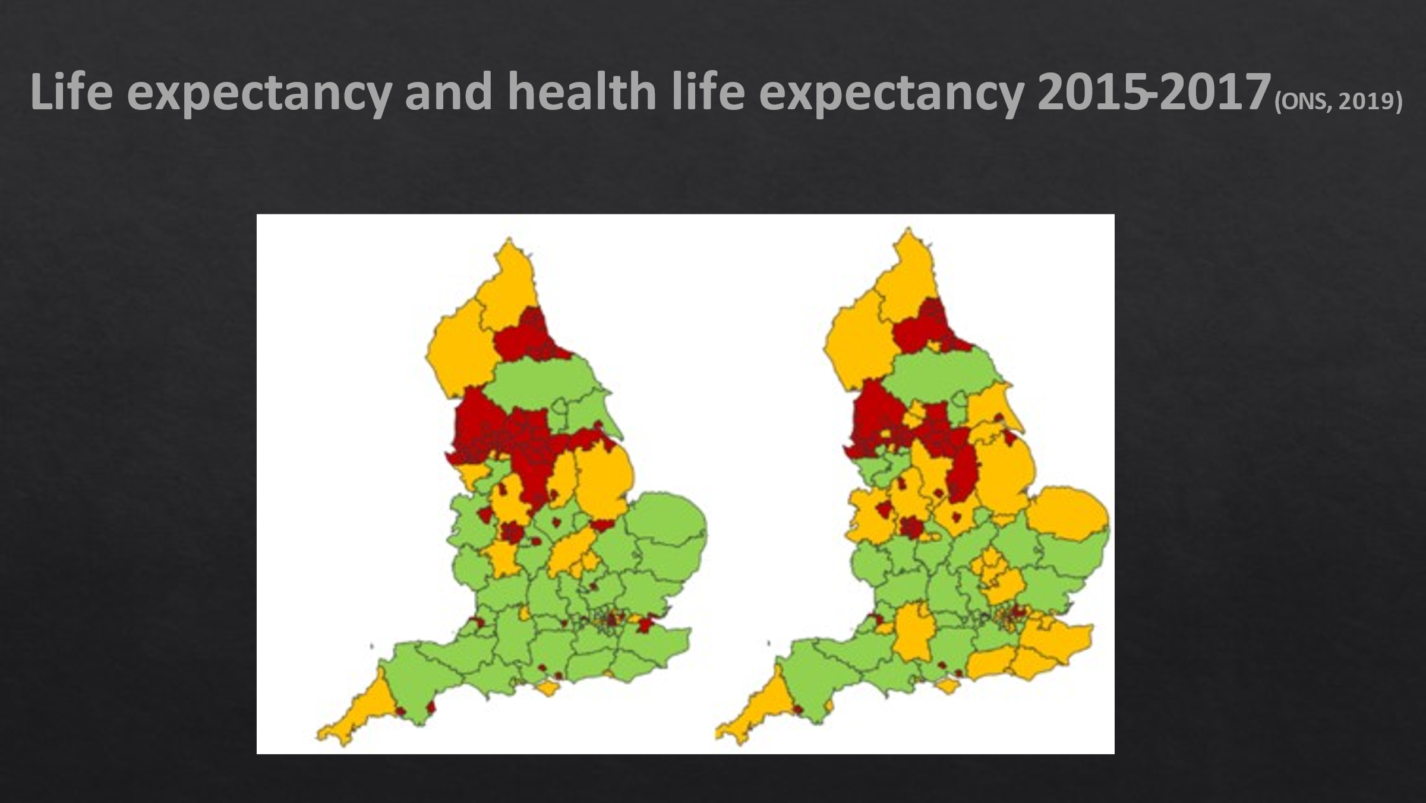

This shows a very similar distribution, as do those of mental health problems and that of emergency asthma admissions which are a proxy measure for poorly controlled asthma and children living in poverty, and the prevalence of chronic pain:

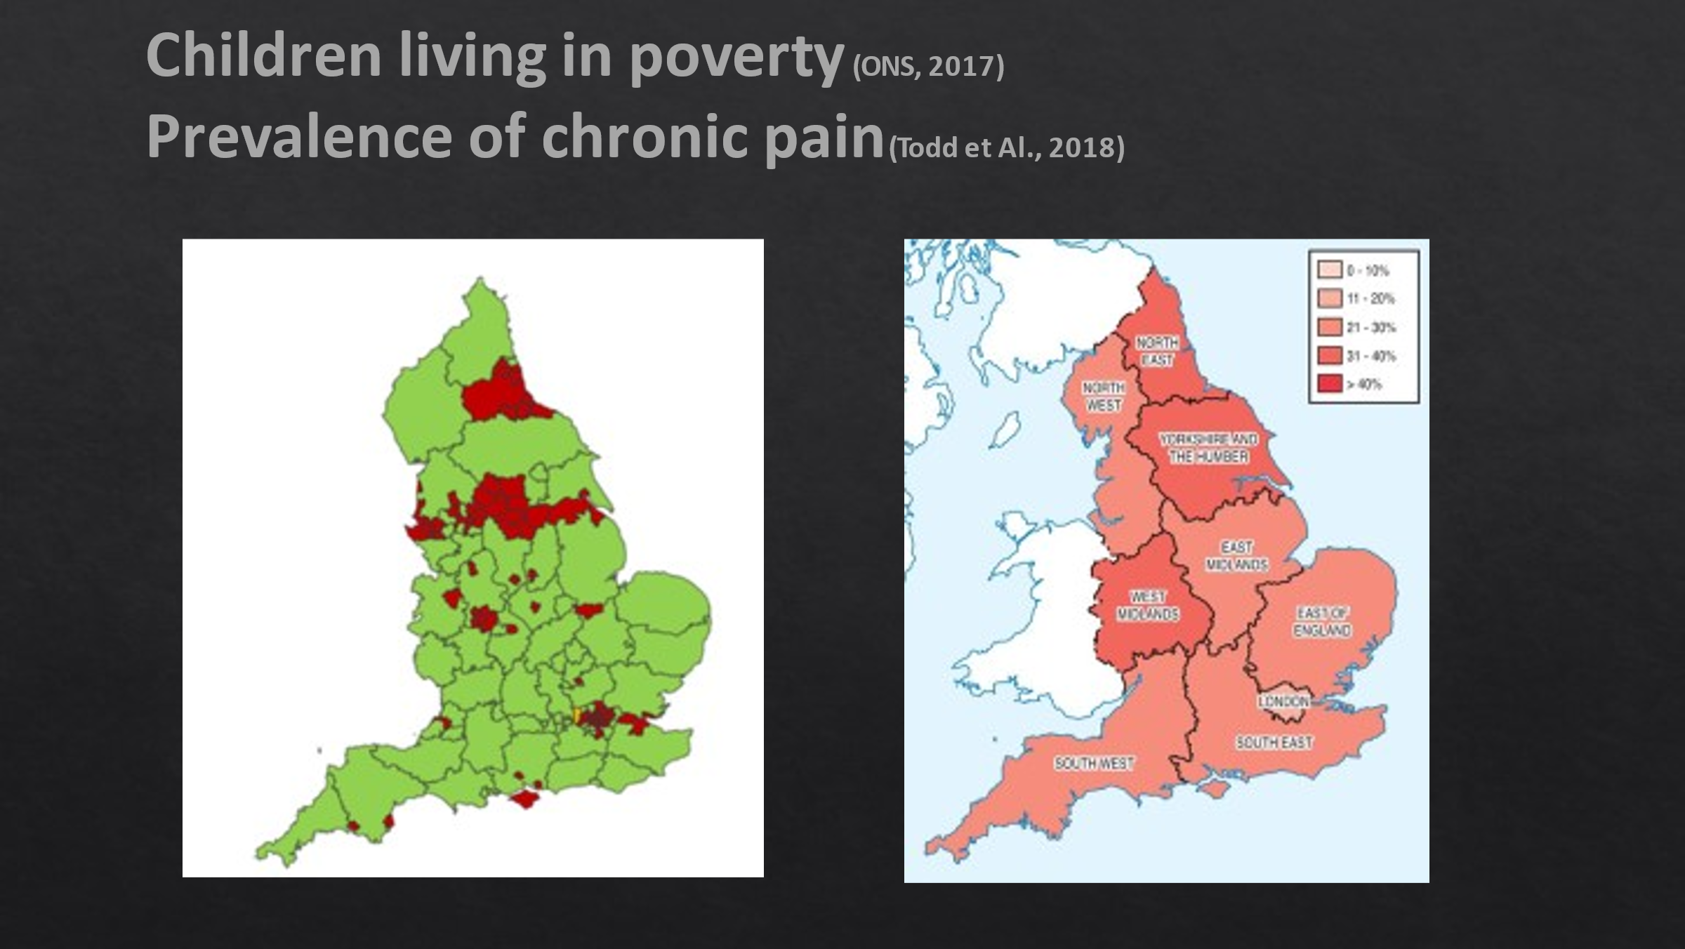

(there is apparently less in the north west but on a more granular map you would see patches around Morecombe Bay, Liverpool and Blackpool.)

Why are all these maps broadly similar? They all tie belong to a map of Indices of Multiple Deprivation which include income, employment, education, health, crime, barriers to housing and benefits and the living environment in general with a broadly similar pattern of north east and west, Yorkshire and the west midlands, with patches in London and some coastal areas including the south-west.

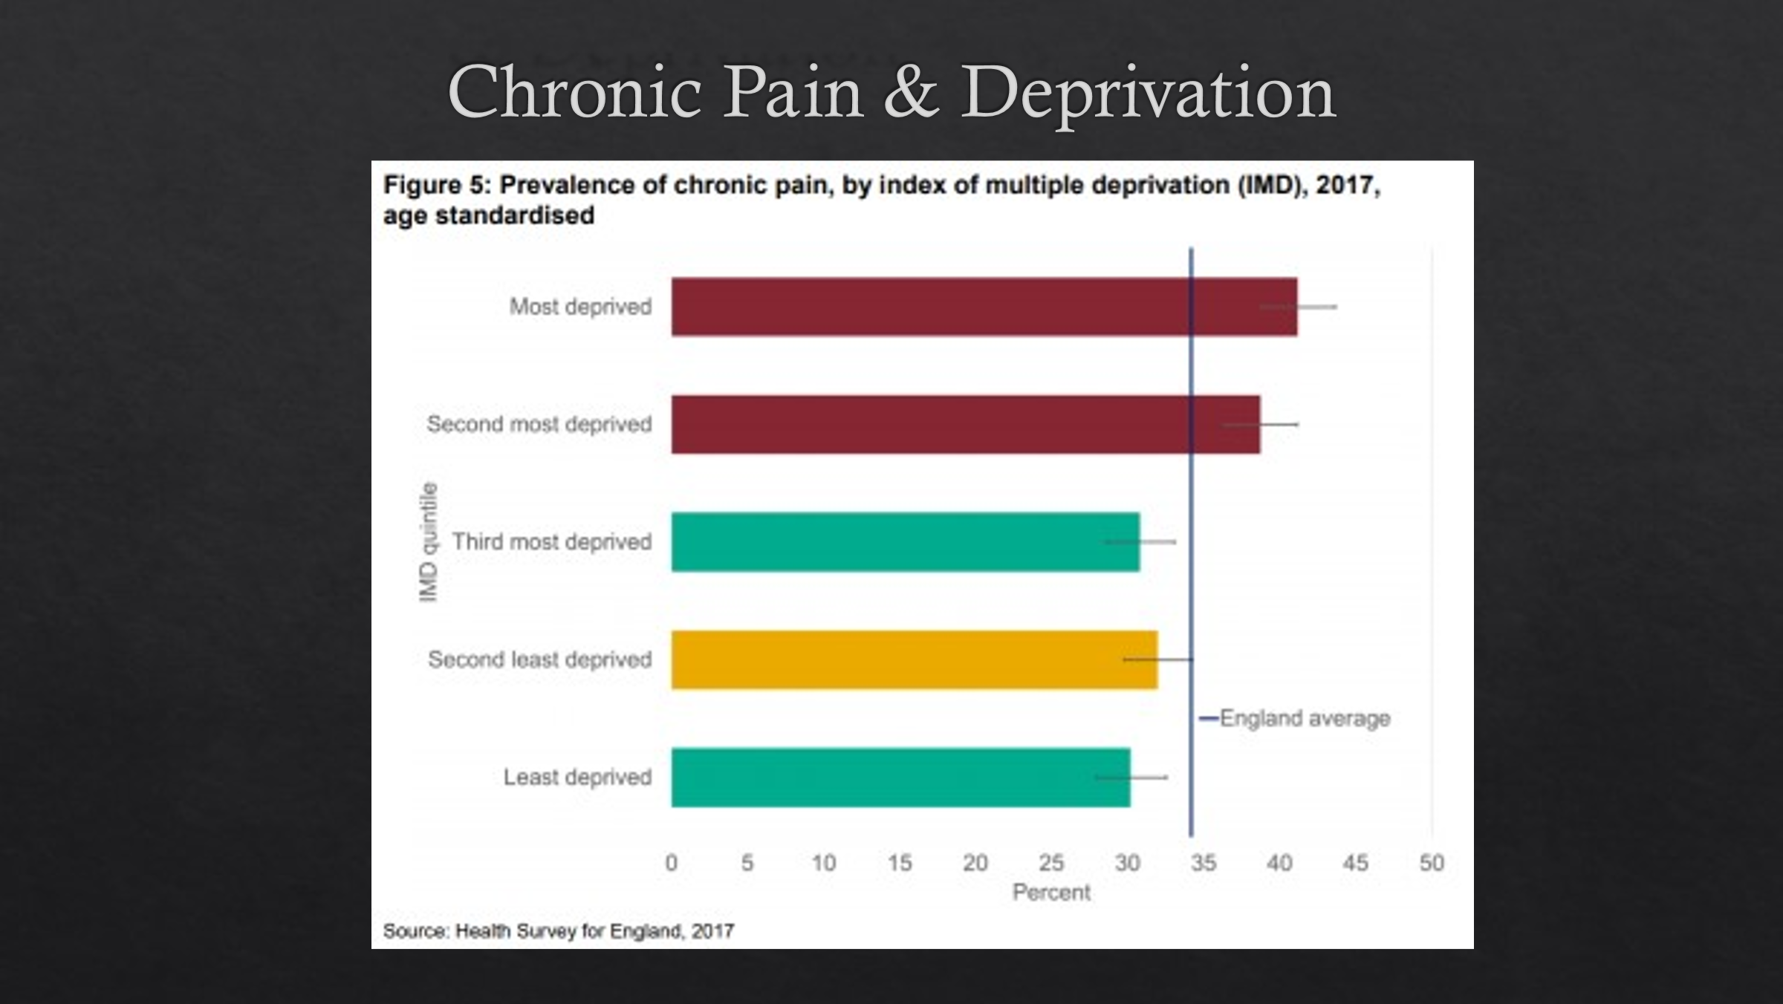

The association of chronic pain and deprivation is shown in this bar chart with a low incidence in the most affluent areas and the highest in the most deprived regions.

Mills et al in their review of the epidemiology of chronic pain conclude that

“ population studies reliably show that the prevalence of chronic pan inversely related to socio-economic factors. Those who are socio-economically deprived are not only more likely to experience chronic pain than people from more affluent areas, but they are also more likely to experience more severe pain and a greater level of pain-related disability”

As illustrated by the next slide:

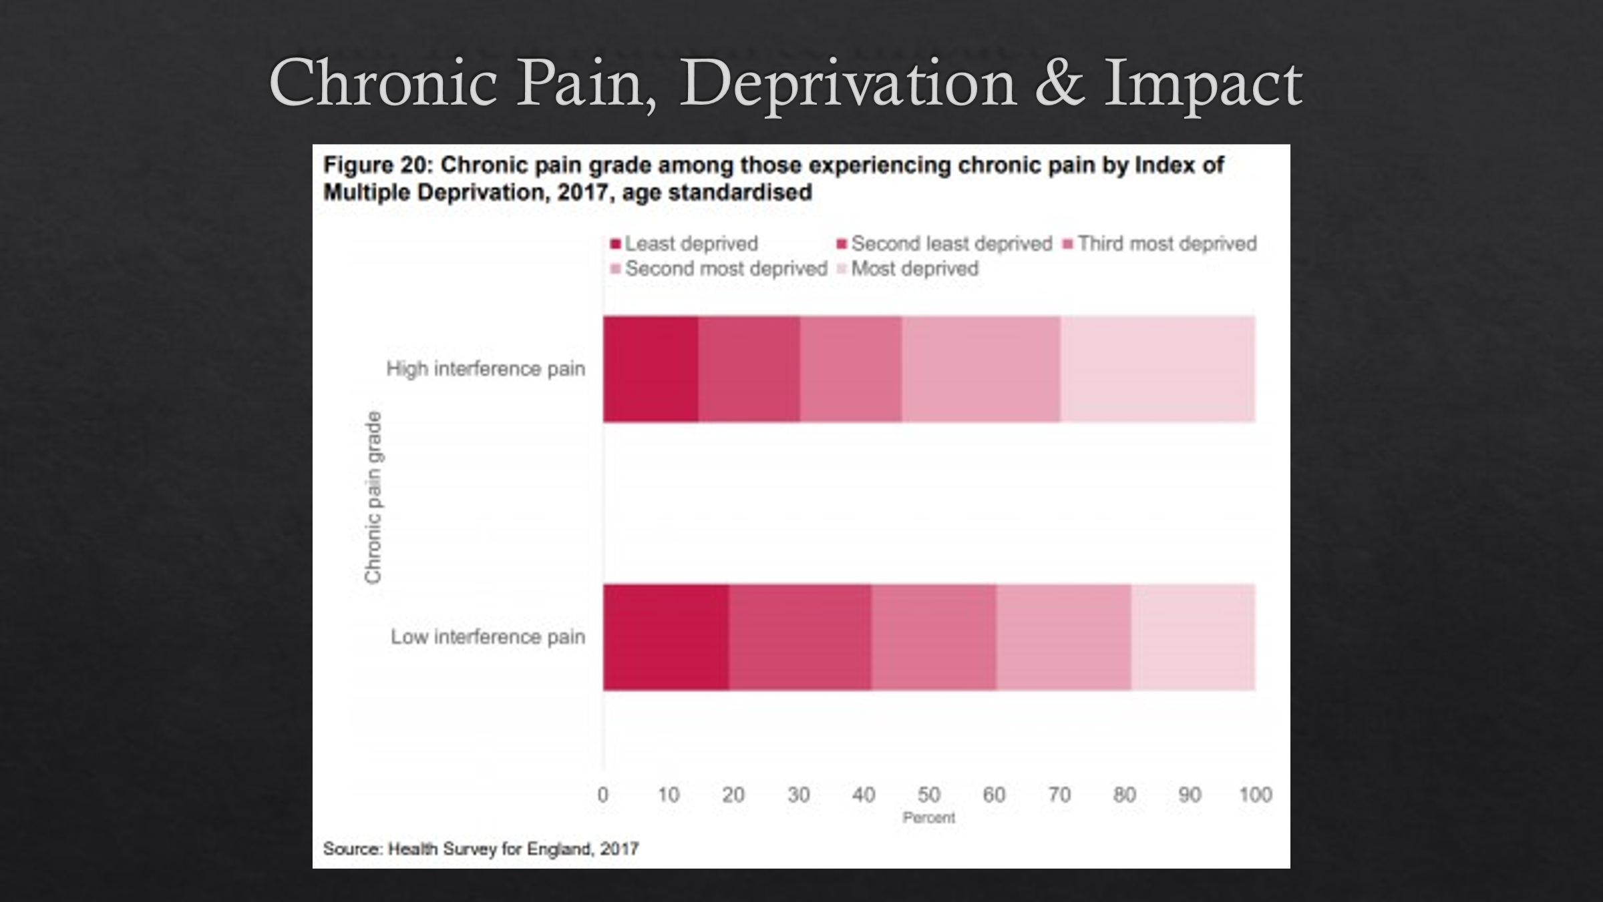

People who have low levels of education, perceived income inequalities, and high levels of neighbourhood deprivation are more likely to experience chronic pain than those who have higher levels of education, less perceived income inequality, and who live in more affluent neighbourhoods.
Mills et al

Prescribing

So what then do we as health care professionals do about this stuff? The number one thing we get trained to do at medical school and are quite well equipped to do, is facilitated by the system, and is quite convenient to do in a ten minute appointment, is prescribing. How do we prescribe and how is that distributed ?

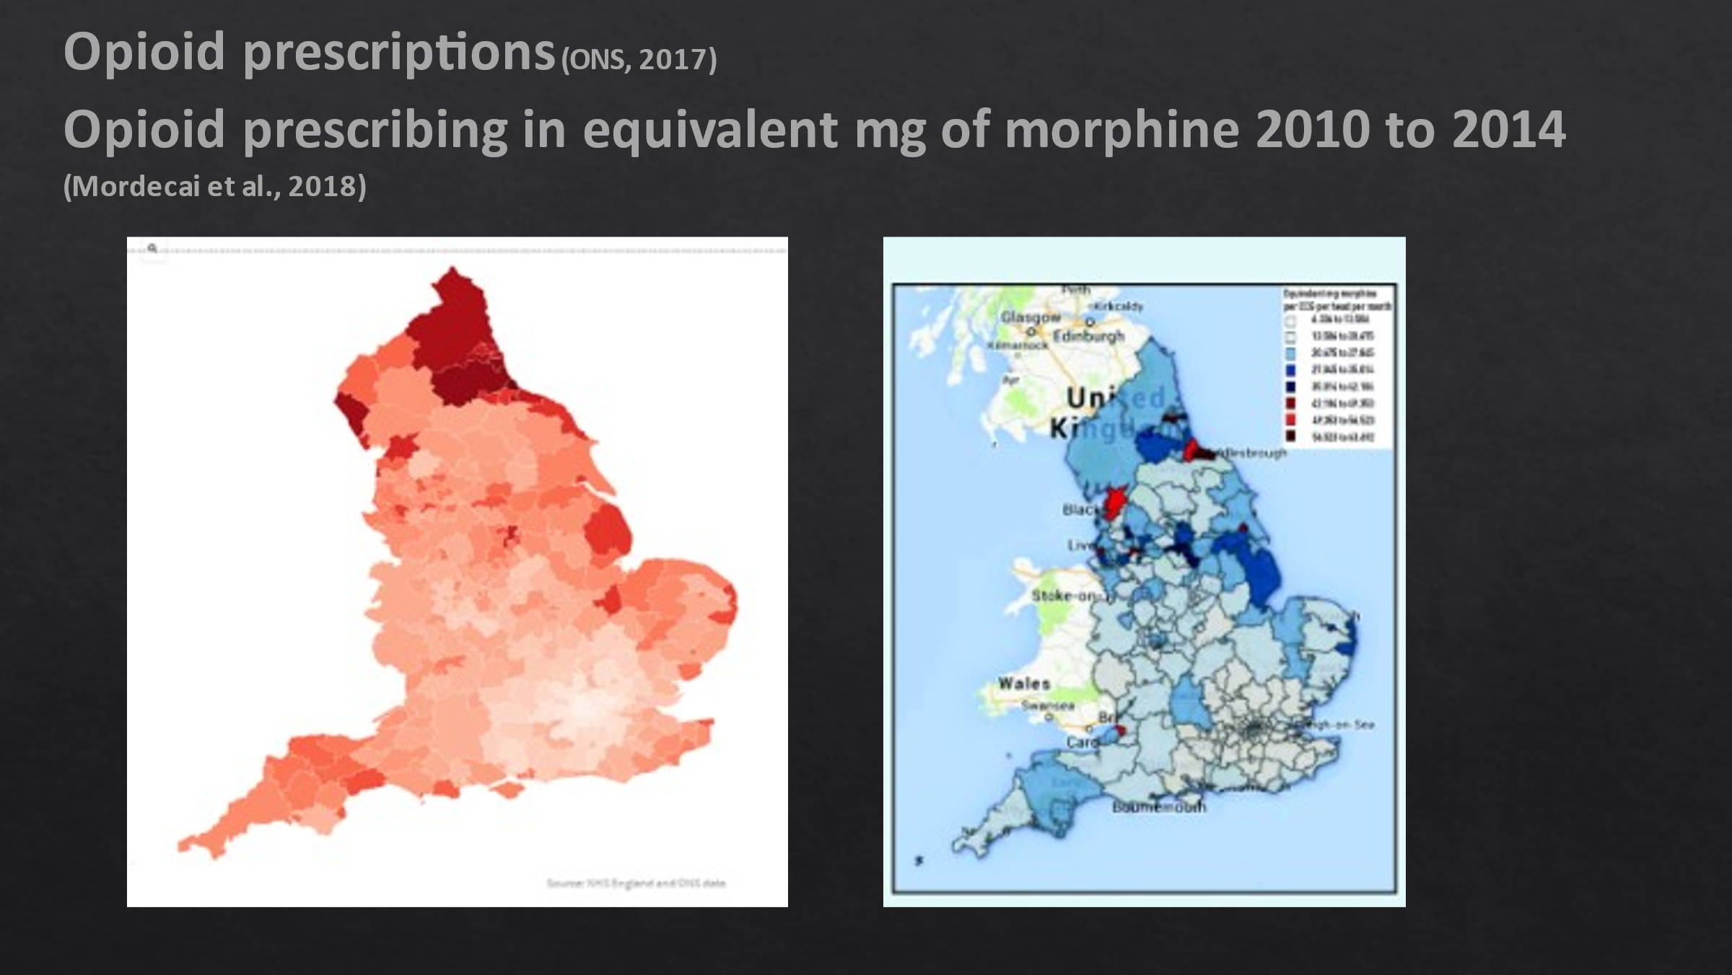

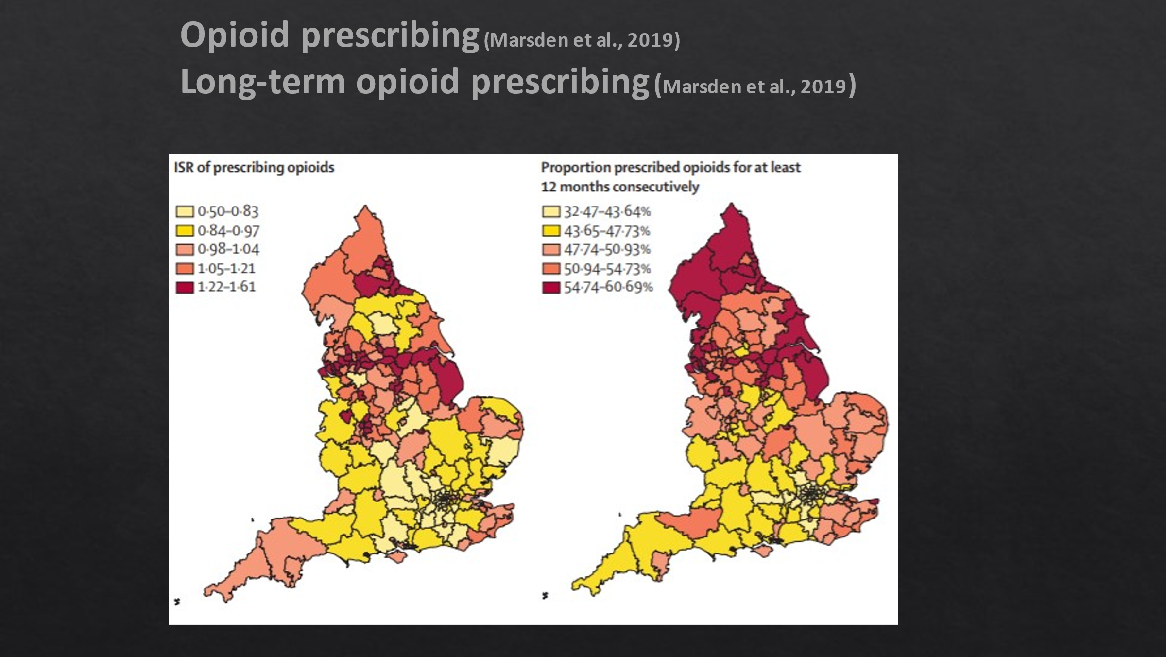

Once again we see the same geographical distribution of numbers of prescriptions of opioids, mg. of morphine equivalents, and long-term opioid prescribing.

So people in these deprived areas are not just being prescribed more opioids but are on them for a longer duration. It’s not just opioids: we use antidepressants in a pain-relieving fashion, and we also find that chronic pain and depression go hand in hand with a two-way relationship between them. The other things that are prescribed, often in the long term, are gabapentinoids for which we see the same pattern.

We as clinicians focus a lot on the potential benefits of prescribing. If we find the right kind of analgesics for our patients with pain we can take the edge off their suffering or even on rare occasions eradicate their pain. But there is a lot of suffering which comes alongside of that in the form of side effects. We see a lot of impact on peoples’ lives from side effects; in extreme examples even quite a few deaths, more than the statistics show.

New analysis by deprivation shows that, in the last decade, rates of drug poisoning deaths have been higher in the most deprived areas of England and Wales compared with the least; this is particularly the case among those aged in their forties where rates reach peaks that are at least 5.5 times higher in the most deprived areas.” ONS, 2021.

Statistics about how people use medication show that in the US 38% of adults are regularly prescribed opioids and 20% take unprescribed opioids. In the UK 13-46% of the population have persistent pain and of these 12% are prescribed strong opioids; 6.2% have taken prescribed opioids for non-medical purposes in the last year and 14.6% in their lifetime.

We in the UK woke up to the idea of the opioid epidemic after we saw the American headlines. We have a good idea of the number of people for whom we prescribed certain medications but we don’t have a very good idea of the numbers using prescribable medicines in an unprescribed way but anecdotally we hear a huge amount about it.

To give you one example: I got message to call a patient last Monday morning; I really enjoy consultations with this patient, a forty-year-old lady with bipolar affective disorder. Unlike most people who ring up about their problems and asking for solutions she rings to tell me that she had a problem and to describe her innovative sometimes legal approaches to how she has managed to solve it, and this was another example. She has recurrent acute back pain; every year something sets off an episode. The first time she had it, it was so bad that she couldn’t get out of bed and ended up calling an ambulance which took her to hospital where they gave her morphine and sorted her out so she could move, and things settled down fairly quickly over a matter of days. So after that her expectation was always morphine after which things were always better in a few days. After many years of negotiations around that it so happened that on the Friday before she called me, not having got through to any of her regular doctors she spoke to a locum. He said we don’t do home visits for back pain (however horrific and immobilising this may be); but I don’t really want to prescribe an opioid or a benzo over the phone to someone I don’t know. He then proceeded to record exactly what she had said in return, which was expressed in very colourful language but the conclusion was that it doesn’t matter because I can call my dealer up and get whatever I want . So I rang her on the Monday and said I was sorry to hear it had been so bad and asked how it was today? She replied that it was a lot better. I asked if her dealer had dropped something round that really helped? “Oh no, he didn’t have to because my neighbour came round and gave me some morphine and some diazepam which took the edge off and now it’s not too bad”. I was conflicted about that: at first I was horrified to learn that such things were freely available on our estate. But I was kind of touched that that was our community coming together to help out someone in need.

There has been a lot of evidence of an increase in opioid prescribing in recent years:

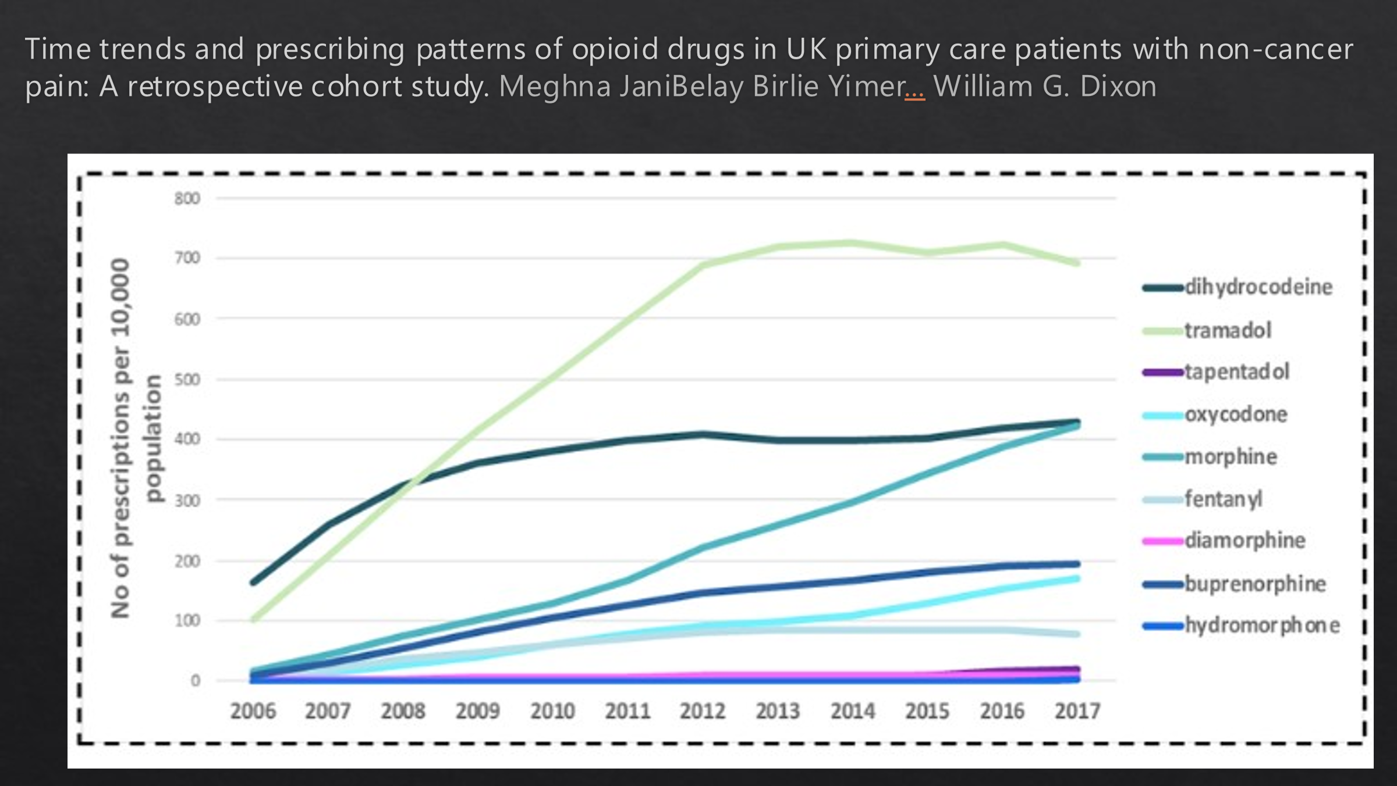

But despite awareness of this nothing has gone down much although some things have plateaued.
So we haven’t learnt, have we. We started learning about harms but one reason why we don’t realise the impact is that we don’t know about it.

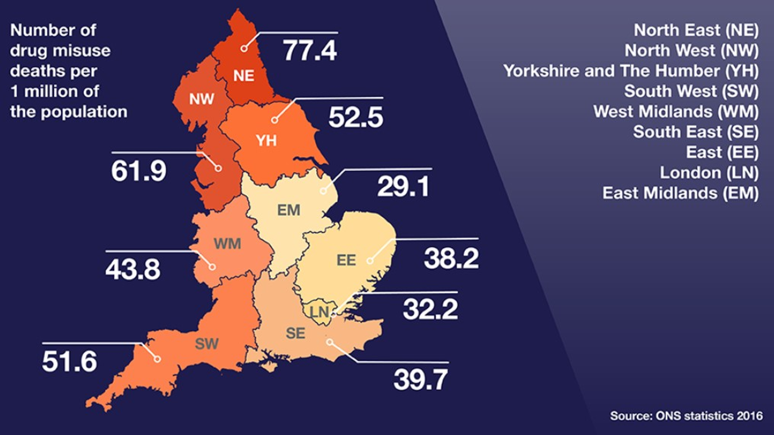

(not the most recent figures and it has all got worse) So when people see the figures issued by the ONS they picture heroin overdose and the drug industry, and the main figures are indeed opioids; heroin is the number one but nearly equalled by morphine, much of which is prescribed but not necessarily to the person who has taken it. But of course these harms are not evenly distributed.

Mortality rates are again related to deprivation levels with the least deprived at the bottom and the most deprived at the top.

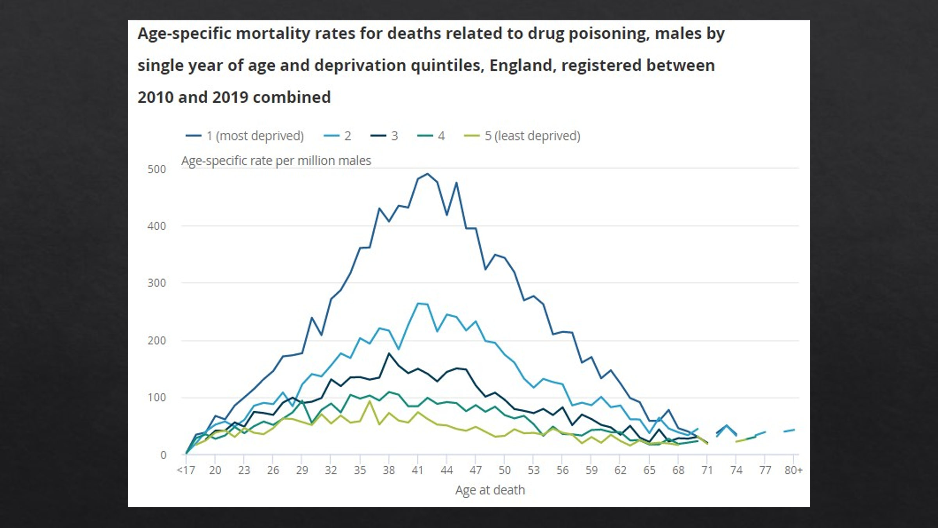

If you imagine the area under the top line of that graph: that is all preventable death. It is all death related to social injustice. People in the most affluent parts of the country get to live longer, get to live more of their lives in good health and are less likely to die from prescribed medication.

Another reason why we don’t appreciate the impact of prescribing is that the figures aren’t really out there, or if they are they are kind of difficult to match with reality because it is quite hard to prove that someone died from a medication overdose especially after the fact or whether it is one medication rather than another. The reality is that when people die is that it usually isn’t one thing but more likely a combination

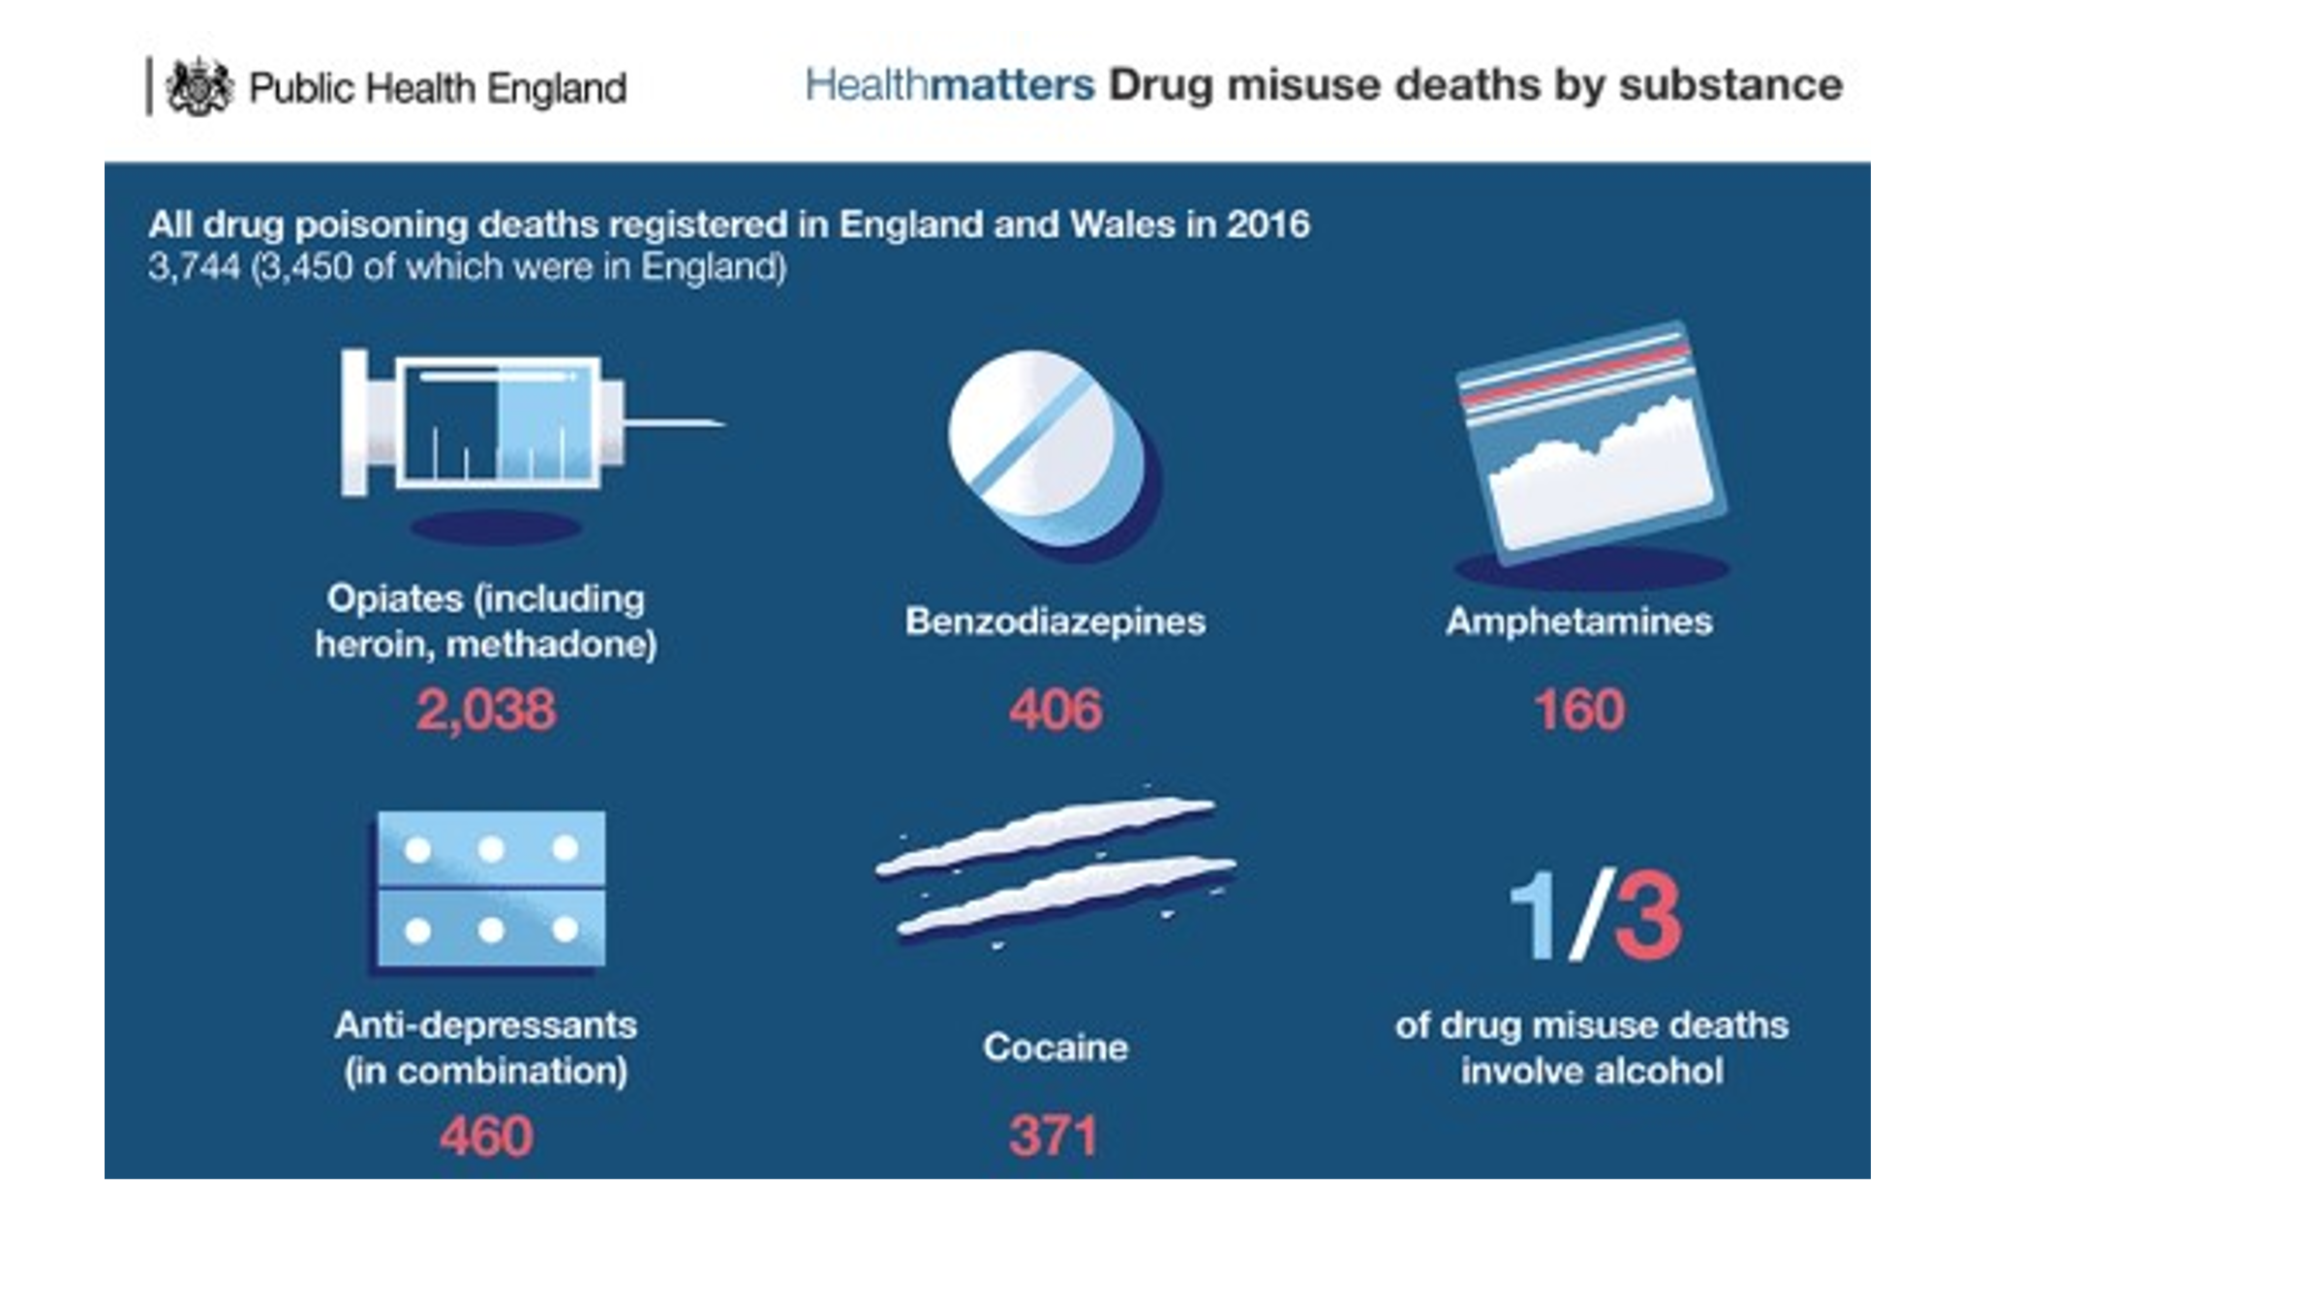
And we prescribe in a world where most people don’t take the medicines they are prescribed. People don’t like being told what to do and prefer to use their own initiative. How often have we heard that phrase “well I tried one, Doc, but it didn’t touch my pain but it did help me to sleep.” We often don’t know what people are taking; they may not have been prescribed a benzo but a lot of our patients acquire them. Some of our patient population use ‘recreational’ drugs - I don’t like that term as they tend not to take them for fun but because they fill an emotional or social void, and take the edge of some of their suffering. And almost all of them combine them with alcohol. Many have a history of alcoholism but if before we prescribe anything we ask about their intake they will only admit to having an occasional drink. But in reality we are talking about a patient population that drinks a lot and a lot of our patients in chronic pain use alcohol as a means of putting a lid on it.

Patients are rarely on one drug and frequently on combinations of, for instance, tramadol and codeine and often a third drug. The potential complexity of the situation is illustrated by this network plot:

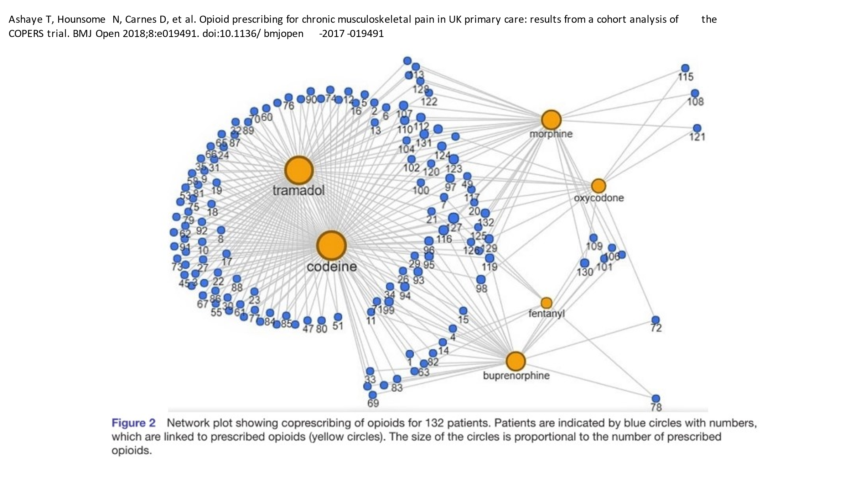

This is a printout of one of our patients’ medication:

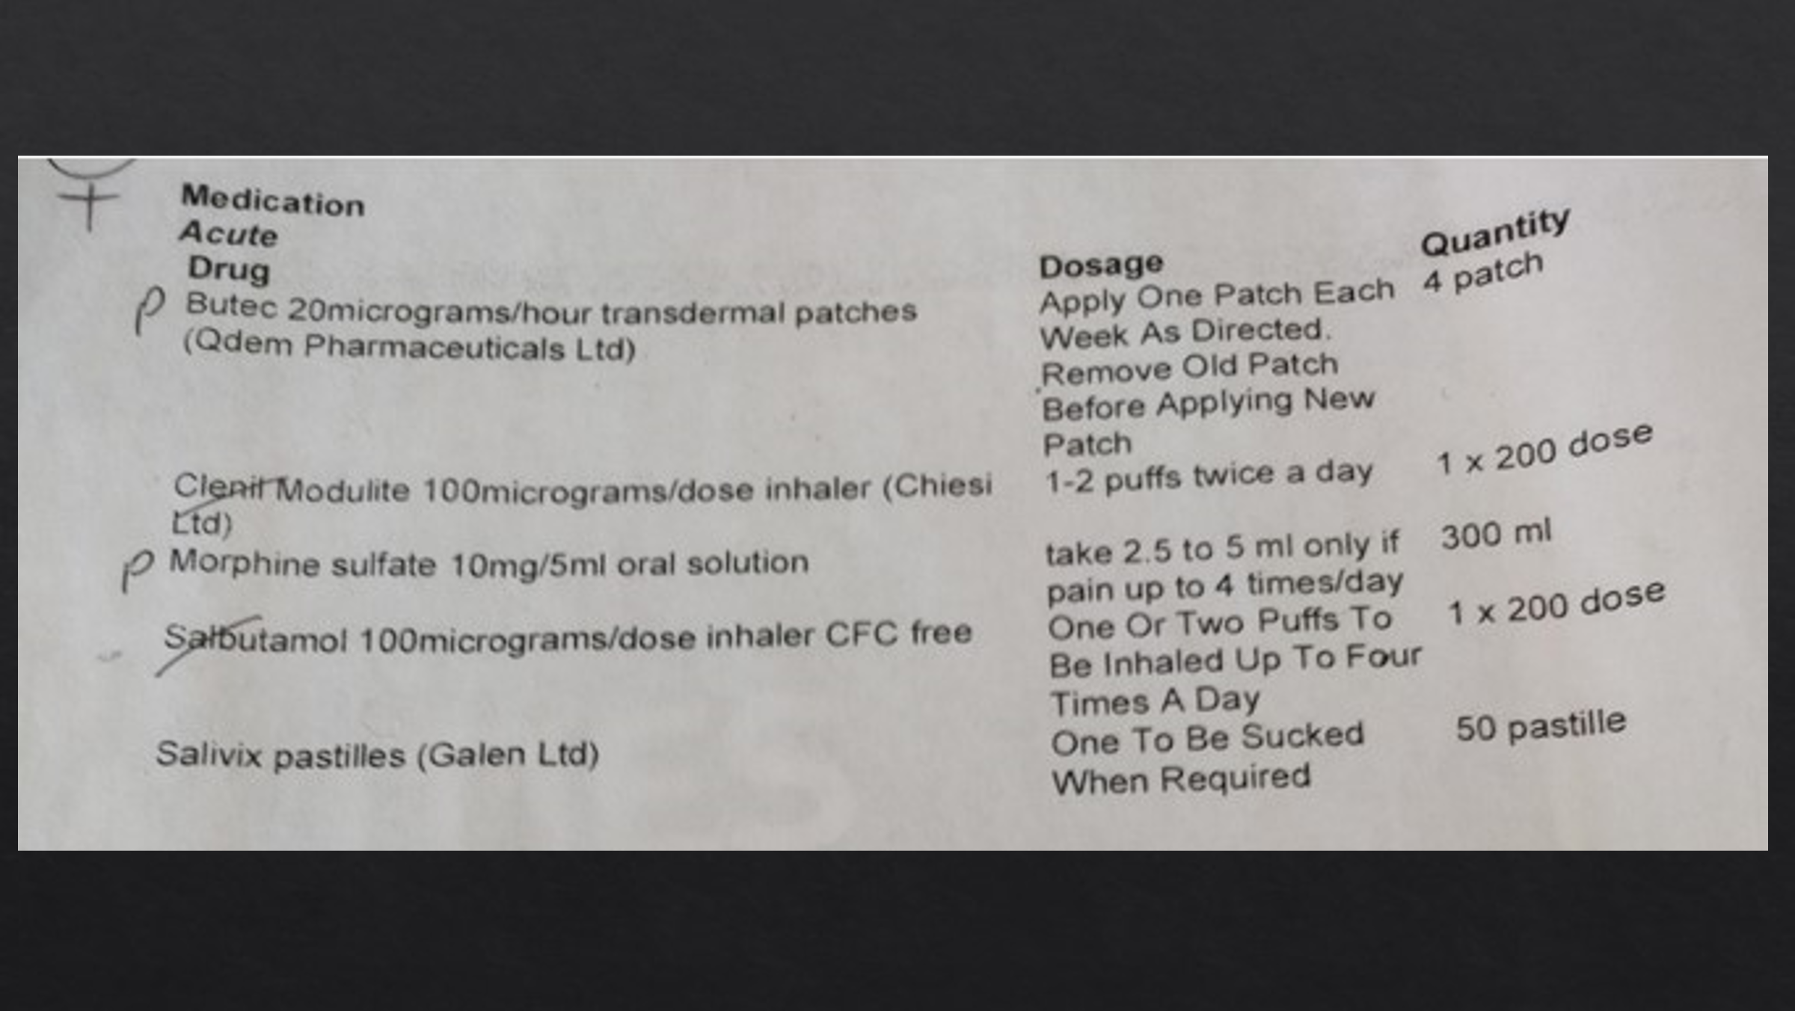

You may think I have picked an extreme example but this patient, who recently joined our practice and is taking morphine in an uncontrolled way but has respiratory problems, is not unusual.

This is from a sixty-year-old lady:

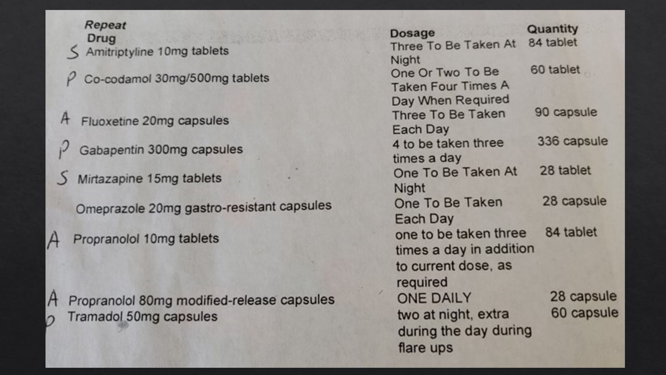

She has a really sad story: she had always suffered from anxiety and depression and was always worried about her health, but then she had two aneurysms which left her with chronic headache and loss of memory, and her anxiety levels went through the roof. She has been seen in A&E about once a month because she forgets a lot of stuff that has gone on before.
So what is missing from this list? Where are the benzo‘s? She had been on them, but this was at the point when we had spent a year or so working with her to reduce her medication. She had been on chloral hydrate and temazepam. When I first met her she had a list of symptoms and was asking for more medication. I suggested that maybe some of these could be due to side effects and she agreed that that might be the case and that she might be better with less medication.

People have started to use gabapentinoids outside the NICE guidance. They kind of got stuck on and tried when other things hadn’t worked, and since 2006 prescriptions of Pregabalin have risen in NHS primary care more than tenfold and of Gabapentin by more than 400%, with the same kind of geographical distribution as before. They can be highly effective but they are also highly addictive with some potent side effects. Some patients love Pregabalin; it is probably the most popular medication that people come after, not just for its analgesic properties but also the euphoria some people experience – the majority of people say “it chills me out” - but not all: I have had one patient say “it totally destroys me” and another who wanted to switch back to Gabapentin.
I may sound judgemental about all this stuff but I have been on the receiving end of some of these medications myself and although some do have harsh side-effects they have been useful. I did take Pregabalin when I had a four month wait for a neurology appointment. I didn’t want to take it but my GP persuaded me to go on it; my neurologist said there wasn’t a lot of evidence for it for chronic headache, but guess what? : it worked! – really well, and much better than anything else. But trying to come off it now is hard work. There are deaths from it: back in 2012 there were 4 deaths from Pregabalin and eight from Gabapentin but in 2017 there were over 50 and over 100 respectively.

Deaths of Despair

We hear about the deaths of celebrities like Amy Whitehouse, once again from combinations of drugs and with alcohol. But there are many more deaths we don’t hear about: there is an almost 10-year gap in male life expectancy between the richest and poorest areas. ‘Deaths of Despair’ was a term coined in the 2019 IFS review led by Angus Deaton, which discovered a rise in early deaths from drug and alcohol abuse and suicide linked to factors including poverty, social isolation and mental health problems. As deaths from cancer and heart disease have fallen deaths of despair have risen.

In one practice I used to work in we had a period of four or five months when eight people died unexpectedly at young ages and were all subject to a coroner’s enquiries. It dropped the life expectancy in our practice to 63 and had it not been for our oldest patients – one of 93 – it would probably have been somewhere in the 40’s or 50’s. Here is the medication they were on:
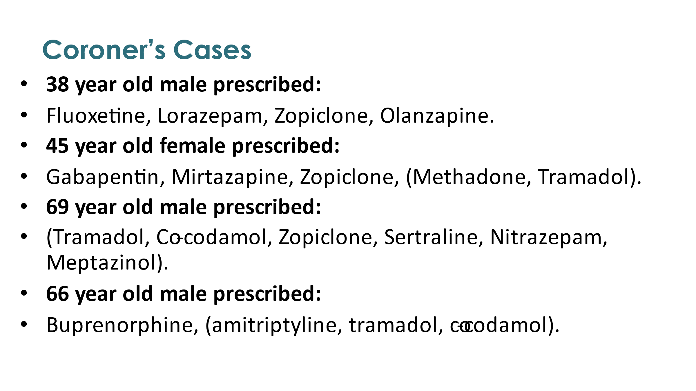
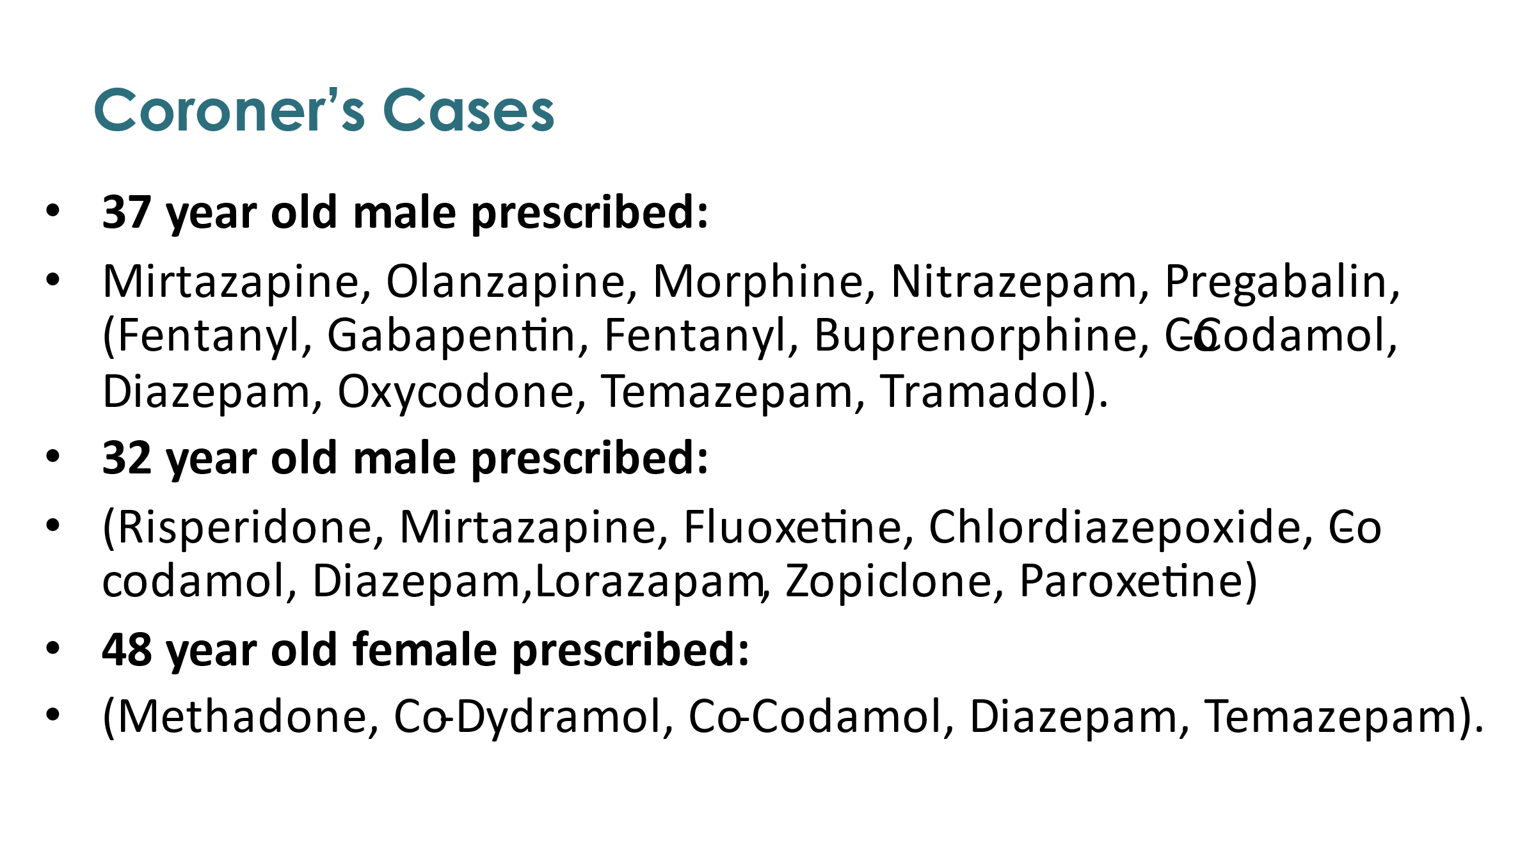
These were what they were on at the time of death (the ones in brackets were those they were not on when they died but had been on previously.) Not all these patients had been with us for a long time and more than one of the deaths came out of the blue. One of the deals that the first doctors made with the local population was to get people to register and they wouldn’t just stop medication in blanket fashion however risky it appeared to be

I want to look at one of my patients I shall call Greg in little more detail. I have changed his name and his age etc. a bit to protect identity although some of the information is in the public domain after the coroner’s enquiry
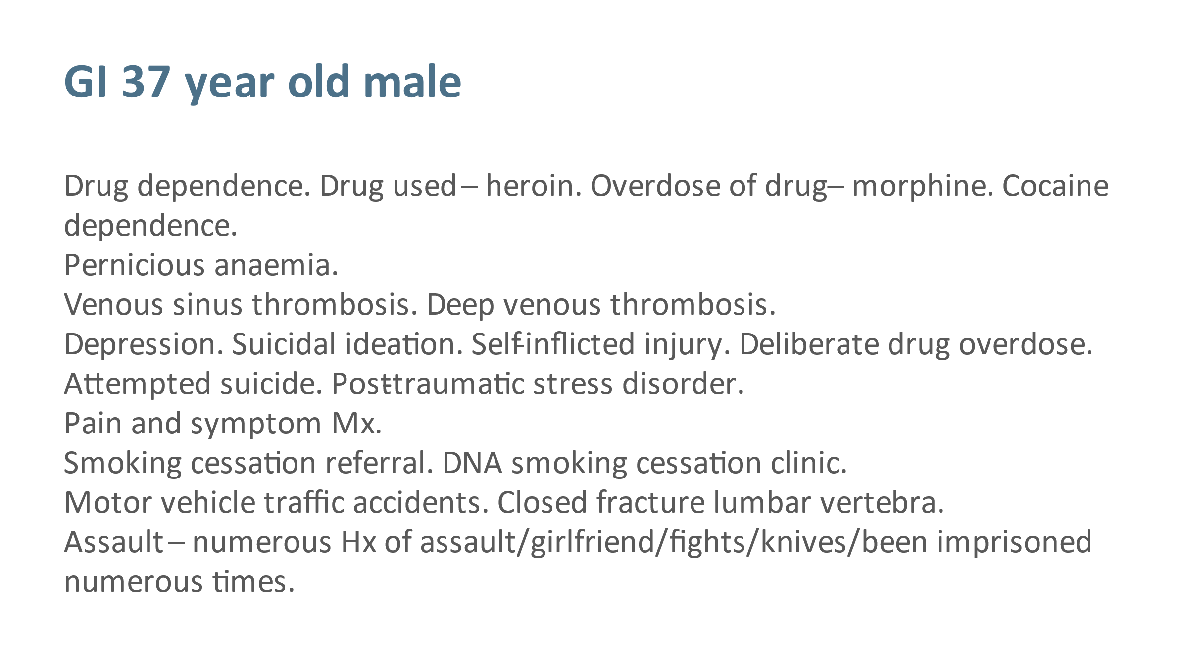

This was all stuff that had been coded and in the electronic record, and it paints a really negative picture. But actually he is a lovely guy. We tried to help him as you will see from his prescriptions and the way we tried to manage them: sometimes he was on very short prescriptions - maybe only one or two days’ worth. We would see him on a daily basis; he was friendly and happy and well regarded in the community, he was a parent and partner, and everybody really liked him at the surgery.

This was the medication he was on when he died:

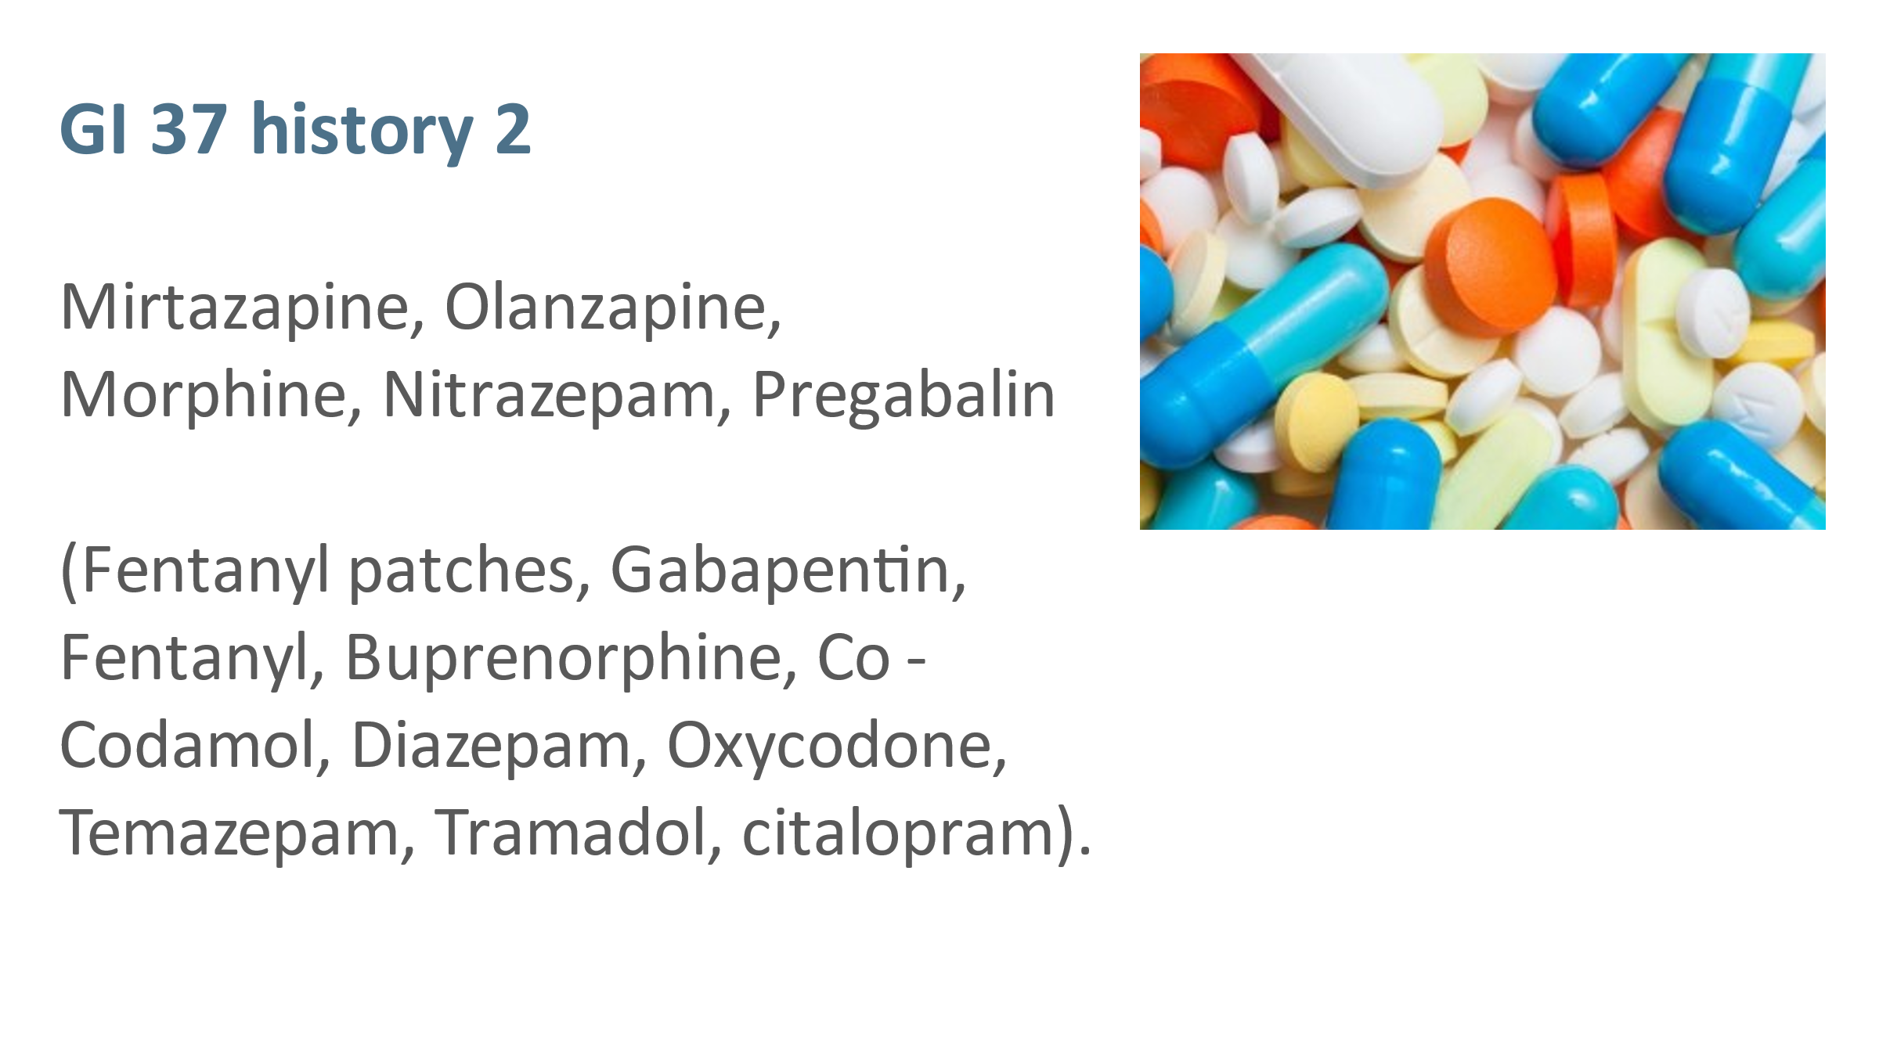

Mirtazapine is an antidepressant. Olanzapine is an antipsychotic. He had been on a whole lot more ( in brackets). He used to take himself on and off stuff and supplement on the street or sometimes pass stuff that he had been prescribed on to the street. That sort of combination is really very harmful, isn’t it? If you asked the vast majority of GP’s they would not know that if they prescribed an antidepressant it increased the risk of mortality by a third. They probably would know that if people with dementia are on antipsychotics their mortality risk is doubled, but they probably wouldn’t know that it’s not just people with dementia. So what about all these combinations? Greg was also on a gabapentinoid and an opioid. We know that that opioids cause increased mortality, but combined with a gabapentinoid it doubles that. Even with opioid substitution therapy being co-prescribed a benzodiazepine double the risk of death. A drug that was being promoted as a less risky alternative such as Zopiclone when I was at medical school more than triples it. So combinations are risky. Other synergistic CNS depressant effects such as cognitive impairment, increased sedation and respiratory depression also occur when benzo’s are used in combination with other drugs.

So what happened to Greg?
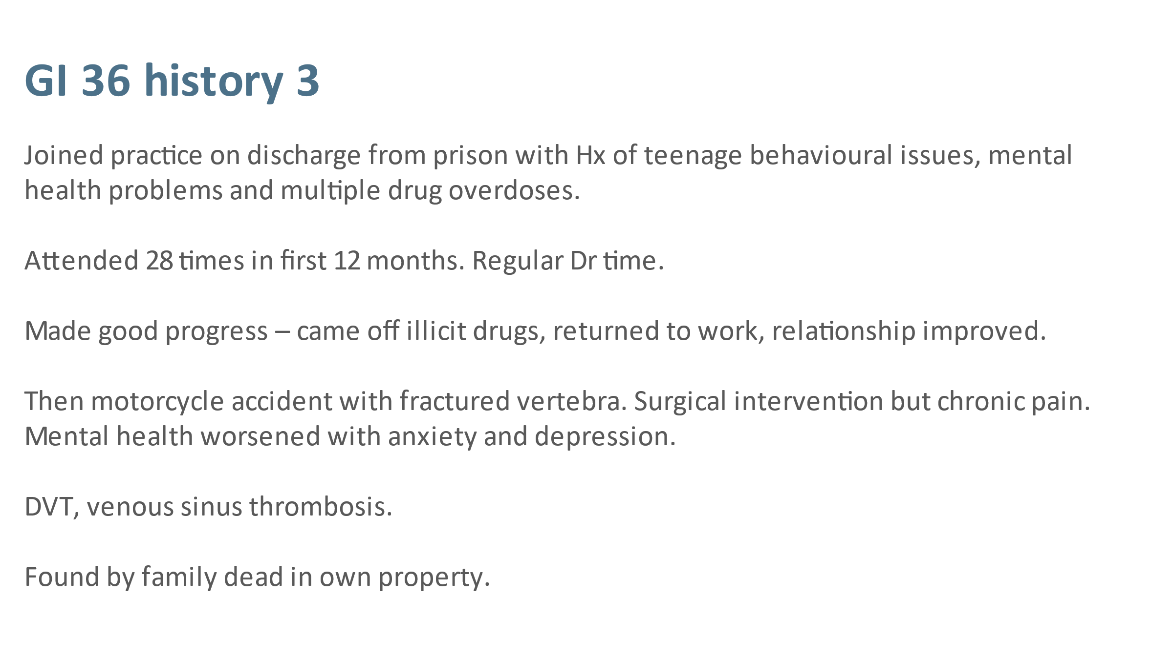

What this doesn’t tell you is why he had these problems. He grew up in an overcrowded house in a deprived area , with real issues of poverty and mental health in the family. One family member had a physical disability , another a learning problem. Greg suffered physical and emotional abuse from his parents. But he really engaged with the people that worked with him and they thought that he made good progress. He .came off his street drugs, went back to work, sorted out his long-term relationship and had two children, but his motorcycle accident and subsequent surgery left him with chronic pain. Nothing he was prescribed helped and he went downhill with DVT and other complications. And one day his Dad found him dead in his flat with the TV on. The coroner came to the conclusion that he had died of exactly the same cause as seven other people in that street. But they had all died from different things, one of suicide by hanging, one death by misadventure, one had been killed by drug dealers, another suicide, one accidental overdose and there were other speculations. But the common factor found by the coroner was bronchitis or bronchopneumonia compounded with the effects of centrally depressant medication.
We in the healthcare professions including the doctors who had prescribed for them or for their neighbours and all those other people around in the community had directly or indirectly contributed to these seven early preventable deaths of young people. Some of them were people we knew, others we didn’t know so well. Almost all were parents with young children, and we see the effects of that kind of traumatic loss of parents in early childhood. Losses affected family and friends, and indeed the community. Some of the funerals were attended by hundreds of people.
But none of us were summoned to a coroner’s court. There were no lessons learnt or published out of this. None of those people would have even have made it into the statistics because none of them had one specific drug or medication on their death certificate. So these deaths aren’t out there and people aren’t reacting to them.

What do we do about it?

But we obviously had to react to them, so what did we do about it? I want to ask you guys for your ideas, but we got all the doctors together across ten practices and talked about what we should do about it. You will remember that it was around this time that all this stuff was coming out of America about morphine and opioid ‘speed limits’ and if you were on more than 100mg of morphine or equivalent per day you had a seven times increased risk of deaths compared to patients on 20mg or less. Around this time something started to happen here with the start-up of weaning off clinics, and some useful guidance emerged:

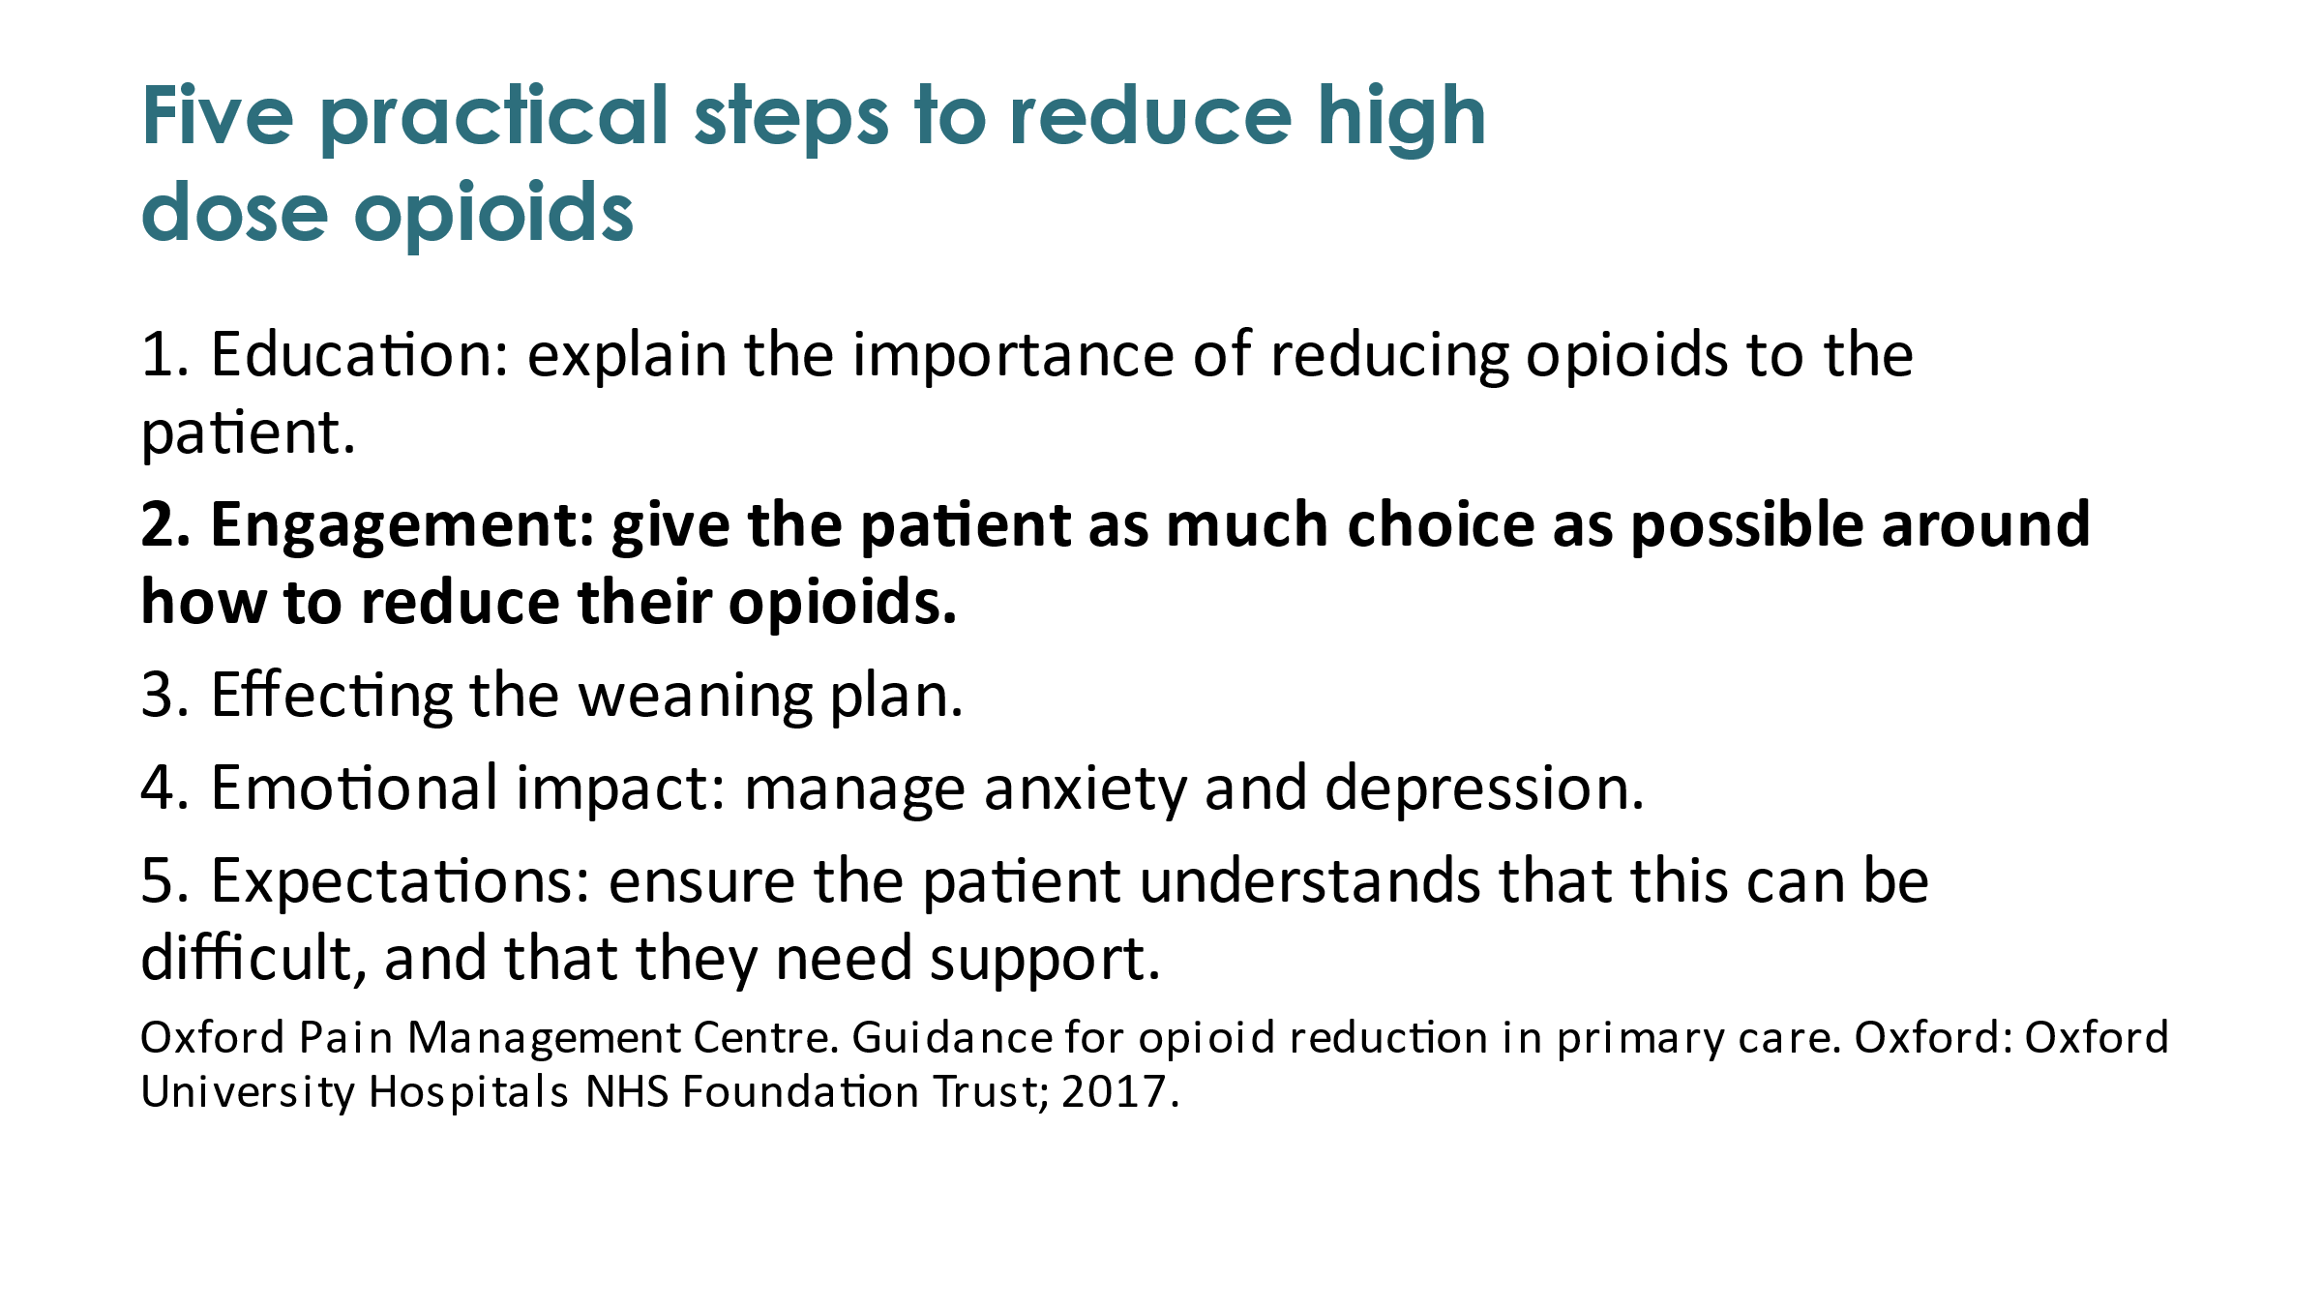
I think engagement should have been number one but there wasn’t a lot of that going on in some of these new clinics. People were being told how quickly they were going to be coming off their drugs and if they didn’t engage with the programme their prescriptions were just going to be stopped - which isn’t engagement or respecting patient choice. In others it was done really well and people found it very helpful.

But are medications necessarily bad?

I may be coming across as rather negative about medications but I will say it again: some of them can be hugely transformative, and not always in the ways we as prescribing GPs think.

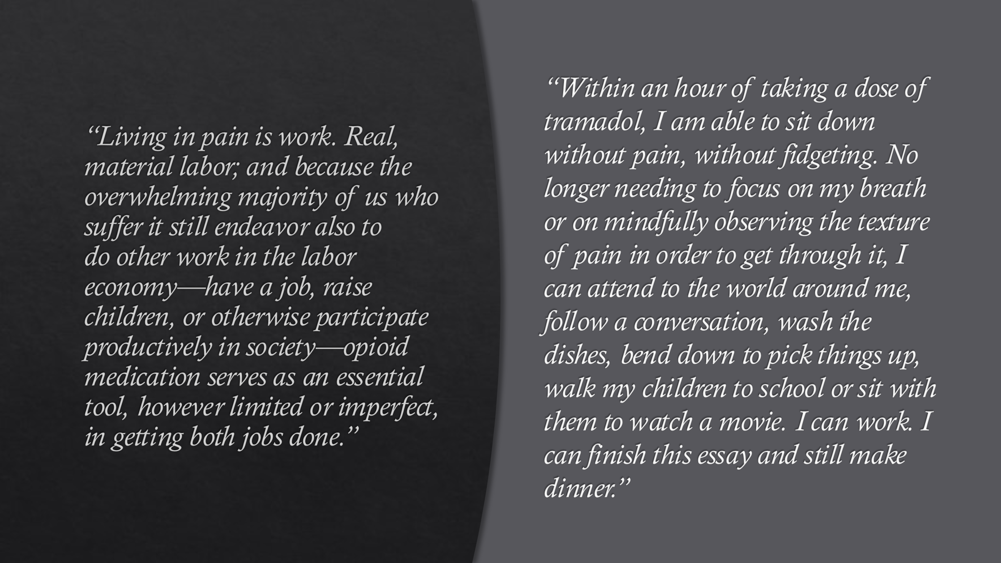

Sometimes we may prescribe something as an analgesic although we are aware of all the literature that suggests it may not be good for chronic pain. But it may make a difference to our patients’ lives because it is improving something else; it may only be because it is helping them to sleep. That may not be the way we wanted it to be used but anyone who suffers from insomnia will know just how awful life can be if you’re not sleeping, and how much worse it makes everything else. Or it may be that it is helping them to function, and make the difference between being able or unable to engage with life. Or is it that ‘it just chills me out’? Living with someone in chronic pain who isn’t chilled out can be really hard.

So does weaning work? Does it help to get people off medication? A review in 2017 concluded that there is some low-quality evidence that pain, function and quality of life may improve with opioid dose reduction. That was from relatively early days of this endeavour and there may be better evidence now, but feedback from the street suggests it can go either way. For some people it has been brilliant and liberating and has given them their lives back. For others it has restored a tiny bit of control over their lives.

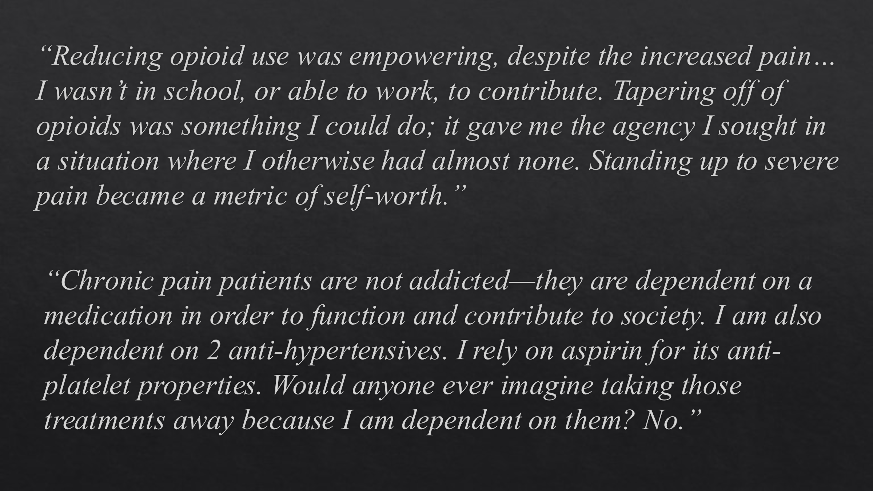

Another approach is to avoid starting the medicines to begin with, or not exceeding maximum doses: ‘the BNF says you can only have this much, but – hey – we know better’ . For instance ‘10% of codeine is metabolised to morphine (the only effective bit) in the liver’, and ‘there is no maximum dose of morphine’. We might not want to double up on opioids: if co-codamol doesn’t work perhaps we shouldn’t keep it on when we try tramadol. We shouldn’t prescribe temazepam at night as well as diazepam during the day. But stopping something that doesn’t work before trying something new is easier said than done because if you tell a patient you are going to stop something that doesn’t work before trying something new, they may say “well actually it does take the edge off, and I don’t want to stop the old one as I don’t know if the new one is going to work”, and that is a perfectly legitimate fear. Should we start off opioids at lower doses? We have some patients who rotate opioids to get around tolerance rather than escalating up the dosage scale by switching between co-codamol to tramadol to DHC and repeating that cycle every three months. It works for some people.

Guidance

This is tricky, isn’t it. I say that thinking in particular of the NICE guidelines which have just been published. (Its final form looks remarkably similar to its consultation form, and they didn’t seem to have taken much of the feedback on board.) These are going to revolutionise how chronic pain is managed. We have been brought up amidst a generation of doctors who have been told that NICE’s word is law and you should always follow NICE guidelines. And these say that none of the things we use for chronic pain should be prescribed. That is really contentious; it means that a lot of people are not going to get the medications they need. It may reduce a fair bit of the harm but at a pretty huge cost in terms of human suffering.

Another form of guidance we have looked at and were talking about at the RCGP before Covid struck and it all got side-lined was about harm reduction and safer prescribing. You may have seen the RCGP publication on safer prescribing in prisons and a secure psychiatric environment. It is very useful; it looks at medication commonly prescribed for neuropathic pain, insomnia, depression, psychosis and epilepsy, and then it stratifies all those drugs into a fairly simple system of red, amber and green according to their risk of harm, misuse or diversion - all big problems for people in prison. We were chatting a lot about whether we should be creating a similar thing about harm reduction or safer prescribing in the community or something on those lines.

I haven’t given a talk like this since Covid lockdown and it has made me very sad to think of the people I know who have died; and all the harm and social injustice that extends way beyond our practice across our country and indeed across the world.

But to end on a positive note, a lot of this is within our control to change.

Discussion

I really want to hear what you think we can do or should do – or indeed must do – to make things better.

The problems you describe are similar to those we have in the USA except that they are several orders of magnitude less for you. You don’t have a southern border which is the entry point for vast amounts of illicit drugs. What has happened in this country is that the problem that was initiated by inappropriate physician prescribing has been taken over by the illicit drug business; and now our most common cause of opioid related death is fentanyl which is manufactured in China and imported into the US via our southern border. It is being used to lace the heroin. This is not within the physician sphere of action, although you might say it was started by physician prescribing, but it is a huge problem and it is completely out of our control.

This is something we saw, when these forced opioid reduction clinics came in, that people either engaged with it or if they didn’t engage with it they got their supplies from elsewhere and went to the street. It was round about the same time that we were starting to see fentanyl combined with all sorts of meds on the street which were often random combinations of benzo’s with other stuff: antidepressants or antipsychotics and sometimes strong opioids. We have been seeing the bad effects of that around Manchester.

I am one of the few non- healthcare practitioner’s here, and by the way John [Loeser] and I have an editorial coming up in Pain very much on this topic. The first part of your talk was very much like what we wrote. Have you thought about publishing it?- something centred on the UK like ours is on the US. One of the things that I have trouble with … a matter of injustice. Covid, like unemployment, hit the working classes disproportionately. What can you do in the clinic about social injustice? If pain is largely a matter of social injustice … we have wrestled with this problem … like if someone goes into the clinic essentially because they are out of work. Pain is disproportionately located in white working-class non-college educated people. If someone comes in with agonising chronic pain what can you guys do about it in the clinic?

That is a really good question, and central to everything we have been talking about. We GP’s can have an impact. These are societal problems and we are often at the tail end. In general practice we look after everyone in the country and across their lifespan, and we have a chance to really get upstream to investigate the factors that make people healthy or unhealthy. In other presentations I have asked that same question and put a whole series of [? infographics] about how people think that we in healthcare can make very little impact on the social determinates of health. [distorted recording : … But there is a good breakdown in one of them …training … access to care which is out of our hands and outside of medicine. I like to make the argument that we can influence all of it to a greater or lesser degree … as we do quality of healthcare we can also do access to healthcare and then we can move outside of prescribing and …]

Work – especially good quality work - is a big contributor to physical and mental health, and lack of it to ill health

We were lucky in our practice; we appreciated that a ten- or fifteen-minute consultation is too short a time in which to make an impact. But there are about 66,000 GPs working in one thousand clinics around the UK, having around a million consultations each day, and a lot comes out of that that can be changed. We have reinforced our team with people who we call Focus Careworkers. They are the people who work with the patients with the most complex needs and across those needs: medical and psychiatric conditions but also housing, benefits, drugs and alcohol and all the things that are the big issues in health and unhealth. And that post-care intervention has worked. They are still evaluating it but the early evidence is that it’s got more people back to work than any previous intervention. And it did that by treating people not as kind of siloed problems but as individuals each with a unique collection of social and psychological issues.

To give you another example involving housing: if you look at life expectancy of people
who have experienced homelessness it is about halved. That is absolutely staggering. In the early stages of Covid we were seeing about a family made homeless due to the financial sequelae. And we can intervene in that sort of stuff: when they switched benefits to the universal credit system it seemed almost as if it had been designed to get you behind with your rent in private sector accommodation, and we got a lot of people being made homeless by that. What can you as a doctor do about that? I didn’t know but I found out I rang the people when one of my patients whose husband died but had been in a fix earlier. she hid all her finances and didn’t know anything about it. She applied for universal credit but there was a five-week gap so she and her three daughters were going to be made homeless. She went to the housing office and begged on bended knee and was told she would be homeless. I rang the housing people within my ten-minute consultation and by virtue of this weird kind of legacy from years gone by, if you ring up and say I’m a doctor suddenly everything changes. So they sorted the whole thing out in five minutes and she wasn’t made homeless. It didn’t even take as long as a consultation around someone’s blood pressure and that perhaps saved about 40 years of life expectancy.

We do smoking, diet and education - and I mean not just health education. To give you another example, one of my colleagues saw a young man from a difficult background: his mother suffered from some sort of psychosis and his dad was absent and only occasionally in contact with him. He grew up with a lot of energy which was often misdirected. He was occasionally taken out of school and took great pleasure in telling us that his teachers had to chase him round, but eventually they had had enough of it and were going to expel him. His mum brought him to the doctor because she wanted him diagnosed with ADHD and have him medicated. But my colleague decided to ring up the school and tell them his backstory, and then, instead of pitching him out they got all their professions including social work round a table and included the boy and his mum. They came to an agreement that they would support him, and the social services got him SEN status. They got extra support in and extra finances for the school. So in the end instead of booting him out, when he would probably have ended up in the criminal justice system with all life chances disappearing, they created an outdoor forest school for him because he was better outdoors and could learn more, so his misdirected energy benefitted that as well.

So these are the kind of interventions that we don’t get taught at medical school and most people would consider outside the scope of medicine. But the place of these becomes massively bigger if we consider that our remit is to look after all aspects of the health and wellbeing of our patients. It takes time but doesn’t always have to be done by a GP. It can be done by …. But it can be done and it changes the trajectory of people’s lives.

I think that is really important. I don’t think you guys as clinicians can be expected to do it all but the original outreach is really important. If you read pain treatment guidelines and recommendations you don’t see referral to vocational or to marriage guidance counselling.

There were schemes that were supposed to do that but they didn’t generally have brilliant outcomes because our patients didn’t generally engage with outside services. We are a fairly [?illiterate?] community and one of our medical team found that of all the referrals we made a third did not attend their first appointment …

…not surprising …

… actually I thought it would be more than half. Even with all our efforts to get them there. If you miss your first appointment you only have a 10% likelihood of getting a second one within a year; missed appointments represent a lot of lost health care.
Doing stuff in-house helps. We try to do as much as possible: we have two psychological medicine clinics, which is one answer to dealing with the unmet needs of our patients with chronic pain and other symptoms. We had an in-house pain group about to start when Covid shut it down. This was to be led by the patients and supported by us and the local chronic pain team. We have other groups: gardening, men’s women’s, that people really value although nobody is keen to join a group until they try it and find they get a lot of benefit from it.

You have answered some of the point I was going to raise when I saw your first few slides which left no doubts, if we had had any, about the association between poverty, deprivation and chronic pain. But what I am less clear about is the causal link between them, but I think you have been saying that there is not one single link but lots and lots of them. One interesting fact – I don’t know how much it applies to pain but it certainly applies to other things – is that the association of poor health and early death etc. is not so much with absolute poverty as with relative poverty and income disparity.

A fantastic talk. I have just come back from Australia where they had very interesting experiences with aboriginal people who had been deeply traumatised and their access to medical care … there was a barrier. And so they started a pain clinic for aboriginal people and they found that the experience they had built up in New South Wales had been that you really needed to go there, not to try and press your ideas on them but to be around if they wanted to talk to you, and to build up trust. That has loads of crossover with deprived or less advantaged areas in the developed world where patients have been medicalised; they have tried things that have not helped or which have only just taken the edge off, in my experience of people with chronic pain.
So one of my questions is where is the pain traum when you get addiction … the adverse childhood experiences, the unfairness and so on which comes into the work stuff as well.
People are dying but we are dealing with symptoms rather than the underlying cause.

Can I recommend two books: Gabor Mate's In the Realm of Hungry Ghosts and Bessel Van Der Kolk's The Body Keeps the Score which are both brilliant reads. If you haven’t read either of them add them to your accumulated list of good intentions!

I know Jonathan Tomlinson was very much into that. In a huge number of our patients with chronic intractable pain, as with so many issues including mental health and physical symptoms other than pain, and especially those don’t respond to conventional approaches, one of the underlying things we find to be very prevalent when we work backwards is adverse childhood experiences. We know from the original study in California that they are really prevalent even in advanced societies but they are pretty much ubiquitous; almost everyone has had traumatic experiences and a lot of people have had many of them. They leave an impression. We know that they effect both neuronal and sociological development and we really see this in terms of chronic pain. There was a piece in a journal a while back that suggested that there wasn’t a huge amount of evidence for this, but anecdotally – by which I mean pretty much in every one of my pain patients it’s there in the background. Whether or how it is causal I don’t understand. I think there is a kind of two-way relationship with chronic pain and disability and inability to work, and where you end up living, but for the most part it’s the other way round deprivation that leads to these kind of things.

The relative/absolute poverty thing is very interesting. I went to a conference recently organised by Deep End movement (GPs at the Deep End originally):
https://www.gla.ac.uk/researchinstitutes/healthwellbeing/research/generalpractice/deepend/ a …
Group of GPs spread across the country and across the world including Australia. It started in Scotland as a sort of alliance of 100 practices in the most disadvantaged areas of Scotland , most of which turned out to be in Glasgow. When we talk about deprivation we talk about the kind of Glasgow effect by which it is much worse in Glasgow. The first time I read about that on the internet I was in a hotel in Mumbai where I was working in a kind of slum clinic run by Indian junior doctors and I was reading about life expectancy in Govan one of the most disadvantaged parts of Glasgow. And it was the same as that in a Mumbai slum! I struggled with that because where I was people were living in houses literally made out of rubbish didn’t have clean water or sewage. They had no real access to free medical care; even the clinic where I was working had a limited supply of medicine. People had no jobs or income but lived on scavenging for pennies and would go without food If they became unwell there were no social services or safety net to pick them up. None of that applied in Govan. In theory if you had a house there the council would give you money to pay the rent and food. You had clean running water and sewage, and if you became unwell you had access to the NHS free of charge. Michael Barber who knows much more about these things than I do has written about how chronic stress effects, among other things, cardiac and mental health. I suspect there is a lot more to it than that; I don’t think that fully explains it.
I noticed another question that came up in the chat about length of appointments. One of the things that GPain in Scotland did was to experiment with longer appointments for people in disadvantaged areas with more complex needs, and they found that there were better outcomes. Which is kind of obvious. A sister practice offered double appointments for people with mental health problems. In my practice we couldn’t do that because every consultation has an element of mental health problems. In our practice we give a double appointment if you speak another language and need a translator, in another sister practice up the road in Oldham in a more Asian area most of their consultations are in a language other than English, so they just get a standard appointment.

I wonder if these lottery of life issues are so deeply embedded in our society … the fact that there are huge discrepancies in life expectancy in this country is scandalous. We are talking about something that should be a big-stage political issue. We ask what we can do … There are a huge number of good projects and examples that we present at these meetings which is wonderful ; but this should often be on the front page of every newspaper and I wonder why it is not.. The cycles of deprivation and their neuropsychological effects that you have pointed out get repeated and repeated. If people come to us and we try to help them with an intensely multidisciplinary approach which can save some people - it’s just a drop in the ocean. I don’t want to sound hopeless about it but …

… this is political – it’s not psychiatric or medical

One of the things I started up was an ongoing support group for anyone who came on my wellbeing programme for people in pain. This was probably more effective than the programme itself. Most of those who attended had been turned away by PMP’s because they were too complex. Of all the things you have talked about today, James, the one thing they didn’t have in their lives was a safe space they could go to on a regular basis. Theis support group, which ran for two hours every week. was such a sanctuary. And a lot of the things you have been talking about happened in that group, because they held together and supported each other.
They were mainly women. I have in mind a mother with literally gut-wrenching abdominal pain. Her daughter who was a depressed drug addict tried to commit suicide at least twice a month. Her pain was being treated with high doses of opioids. So at least we provided somewhere she could come once a week and be safe. That kind of intervention is easy to set up at very low cost.

That can be really useful. We made an effort to get one started. Our patients came together with much encouragement and with lots of ideas about what it would be useful for. They agreed about two things: one was as you have just said it needed to be a safe place where people could support each other, and the other was that they didn’t want me coming regularly and preaching at them about the harms of medication.
The problem lies in attitudes entrenched in our society, one of the most unequal in the world, and that creates harm in its own right. Because it has been going on so long people accept it as normal that poor people die sooner. But we as a society like to blame them and their behaviours for that. The reason why that remains the case is that we accept it and not enough people care enough to challenge it in a way that creates change. It is indeed a political issue. I’m a terrible optimist and I was horribly naïve when our prime minister came into power talking about levelling up. I imagined that because his voting population now includes some of my patients and he is going to rely on them for a second term he’s going to make changes. But of course this was absolute nonsense. But in order to change anything we need to want change and we don’t even want change as a profession. So all the stuff I have been talking about we pass through the College and it gets opposed All the stuff I have been talking about, which really all just a matter of good sense and kindness, gets opposed by health care professionals who are good kind people by and large. When the RCGP voted for its priorities last year on a lot of things mostly around pay and conditions, housing and the workplace etc., bottom but one came health inequalities. (The bottom one was global warming)

If you try to stir things up you get opposed. People are paying lip service to the biopsychosocial model but they don’t really; it’s big need for us to educate the medical profession. The sort of thing that Betsan is doing is marvellous and if everyone was doing this there wouldn’t be a problem but there is a lot of opposition to setting up something like this and the biological model is still very much alive and well.

I did have a lot of opposition and was advised very strongly not to go to these support groups because people would become dependent on me. But it was the opposite because people became more independent because they had that foundation to rely on.

Some of the opposition which comes in the terms of medical models I tend to get. The usual things that people say is that they are too busy; in medicine and healthcare generally we are very busy . My argument against that is that unless you sort out the causes of unwellness you are just treating the symptoms and not the disease.

I think we have filled the time incredibly well. You have been an inspirational speaker and have generated a lot of interest in what you have done, not only on a personal level but also via the political input that you are having. You must keep on doing that and I hope we can find some opportunities within the Pain Society for you to become more engaged with us., and get this message out. You have pointed out the power of the number of consultations – a million a day, which is quite staggering - which could make a difference. And we should do more of that. So I would like to thank you again for inspiring us. I am certainly encouraged to try to put some of your ideas into practice.

If I have inspired anyone I would protest that my inspiration has come from the people that I have worked with and our patients and all the people that have worked with them. I would love to use the college as a kind platform from which to push stuff out that

I think we should make a plan of action. I am particularly interested in undergraduate education about in pain management and the false separation of biological, psychological and social. We need to get a coalition of patients and students and perhaps GPs to confront opposition to changing curricula and educational priorities. I fear that for politicians, like the RCGP, self-interest comes first and we need to hear the people that have no voice.

I would love to find a group with clout so we are not doing it all on our own …That could start something that could spread. Is there anything along those lines?

The Footsteps Festival is a kind of online version of it which is on the Live Well with Pain website. That is a good starting point

There is loads stuff on the American Chronic Pain Association and the Australian Chronic Pain Association

We are starting to gather some of these sorts of resources Global Alliance for Partners for Pain Advocacy which is a task force for IASP; there are organisations around the world who have training programmes and things like that in place to train peer support facilitators; and I can point you towards other resources.
And I am going to beat the drum again for peer support … when it comes to pain care … relatively cheap to implement … people exposed to those groups. It has to be supported as well otherwise it can spiral into …

Points from chat and links

Sam Quinones’ book ‘Dreamland’ covers the relationship between drug prescribing and the illicit drug trade in the US - it is well researched and well worth reading

I think peers can be integrated better into health systems as well. As pain peer-mentors, within facilitated peer support, even in the clinic

(https://blogs.bmj.com/bmj/2020/02/28/community-initiative-co-led-with-patients-could-improve-care-for-people-with-complex-health-and-social-needs/)

https://jamanetwork.com/journals/jamapediatrics/fullarticle/2775420

https://www.bmj.com/content/371/bmj.m3048

The Spirit Level by Wilkinson and Picket

Some US based books on pain/health and politics: https://jhupbooks.press.jhu.edu/title/political-determinants-health
https://jhupbooks.press.jhu.edu/title/pain
Titles are Political Determinants of Health and Pain: A Political History

Joletta.belton@gmail.com - I can share resources we are gathering for GAPPA (Global Alliance of Partners for Pain Advocacy through IASP) as well

RCGP Health Inequalities Standing Group : jamesmatheson@doctors.org.uk

In the Realm of Hungry Ghosts Gabor Mate:-
https://www.amazon.co.uk/Realm-Hungry-Ghosts-Encounters-Addiction/dp/1785042203/ref=asc_df_1785042203/?tag=googshopuk-21&linkCode=df0&hvadid=310831412334&hvpos=&hvnetw=g&hvrand=7327687216338227066&hvpone=&hvptwo=&hvqmt=&hvdev=c&hvdvcmdl=&hvlocint=&hvlocphy=9046716&hvtargid=pla-565028986465&psc=1&th=1&psc=1
The Body Keeps the Score: Bessel Van Der Kolk:-
https://www.amazon.co.uk/Body-Keeps-Score-Transformation-Trauma/dp/0141978619/ref=asc_df_0141978619/?tag=googshopuk-21&linkCode=df0&hvadid=310865071345&hvpos=&hvnetw=g&hvrand=12096639122007364081&hvpone=&hvptwo=&hvqmt=&hvdev=c&hvdvcmdl=&hvlocint=&hvlocphy=9046716&hvtargid=pla-452579060347&psc=1&th=1&psc=1

