Webinar 15th March 2021
Pain and Work
Elaine Wainwright

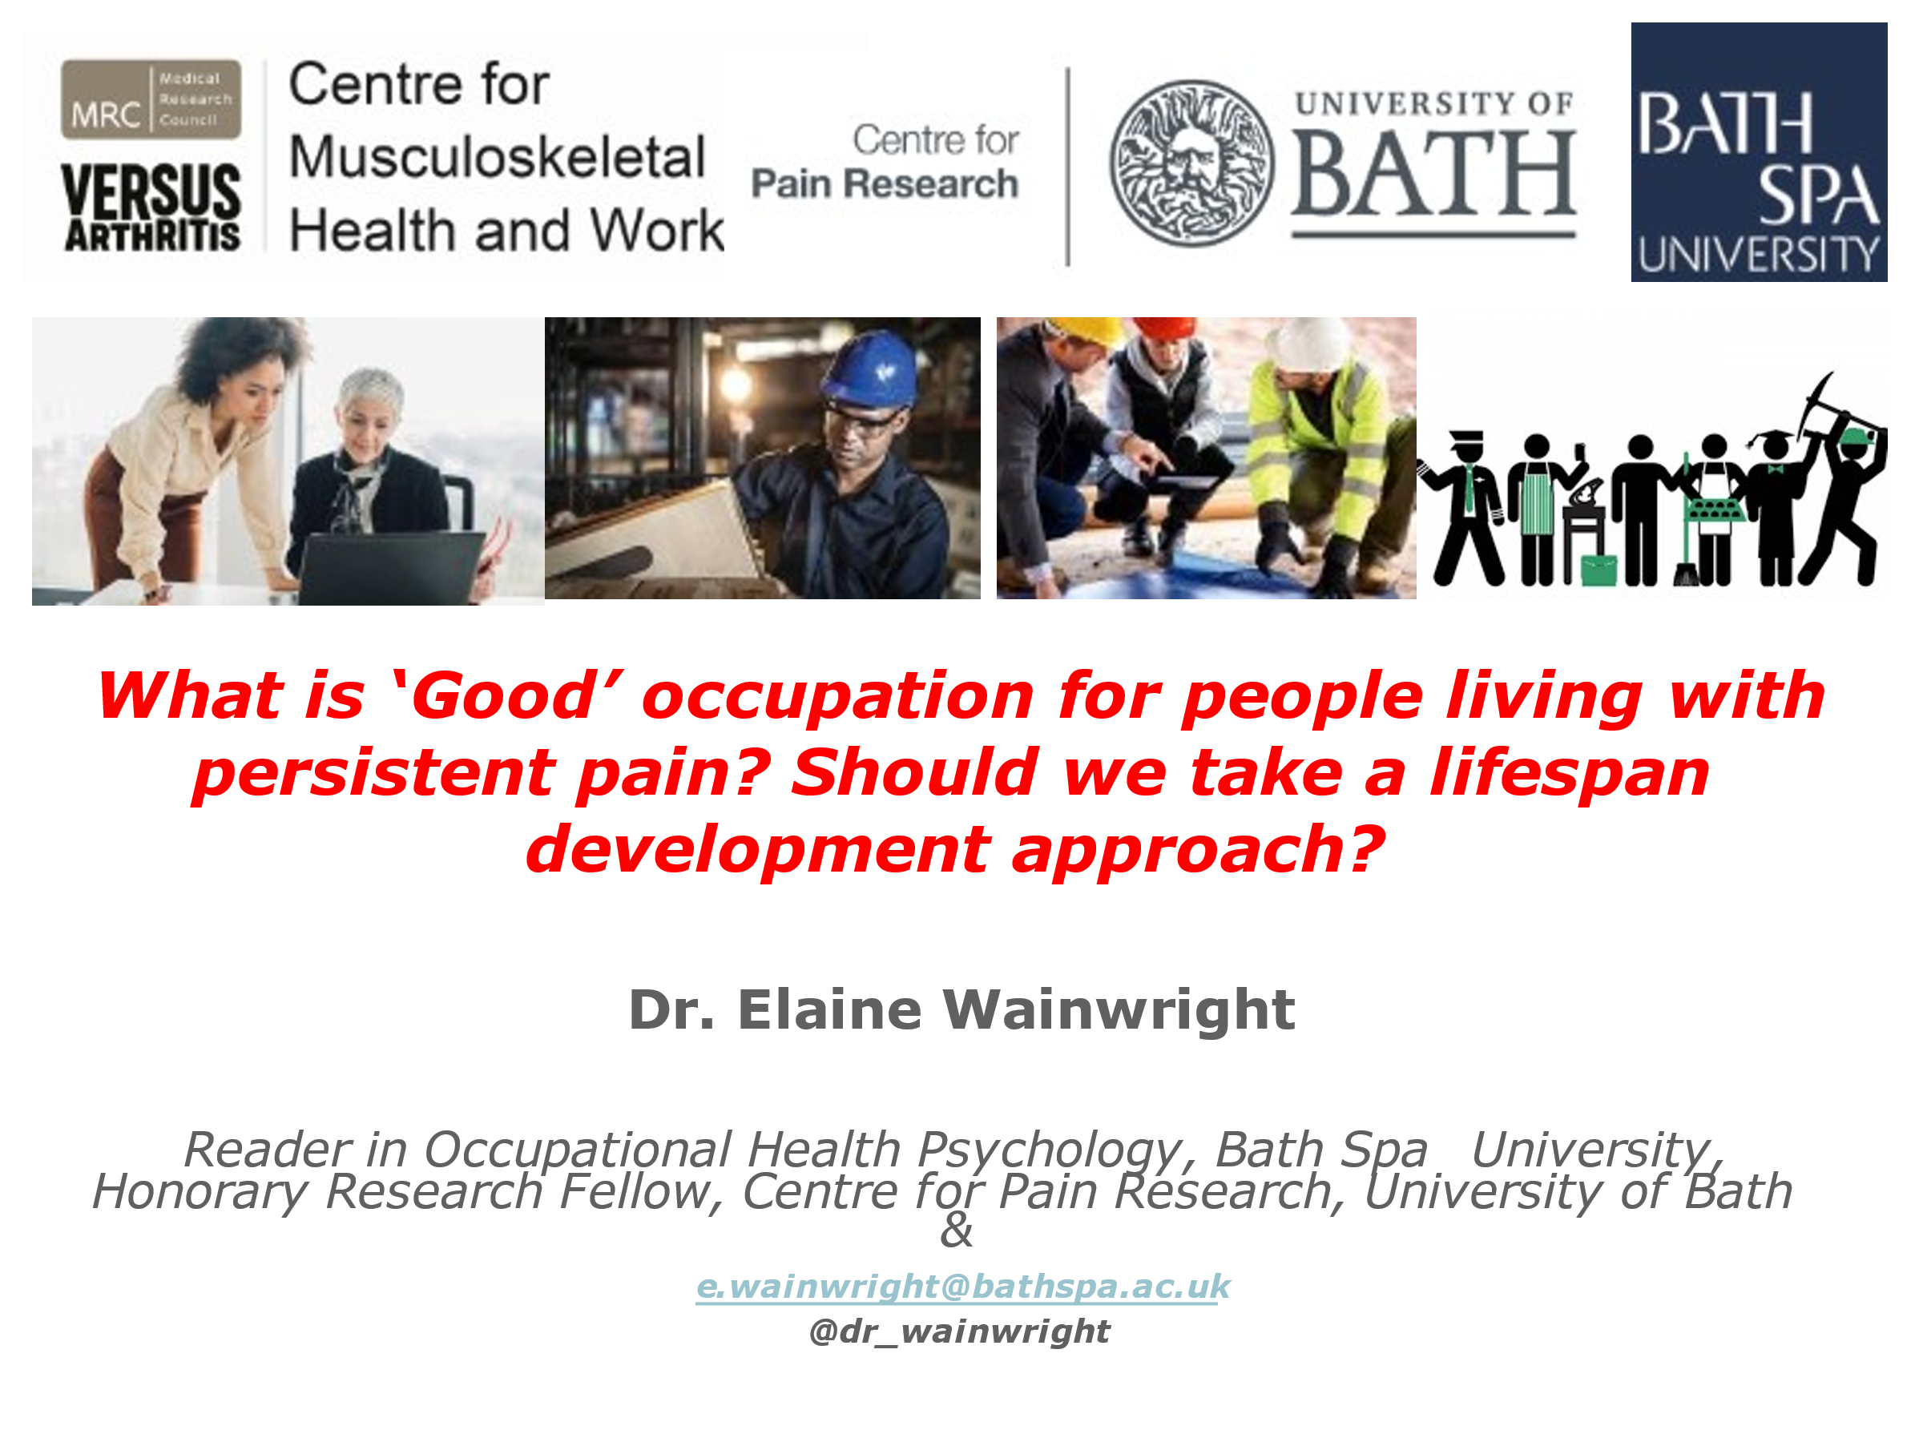

Abstract
What does it mean to have ‘good’ work, or meaningful occupation, for people living with persistent pain in the twenty-first century? How might this apply across the life-course, to young people in pain who are also negotiating transitions from school to modern labour markets, or to millennials, or to people in later life production? What helps us to be meaningfully and sustainably occupied when we have pain? These issues are important ones to think about so we can enable as many people as possible to engage in meaningful activity. Recently, I co-edited a book on the impact of pain on occupation across the lifespan with Professor Christopher Eccleston, Director of the Centre for Pain Research, University of Bath, which I will draw on to start our exploration of these questions.

Biography
I am a Chartered psychologist, with a key research interest in how work, and more broadly, meaningful occupation, matter when we think about pain across the lifespan. I’m also really interested in how we can embed the idea that “good” work can be seen as a health outcome in different care and work settings. I was lucky enough to do my PhD at the Centre for Pain Research, University of Bath, where I hold an Honorary Research Fellowship, and I have a readership in Applied Psychology at Bath Spa University. I am also a co-investigator at the Centre of Excellence for Musculoskeletal Health and Work, directed by Professor Karen Walker Bone, at the University of Southampton. In partnership with people living with persistent pain, we are currently planning research investigating how to deliver occupational health in primary care for all, in times of recession. We will explore what all key stakeholders think about a particular form of individual placement support.
I live in Somerset with my lovely family and enjoy kickboxing in my spare time (currently via Zoom!), baking with my kids and then attempting to walk off our cakes in the local fields. I am delighted to be discussing work and pain with the BPS Philosophy and Ethics SIG and very much look forward to meeting everyone.

Introduction
The work I want to talk about comes from my PhD research looking specifically at fit notes and what happens in that that micro-interaction between patient, doctor and the employer who isn’t in the room. A lot of this work has been informed by a big patient participation group in Bath and Southampton and I want to offer them huge thanks. I was a secondary school teacher but I must keep a rein on my teacher head and try to keep this quite discursive.
In a nutshell, I want to discuss three things: firstly about pain and work across the lifespan and how such an approach can help us rethink how occupation matters for pain. I have moved in some of my slides between the words work and occupation. My research encompasses paid work; part-time and fulltime contracts, portfolio working and self-employment .But my broad interest is occupation and being meaningfully busy; that is important over a lifespan so I am thinking about schooling and young children in pain as well as people in later life, and what useful and meaningful occupation might look like for all these groups. Secondly what is good occupation when we have persistent pain? - and thirdly what can help us to be meaningfully occupied? I expect I am preaching to the converted regarding the value of work but we will need to be open to all challenges large and small.
So this is what I have been doing with an amazing body of people both of people and pain researchers.

I want to point up a caveat which becomes really important when I come to talk about the policy implications of some of the things we have been up to. In the policy literature workers living with pain are often seen as homogenous; it seems so obvious that they are not that it shouldn’t need saying, but it clearly does. We need to get the perspectives of a whole range of people on board; we are moving towards doing that better in the research policy interactions that we have. However, I have a good sense that the people in the DWP who are thinking about policy that I have been working with really do care about making life better for people in pain who want to work.

First I want to talk briefly about some of the effects of pain on occupation, and consider why we should care about this stuff, and some of the issues around whether good work and occupation can mitigate the damage that might be caused to someone living with ongoing pain. Then I want to ask what is good work and what does it look like? And finally, among the things that help, I hope to persuade you of the value the lifespan development approach.

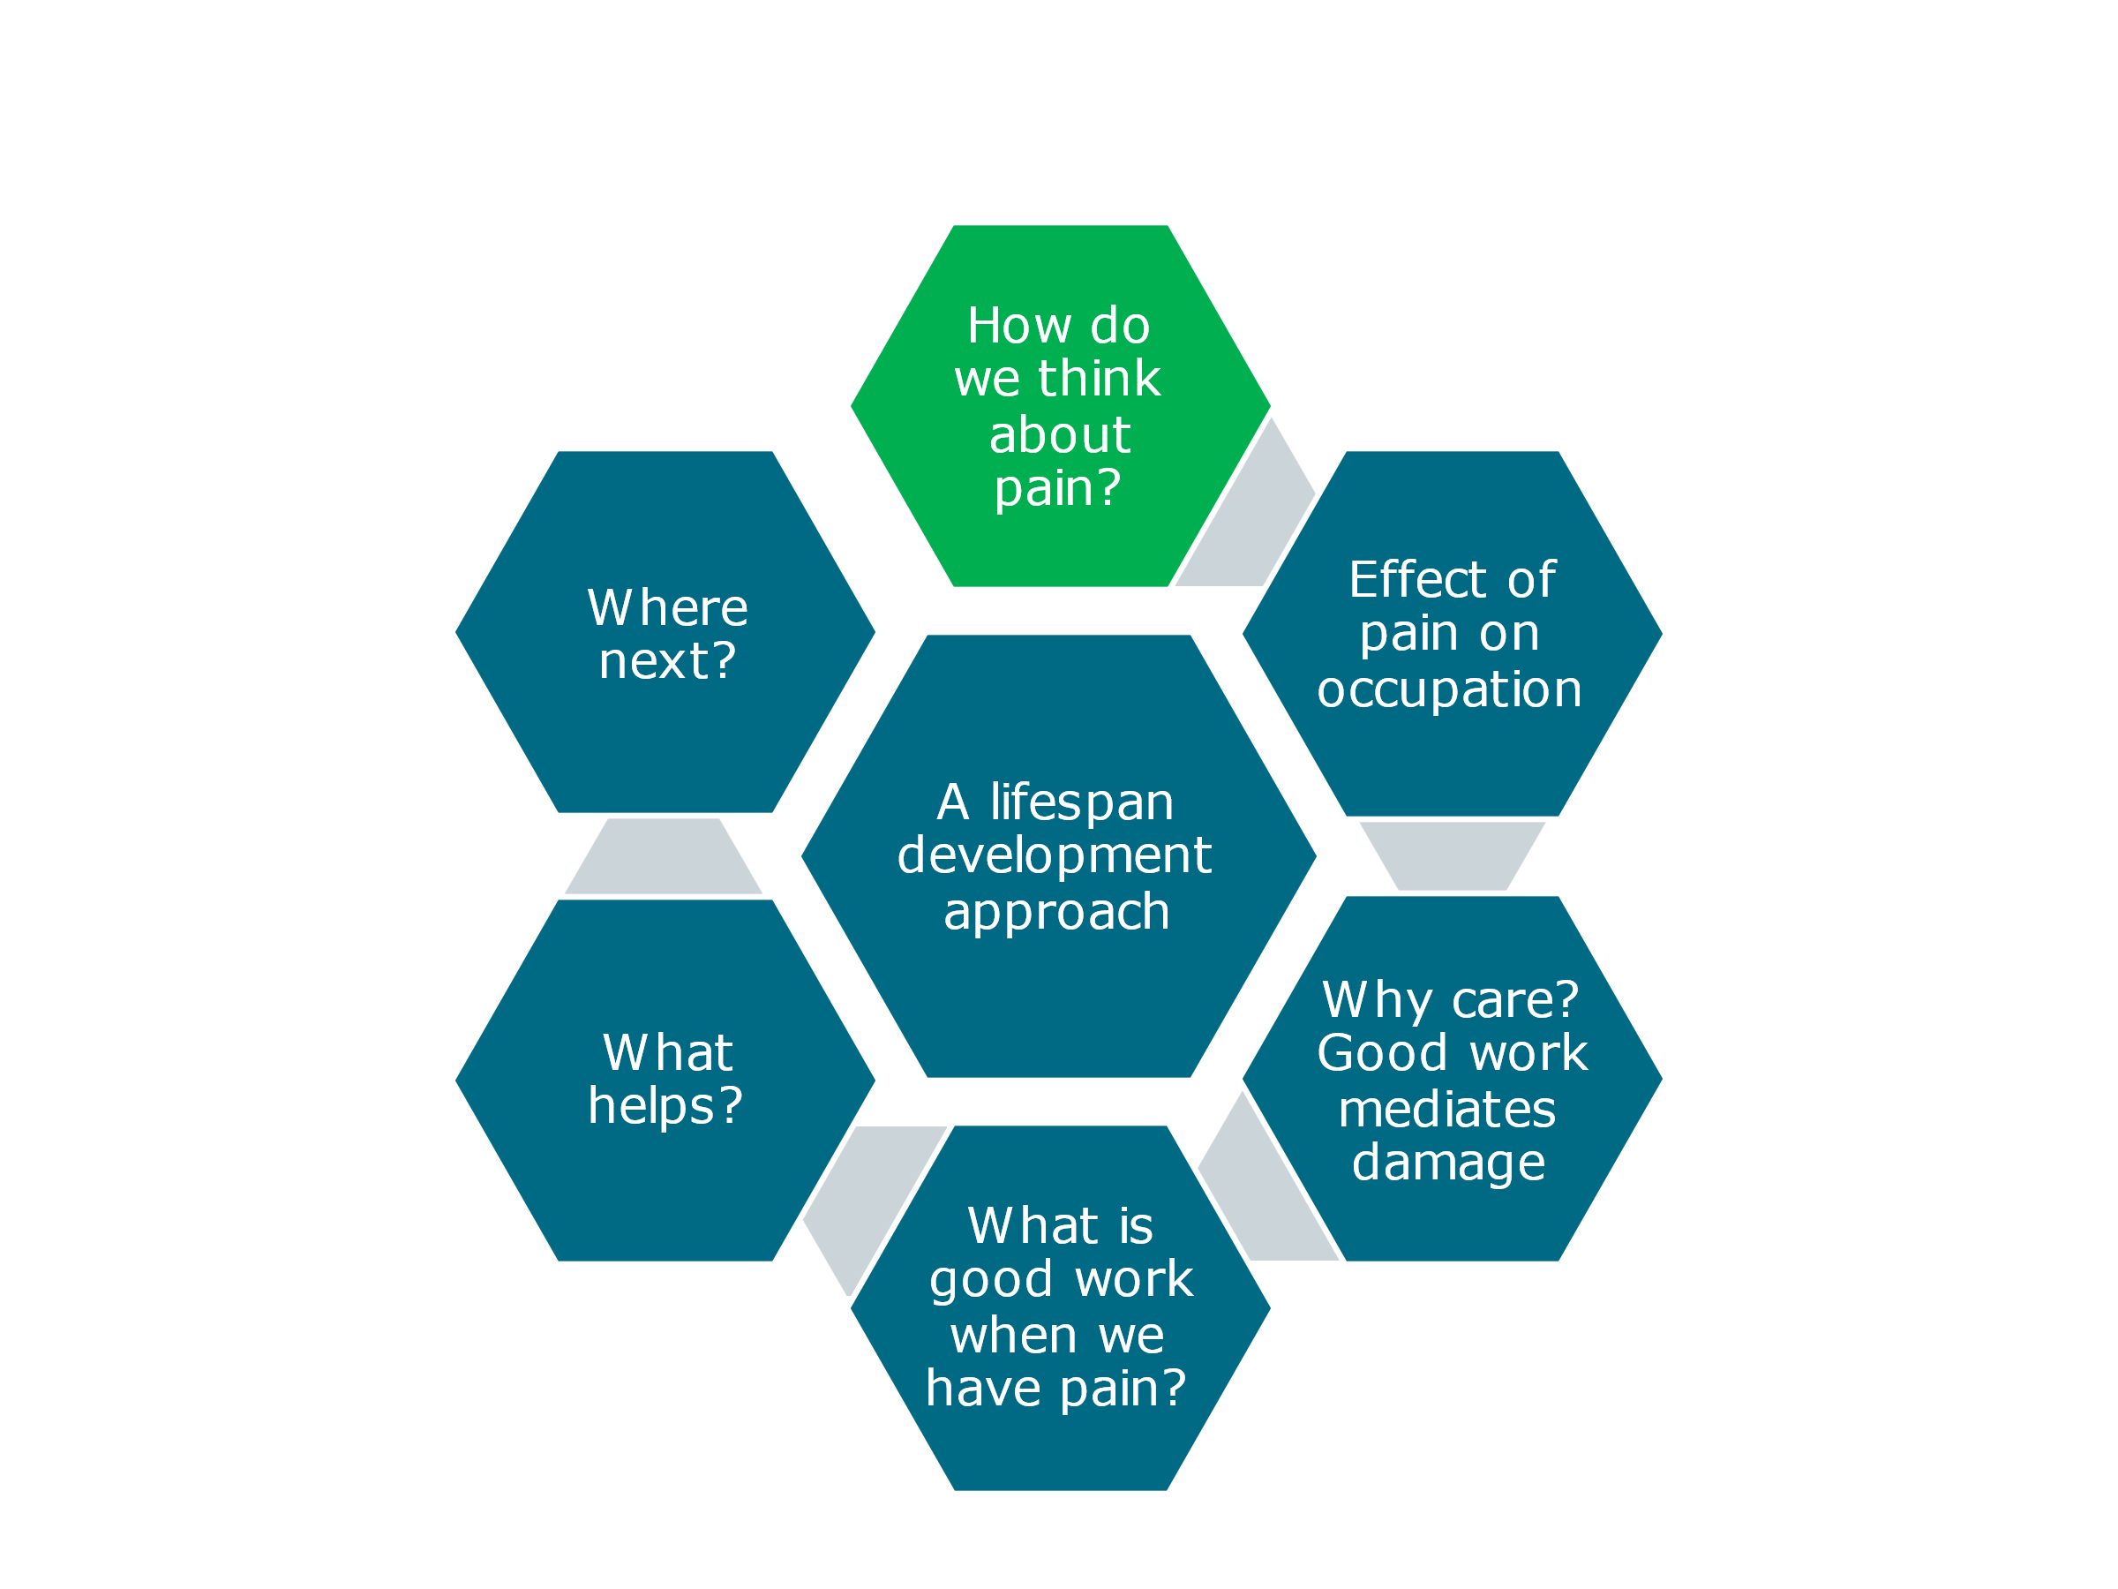

How can we think about persistent pain ? I like to pull out from the IASP definition of pain its focus on ‘associated with actual or potential tissue damage’; there are lots of openings there and my students find this interesting or even upsetting if they have personal experience. Amanda William’s work on sensory, social and cognitive aspects of living with ongoing pain describes the way in which if pain is interrupting or forcing attention to be paid to it, it affects these aspects of your relationship with your workplace.
Tabor and Eccleston, looking at chronic pain and our reaction to it from a motivational perspective, conceptualise it as ‘embodied action against uncertainty and threat’: you are constantly striving for coherence and to keep identity together. How exhausting that sounds, having to manage that sort of perspective on your pain and your life. Palermo asserts that as well as reporting the prevalence of pain we have to think about it functionally and its severity and impact. But as well as thinking about pain at an individual level, and the immediate experience of the person at the centre of their web of meaning, we need to think about what it means in society. (I am going to come back to this when we talk about policy.) And globally, we see the inclusion of pain relief in the Montreal Declaration on Human Rights. It is of course a hugely complex issue.

A lifespan development approach

We know that pain is a major part of childhood for many children – anything from 25% to 44% in different reports. There are also plenty of data to testify that pain-free life experience is reduced by earlier experience, so it is very important to go into this when we are dealing with someone in pain. Brevik’s massive European survey revealed that one in five of us is likely at any one time to have had pain lasting six months or more and as a consequence about 20% of us report poor quality of life and working life in particular. There is a lot we know about the effect of pain on different occupations throughout life from schooling onwards including home-working, paid work and parenting: we may not think of the latter as labour but we want to do it well and pain can interrupt that quite dramatically.
So what does Later Life Production mean in the context of living with a long term condition of which pain may be a part or may itself be the main condition? A meaningful occupation may be really critical to your life, your goal and your values. Work is very complicated, particularly his year when it has changed so dramatically for all of us. Calnan and Douglass have written a wonderful chapter, in the book Work and Pain I edited with Chris Ecclestone, on change, continuity and consequences, for instance recent changes such as working from home; and over the last few years the extension of working life and the gig economy. In the literature you do get a sense of a vast change of pace and fragmentation. But there still is continuity in the sense that most people still sell their labour in one way or another, and a lot of us are very lucky - and it seems almost frivolous to say this in the context of the past year- that we can get identity and meaning from work as well as earning a living. (I feel almost guilty saying this on the day that John Lewis has announced so many job cuts) However there are opportunities to keep up the drive for designing in good work think what this might look like.

But first I want to return to the issue of persistent pain across the lifespan and think about childhood. There is ample evidence that chronic pain disrupts development for the child as regards independence and identity formation, as well as impairment of sleep and social functioning. Caes and Logan record that teenagers with on-going pain self-report that they see themselves as socially delayed relative to their peers. Jordan and Jaaniste write compellingly about the challenges of parenting a child in pain, for instance as a parent you might have to withdraw from the labour market. So there are really complex bi-directional relationships between pain and family functioning.
Regarding school , it is probably no surprise that children with ongoing pain suffer in terms of academic performance and attendance but also social interaction.

Only today I was on a call for nearly two hours with someone I know to have chronic pain. I was trying to be sensitive to that, stopping the call and having breaks and walking round the garden with someone who is lucky enough to have one, but you can see how that might lead to difficulties for other people on the call who have not had that experience. In some ways this may be liberating but doesn’t solve all these problems,

Fischer and Eccleston have been interested in millennials* as an example of the way we can use cohorts. They argue that although we are generally pretty good in occupational psychology at studying cohort data we know very little about how millennials experience and cope with pain, and access healthcare information, compared with other generations. They are a quite specific generation; Jean Twendy has been quite hard on them and suggested that they are not as optimistic and helpful and hopeful as other cohorts. Other studies may disagree but the point is that here is an opportunity to understand the broad psycho-social impact of being, for example, a millennial, and look at the socio- economic effects [of pain?] on generational behaviour (such as changes in health, education and labour) and the way that that shapes how they manage information. There is other interesting research looking at millennials and their feelings about justice and injustice and the just world hypothesis; and the difficulties associated with not getting a diagnosis when they want one which seem to be specific to this cohort. So they represent an example of how we might use the lifespan idea to study different groups of people in slightly different ways. There is some really wonderful work by Pinker and his group on anger and disappointment.

*The group born between 1980 and 1990 or 2000; this generation was severely impacted by recession, as it caused record unemployment, affecting young people joining the workplace, as well as a period of economic instability.

The impact on paid work of persistent pain across the lifespan

This is where nearly all of the studies come from. It will surprise nobody that over 50% of people with chronic pain say it interferes with their work. There are some recent data from a Southampton study of 50- to 65-year-olds showing some important links between pan experience and outcomes and trajectory of work and health in that age range. Nearly all studies have revealed a negative impact. Musculoskeletal pain is the second most frequent reason for being off sick. (fluctuating with so called minor mental health disorders, as they are classified in Government policies papers, by which they seem to mean non-schizophrenic type disorders) Steve Bergan at the Institute of Employment studies already has two or three waves of data from the pandemic, and unsurprisingly reports of pain and work were really high.

My PhD looks at stigma and role disruption for people in pain. One example of that I will never forget was a young female worker who said “I work fulltime but it is at the expense of absolutely everything else in my life and I am covering myself so I am seen as a good worker”. Some not very nice but unsurprising sociological data has come out of that work.

Regarding the impact of pain on later life production: concepts of ‘work’ and ‘later life’ are in flux. Some of you may have some across the One Hundred Year Project, which avers that anyone born after 2010 is quite likely to live to 100. So how do we conceptualise later life? We’ve got the Extending Working Life Agenda which involves a lot of physical issues but seems to beg the question of what work is. There is some interesting research on the lack of boundaries in normal life. How far are we willing and able to work if we are in pain in later life? Maybe half the people in later life are reporting their pain as bothersome. Chris Ecclestone writes beautifully about pain being a challenge to your identity management when you are an older worker and whether you can simulate or accommodate goals and what that might look like.

I hope I have convinced you that thinking across the lifespan might be useful. But why should we care about work and occupation in this context? My argument would be that good work and good occupation can mitigate damage. I hate the word damage which might be seen as derogatory but people with ongoing pain I have spoken to say no – it is a useful word to think about in this context, when people feel they are behind in social or functional ways relative to their peers.

Public Health England produced a report in 2019 on work as a health outcome which hadn’t got very far healthcare professionals didn’t seem very convinced about it. I can understand that, but I have had some interesting conversations for example with pharmacists when they do medicine use reviews. There are questions on the form that they have to ask about the impact of medication and pain on your life. But there is nothing at all about work.

So to sum up so far: good work is good for us: for health and wellbeing, and critical for identity management and positive self-regard. Good work is physically and psychologically safe. It is still the case even if we have pain that good work is good for health, social and financial outcomes, and can reduce the risk of developing co-morbid mental illness. The benefits are inter-generational and are passed on to your children and grandchildren.

To end with a personal example: when I was a secondary school teacher in quite a challenging part of Northumberland I had kids in my class whose parents and grandparents didn’t work who would ask: “why do you work, Miss? – you don’t have to.” So you can see how important it is but how difficult it might be to intervene for different generations. Having said that, we know nothing about backward transmission from children to adults in terms of pain behaviour and possible positive ways to intervene.

Discussion

So what I want to ask you is what is good work when we have pain? Does this necessarily mean paid work? When we are doing something we enjoy it may be a source of distraction and draw us away from some of the attentional biases and cognitive draining that is going on. The idea that work can be a force for positivity is probably instinctive to most of us.

I would like to look at meaningful occupation and health outcomes. When I was a community physio I would go and see people of all age groups and the conversation would go round their difficulty with getting out of bed or a chair, but it often appeared that their problem was more complex than that. But all I could do was give them a set of exercises and hope they would do them. I was only allowed to visit them a maximum of five times. A lot of the time it seemed to be that someone couldn’t get out of her chair because she had no reason to get out of the chair , and nothing of meaning to fill her days. There are so many people living with pain in the UK a lot of who never get to see their doctors; often I was the only person they would see. This eventually led me into therapeutic knitting. I would love to see hobbies as a way of expanding the idea of occupation, and as a springboard to other activities. I have been working with a charity in Madrid who run all the care homes there who have a fantastic project going on. They have teamed up with a paediatrician who works in Sierra Leone. One of the problems there was that they couldn’t get mothers to go into hospital to give birth so they had a very high neonatal mortality. So they got all these care homes for men and women in Spain making gift boxes to send to Sierra Leone which included a toy for the older child and a blanket for the baby and a gift, usually a cushion, for the mother. So the new mothers all wanted to go into hospital so they could get a gift box. And then the families would send back videos to the care homes. Two years ago I visited the homes and there was such a difference from care homes in this country: people were vibrant, chatting and laughing. They told me they had got their identity and meaning back; doing something to help somebody else had health benefits that were so clear.

About eight years ago you let me sit in on your knitting clinic and I could see this happening before my eyes. In our book where that came out the most was in the phrase ‘people in later life production’ and Chris Ecclestone wrote compellingly [to suggest that] …occupational health and ergonomic and vocational support and all these things were not necessarily wanted or needed. People might not necessarily want to go back to the job they were doing, or could not do so if they hadn’t been near the labour market for a very long time because they had a complicated set of circumstances. He talked about a more up to date o relational or CBT support that could be there for people, alongside the sort of activities that you have been talking about but perhaps don’t need to be as formalised as that. You have been looking at the power of knitting to interrupt positively – I always think of pain as a kind of interruptive thing . At the other end of the scale, in schools: Kath and Logan wrote a lovely chapter about quite young schoolchildren as well as secondary school pupils and the support they could have, not just about access to the labour market but what they want to do when they are 16, 17 or18. There may be opportunities to have these conversations that we don’t at the moment in our schools . That is not to denigrate teachers – I was one – but there is very little out there about how teachers could support children in the UK.
I am just finishing writing up a study in which we asked groups of 14- to 17-year-olds, in pain and not in pain, some open questions about the content and process of worry. One thing that came out of that study was that young people who self-identify as living with pain were already predicting a dismal future. I think about one who was an artist who said how worried she was not being able to do this from a physical point of view but also psychologically: she felt that her options were shutting down. It’s that kind of students we could support, and help to think about what kinds of meaningful occupation they can do and be supported to do.

One of the important things that our group had to offer was actually being successful at something, unlike most of the people I had visited at home. So we tried to give people something they could be successful at from their armchairs as the first step as often the step back into work was too big and this could be incremental.

A few years ago we did some work with people who said they were seeking work but hadn’t been in work for a very long time. One of the things that came out was about their identity. Self-efficacy was the first thing we had to talk about and compassionately helped to achieve but something they were not getting from job centres .

I feel like there is a ‘mind the gap’. Betsan talks very well about people finding the way back and the means to contribute. But there is another level and the inspiration for me has been the foundation of the Stoke Mandeville hospital way back just after WW2, and Ludwig Guttmann’s vision to get the men who had survived plane crashes with terrible spinal injuries not only to survive but to get back into life and work. The Paralympic Games started off as the Stoke Mandeville games and became a big international movement. But his original objective was to get people back into work. There is a huge gap and the Paralympic movement is a good example: you have some phenomenal athletes who are achieving some amazing things, but how many of them could get a position in a company?; how do we manage disability disclosure?; how do we have a decent conversation given that one in five adults in the UK are affected by this? The Diversity and Inclusion agenda is simply not talked about . The very word disability … when you’re going for an interview, talking about ability sets you up for an instant failure in a way that other aspects of diversity and inclusion don’t. People who live with pain have already overcome a huge amount and may have developed exceptional talents, but that isn’t a conversation that is welcomed in the workplace even at a level of head-hunters who fall off their chairs at the mention of disability. Even people who have been in the recruitment industry for decades still fall off their chairs. Somebody said to me the other day “you’re only the second person I have had this conversation with and I know that is wrong; I know that you displace people who have disclosed” … they are out there trying to live an almost unmanageable life because of the compensating they are having to do at home to cover it at work. That isn’t a sustainable position and can’t be what we want, but is our reality.

That was inspiring in some ways but also horrible in others. …[poor quality recording] There is a PhD student who is a clinical lead who has just started looking at people with rheumatoid arthritis disclose or not Even the word disclosure has some kind of implications… . […] is an amazing woman in Canada who has done a lot of work on that in a Canadian context. In a more optimistic frame Chris Main and Bill Shaw have written about changing the phrase back to work and return to work … [to ] … put the worker at the heart of that which can be very individualised and personalised …

I have been out of work with pain for 18 years. The biggest barrier to getting back to work has been the DWP. It is adversarial, punitive, and terrifying. I will not engage – when a brown envelope comes I have palpitations – it’s that level of fear. And that is before I get to an employer who doesn’t want me because I have not worked for 18 years even though I self-manage my pain now which is a part-time job in itself. Helping run the festival … I have so many skills but I would be lucky if I could pick up a job in a farm.

I can only offer one small possibly helpful thing: there is an amazing occupational therapy unit in Southampton led by Jo Adams. They have just published a study which has really tried to help people back into work who have been off with pain for a very long time. The situation is complicated but in a nutshell it was a feasibility study so it didn’t go to trial. But the good bit was that all the people in the study are better and we are trying to do something with that. The study was funded by the MRC. We are trying to think about what we can do; despite some useful results that trial isn’t going ahead but the individual therapeutic intervention has helped people back into work.

Is anybody looking at Universal Basic Income to help such people? because that frees you up

That is a very good question but I don’t know the answer. I would certainly like to look into it.

Work that makes a difference to someone else’s life is so much more rewarding than working in a bank or to make profits or a bonus. Some while ago I read about a ‘ time bank’ in Campden who got some student volunteers to go into a residential unit and ask the elderly residents what they would like different in their lives. Some of them said they would like to go down to the park. So they were put into wheelchairs and the students wheeled them down. But in the time bank everybody has to pay back. So they asked the old people what they would like to do to give back into the time bank. They said they were too old to do anything. “Do you play draughts?”… “yes”… “knit, play ludo, read …” “Yes, all of those”. So they got children from a school for children with disabilities to go into the home and the residents got totally animated because they were giving something back. There was no money involved, it was just trading time and skills. But instead of just sitting in a chair watching TV they suddenly found meaning.

The original question was what is good work. We have heard some nice examples which illustrate the fact that it means different things to different people. In the groups we run we often ask people what in most important for you to change by the end of the group or in the next year. This often makes them think about work, and we always explore why work is important to them, and it is surprising how many different answers we get. For one person it may be providing financially for their family, for another to challenge themselves, and yet another to find interaction as they just love being with people. Some may say that they want to contribute to society. For me, good work would mean an occupation that allows people to express the values that they hold. Many of you have been thinking of examples of that but we need to be mindful that it will mean different things to different people. It also creates possibilities for those people that want to create social interaction and help them to find the value of volunteering for that , whereas the priority for some is to to provide for their families.
I want to go back to communication with employers. I am an OT and I often speak to people about difficulties they have, even while they are in work, in communicating with their managers and also their colleagues with regards to the kinds of needs they have. It is often helpful to think about styles of communication. Maybe I am naïve but I do think there is a lot of misunderstanding of what people in pain can do. I think it is fear of the unknown that creates a lot of misunderstanding and if you can communicate in a really clear way as to what would help people to be able to work that can often help the employer or a potential employer to have a better understanding of the possibilities.
Living with pain is a big challenge and you can use your efforts in facing that as a selling point. Whatever you have been able to do in spite of it can often show you to be really resilient and persistent. So a lot can be helped by presenting the situation in a particular way. It may not help all the time but it is important to consider.

Part of my PhD involved looking at how people in pain, their employers and their doctors talk to each other. I found that the quality of communication was really important. Some employers said that there were some questions they were scared to ask And I wanted to assess the value of helping a person in pain wanting to come to work to express the kind of questions they felt would be useful to be asked, and being really explicit about it.
I liked your description of good work as occupation expressing people’s values. The Southampton people have advocated Individualised Placement Support (IPS) from a pain-specific OT.

There is a wonderful Government sponsored organisation called Access to Work* and they play a really important role in mediating between employee and employer. They also act as advocates and provide training. I have found them really useful and often prepare the client for being able to communicate their needs.

…[poor quality recording of transatlantic contribution] huge challenge … assistance from employer … accommodation … especially if there is a workplace injury … often look at the physical and neglect the pain …. They become less productive than the other [?employees?] so the resistance can be felt with their co-workers and with managers, so it can be a challenge … [can be] easier to meet that head on and what is coming at the other end but you don’t know what you are going to be met with.

Main and Shaw wrote a wonderful book about trying to get all levels of an organisation on board. It’s not the worker’s responsibility but they are at the centre and helping to design. You have got to have people with lived experience when you are creating your top-down policy. You shouldn’t be making top down policy without all the work behind, before somebody appears in your organisational to be supported.

Most of what I was going to say has been covered but when you asked your original question about what was good work I was going to turn it on its head and make some fairly obvious comments on what was bad work, like the boring and repetitive jobs that so many people are condemned to in order to make a living. But there are one or two particular practical things about the barriers to getting back to work I want to ask you about. I did have a particular interest in the subject before I retired nearly 20 years ago and the only time I submitted a poster to a BPS ASM it was about returning to work, and I got a prize for it, not because it was a particularly great poster, but because I think it reflected the fact that only a few people had thought very much about the subject in those days. One thing which prompted me to do this was the Disability Discrimination Act of 1995 which obliged employers to remove barriers for people with disabilities which included pain and specifically back pain. I had the impression that this was widely ignored and I should be interested to hear if things have improved in the ensuing 20 years. One specific practical problem for people with back pain working on the boring and repetitive jobs I mentioned earlier, such as assembly lines, is that they are pressurised to stand for hours on end and not allowed to sit even for a few minutes, or if they find sitting uncomfortable are not allowed to stand up to relieve their pain. So have those sorts of barriers been fenestrated in any way?
There was an initiative towards the end of the last century for the government to provide advisors for people with pain and disabilities. There were a number pilot studies around the UK of personal advisors for people with pain problems which were very successful but never really followed up. I had a long conversation with the very enthusiastic people on the one in Brighton and I thought it was a brilliant idea but it was never funded properly and never actually got off the ground and rolled out nationally. Is there anything of the sort available now?

“ which can: “provide practical and financial support to help people overcome barriers to starting or keeping a job if they have a disability or long term physical or mental health condition”

One thing which has worked in some degree, although not as much as intended, is the Fit Note which came in in about 2009 or 10. There is some evidence that in some cases that has been helpful for most GP’s, (although it can be hospital doctors and other health professionals) There is a lot of work by Mark, Shields, Gavin and others which unfortunately shows that a lot of fit notes, for complicated reasons, are not as helpful as they were designed to be. But they were a step in the right direction and there are people working on redesigning them and determining whether we can have one for people in work and another for those on benefits; and whether the list of different sorts of healthcare professionals legally certified to see those notes (and some AHP notes) could be extended.
So a quick answer to your question is that there are still lots of problems, although it is slowly getting better.
There was the back to work scheme which had some problems for example it specifically excluded self-employed people. There is virtually nothing in the literature about this category or about transition from self-employed to employed. There is another group at Keil, Foster et al who initiated the SWAP ( study of work and pain) trial* which has been one of the shining beacons, and found it both effective and cost-effective for a physiotherapist to give vocational advice as part of their service . Whether that can be scaled up to a national level I don’t know.

One statistic I read which is probably out of date was that if you have been out of work for a year it doesn’t matter what the reason you only have a 5% chance of ever again working in your life.
I had a patient with puerperal psychosis who had been off work for a while. She still had her job and there was a charity in Norfolk that provided her with a support worker who went to the workplace with her and in a very diplomatic way negotiated her re-introduction into the workforce. There had been a huge barrier put up by the other workers who had dreadful prejudices about mental health (… ‘she’s a crazy lady, she won’t be able to manage the workload’ etc etc…) Her supporter held her hand and negotiated for three months. I don’t know whether that was something that works in other areas?

One of my PhD students was looking at what works including really expensive interventions involving that kind of thing. An investigation in Hackney found that even if you’re not back at work you still might go there. … Those are the sort of things that tend to work but unfortunately in terms of cost … but in the long term there is some hope and you are absolutely right … the Southampton group have worked with people who have been out of the labour market for a very long time and have shown that they can get people back into the kind of work that person wants to be back into in a sustained way. But that trial isn’t going ahead after the feasibility stage due to recruitment issues but they have taken that on in other areas

In terms of paid work some of the up to date data which have included Covid have illustrated the importance of prevention and early intervention. Line managers are really critical to include in communication. But there is some other research that suggests that with all their responsibility for dealing with organisational problems what we expect them to do is unrealistic without training them very time-intensively.

This is all very complicated and we have probably covered everything. We have heard some horrible stories this evening. But all of this is around the person and your culture… does your culture value you as a person in pain and want you to work. Where is the legality of all this? … I talked about stigma earlier.
There are all these great revues I have talked about that suggest that these interventions work but you have to match them against … One specific thing I have noticed in the literature is that you never know whether people in these big trials actually wanted to go back to their previous job or a different one, and there is much in this diagram that we researchers need to do better

*Patients consulting their GP or nurse practitioner with an episode of pain who were either struggling at work or absent from work for less than 6 months, were referred to a vocational advisor, delivering a stepped care, case managed intervention to address obstacles to working, tailored to each patients’ needs.

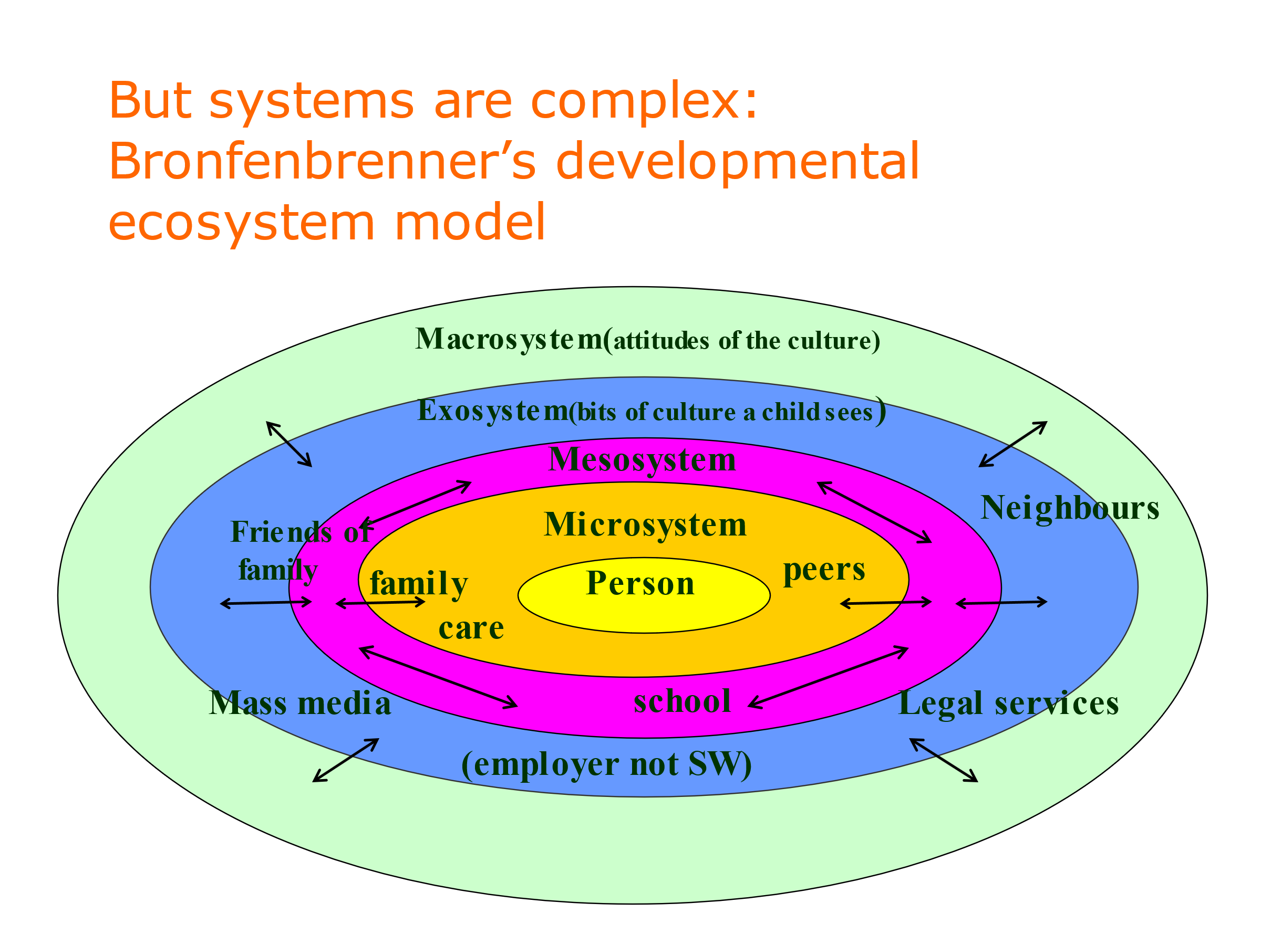

Steve Bevan has written really compellingly about how people in pain tend to fall between policy silos in the UK and in Scandinavia. We have employment policy and policy for things like accommodation. We have welfare and active labour market policies; we have already talked about conditionality for benefits and how hard it is to really decide equitably what somebody deserves; there are huge complicated problems. Then we have health policies, in which GP’s and intervention are important. Often these things don’t match up and people in pain drop between these silos, and as I said at the beginning workers with pain are not homogenous although they are often written about both in policy and research context as if they were, which creates problems in translating back into real life.

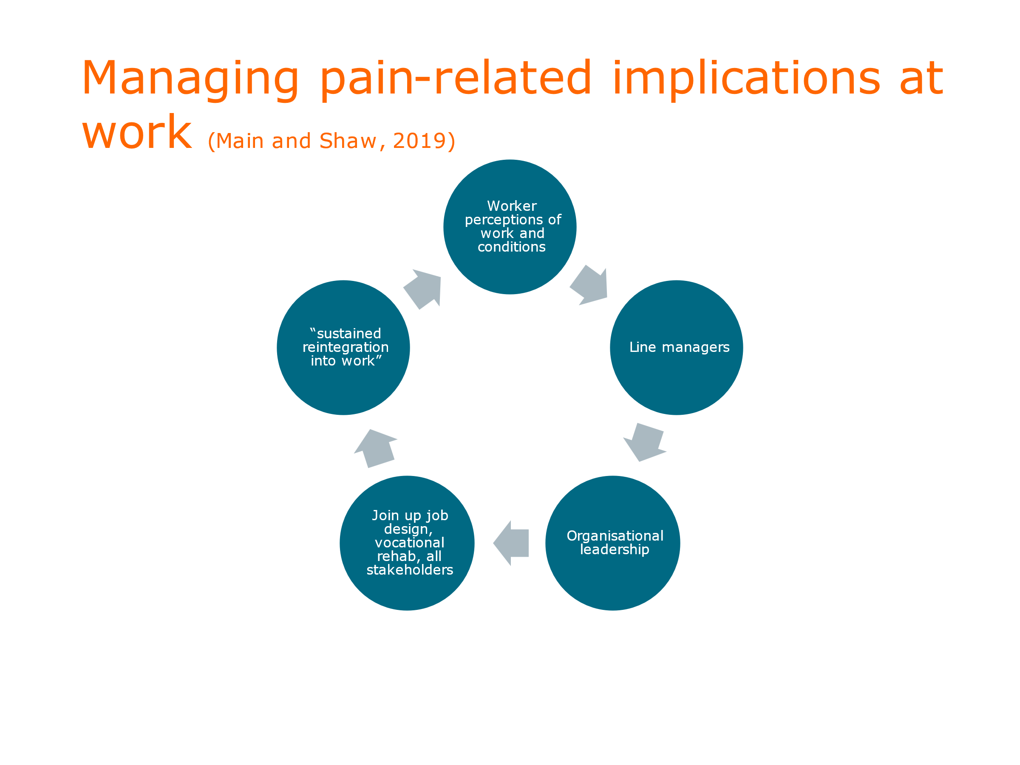

This slide sums up Chris Main and Bill Shaw’s work (Chris is British and Shaw is American, so they have an international outlook between them.) They have put the person who wants to work at the top centre of this and they talk about sustained long-term investment. They don’t like the terms return to work and back to work as they see them as too static for managing pain-related implications in work. They emphasise the critical importance of line managers who need to be skilled up and given time and coaching. They also talk about organisational leadership, and insist that the person needs to be at the centre of involvement of redesigning their job and decisions about the kind of vocational rehabilitation that might be needed. The involved stakeholders should include the person’s colleagues and peers and take account of the issues people feel have not been adequately discussed. They talk about a sustained reintegration to work. Some of this is based on empirical data and some on modelling and ideas.

Policy implications

In this country we are particularly bad at focussing on long-term initiatives and are stuck in electoral cycles whereas in Scandinavia, for example, there are some nice examples of pooling funds between different political and social organisations, and making it so that things are deliberately and explicitly meant to last longer than the next electoral cycle. People have managed their expectations much better than we have in this country with our sort of quick fix approaches.
It is important that we should be working towards bringing the policy, research and lived experience worlds together, but we haven’t much yet. There is another interesting idea regarding funding of research: as you know, when we evaluate the spending of taxpayers’ money we don’t include any impact of this as to whether or not people might be helped back to work. You can ask why not? Perhaps there is a fear that people would worry about equality and what that might say about people who can’t or don’t want to work. Some researchers and policy-makers have argued that we should at least try to include data on individual histories and consider what assistance that might be but that is not there at the moment in back-to-work research, at least in this country. That is a small specific example of something that people want to change, but a really big example in the policy context is the idea of occupational health provision which is really low in the UK. as regards the number of people in work who have access to it. I mentioned Fit for Work which was brought in to try to remedy that but explicitly excluded self-employed people You would be very fortunate in this country to actually work in an organisation that has, or can get, occupational health provision; it is very patchy. The Southampton group are researching what good occupational health in primary care might look like from the points of view of the patient, the doctor, the first contact practitioner, the practice manager, nurse, physio etc.

But, talking about what is actually valuable to people, we know virtually nothing about how we can help people who want to do voluntary work or want to be self-employed, and people in what I would call precarious work. (Some people might not like that term as some people on short-term contracts might be highly paid IT specialists who are quite happy with it.) But as we all know there is the zero hours contracts issue: despite the huge problems around the protection that many of these workers don’t have, but I can see that some people might find it helpful because it gives them a measure of control.

If we take a motivational perspective on pain we need to ask how people in pain at work manage threats to their identity and coherence. There are big psychological questions here that we don’t know much about and don’t know how to support people with.

So returning to a lifespan development approach involving school, parental and intergenerational transfer, Caes and Logan have argued for a biopsychosocial theoretical framework of school functioning where we support all the people working with young children and the young people themselves and help them to think about their pain functioning and what they could do that would be a meaningful occupation for them . Calnan and Douglass talk about better authentic careers advice for young people who want to enter the labour market so they can manage their long-term conditions as well as this complicated and fragmented labour market we have at the moment. We could cast parenting as occupation or labour and that would really meaningful for people that don’t have paid work. Jordan and Jaaniste have suggested that we can tailor parenting interventions to support parents with a child in pain, and don’t pay enough attention to key individual differences in parenting styles. I mentioned backward transmission earlier; we know some useful things about parent to child influences in pain behaviour but very little about the other way round. So how can we promote intergenerational knowledge and communication about living a good life with pain?

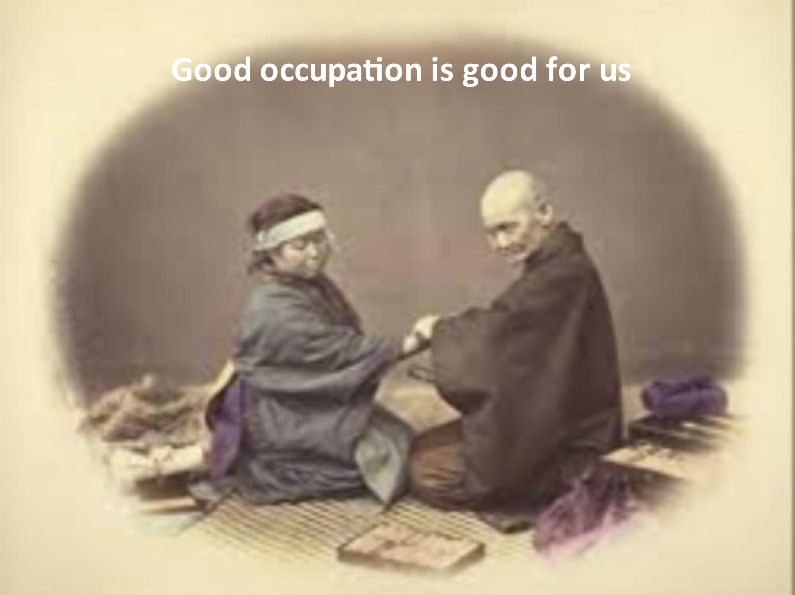

We know that there are developmental impairments associated with chronic pain in your teens, such as negative self-perception. What might help towards recovery? How can we support relationships between early academic and later work outcomes? We know quite a lot about the impact of pain and pain medication on cognitive functioning in child, youth and adult populations - one of my post-doc studies looks at the interruptive and disruptive effects of headache on cognitive functioning, so that, for example, task switching becomes difficult. But we don’t know enough about how to repair that.

Finally, could we – or should we? – embed the idea of good work for health in other settings. For example a pharmacist conducting a medicine use review has particular questions they have to ask and document. Could there be a question on patient’s work and occupation and how pain and pain medication is impacting on that?

Public Health England found that a lot of health professionals were not very convinced about the importance of work in this context – they kept asking where is the evidence and we don’t have enough yet; but that doesn’t mean it isn’t worth pursuing.

It’s inspiring to have this conversation but it saddens me that with all of these initiatives we only make progress when we have data and measurements so that we know where we are and can map progress. And I feel quite disheartened when you say that we don’t have a picture and even more disheartened to learn that things that might have helped have not got funding. So given the magnitude of this issue, what is the missing piece in the picture? I don’t understand where the blockage lies.

One way of getting a picture is through systematic literature reviews which are limited because they are just ‘research’ but they also include ‘grey’ literature* and policy documents which can be very useful.

As regards funding; although in Southampton they didn’t get the funding for that particular project to go forward, they have been able to start another big trial on the back of that and included elements of it. The value of ongoing support from physios and others is recognised
Out of all the work I have been involved in the cheerful bit is the funders are more and more are so utterly serious about the lived experience and being upfront in everything researchers are trying to do.

In terms of evidence I agree with you that sometimes it is quite difficult to know what is the level of certainty that we need to move forward. Just today I was on a big call with lots of important people. I was just observing which was really useful; it was absolutely about the individual lived experience coming forward to shape the way forward in a particular area that is not just to do with work. So there are some good things happening but they are too slow

How do you find the political will? My oldest friend is an MP and she agreed talk to me about chronic pain but she has not replied to any more of my messages about it which is upsetting at a personal level although she is obviously preoccupied with Covid … [is there] any MP interested in chronic pain? I’m interested in the opioid aspect. How do we get MPs interested?

I can only speak from my personal experience of working with a few particular people in the Health and Work Unit which was set up between the DWP and the DHSS to try to bring the work and health silos together. I have been cheered and encouraged by those conversations. There is a fiscal thing going on that we know that if we can support people into good work it is very good both for them, and society in the long run.

* materials and research produced by organizations outside of the traditional commercial or academic publishing and distribution channels.
I may be just a naïve young researcher compared with the people I have been talking to but I have genuinely been cheered by some of the conversations. However I know … a little bit and he is phenomenal but it saddens me that he has been working in this area for 30 years without great success in getting things moving. Nevertheless some people I have been fortunate to work with in my research – some big cheeses - have been successful in lobbying for more public funding to try to fix some of these issues.

Covid has had to shape so much of this. In December there was a call put out about aging which did have a big work component, which is a little encouraging. I can’t give you a really clear answer but I have been encouraged by some of the conversations I have had and some actions like Fit Notes, despite the problems with these. But nevertheless people with pain are being involved in debate about the problems. So there is some positivity but I appreciate that progress is slow. But I do think there is a will not to leave people behind that there wasn’t there 10 years ago when I started.

If you think there is progress … you started off with the background for many people and the popular culture that pain is an obstacle to work only because people don’t want to work; and you have been chipping away at a lot of attitudes in the professional setting. It is very convincing. I spend a lot of my time doing medicolegal work where there are clearly conflicts between patients – or claimants and their ambitions and wants in life – versus the employer. It is often a very contentious and acrimonious debate and the whole area gets tarnished with that.
I congratulate you; I think it is marvellous that these barriers are being broken down. I know Chris Main and others have been fighting this … but it does make a huge difference to a lot of our people to know that these incentives to get people back to work are effective.

I also hope that generally as a society … we have had some useful campaigns in the last few years thinking about different kinds of disability and I do hope that comes over in a positive way for people in pain. When I started my PhD, [?signal?] was such a big issue when talking to doctors and employers. It is still there, I can’t say it has gone away, but I have had some really positive conversations with different bodies representing people with pain and some of the ways in which they feel that they are valued.

In my medicolegal practice I work for both claimants and defendants. One of the regular criticisms I get when I am making a report for a claimant is that I am too optimistic about getting people back to work. Clearly that has a substantial – hundreds of thousands of pound’s worth of – impact on the potential claim. It is very hard to fight against that and the system is very much geared to discouraging people from working when there has been injury or pain associated with work.

There are a lot of issues with fear around this. Keil are running another trial called PROMPT looking at some of the issues we have been focussing on as well as opioids and there are other things going on that are working
Amanda Williams has read our (Chris Ecclestone and my) book and told me it made her more hopeful, which is the best feedback I have had

I mentioned earlier the government funded advisory service for people with disabilities which never really got off the ground despite very encouraging results from the pilots. One of the important functions of the advisors was to act as the interface and means of communication between job seekers and employers, and advocates for their clients. Is there any such service available now?

Part of the purpose of the Keele SWAP (Study of Work and Pain) trial and the Southampton INSET study was to show that an independent person to help you can’t be part of the employer or organisation. That and other pieces of qualitative work around that show that independence and security of information come out really highly among peoples’ concerns. But they are all local and there is nothing national; the occupational health provision is very patchy and needs to be sorted.

[very distorted recording] The Shaw Trust* used to do that but they may have got a bit too involved with the government now. [They could help with] … protected benefits … and stuff like that which is invaluable and we need more of that. …. have to get employers … independent support …

There was a small-scale qualitative study that I was involved in which employers talked about valuing the things we have been discussing in terms of resilience and really valuing peoples’ articulation. [?plastic?] knowledge was a phrase that came up a lot and ‘soft’ interpersonal skills. We did get some positive messages from employers particularly around back to work with pain.

Thank you very much for giving us so much of interest; we have learnt a lot which we will find very helpful when dealing with our patients.

*The Shaw Trust is a charity in the UK which helps disabled and disadvantaged people into employment and independent living. It was formed in the village of Shaw in Wiltshire in 1982. , and helps people seeking work through support in job search skills, interview practice and practical help to enter employment.

