Dr Johnson’s busy day

Webinar March 2023

Tim Johnson

Tim trained in both general practice and anaesthetics before specialising in pain. After touring the world in a GP capacity he did a pain Fellowship in Seattle. He is a pain consultant in Salford.

We had been discussing possible topics and speakers for this session and it occurred to me when I had just finished my routine Monday pain clinic that there might be something of interest for our colleagues. There has been a lot of emphasis on evidence based medicine and we often talk about the literature and quantitative trials etc but there is a lot going on that we are missing I our day-to-day practice, and sometimes we miss the qualitative element of what we do. So I am taking the opportunity to look at a day in the life of a pain clinic that I did a couple of weeks ago. I was a typical clinic; I have been to a lot of trouble to anonymize the patients but these were the sort of people I saw on that day.

I have worked in the Salford Royal hospital for thirty years, initially doing anaesthesia as well as pain management but for the last ten years only doing chronic pain. I am now semi-retired having taken my pension at 60 and have been able to drop anything from my work that I didn’t enjoy. I no longer do any injections. Overall I think I relish the difficult cases with the experience I have had of trying to understand chronic pain and trying to help people to deal with it. And I will often seek out what other people call heartsink patients. I work fairly independently with these patients but I have 25 very helpful colleagues in clinical psychology, physiotherapy and nursing. We are quite well resourced in that we spend 45 minutes with new patients and 15 for follow-ups. We have no limitation on duration of treatment and numbers of visits; we don’t have insurance companies telling us what we can and can’t do. Until recently we could do as many procedures as we wanted but that is under the spotlight now and will be stopped.

So this evening I will run through the 14 cases I saw that day one by one and the ideas about them that pop up. We are a philosophy and ethics group and there are some issues that emerge from them, but you will find that there are a lot of questions and relatively few answers. I shall pause after each history in case there is anything anyone wants me to clarify.

The Patients

These pictures on the following pages were drawn by Vuokko Hägg, a psychoanalyst from Finland, while she was listening to each description. She finds this very helpful when listening to actual patients in her practice and 'counterdreaming' the session afterwards.

Case 1:

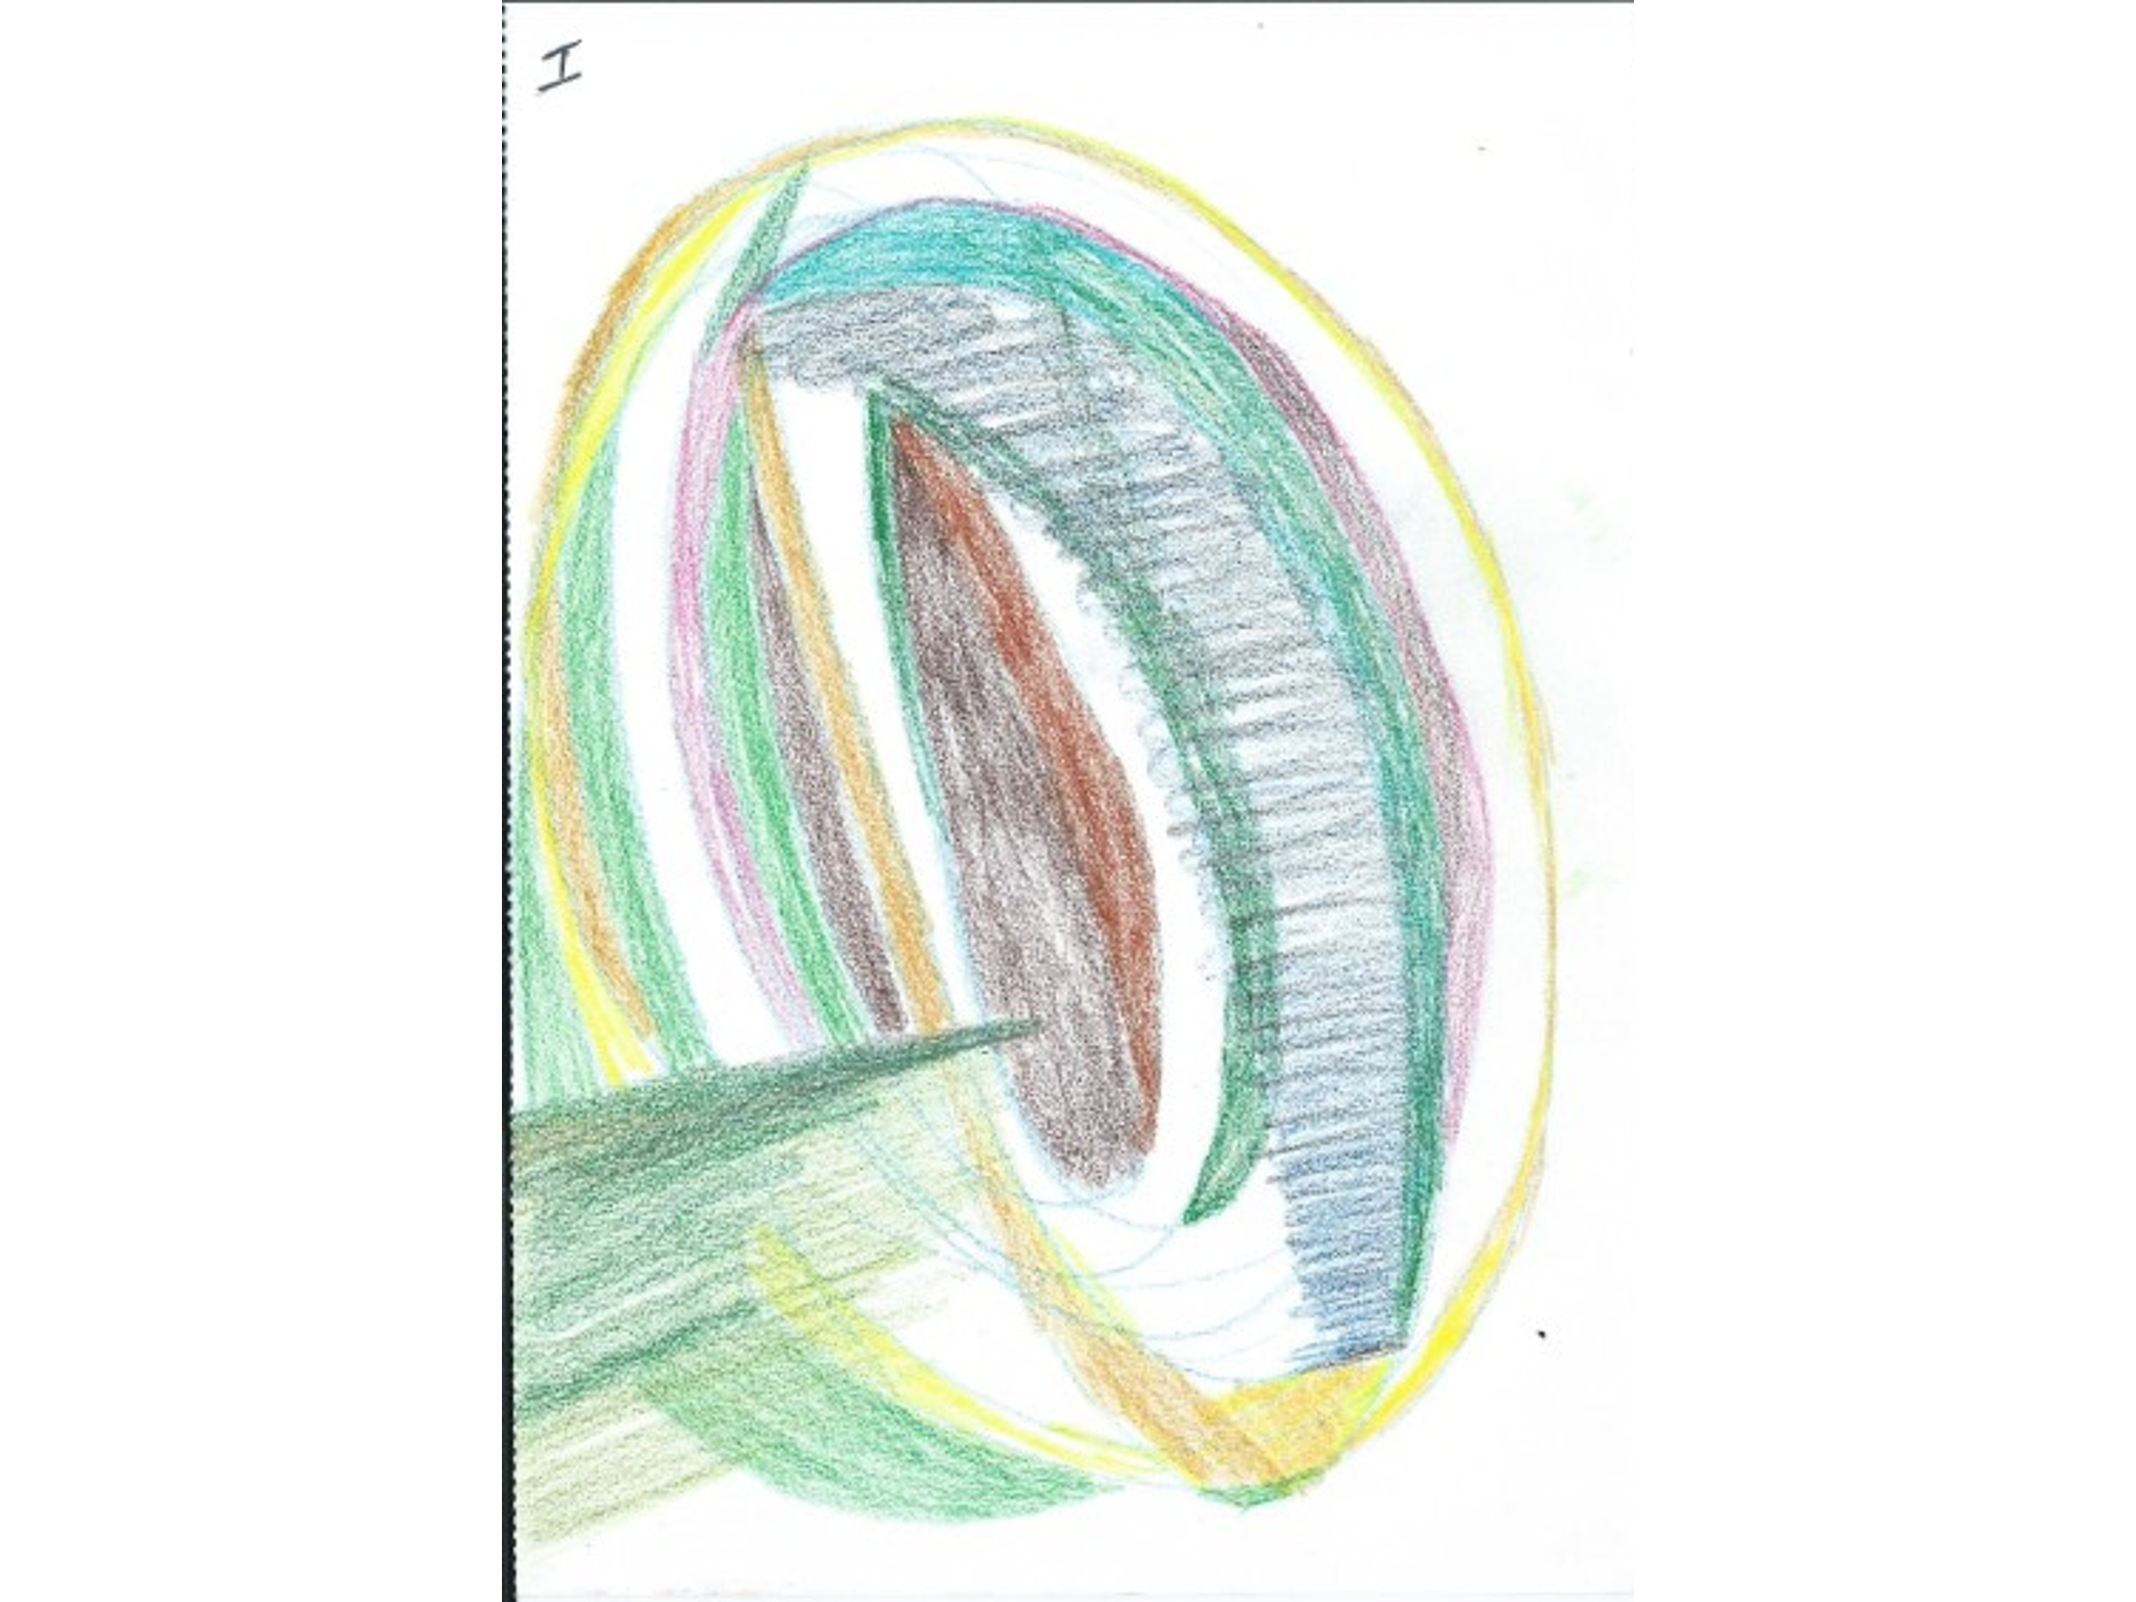

A female aged 53 with a history of connective tissue disorders and lung disease. - a pretty severe burden of disease. She was on long-term steroids which had resulted in multiple thoracic fractures. The problem she was referred for was localised left-side chest wall pain with grinding sensations. This was not typically neuropathic, such as you can get with thoracic fractures. She was fairly functional, working from home in a responsible job in administration. She wasn’t particularly distressed, but she had experienced a lot of social loss mainly due to Covid because of her vulnerability to infection due to steroids. She had had many investigations including MRI but apart from the fractures nothing significant had been found. Apart from erythema ab igne, probably caused by hot water bottles there was nothing to be found on examination.
She was referred from rheumatology for ‘injections or topical treatment’ – something we often see in pain clinics: requests for ‘something to be done for pain’ , and people have been sent with high hopes.
When talking through this with the patient it emerged that she had a lot of fear of the fractures; she had a mental picture of splintering bones in her chest with sharp bits sticking out and injuring nerves. I explained that it was more like bending of the bones and squishing of some of the softer tissues and that with time the fractures would be safely healed, and it was perfectly OK for her to remain active despite the pain. She was encouraged to do regular exercise with the guidance of the physios. She was very happy with that and I didn’t arrange to see her again.
My take-home message from that was people often do cope with pain and not all pains need treating. This was a very nice lady and it was very easy to be sympathetic. She had a positive work ethic, she listened to what I said – so this was a quite easy one. But even so,. If she had been sent to some pain clinics they would have gone through a sequence of injections etc.

Case 2:

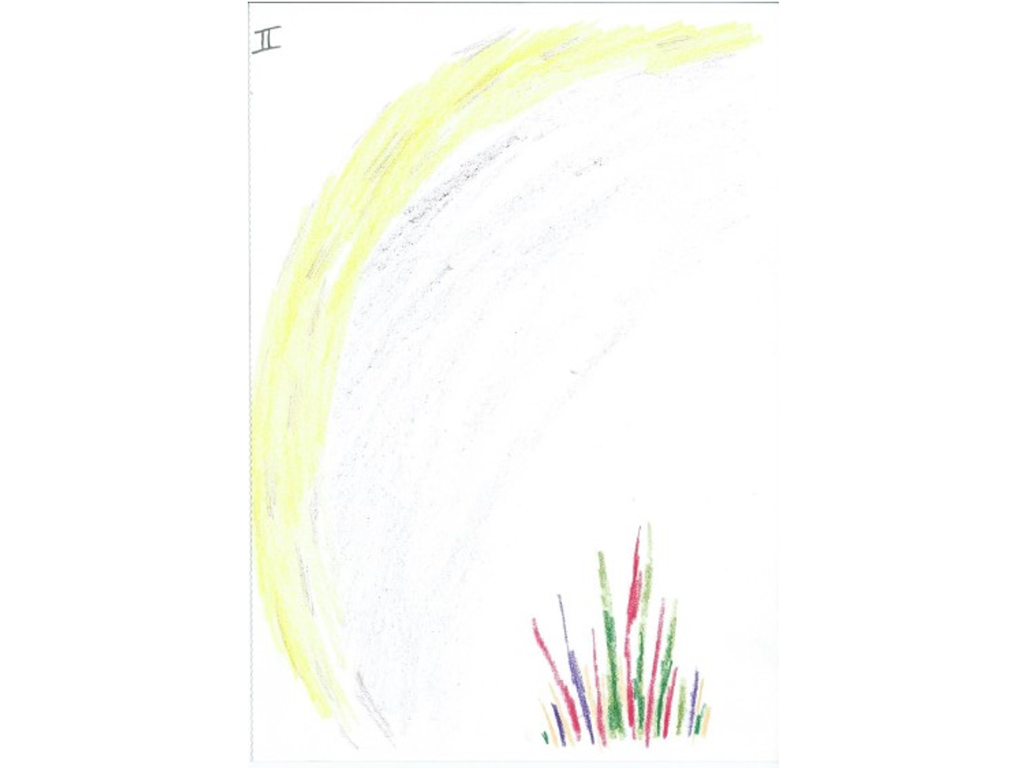

A 29-year old Iranian asylum seeker who spoke only Farsi who had had right knee pain for eight years which with other injuries he had sustained while in custody. He had been getting episodes of collapse associated with the pain He been to A&E many times where he had been given analgesics including morphine and the dose of the latter had been built up by his GP to 300mg orally per day.
He didn’t show up. This is something we see often particularly with more challenging patients. This did give me more time to talk to the first patient, but my dilemma was whether to risk giving him a reappointment in the assumption that he had a good reason for not attending, or simply discharge him do that if he is referred again he has to join the back of the queue. Patients like this can find it very difficult to get to the hospital. Alternatively I might write to his GP making recommendations for the morphine to be reduced or stopped as it didn’t seem to be appropriate. I have often thought about this but rarely do it. I have a suspicion that there may be some GMC issue with making recommendations for patients without actually seeing them and it is perhaps ethically doubtful. With cases like this it is difficult to be as sympathetic and engaging as I was with the first lady. You are having to do everything through a telephone interpreting service; the cultural background is very different; they have probably had an atrocious life experience. So approaching the high levels of distress can be very difficult, especially for the psychology services

Case 3:

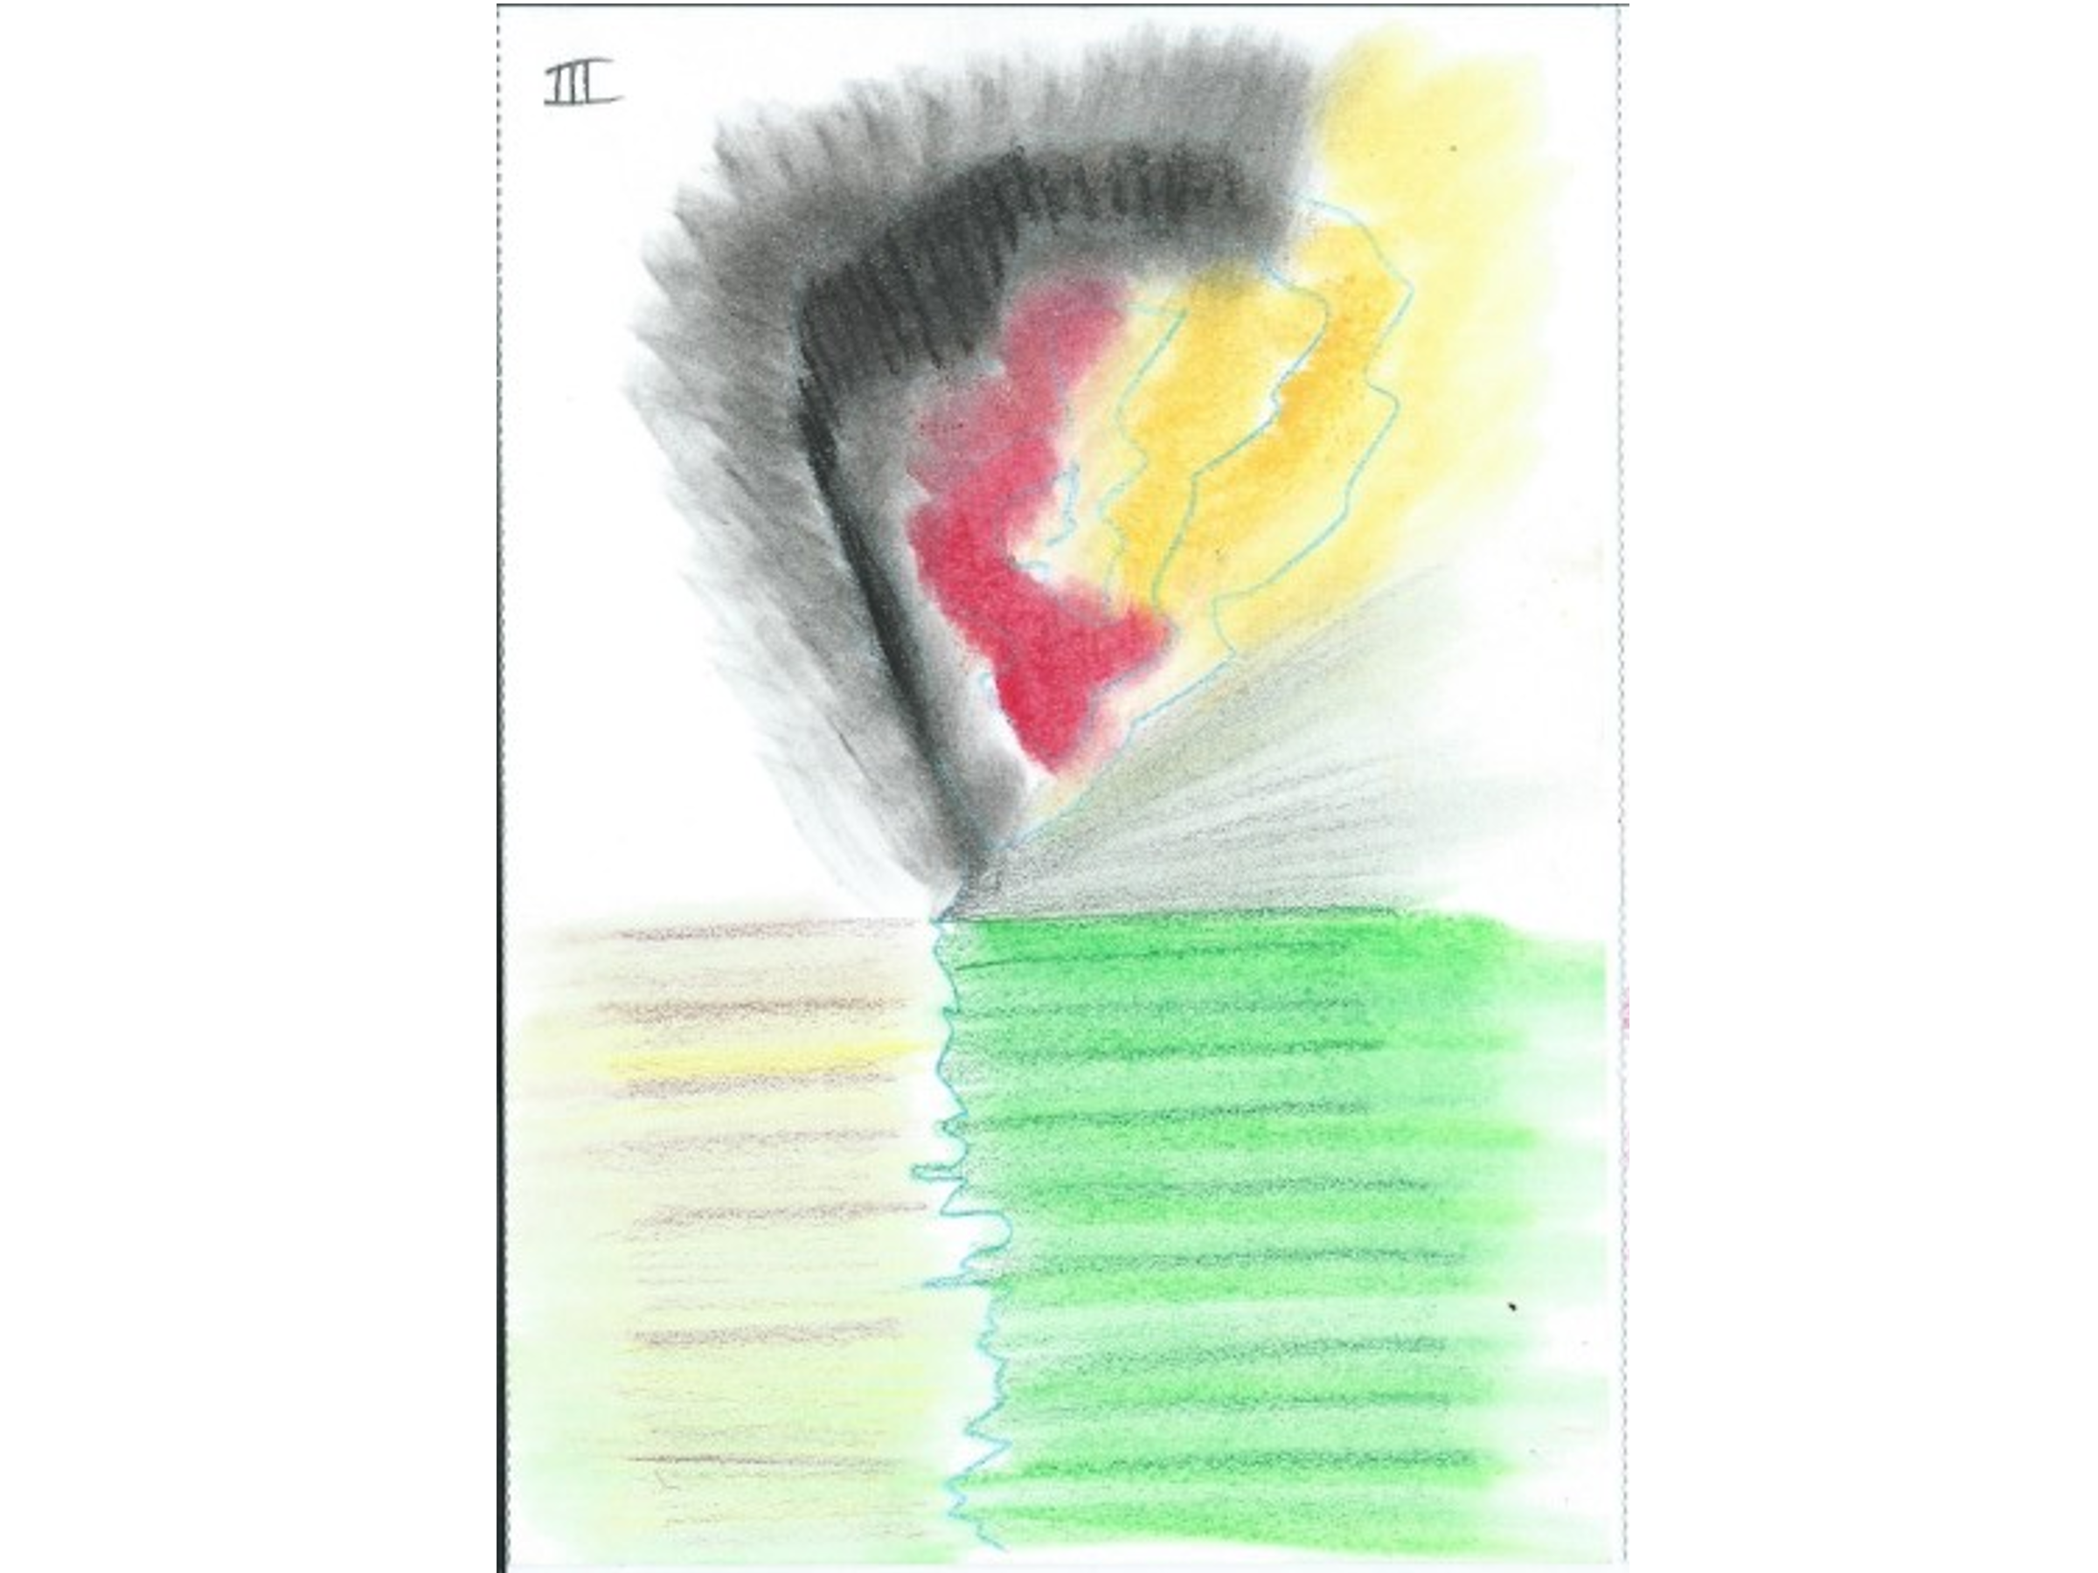

A 66 year-old male; a builder who had fallen 40ft. off a roof two years ago. He wasn’t insured. He had suffered a moderate traumatic brain injury and a lot of other injuries of which the worst was a T7 burst fracture, fortunately with an intact cord. He has a kyphosis and scoliosis with severe cervical, thoracic and lumbar pain. He also had non-specific cognitive dysfunction with which he had been
He had spent several months in a thoraco-lumbar brace. I was able to reassure him that his pain wasn’t ‘dangerous’ and didn’t imply further pathology or damage – a concern that had never been addressed for him before. I encouraged him to have further physical rehabilitation. We are fortunate to have the Brain and Spinal Injury Centre ( BASIC) which is a national charity based locally in Salford and we referred him to this. We encouraged him to wean off opioids and discussed the possibility of a return to work. ( He had recently started driving his van and doing odd jobs) So we were able to provide reassurance that it was OK to have pain and it was safe to do stuff ; and that not all pain needs to be – or can be - treated. Nevertheless validation of his pain was helpful. This is the sort of case where I would get a letter from the benefits agency asking me to verify his level of disability. This can be a challenge because we don’t necessarily assess levels of disability for this purpose.

Case 4:

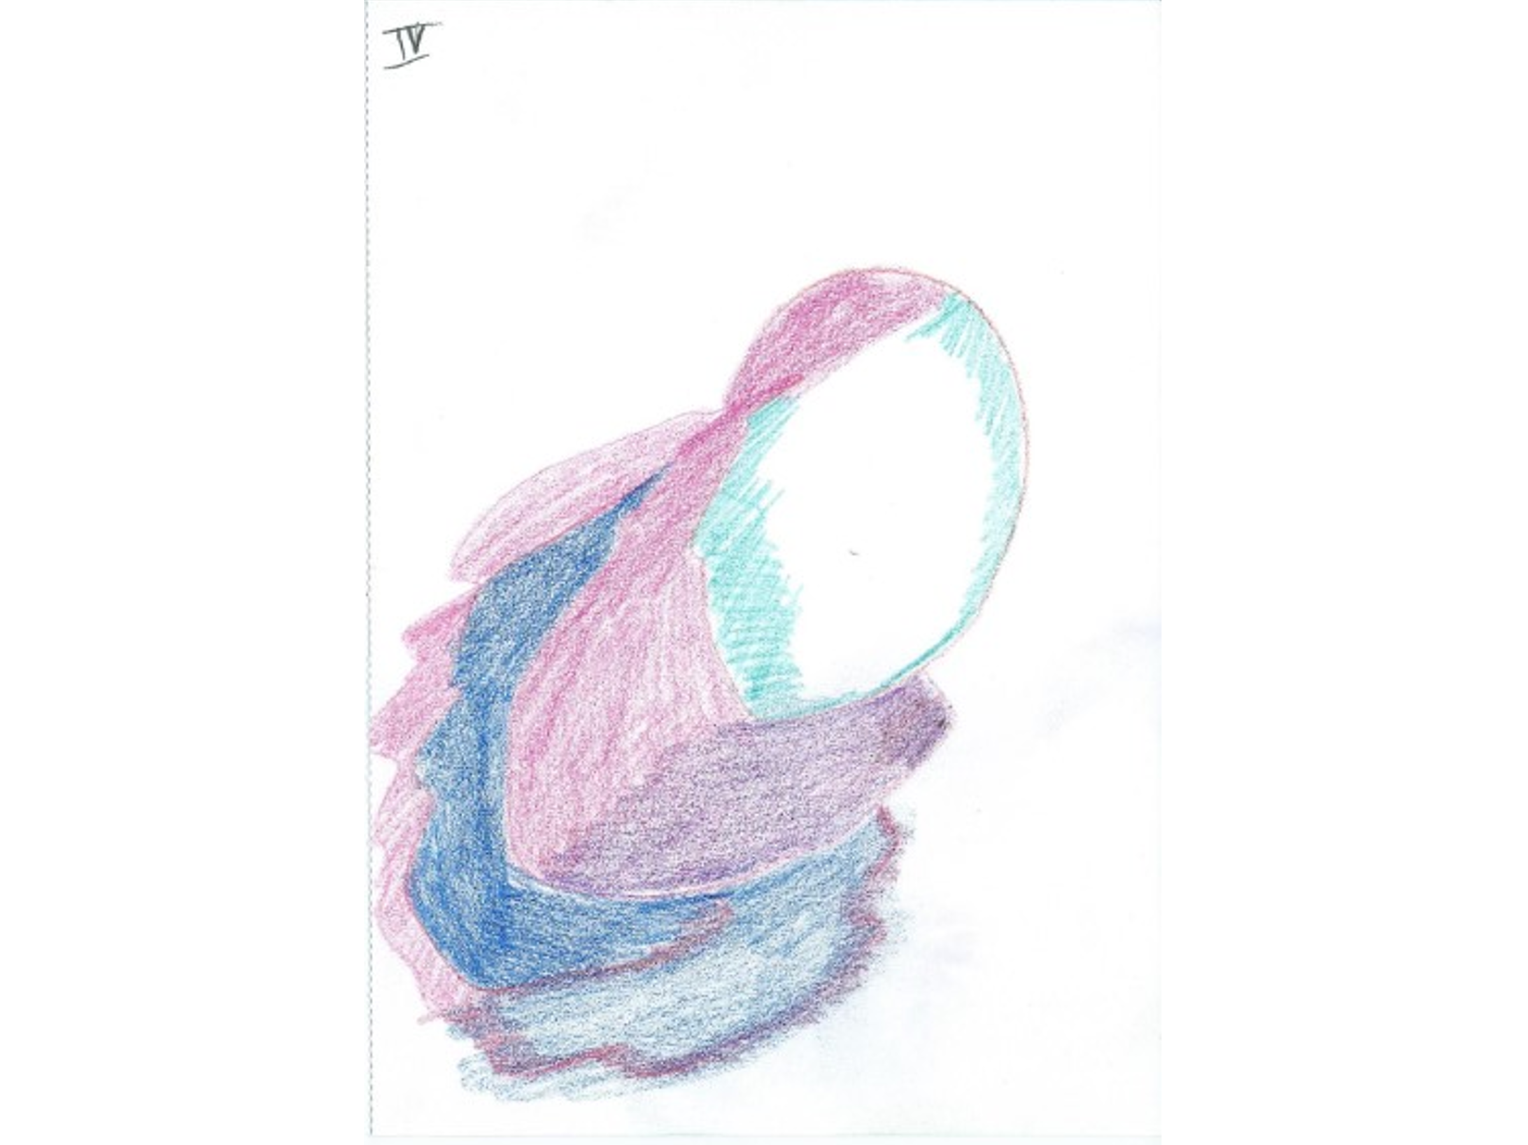

An Iranian lady that I interviewed with the help of a telephone interpreter. Most of our translations are now done by telephone which in a way works very well as it is fairly anonymous as the person you are speaking to is distant and you can say something to the patient and watch their reactions as it is being translated. I have had problems with an interpreter in the room; in one case where the interpreter was very antagonistic – I think he came from a different African tribe.
This lady had had a good life in Iran before she developed a tumour in her lumbar spine, which was operated on since when she has had back pain. Because of her illness status she ended up marrying and came to the UK with her husband who became emotionally and physically abusive. They were divorced so she was left abandoned in a foreign country with her back pain. She now lives with friends, has British citizenship and reasonable access to benefits. She was referred to our neurosurgical unit where she was diagnosed with neurofibromatosis (benign tumours on nerves causing pain and neurological dysfunction) She had also developed hemifacial and noise sensitivity caused by a vestibular Schwannoma.
When she came to me she had very high levels of pain all over which couldn’t be attributed to any localised pathology. She had high levels of distress and admitted to being very worried, and had to stop her college course because of her pain. She had been given some counselling regarding her experience of marital abuse.
She was on all the pain medicines but not much opioid. She was very preoccupied with her diagnosis of neurofibromatosis and its possible consequences and we spent some time talking about that. I arranged for her to have some further mental health service work and encouraged her so start some physical activity, and she thought she could commit to a short daily walk with a friend. I recommended maintaining her medications even though these were not terribly appropriate as there is a limit to the number you can change at one time and I thought it was important to establish some sort of therapeutic alliance with this woman.
She was another patient with whom it was easy to be sympathetic, and to listen to her problems and validate them. I plan to see her again simply to help her to understand her problems and validate them

Case 5:

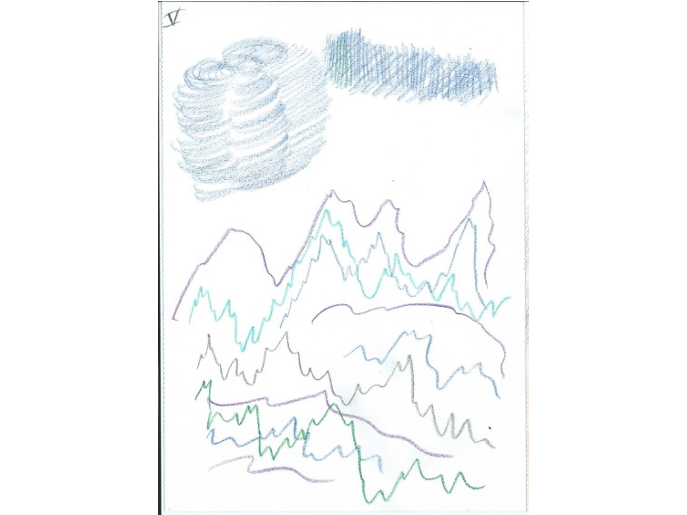

A 71-year old man with widespread osteoarthritis. He had an infected hip arthroplasty which had to be excised and he was dependent on a manual wheelchair. He lived alone with the help of family and friends. He had pain in all the joints he was using, especially from his knee and shoulders from using the wheelchair. He was just about able to transfer to toilet and bed. He had lost his wife to Alzheimer’s last year, so his mood was poor and he had difficulty sleeping. He would have been helped to be more mobile, around the house and outside by an electric wheelchair but the standard NHS model was too big for the doors in his apartment.
Co-Codamol was quite helpful but making him constipated which limited the dose he was taking to minimal amounts, so we gave him some advice about laxatives.
I asked him if his family and friends could help him to buy a compact electric wheelchair which he thought was a good idea. Sometimes simple practical suggestions like this can be very helpful

Case 6:

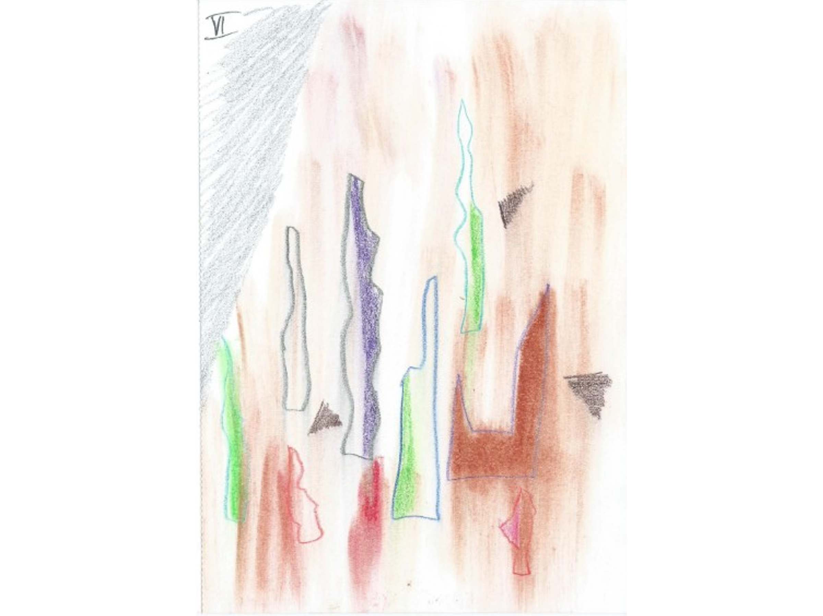

A 49-year old man who had been previously fit before an industrial accident five years ago when a box fell on his head. He had an anterior cervical discectomy and fusion (ACDF) to eliminate spinal cord compression. After this he had a stormy time with post- surgical hallucinations. Somehow under the influence of all his post-surgical medication (including cannabis of which he had been a regular heavy user since the age of 13) he had stolen and crashed a car although he wasn’t a driver. He had heavy debts.
He now presents with widespread pain. He is very distressed and has suicidal thoughts. Both he and his son have cannabis induced psychosis. His wife recently left him and has been replaced by a dog.
He was taking Baclofen but stopped it but is still on several medicines including Pregabalin and an antidepressant. A recent MRI revealed post-surgical and degenerative changes in his spine but no myelopathy or anything that should disable him. He had made an unsuccessful application for enhanced benefits – the assessment can be very unfriendly – and was living on soup.
We spent some time talking about the safety of his symptoms ( he been told before his operation that if he didn’t have it – or it went wrong – that he would be paralysed ) as he was constantly anxious that he would suddenly become paraplegic. I encouraged him to take some gentle exercise and agreed to see him again.
Cases like this leave one with a general feeling of helplessness. There is so much going on and it is difficult to know what we are aiming for.

Case 7

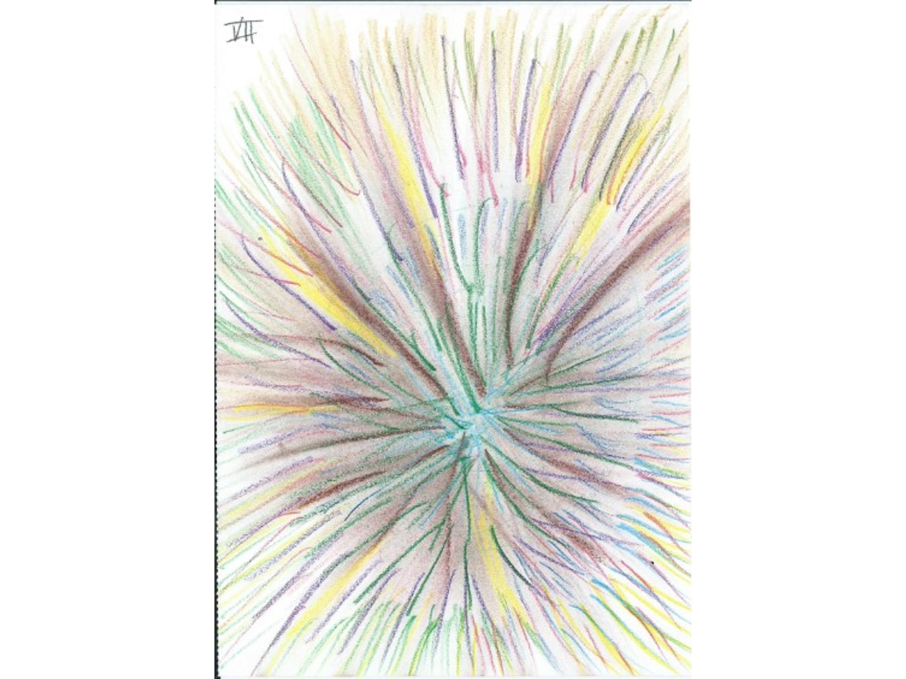

A 67 year old woman with unilateral trochanteric bursitis. She had undergone many Investigation3 including an MRI which showed bilateral changes. She had had three
steroid injections under ultrasound so it had definitely gone in the right place with no benefit. Trochanteric bursitis is common in hip for no cause that you could pin down, and makes it very tender.
She was on a range of medicines including Gabapentin and Co-codamol neither of which were useful for her. She had an extensive background of medical problems that had blighted her life including migraine, restless legs , Irritable Bowel Syndrome, dyspnoea for which she was on intermittent prednisolone, insomnia and drop attacks. The latter occurred almost weekly when she collapsed in a heap or the floor without warning, which had resulted in several hospital admissions. But three years previously she had been given a medical alert dog who now gives now gives her a 40min warning of the drop attacks, so she could lie down.

Had she had a cardiac monitor?

Yes

This dog had enabled her to live a normal life including travelling around Europe and even to Japan (she was a keen rugby fan) She had a range of mobility aids and a very supportive partner and family.
There was basically nothing for me to do – she had all the possible medical treatments – and she accepted that. We discussed the way pain is in some people’s lives and has just got to be left alone.

I suppose it depends on how disabling it is? – She is very active

It depends on your definition of disability. She was able to do some things with high levels of support but without that she would have been very disabled
Case 8:

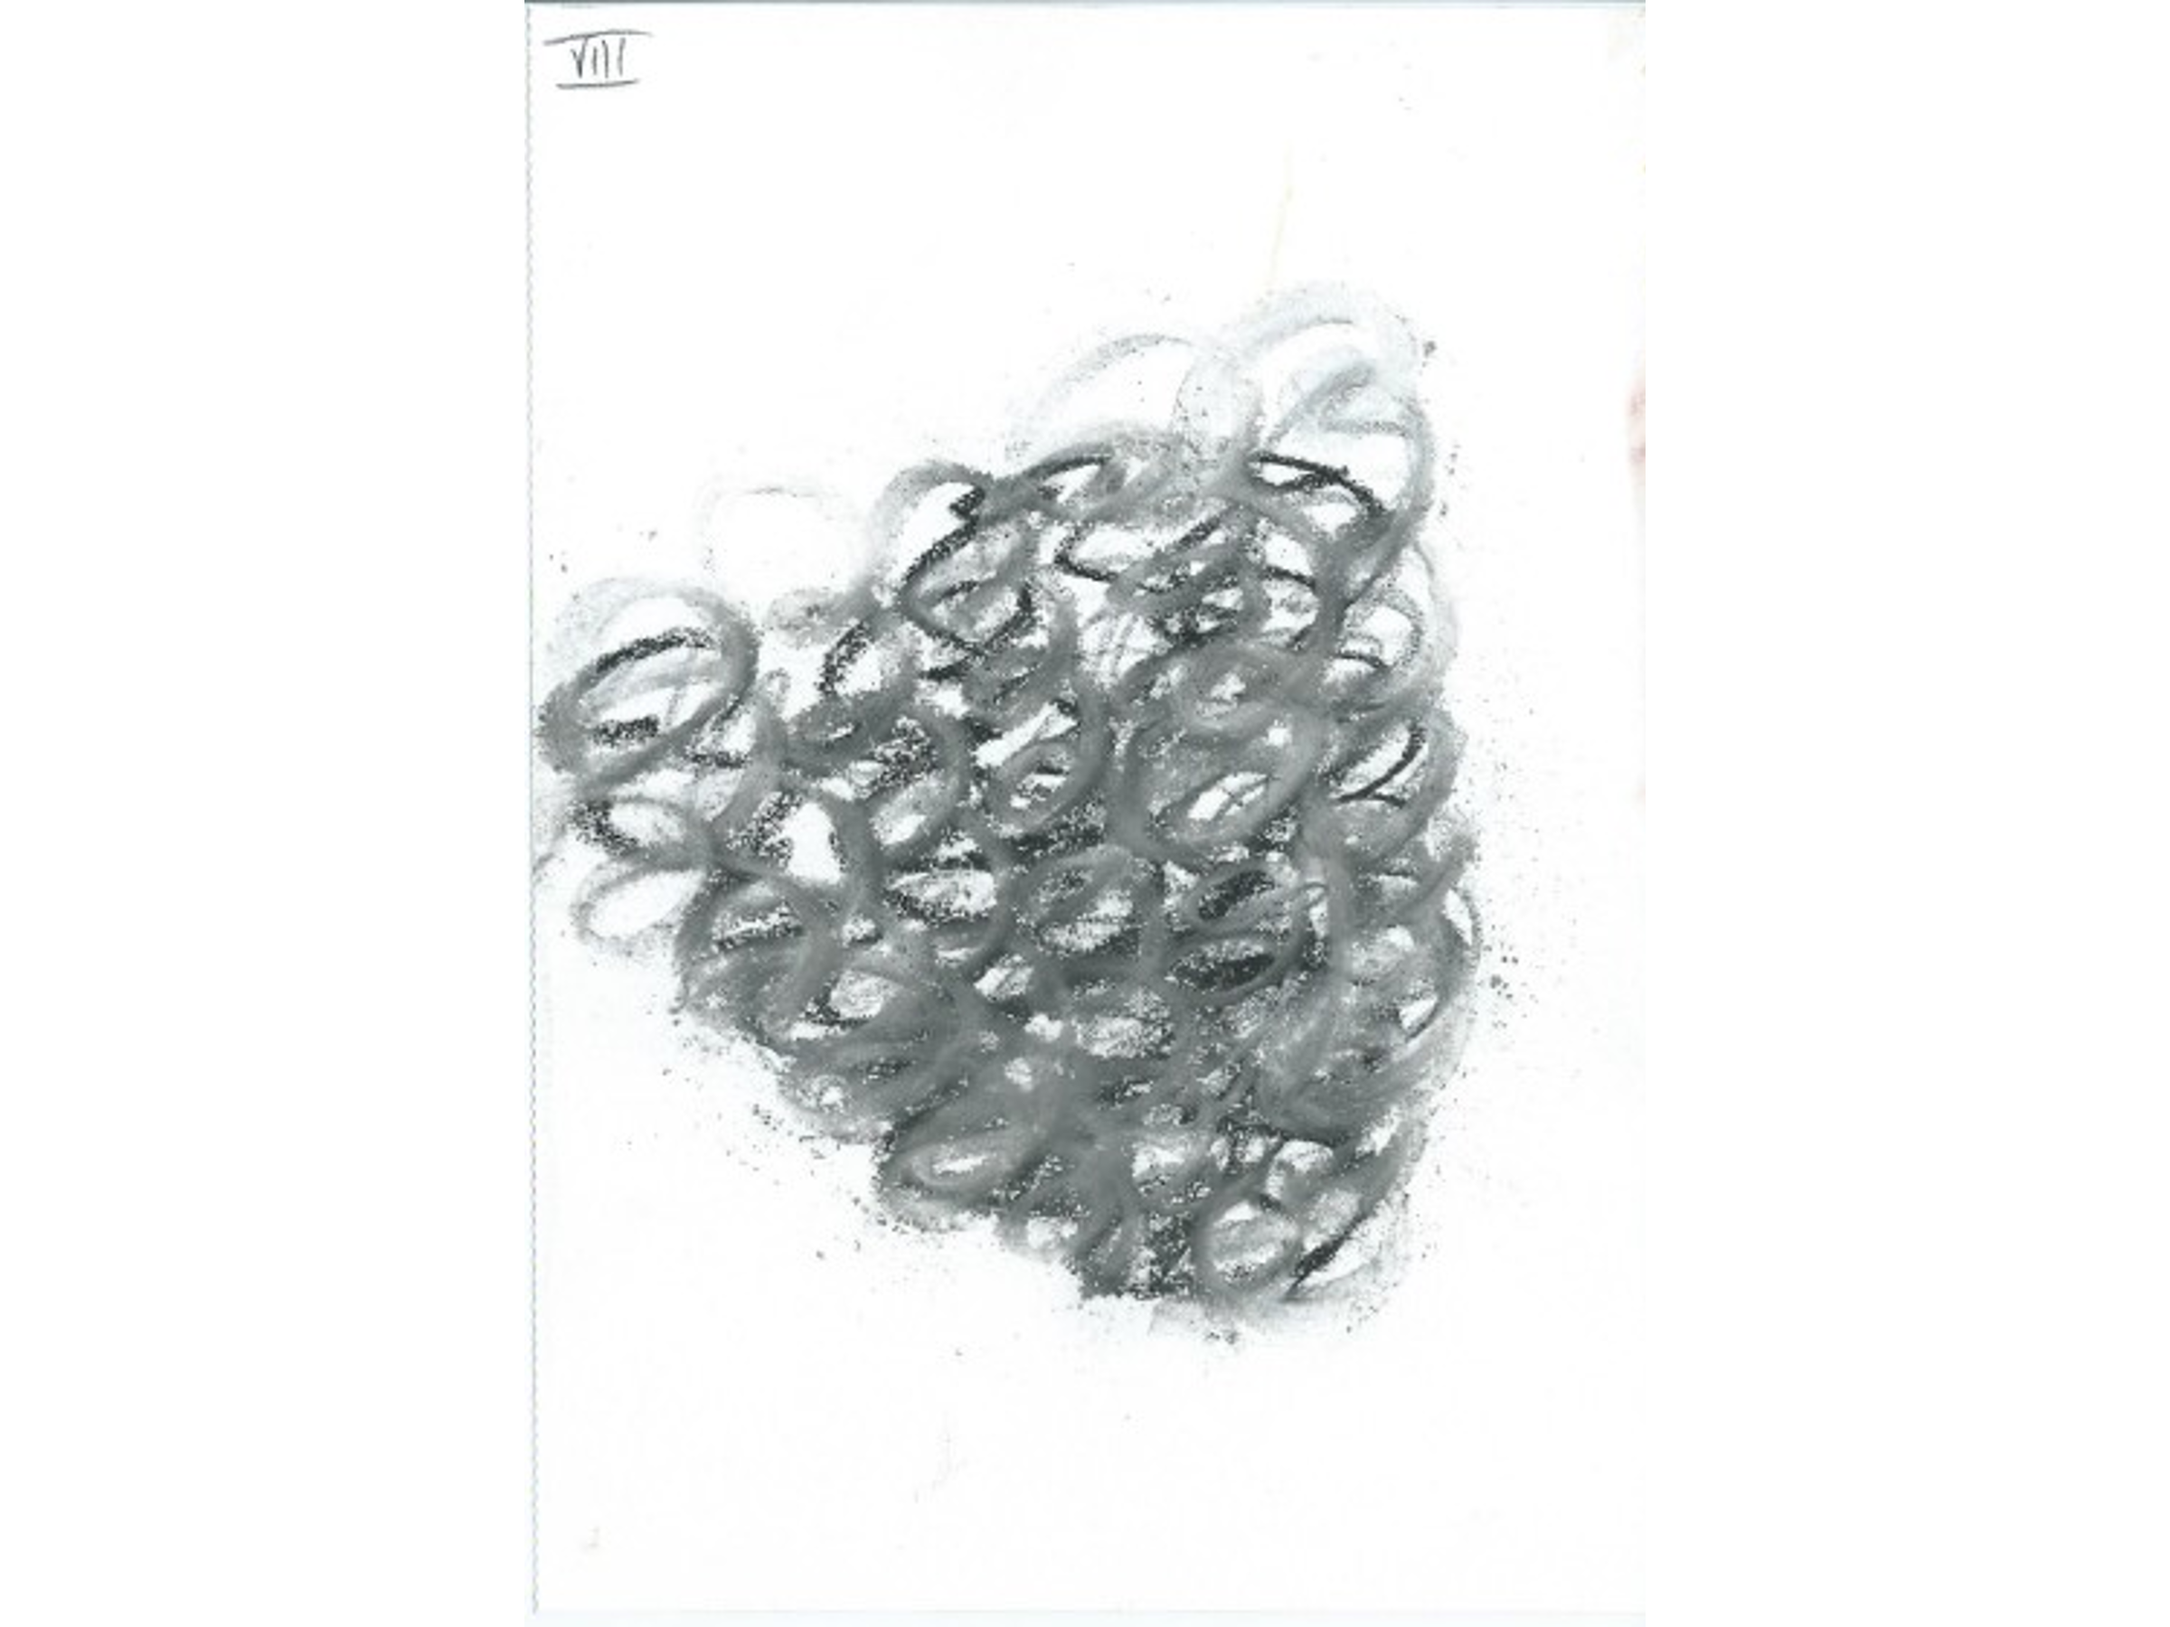

A telephone follow-up of a 40-year-old lady with Fibromyalgia and major family and social stressors. She had recently had surgery cancelled on the due to lack of beds. Because she was nil by mouth she missed her pain meds which caused a major flare up of pain symptoms.I wrote to the surgeon requesting that she was put first on list when relisted.
The NHS can be difficult to navigate and sometimes doing little things for patients is very important.

Case 9:

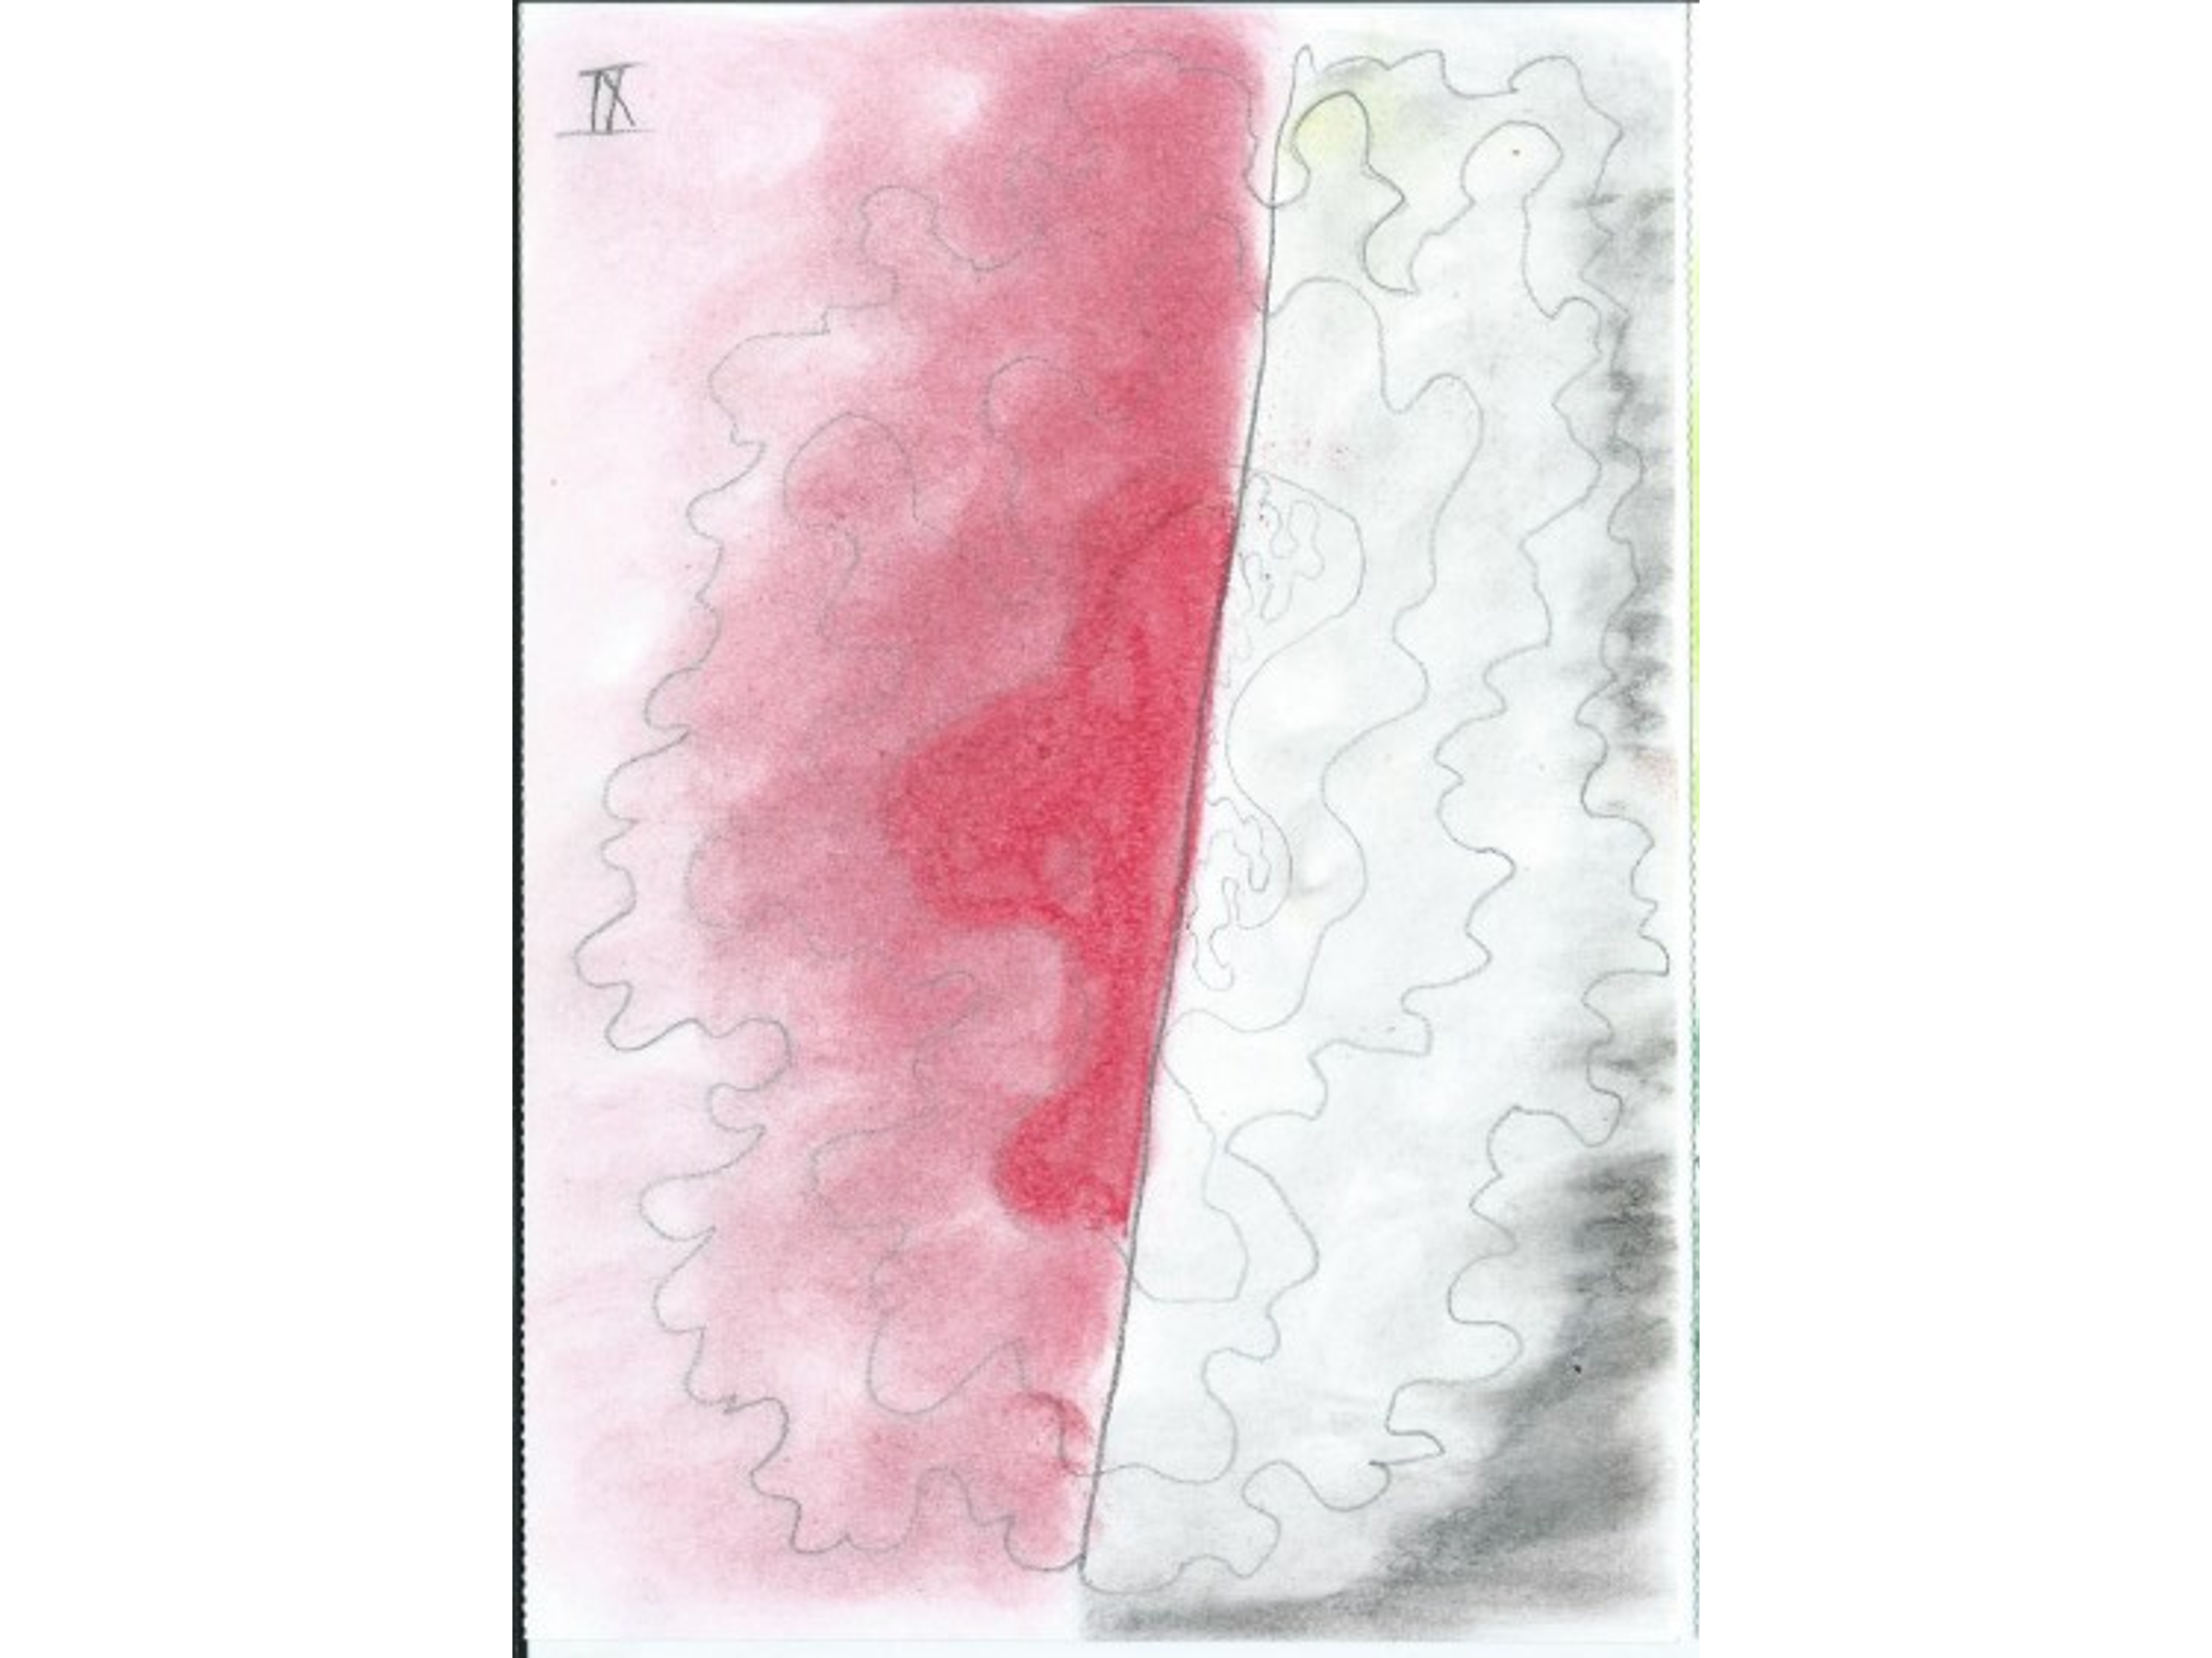

Another telephone follow-up. This was a 25-year-old female with what I had called
complex chronic widespread pain. She disclosed, apparently for the first time, a dreadful; history of adverse childhood experiences. We referred her for counselling which she had found very helpful.
She was stuck upstairs close to bathroom and following my letter to the authorities she had been given a new home with a stair lift and an accessible bathroom .
She was on high doses of both tramadol and morphine. I am normally reluctant to rush into opioid reduction. When opioids are given for chronic pain they are pretty safe on the whole; I know there are issues with toxicity and death but in this situation where people are taking them for chronic pain they are safe. Rushing into withdrawing them can sometimes risk breaking the therapeutic link with the patient. If you can get them to the point that they are doing much and there are more important things to do, it is much easier. So I had discussed gradual opioid taper with the GP, but without any discussion with the patient he stopped the tramadol completely and started withdrawing the morphine. This was not what she was expecting and certainly not what I had recommended. She had a lot more anxiety about this situation than the withdrawal as such. After some discussion she accepted that this was probably right thing to do albeit with clumsy handling. So I wrote to the GP to emphasizing that further opioid tapering should only be on a gradual basis. I recommended that she should continue pregabalin, mirtazapine and propranolol, and arranged to review her in three months. This case raises the issue of problems that may arise from compliance with guidelines for opioid prescribing and withdrawal.

Do the guidelines give you a regime for tapering withdrawal or is there allowance for negotiation with the patient?

There are regimes but patients will stop them themselves if you can get them to realize that the opioid is not ‘the answer’. We can talk to them about it alternative ways coping with the pain and nine times out of ten they will stop them. They can work out their own reduction programme with the GP. But the problem is that GPs are increasingly working towards a limit that says more than 120mg oral equivalent per day is illegal. Crashing down to this probably doesn’t cause much physical withdrawal reactions but it makes patient very anxious and upset. They have often worked hard and long to get recognition of their pain problem in order to get some ‘proper’ treatment.

I spent hours recently helping one of our group members to write a letter to her GP is doing the reduction at such a rate that she was buying God knows what off the internet. She hasn’t been able to discuss this with her doctor who just says I have to comply with NICE. She has been on huge doses for 20 years.

Case 10:

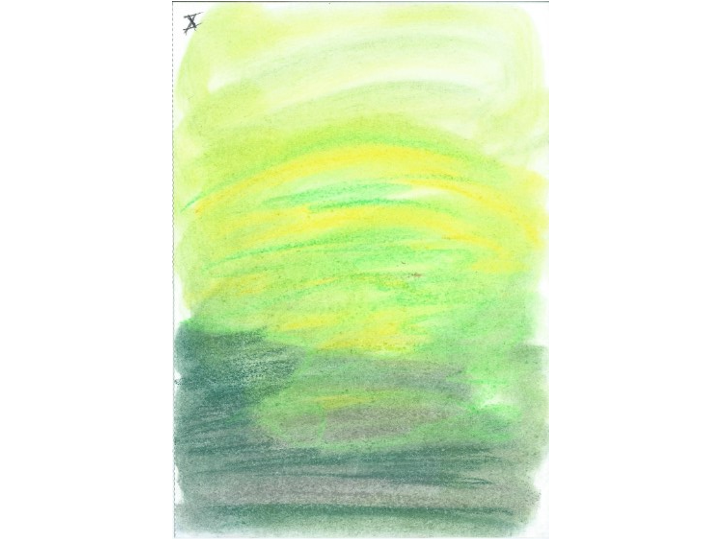

A 78-year-old male with prominent spinal stenosis and sciatica symptoms
for annual review. He has longstanding lumbar degenerative changes including scoliosis.
He had an instrumented fusion some years ago
He has been given 4 monthly then 6 monthly caudal epidural steroid injections since 2009. These have always been effective for 2-3 months. His wife has dementia and is totally dependent on him. So although these injections are not recommended by NICE and indeed against our local guidelines my sympathy for his circumstances prompted me to arrange for him to ccontinue with them every six months – perhaps slipping him onto an operating list. This is breaking the rules and the hospital may not be reimbursed, but it seemed the kindest thing to do.

The problem with the NICE guidelines is that they are based on population- based studies and make no allowance for individual responses.

Case 11

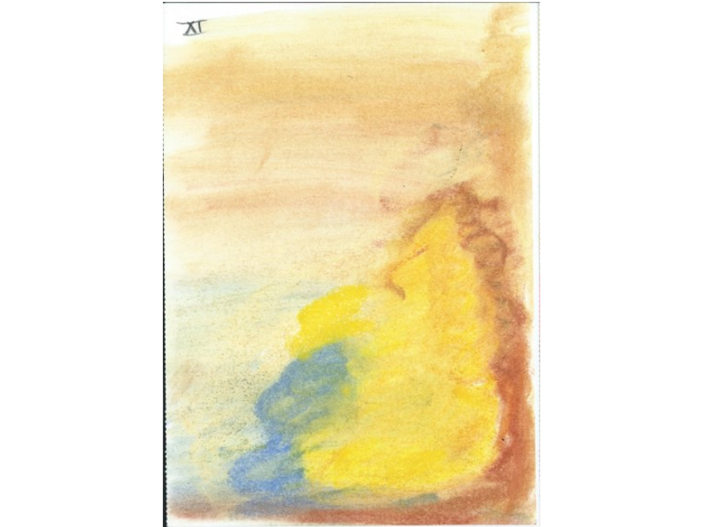

Another old man of 80 who had been referred back to us having been lost to follow-up following a long series of epidural steroid injections (80mg triamcinolone 6 monthly) for back pain associated with degenerative changes. These had always helped with his back, shoulder, arm and hand pains. His meds include topical NSAIDs, paracetamol, pregabalin 150mg bd and small doses of tramadol.
He hadn’t had any injections for a while and I took the opportunity to ask: do we really need to continue with these injections? He seemed to be managing OK so as there are some side effects and problems with steroids and the injections are certainly not within the guidelines. I realize that I was playing God to some extent but I tried to couch this in terms of his best interests; he was a very compliant patient and happy to accept that. I don’t know whether that was the right decision; perhaps I should had treated him the same as the previous man, perhaps I didn’t feel quite sorry for him or took advantage of his compliance.

Are there guidelines in your hospital for injections?

There are but I don’t know how strongly they are enforced. We are lucky in Salford as we have always made it clear that we do these things because there is documented benefit and on that basis our funding authorities have been supportive and have never tried to stop us. Other hospitals have said this is something you cannot do in any circumstances

Case 12:

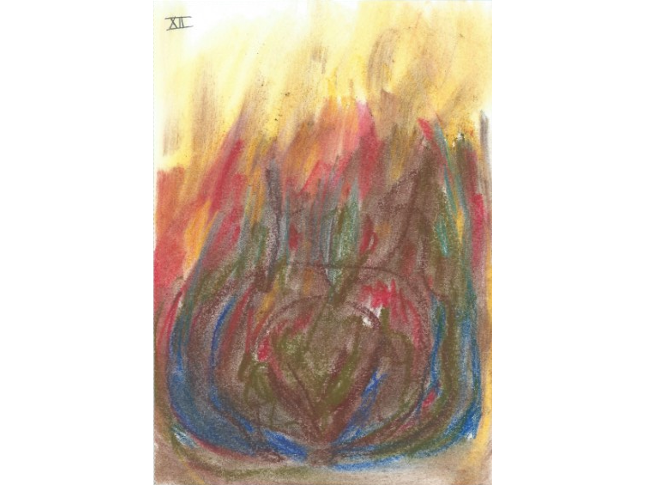

A 27- year-old female with congenital neurological problems and complex needs and requiring a high level of support.
She has been on anticonvulsants including carbamazepine for apparently atypical facial pain. But we are not treating trigeminal neuralgia here for which CBZ is normally indicated ; I have seen her over the years and she has had some somewhat bizarre medication responses which suggests some probable non-specific, placebo treatment effects. She has previously had some successful withdrawal of meds but the symptoms have flared up so they have been resumed.
She wishes to get pregnant; she has good family support for this and I encouraged her to try stopping the medicines and explore alternatives such as self-hypnosis, or Headspace*

*An app for teaching meditation. https://www.headspace.com/how-it-works
.

Case 13.

An 87-year-old for follow-up seen with daughter. She lives on her own with a lot of help from her family who are struggling to support her.
She previously had symptomatic spinal stenosis causing radiating pains including . claudication, which had benefited from caudal steroid injections, but now only has severe back pain associated with thoracolumbar kyphosis. She has difficulty with standing and basic household tasks and lives on the sofa.
She and her daughter were very keen for her to have further injections, and distraught that these are not indicated, and are outside the guidelines. But we did have a plan that she should continue with some medicines including paracetamol, consider acquiring a seated walking frame so she could get out more, and consider moving to more accessible property or sheltered accommodation. I seem to do a lot of this kind of thing, especially with elderly patients: acting in a sort of life coach role, which may be the most helpful thing to do for pain.

Themes

So the themes which seemed to emerge from a typical day in the clinic and which I was reflecting on on my way home were:

1 Chronic pain is extremely complex.

2 It is actually chronic. That seems not to be recognised even in chronic pain clinics whose aim is to fix it. But for a lot of the patients we have seen this evening it isn’t going to go away. If you have had pain for 15 years you are stuck with it and anything other than recognition of that, albeit alongside helping with whatever else we can throw at it, is difficult.

3 There are many stakeholders including the patient and our first responsibility as health professionals is to the patient. But that is not our only responsibility; we have to be responsible to the Trust who employs us and to the NHS generally in our use of resources.
Balancing that can be difficult, and some of the ethical issues that have emerged are about the conflict between the guidelines and, for instance, the patient wanting to continue opioids.
When the guidelines were first published I was very sceptical and thought they were excessively draconian, but being able to say to someone: “look, there is what is considered to be a safe level of opioid and this is what you can have. I am happy to supervise reducing you to this level and if it is helpful you can continue with it for the time being and hopefully reduce it further.” So I have found guidelines helpful but problems arise in how they are implemented due to lack of understanding as to why they are there and what they are trying to achieve. We have seen several cases this evening of pain that doesn’t really require treatment. In my view, that people may differ from, for some of them treating the pain would be meddlesome if it is an alternative to talking to the patient, explaining things to them and letting them carry on coping with it. I see quite a lot of patients at follow-up. Some of my colleagues think that giving them 45 minutes is enough but some of what we talk about in those 45 minutes may be challenging for the patient. They get a letter explaining what we have agreed in that appointment but I find it very helpful for them to come back at least once more for further discussion, particularly when we are dealing with something as disabling and distressing as chronic pain. Sometimes continuing to see people in the pain clinic is necessary; I see some people every six months and even every year, but they know that if they can talk to me about their back pain they will not be referred back to the spinal surgeon who will do more scans and perhaps frighten them with the way they describe the findings, and as long as they are seeing me I can perhaps guide them through their pain even if we are not specifically treating it. In many cases we can provide comfort and companionship although it is not in my job description.
Listening is very important and I hope I am a good listener. If we are going to advise patients and expect them to accept our advice it is critical that they feel we have at least listened to the extent of their problems.

Finally, in many cases our behaviour in terms of what treatment we offer or wanting to see the patient again or what treatment we offer is determined by our attitudes and beliefs. If we see an asylum seeker who doesn’t speak English it is quite difficult to be enthusiastic about saying “this has been a difficult consultation and I don’t think I have helped you very much; your problems seem to be insurmountable but let’s meet again for another discussion”

Discussion

When we had people converting from heroin to methadone they always gave it as a bright green syrup and rather than going from 10ml to 5ml or whatever we would give them the same volume but in progressively reduced concentration. So they didn’t lose the placebo effect.

That was the policy in Seattle 30 years ago – a pain cocktail with as much of the polypharmacy that many of the patients were on in gradually reduced strength. That’s fine but my own approach is that things work better if the patient feels that they are in control.

In Seattle we did reduce the dose in this way but at the beginning of the treatment we told the patient that every day there would be less active ingredients in the mixture. We did not deceive the patient in any way.

It was a good system but complicated and a good alternative is to negotiate with the patient …..

… ...the other thing used to do to help people to get off Valium and Librium was to suggest that they used a nail-file to remove a bit of a tablet every day. You could give them the choice as to how fast you did it

With opioid reduction it is rare to see significant physical withdrawal. The usual thing is that the patient misses the idea that they are having it and that they are in control of it. As an anaesthetist treating opioid overdose I found that as long as they were getting something like the dose they were on the day before , or at least a half, they are probably not going to get a significant withdrawal reaction. It’s more the worry of thinking you are going to have a horrible reaction

What preparation are they using? - capsules, tablets or liquid?

It doesn’t matter. Sometimes it is easier if they are on long-acting medication like MST if they are on 50mg twice a day the strength can be cut down, and it is probably better to get rid of prn short acting stuff before you start on the long-acting.

I’m interested in what you said about steroid injection because I run a support group for people with chronic pain, who have usually been turned out by the pain clinics. So I have been fascinated to hear what you have been saying and the way you try to help your patients. You say that steroid injections are not suitable for all patients. So how would patients know whether it is right for them or not?

The reference would be the NICE guidelines which are very clear that if you have back pain you should not have epidural steroid injections – full stop. The only indications now would be a radiculopathy causing sciatica. The problem is that we now have a whole cohort of people over the years from pain clinics run by anaesthetists. Anaesthetists have needles and there are steroids in the cupboard and when you have a patient in pain it is nice to try to do something to help them, and these injections do seem to help in many cases. Population-based studies suggest that they don’t work very well but when you look at individual patients they sometimes do very well. Unfortunately NICE committees don’t recognise individual patients. There are other problems: for instance systemic effect of a shot of steroid in the back the can make them feel a lot better and reduce their aches and pains.
So it is complicated . Steroids are very useful medicines but they are also toxic, but there are not many studies addressing this problem. I showed you a patient who had been getting steroid injections for 14 years and there was no evidence that he had been getting any harm as a result, but I have no scientific evidence for the safety of this.
I am interested to hear about the patients who had been ‘thrown out’ of pain clinics?

They have been on a pain management course and told, in effect, ‘that’s your lot – there are other patients on the waiting list – go off and sort yourself out’ They get no support from their GP or the pain management team. I have spent 4 ½ hours today supporting patients in our group because they have nowhere else to go. (I am not a medic and I do this voluntarily) They have come to rely totally on their medication because that is all they have got, and the only way they have of justifying to themselves that their pain is real.

It's a validation. If you are having proper morphine or proper injections for your pain it means your pain must be ‘proper’. It may enable you to get benefits as well. The whole situation is so complicated.

At our last meeting we had some discussion about the idea that once pain has become chronic it isn’t really a medical issue. The injections don’t work and they have to come off the drugs … people are distressed and they don’t know where to go. Perhaps you have to be in a craft group or a singing group … it’s a social human investment in meeting up with people and doing something together, and a powerful healer.

Some people coming to our group were spending virtually all of their time on the sofa or in bed. I have now got them starting craft groups in their own neighbourhoods. The crucial thing is that when they come to us we believe them. They don’t have to pretend that their pain is worse than it is. We have walked in their shoes. I heard from a lady only today who said “if only I had ‘met’ you (online) at the beginning of the pandemic … I was near suicide because I had nowhere to go”. I spoke at a conference in Cornwall recently about insomnia which has been a problem for me but I am beginning to overcome with the help of Sleep Station here in Somerset which has been amazing. I have CFS - there is a difference between this and just being tired – but I am getting over this awful feeling and able to do and able to do the things I am doing now.
So I really believe that the way forward for most people with chronic pain is not through medication. As we say ‘It’s Skills not Pills!’

When I see a doctor ….. physicians can organise our symptoms for us and point us to treatment guidelines. But in terms of chronic pain success in therapy is largely dependent on therapeutic alliance. I am a believer in acupuncture and acupuncturists have a strong therapeutic relationship with their patients which is very powerful as are craft groups.
But I do think that the number of treatments is important and so is saying I will see you in six months or a year.
I deal a lot with foreign cultures. It’s a big deal for someone who doesn’t speak the language or isn’t comfortable with seeing the doc – I don’t know how you get around that. Perhaps it is a topic for another time.

I think they can get some comfort from the fact that you kind of give a damn and that they can come and have some sort of conversation with you.

That is the therapeutic alliance but the doctor has to listen to your story empathetically and then compressed time to organise your symptoms and treatment – it’s not necessarily to prescribe pills or injections that is most important but you want the patient to be better after the effects of the epidural have worn off. The ritual of the waiting room and being shown into the consulting room is all part of this.

When we were doing epidurals it was better than that; you ceremonially disrobe them and put them in a gown, and put them on the operating table which is the high altar of medicine and pull the X-ray machine over them. Some of my colleagues practice interventional medicine including radiofrequency denervation. This involves a fantastic machine that makes different kinds of bleeping noises and is a wonderful placebo! (it may even work as well)

We are all working in a particular environment. But in many ways this can be so unfit for purpose. It may be expensive or give treatments that may have done harm. The understanding of placebo has come on by leaps and bounds and the thing about it is that it is not just about people being suggestible, but when we are talking about the effects of ritual etc, what we actually mean is the care for one human being for another. That action produces this response which makes them feel better but also makes them feel safer. And if you make people feel safer it reduces their pain and their anxiety. But we have medicalised all this. And medicalisation is very expensive. Pain medicine has been described as ‘luxury goods’ for which there is a huge demand which cannot be met, and doesn’t leave time for developing a therapeutic relationship. And you have people like Ann who are doing this amazing job with her groups for hours and hours all for free. And I think this is actually wrong in many ways. They should take money out of what we (as pain clinicians) do and train people up t to run courses …

Different people want different things. We don’t invest enough in the sort of thing Ann is providing for free in her groups. If people come to see me in my clinic the hospital charges £240 and £80 for follow-ups so in a day’s work you are talking about £3000 paid for a short intervention for which people wait months and months and then they go off and never come back - and all we are providing is a little TLC - which in many cases that is all a short intervention is - and that is where we should be putting money.

A lot of it is about getting out more.

Thinking about ethics : we have very limited provision of pain services in the UK ….. I still have patients I have inherited who have been having injections for years and years and are incredibly dependant on them which is potentially harmful: when they have got relief and are waiting months for the next injection which can be a very dispiriting situation to be in. I had a patient who had been to a clinic in Dundee where the doctor had said “come back and see me next year; they might have discovered something new!” So she was still waiting as there hasn’t been anything new since Pregabalin. But I get upset when someone from the Pain Society , talking about the NICE guidelines, says let’s not pay any attention to evidence based medicine because my patients benefit from this unproved treatment; and we are spending a huge amount of time and money doing things that are potentially harmful, and denying people these sorts of group based support activities for which there is a lot of published evidence.

You (Tim) mentioned empathy a few times and how you can have more empathy with one patient than another, and this has something to do with the alliance. So I did a little experiment: while you were going through your patients I decided to do a painting suggested by each. I sometimes use paintings in my practice as a psychoanalyst to help with transference. With some pain patients my reverie is non-existent and I can’t get any images in my mind because of the impact so I have to draw it.

As a psychoanalyst you have a supervisor that you can go back to but pain doctors don’t get that. It’s very useful to be able to discuss transference issues etc. And regarding patients who don’t show up – I always ring them because there are all sorts of reasons why people don’t show up and when we start judging people which we all do, especially before lunch We have a very good psychologist who helps us with reflective practice and it is a very important element of what we do.

We need mentoring; there is a little of this coming in general practice where people are burning out like crazy.

This has been quite therapeutic for me, thinking about a day in practice in retrospect. But we don’t generally do that – we move on and we may not recognise any damage we are doing or the opportunities we have missed

