Using Hypnosis for Chronic Pain

Maureen Tilford

Webinar 24th April 2023

I was a GP in Norfolk for 35 years and I had a strong interest in mental health because about 40% of the people that come through a GP’s door have an emotional problem and many of the other 60% with a physical thing also have an emotional problem on top of it. There was hardly anywhere we could get help for people and little we could do other than prescribing things. So I went and did some training in hypnosis, thinking that if I could get people to relax they might feel a little better. So I trained with what was then called the British Association for Medical and Dental Hypnosis but now the British Society for Clinical and Academic Hypnosis (BSACH). I used hypnosis quite a lot for pain and other things

Pain is usually categorised as acute, which is a relatively straightforward problem , and chronic pain which people find very difficult to deal with as it goes on for weeks, months or years; doctors can’t find a clear-cut diagnosis for it and it is very frustrating for both clinicians and patients – it is obviously worse for the patients who have been told we have done all the tests and haven’t found any cause for their pain . But chronic pain is complex and tied up with so many other things in their emotional and physical lives, and has all these other aspects of stress, depression, insomnia and exhaustion. It’s a real ring around: they can’t get rid of it or deal with it, they are desperate for help and keep coming back and forth to different doctors without any solution. So it needs a different approach from acute pain. You do all these tests and find nothing – although sometimes you find other things like high blood pressure or heart disease and you have to deal with that on the way. Some people have had emotional trauma in the past like death of a parent, abuse or violence when they were very young. So there is this huge amount of human suffering and it is like a maze trying to find an answer or a magic bullet. It can present in a whole range of ways and almost any part of the body: back pain, IBS, pelvic pain, headaches … If people who already have a ‘bad back’ get depressed the back pain will nearly always get worse for the duration or the depression. (It was quite a relief to be able to tell people when your depression lifts your back pain will improve) and of course chronic pain brings stress and depression with it. There is also shame associated with chronic pain; people feel reduced – they cannot work, their families fall apart and they may resort to drink and drugs.

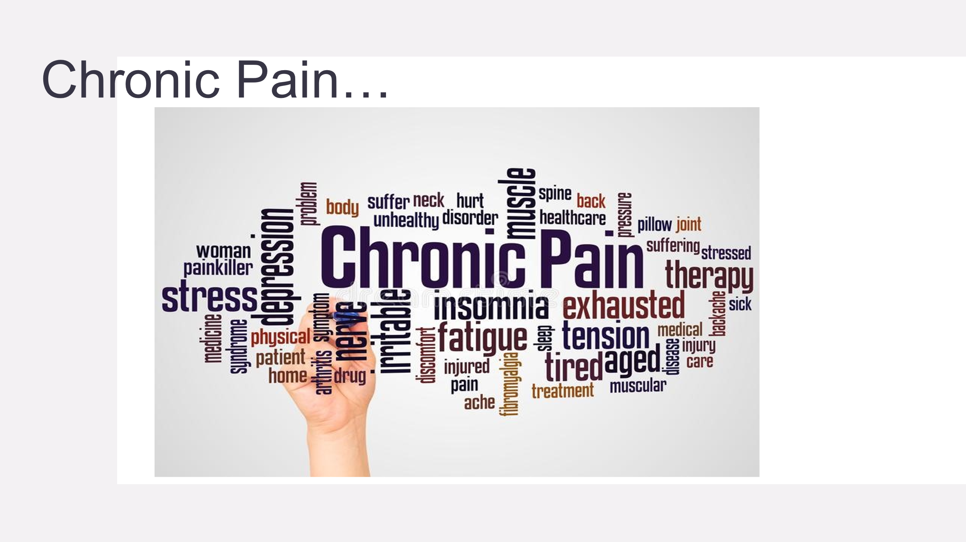
Physical and emotional suffering are very closely intertwined. So what are we going to do? There are physical interventions: drugs, nerve blocks and other injections, acupuncture; physio, exercise and getting people to move; there is psychotherapy, CBT, acceptance and commitment therapy (ACT). Then there is the group work – the idea of the group as a healing device which I find fascinating - which aim to get people into a group, not just sitting around saying how awful they feel, ,but with some sort of activity like Betsan’s knitting groups, singing and gardening.

And of course my hobby-horse clinical hypnosis. Although this is not really accepted in the UK, it is in many countries all over the world. The BSACH is associated through the International Society for Hypnosis (ISH) with the European, American and Australian societies. And there are people all over the world using hypnosis for pain. There is a famous professor of anaesthesia in Belgium who uses hypnosis in place of general anaesthetic and also runs a pain clinic. You get pockets of people around those who have done hypnosis training who get hooked into it because they can see it really works.
There are two sorts of levels at which it cab used. It is all just talking but there is informal hypnosis which is just using language carefully; like getting your colleagues to stop saying ‘this is going to hurt’ or ‘sharp scratch’ which only make it hurt more and something like ‘I am going to make your tooth nice and numb’. Choosing words that are comforting rather than threatening This book
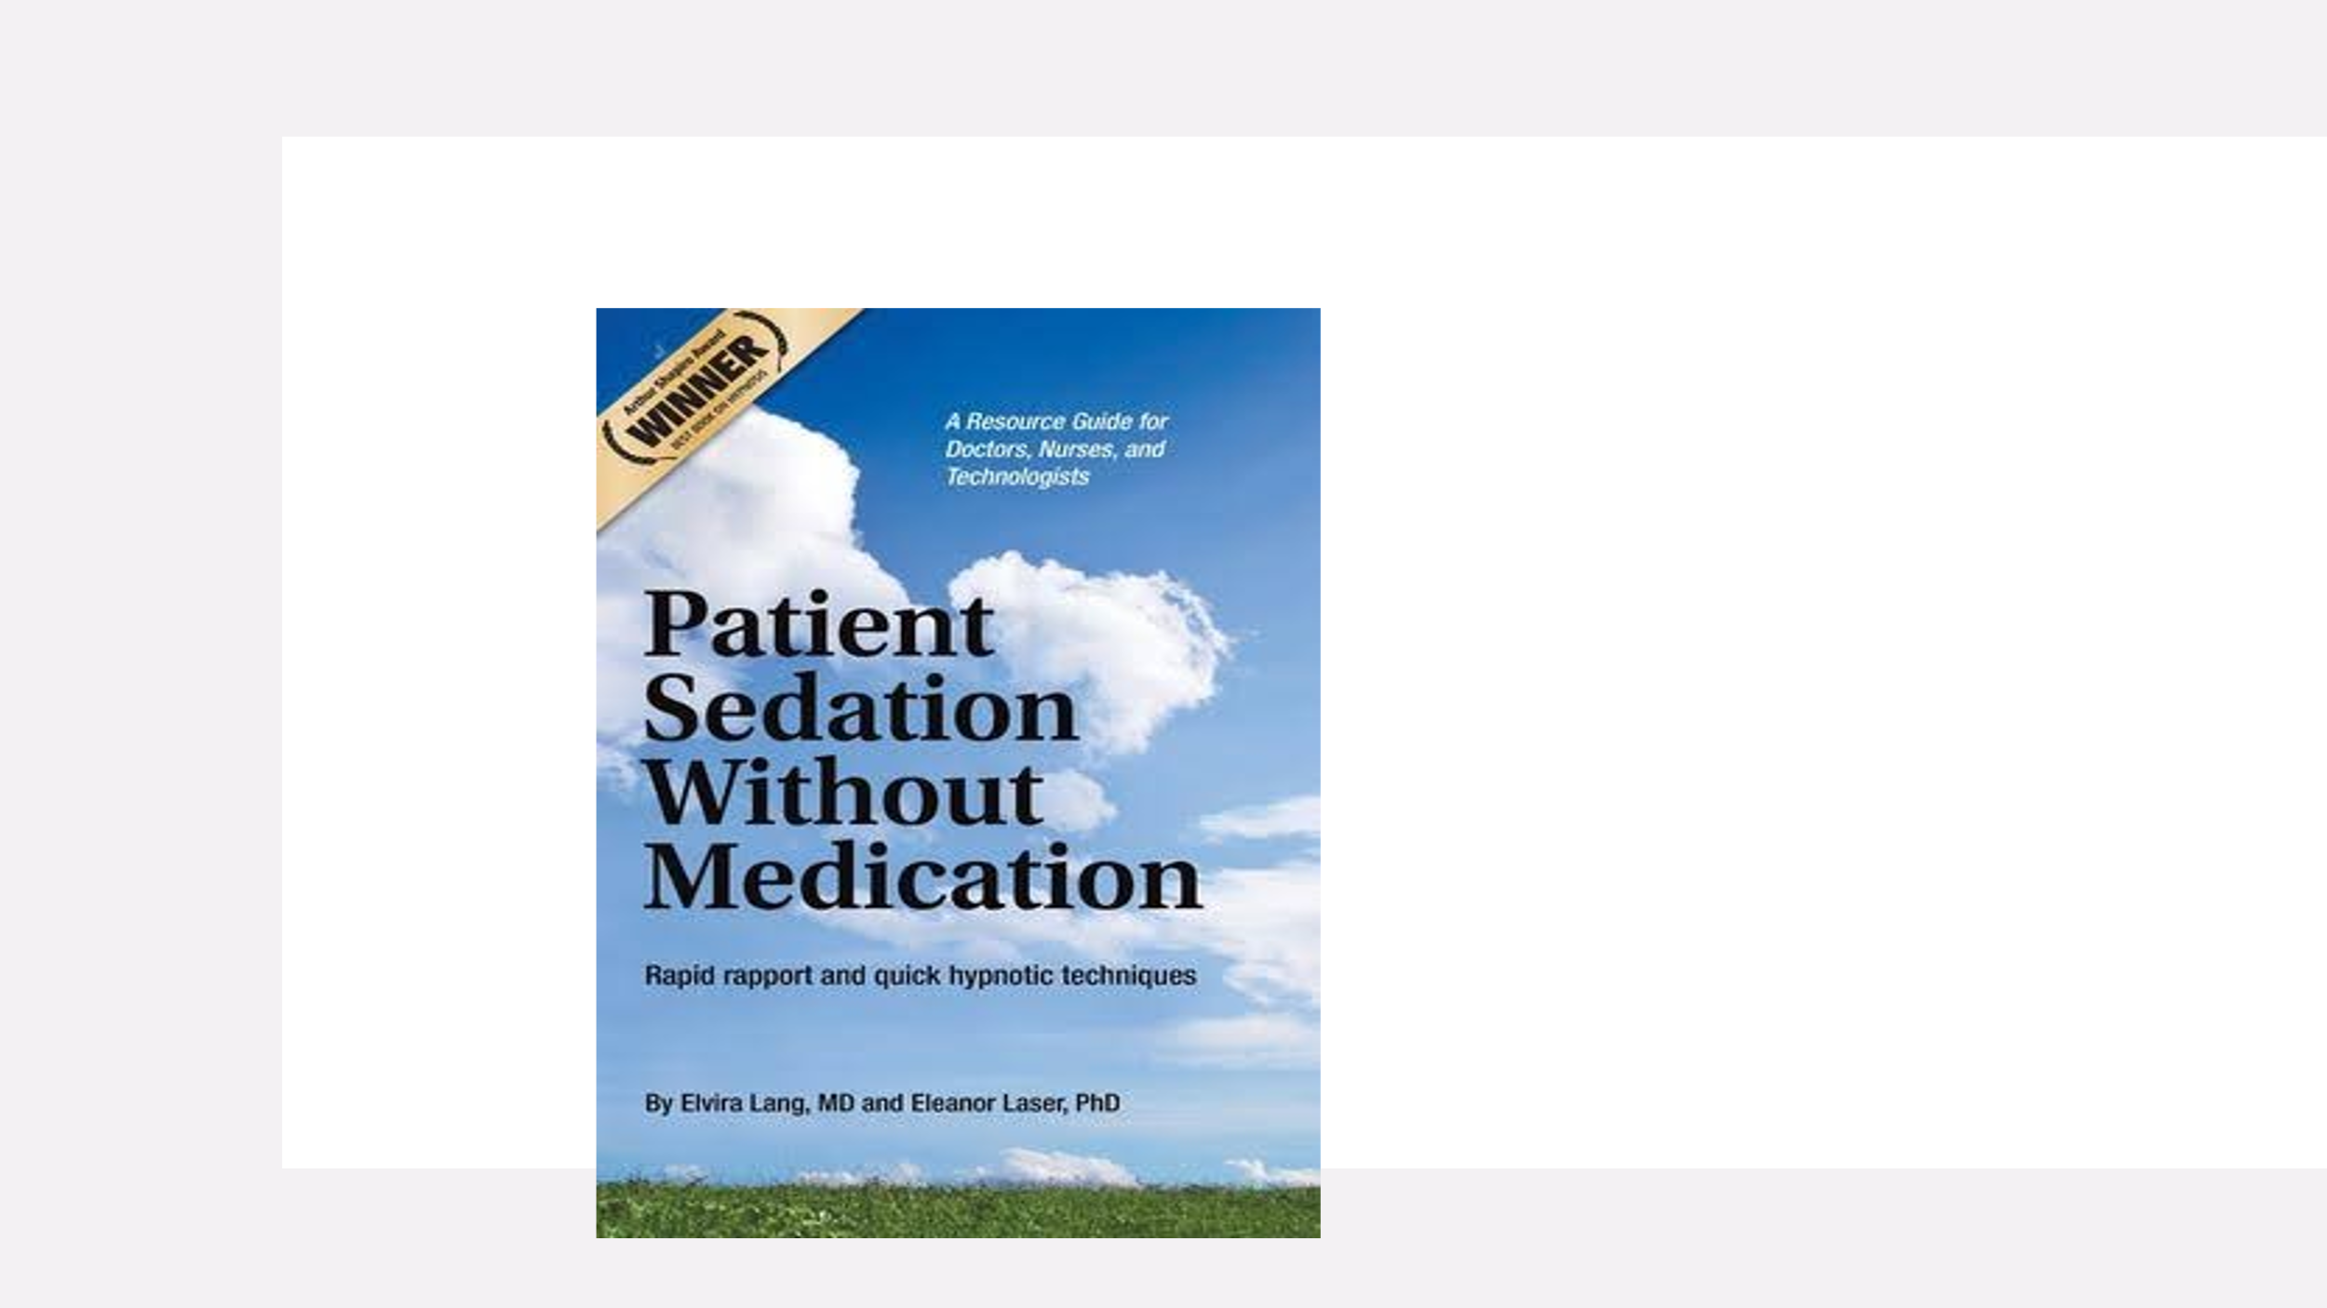
is by an American radiologist who worked out some techniques to help people who were so nervous they couldn’t keep still for the procedure, or tolerate the claustrophobic scanner, to calm down. They discovered that their hospital actually saved money because procedures weren’t being abandoned so often.

And then you have the more familiar formal hypnosis .This is really just using the language of the imagination; getting the patient to come up with something creative from within themselves. Everybody has creative powers that they are unaware of – often for all their lives hitherto – and can come up with some brilliant ideas. You will have often met people who use vivid imagery to describe their pain, like a knife, feet on fire, electric shocks etc. These are all metaphors which people have been kicking around in their minds and offer you.

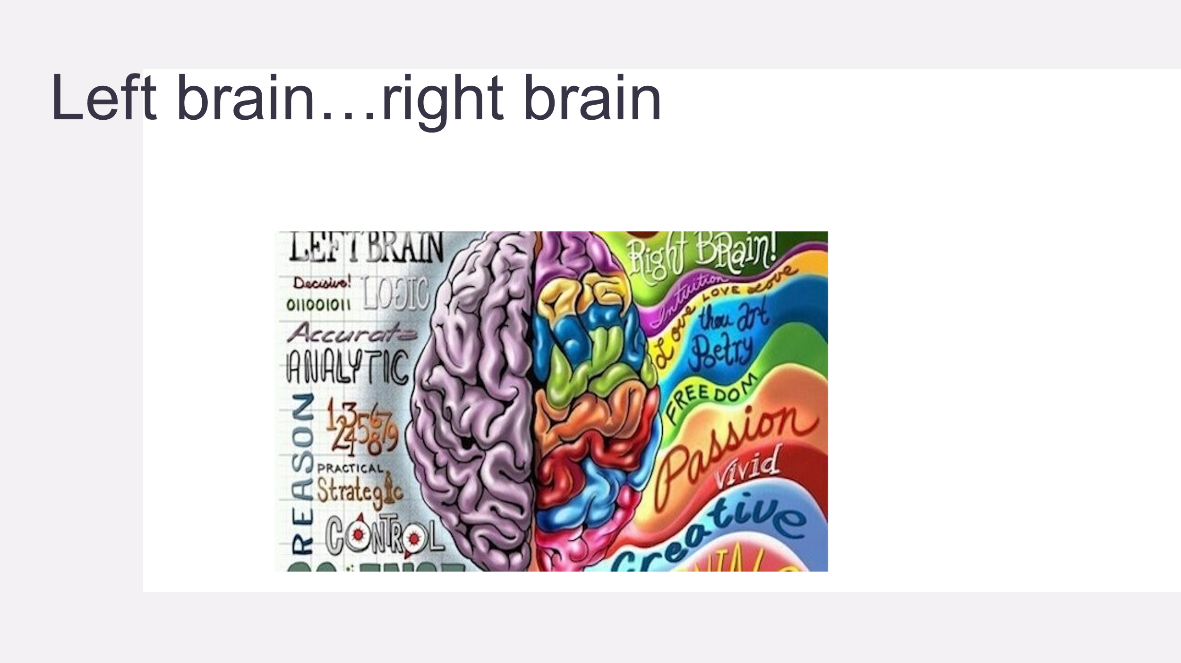 It’s not strictly a left-brain right-brain matter but this perception has come to strongly influence our thinking. In essence, the left brain is seen to be involved in analytical, critical, reasoning and logical mental activities, and the right is the creative brain involved in arts and music and where vivid imagery is created. We all have this but it is often neglected . What we are trying to do with hypnosis is to put the rational, critical mind to one side and unleash the creative mind. In fact it is thought to be even more powerful than the logical mind which we think of as being ‘up front’. But the creative mind knows no limits.

Hypnosis in practice

So when you are dealing with a patient with pain and going to invite them to a formal hypnosis session, you first have to establish rapport and trust. This of course applies to any clinical procedure. If someone doesn’t trust you nothing is going to work. So you have to do some rapport building; some people have weird and wonderful ideas about hypnosis and think you are going to take control of their mind and you may need to reassure them that this is absolutely not the case: they are going to be in control the whole time and they can walk out if they want to. There is another myth: you can’t get people under hypnosis to do or say anything they wouldn’t normally do or say. Stage hypnotists who get people to do silly things during their acts spend a lot of time before the show testing and selecting people in the audience who are exhibitionists and highly hypnotizable.
( About 5% of people are highly hypnotizable and about 5% can’t be hypnotized but the other 90% - most of us – can be hypnotized to a point which is clinically useful. They don’t need to be in a deep trance to get some benefit.)
Having explained all this I would then discuss the nature of their pain. When I first started doing this I thought if I asked them the colour of their pain and they would think I was bonkers, but nobody flickered - they would just say ‘oh – it’s red or black or whatever’ So you get as much info as you can: the temperature of the pain, freezing or hot; its texture, rock hard or spongy; how big is it and where in your body is it. Then I would write a list of all these things and say: “OK - so what does the colour have to change to in order to become more comfortable? (Not what would make it go away because that might not be possible.) I then write down the counter-characteristics: red to pink, hot to cool, rock to soft or mist, and so on. Then you ask ‘ what would be your perfect place? – where you would feel most relaxed? Which can be a garden or a beach or a mountain top It can be an imaginary place - I had one lady who wanted to be in a pink cloud! – or somewhere they have been, perhaps on holiday.

Changing the characteristics of the pain

So you get all that lined up before you begin. Then when a person is deeply relaxed and feels comfortable with you they are receptive to suggestions which must be something they feel they can control and are comfortable with. (I can’t teach you the whole thing as in BSCAH we only train health professionals. But there is lots you can read and there are courses for non-professionals) So I would then take them to their special place. I like to get as much detail about it as I can - is there a sun-lounger or an umbrella on your beach?- do you want to paddle in the water? - is it hot or pleasantly warm and things like that. You then walk them to their special place, lie them down on the sun-lounger …. and when you see their breathing slowing down and they look very calm you can start to talk about changing the characteristics of the pain. You could say something like: “I wonder how it would be if you noticed that the redness is changing a little bit ? or is going to change to a bit pinker? – and softer?” It’s all very permissive and not directive – you don’t say “now it’s going to change” – you use words like wondering and noticing and give them a lot of freedom to change their minds. So having changed the characteristics of the pain you might ask if it feels a bit more comfortable? Also you give them a lot of ego strengthening: suggestions that they feel more positive and stronger and lots of little encouraging words and noises. And then you make post – hypnotic suggestions like “when we have finished our session today and go home you will feel so much more comfortable than before ( you avoid saying pain-free) and from now on, every day you will feel calmer and more comfortable, stronger and more able to deal with things. You are giving them the suggestion that over the next few days and weeks things will continue to improve; it’s a dynamic process and you have set the wheels in motion and they will progress.
Then you wake them up. I usually count down from five to one and tell them when I reach one they will open their eyes and feel refreshed and comfortable

The pain dial

Instead of changing the characteristics of the pain, when they are relaxed and in their special place I might say “ I would like you to go into your mind and find the control room. And you may notice in there that there is a pain dial. And I want you to consider what it would be like if you turned it down a little bit.” You may have established beforehand that it was 9 so you suggest turning it down to 8 ½ or 7. (I had one guy who was very sceptical and said “ what would it be like if we turned it back up?!”) You encourage people to feel that it puts them in control. It can be a slider rather than a knob or something on a computer screen and something that ‘dims’ the pain.

Self hypnosis

While they are in trance you can suggest that they will be able to do their own self-hypnosis whenever they feel like it, and the more they practice the easier it becomes. As we know when people are tense and anxious pain is always worse, so you encourage them to practice at home – to find somewhere comfortable and spend a while relaxing on the beach or wherever. Having done all this you wake them up and send them off with the feeling that they are more in control – not you as some sort of authoritarian figure.

The anchor

The ‘anchor’ I often use is when patients are pleasantly relaxed in their special place is to ask them to touch together the tips of their fingers and thumbs and tell them that whenever they do this in the future they will feel as relaxed as they do now. So when they are worried or stressed they can use that anchor to bring back that feeling. And the more they practice that the more effective it becomes.
Another thing you can try is to ask them if there is a moment they would like to go back to when they felt the strongest and most in control ( I had one lad who said that was when her daughter graduated and she was all dressed up in a nice suit and hat ) and get them to remember all the details surrounding that moment - like a technicolour painting or video – and go back to the situation when they are in trance.

Cases

1 Phantom Hand Pain

This was a woman who was already very creative and worked on her own in a creative occupation, knitting garments. She suffered a partial amputation of her hand, so she couldn’t knit any more and had pain in the missing part of her hand. I asked her what would soothing of her pain be like? She said: “it would be like a cool blue liquid coming out of the crown of my head and pouring down my body including the missing bit of my hand, which is both soothing and healing” So I got her into a trance state and practiced this. I think we had about five or six sessions and she was able to reduce her medication and go on to a completely different career.

2. Severe sciatic pain.

The patient - a male – said it was like sparks going off in the nerves which were criss-crossing one another down his leg which was excruciatingly painful. I asked him – what would have to happen to make that less unpleasant? He had previously had a painful ulcer on his leg and the most soothing thing was when the nurse came round and stroked the ulcer with a cotton wool ball soaked in saline to clean it. So in the trance he got an imaginary cottonwool ball soaked in the healing liquid and smoothed out the wires. As the healing took place the wires got straighter and stopped sparking as they were insulated and no longer bare.

3 Tension headache

This is often described as a tight band round the head. So I would ask what it would be like to loosen the band? – or remove it so the muscles of the head became nice and soft. You can give them an anchor and when the band starts to tighten you can loosen them with that little trick.

4 Difficulty with visual imagination – an alternative

I had one lady who couldn’t come up with anything but who said: “I can think in colours” and her soothing colour was orange. When she was in trance a lovely orange light would envelope her whole bod from her feet upwards. I would just leave her for a few minutes enjoying the soothing healing sensation. She used it a lot; she had a very grumpy father who she used to cook meals for and before she went into his house she would surround herself with orange light she could remain calm with him however annoying he was.

5 Dental phobia

One lady hadn’t been to the dentist for 25 years. We did the finger and thumb tip anchor which she used successfully to overcome her fear

6 Psoriasis

One guy had a torso which was completely covered in this terrible rash: plaques on the skin which are itchy and peel off. He had experienced a lot of stress and there is evidence that the condition is stress related. His special place was lying on a lakeside with mountains and blue sky in the background. I asked him what healing would be like for him and he said this would be a blue fleecy dressing-gown coming down from the sky which enveloped him in a magical way. We had about six or seven sessions and his skin did heal up.

7 Post-herpetic neuralgia

One lady with this would walk onto a beach, lie down and turn the colour of her pain from red to pink. reduce the dimension of her pain (which was all the way round her right flank) and allowed it to go from rock hard to kind of misty. This enabled her to reduce her medication quite dramatically although it took a while and a few goes because she had had it for ages.

The BSACH and training in hypnotherapy

If you are a health professional and interested in learning what the BSCAH has to offer you, you can find the website BSCAH - Search (bing.com) . The email for the secretary is natoffice@bscah.co.uk . If you want to do the training you can do it in three online modules over three weekends. You can also do the Advanced Diploma in Professional Studies (BSC level) course which is part time over a year and involves nine days of tuition both online and face to face.

Discussion

When you hypnotize a patient and they have pain in more than one area would you do that in more than one session or concentrate on one thing at a time ?

You don’t want to make the session too long and complicated as you need the unconscious mind which is doing the work to grasp the thing. What sort of thing were you thinking of?

Actually I am a dentist and I have found this really useful so I can do the treatments for them. But I am looking to help a lady who has issues with chronic pain – headaches and stuff like that. She also wants to stop smoking and grinding her teeth. You wouldn’t want to try to deal with all three of those …

… no – better to split them up and deal with the headache first – keep it simple. …

…I’ve never thought about the shape and colour of pain …

… people know immediately what the colour is …

What do you mean when you talk about post-hypnotic suggestion?

Towards the end of the session when you have done the pain reduction and shrinking etc you might say something like “every day that goes by you will find yourself becoming more calm and more at ease with and confident in yourself. Everything will seem to become easier and you will feel stronger both physically and emotionally. We call this ego strengthening; you have to make them feel confident that they can do this work and manage their pain and their sense of themselves better.

So it’s all about the words you use. But can it be enough to use the breath as an anchor ?

You can do that and I used to do it – just take a deep breath and let it our slowly and you will find yourself in your special place. I had one patient who was so good at that she found it distracting when she was in the middle of doing something! But you need something that is not too obvious when you are at a bus stop or somewhere …

Would you take someone back to a time when they had less pain?

I wouldn’t use the word pain at all unless you have to apart from the ‘pain dial’. I would only use positive words like more comfortable and calmer. Otherwise the unconscious mind will only hear ‘pain’ and ‘stress’.

Regarding language like ‘sharp scratch’; I did end up as a patient in a pain clinic many years ago, having broken a lower rib when I was eight months pregnant which was extremely painful and they took me in to give me an injection into the fracture site because I didn’t want to take any medication. As I was leaving the room the consultant said : “Mrs Corkhill - if tonight you wake up in the middle of the night and can’t sleep don’t panic!” …

… Laughter! …

You only say ‘ a big prick with a needle’ once because the patient can say “I know you are but what are you going to do with it?!”
Thinking about the patients I presented last time, where we found a lot of trauma, much of which hadn’t been explored: I used some hypnotic techniques that I had trained for with BSCAH. I found this extremely helpful, not so much for the actual sessions – it is difficult in my clinic to set aside time for these – but just to understand the way language works as you have been saying. Sometimes outside of hypnosis you can still use hypnotic language. For instance when arranging a follow up appointment I may say something like ‘ by the time we meet again I think you are going to feel better’ - putting a positive spin on things. This also informs the way I run the clinic. When I was doing anaesthetics, I realised that I could organise the anaesthetic room before I started in a way that was to be relaxing and inspired confidence. In the hypnosis courses I have done the clinicians who seem to be good at it are all very confident and instil sense of control.

It is a way of speaking: slow, a bit ponderous , not your usual conversational chat – you leave little gaps …
As regards trauma: there is another device you can use if a patient reports a traumatic event: you can get your patient into a nice relaxed state and say “ now I want you see your life laid out on a line with the future over here and the past over there; and now float above yourself and take yourself back over the years to the time when this event happened and if necessary go higher so you are separated from it; and you can now look down and see your younger self going through it. Then you who are older and wiser can speak to your younger self and give them comfort and reassurance that they are going to recover; and if it seems safe and they aren’t distressed to let them go down and hug their young self …

I have concerns: if it is a specific event or a series of events it can involve a traumatic ….

…. You have to be very careful and if there is any distress or risk you don’t let them go down. But it can be no longer a mysterious bad thing that has happened and they have more control over and understanding of their child self.

In some ways it is similar to the EMDR we heard about recently where you can revisit trauma and get more comfortable with thinking about something that has been put on one side.

Has anyone else used hypnosis or done the training?

I have done the postgraduate certificate I use it a lot in radiotherapy and find it really helpful. A lot of my patients struggle with procedures and claustrophobia. I also use it for pain and secretion management.

It can be used a lot for procedures such as CT scans. The only thing we used to have was Valium and we got patients sent back because they couldn’t tolerate the anxiety which was a waste of resources which hypnosis could save - as the author of Patient Sedation without Medication, which I mentioned earlier attested. Eamonn Coveney, (who spoke at our 2016 meeting) who is a surgeon in Bury St Edmonds, uses it a lot, particularly for side effects from chemotherapy, for which he gave them the suggestion that these would be minimal.

I am a mental health nurse and a member of BASCH. I work every Thursday as a volunteer in a hospice where I have started using it for pain management with a moderate degree of success. I use a script by Mark Jensen which my supervisor in which the language is very positive and geared towards comfort and the ability to ignore unwanted sensations. I would endorse your recommendation to avoid referring to pain at all. The first time I used this script was with a gentleman who was in considerable pain with his arthritis unconnected with what he had come to me for. I prefer to use my own language as I like to keep an eye on the patient but on this occasion I read it out to him when I had him in a nice trance state and when he came out of it he almost bounded out of the chair and was completely healed of his pain. He asked me if I were a wizard or something! I said no, you have done it yourself and I have just acted as your satnav to your inner resources. And that is what I say to all my patients.

I had a patient with a fear of side effects from chemo and was very nervous about going for it. She visualised the chemo as a sort of net that would capture all the cancer cells. I got a recording on her phone that she could use later for reinforcement and play this on the way to the hospital for her chemo. She had no SEs from her first three visits so didn’t use it for the fourth after which she was very sick! There is a lot of placebo associated with these techniques which is fine.
But as regards reading a script: I was so nervous when I started doing this that I would say the wrong thing or leave something out that I would prepare a script from my books and lectures. But as you gain confidence, using your own words is more natural and more meaningful for the patient …

… I have used the script on several patients as a standardised method on several patients so I could report back my results to my multidisciplinary team who are generally positive about it.

In her book Patient Sedation without Medication , Elvira Lang describes a woman going for a breast biopsy and as they hadn’t got a trained hypnotist, the nurse the assisting was just reading an A4 sheet as she was handing the instruments, which worked very well. She was lying face down and the nurse said when I put my hand on your back you will feel ten times more relaxed and comfortable. It was also suggested that when the LA wears off it will still be comfortable and heal very quickly. You can indeed influence recovery time and physical healing

… I have used it in the hospice where it is well accepted. (They are also happy with complementary medicine.) I use the Dave Elman induction technique which is extremely quick and you can have somebody in a trance in two or three minutes

If you are working in an institution like a hospice you already have credibility and you have already built-in trust and belief . They may not believe it is going to work – a lot of patients come out of trance saying they didn’t believe it was going to work but it has - but they do need to trust you.

The patient you described with chronic pain that you asked what it is like and how they want it to be … [Inaudible] …

I talked about this beforehand; it’s easier if you know what they are going to do but when they are in trance they may change it. So you keep the language fairly loose

How much progress are you making with popularising hypnosis? What are the hurdles to be overcome?

‘Rolling the boulder up the hill’ kind of thing. Last Monday we had a joint session with the hypnosis section of the RSM and the anaesthesia section which was very interesting because we now have groups of anaesthetists requesting training. Anaesthetists seem to be much more open to it. The Royal College of psychiatry also have a handout on it. Although the word ‘hypnosis’ carries so much baggage like stage hypnosis, if we ditch it people wouldn’t be able to able to look up all the research . But in Vera Lang’s book she has ditched the word altogether and calls it ‘comfort talk’. But studies have shown that the word hypnosis is more powerful as it has a mystique about it which brings a bit of belief.

Could hypnotherapy be a better word?
In the BSCAH we don’t call it hypnotherapy because it is an adjunct – so if you are a psychiatrist or a pain clinician you can add it as a tool to what you do every day. ‘Hypnotherapy’ implies that you are going to do some proper full-on psychotherapy. You can do that but we are a bit worried about people who are not fully qualified going off-piste and doing in-depth interventions which is probably best avoided as it can be very damaging

Is it taught in medical schools?

No, but the dentists … there is a dentist in Bristol who teaches it to his dental students.
Sometimes you can get away with it if you call it communication skills and teaching people not to make people feel worse by the bad use of language and metaphor.

[partly inaudible] … I tried … with a young patient with awful long-standing back pain and multiple surgeries … her pain completely went but she went completely numb below her waist and she was horrified that she couldn’t feel her legs …

What was your suggestion?

I was using the pain dial to turn it down and unfortunately it changed the nature of her relationships. She was not relieved that the pain had gone. She was however able to walk (she had previously been a part time wheelchair user) . This rather threw me! I was using her as a case study in my training. The numbness did wear off …

In that sort of situation you have to spiel a bit – and say something like ‘that’s really amazing – this is obviously something you are really good at! Over the next few hours the sensation will come back to normal and you will still be much more comfortable …’

It’s interesting , the metaphors that people come up with. There was a boy who was very traumatised and dysfyunctional who told his therapist that he felt as if he was chained to a great big boulder and dragging it around with him all the time. So the therapist said ‘I wonder what it would be like if we cut the chain off you?’ That worked - but he didn’t really know what the boulder represented to the boy because he hadn’t heard the whole story. But if you can visualise and experience relief, as in loosening a band round the head etc it’s amazing what the mind will take on.

This story reminded about an experience I had when a colleague asked me to practice hypnosis on her and I gave her suggestions about tingling in her extremities which might start to feel a little numb. I put her into trance and when I took her out – she was a very good subject – she said ‘ I feel wonderful but I can’t feel my legs!’ So I said ‘don ‘t worry - I will just re-hypnotise you and give you the feeling back’ – and that seemed to do the trick.

When I retired more than twenty years ago I considered taking up hypnosis but at the time the only training available involved a lot of travelling and being away from home and as my late wife was ill I couldn’t do that. I wonder if other people have found that a barrier?

It’ nearly all on-line now. If you are a health-professional you can do three modules. With Zoom you can have ‘breakout rooms’: You have 15 people in the class and five tutors, so you can have three people on the screen to try out the techniques on one another. It works much better than we thought it would. Indeed most of the therapy is online now.

I have also done the NLP course* which was quite eye-opening
I quite like NLP. It is quick. I think it was a spin-off from hypnosis.

*Neuro-linguistic programming - Wikipedia - a somewhat sceptical article! – it calls it ‘pseudo-scientific’ ed.
Has anyone else done the training ?

I have, but wasn’t able to pursue it at the time because our practice was in melt-down and my partners wouldn’t let me do it….

….Mine wouldn’t let me do it except in my own time …

I was on a Zoom with the ISACH (international) recently. It is the same thing in a lot of other countries although there are pockets – one at Liege where the professor of anaesthetics Marie-Elisabeth Faymonville has produced some interesting videos online. One is of patients having thyroid surgery and she is just talking ! They use a bit of local and hypnosis. Eamonn Coveney who I mentioned earlier used it successfully on a patient with an incarcerated hernia who was unfit for GA even though he had to open the abdomen to resect ischaemic bowel. And he has used it for mastectomy with minimal LA.

Thirty years ago I saw acupuncture used in China for thyroid surgery. They first showed the patient that when the needles were inserted the skin goes numb, so they are conditioned before starting surgery. I think this may be a form of hypnosis. But a lot of surgery is not necessarily painful, as making an incision with a super-sharp scalpel - like you can cut our finger on a piece of broken glass when you are doing the washing up and not notice it. You are not aware if you are not focussed on that pain. The Chinese surgeons were very gentle; they said a surgeon needed ‘hands like fish’ .
If I go to the dentist it is the thought of the injection or the bone crunching … What we are doing is using language … if we were to tell someone ‘We are just going to saw or wrench the bone’ - or something similarly provocative – the pain would be much higher . what we are doing with hypnosis is the opposite so it’s no surprise that it works

That reminds me of the Kansas experiment where they trained paramedics to use a script when they are going to cut people out of crashed cars which said something like ‘we’re here now, you don’t have to do anything, the worst is over, the hospital is getting ready to receive you, we’re deal with everything’. And apparently the bleeding decreased! And when they reviewed the cases over several months there were fewer complications, shorter hospital stays etc. They are also doing it in Budapest. There is a book about it: ‘The Worst is Over.’

Tim is absolutely right about the kind of language that clinicians use when they are doing surgical procedures and the patient can hear them. For example pacemakers: I know a few people who found having a pacemaker fitted who found the experience very traumatising. These include my mother when the person doing it had a trainee with them and was explaining exactly what they were doing: “this vessel is a bit too narrow to put a wire down and we are going to have to … etc.” Even though she was sedated she could hear it all.

You should have thought it was common sense. I had a bit of a set to with an anaesthetist at a hypnosis conference who said she would tell patients before procedures how much discomfort to expect. I said that’s only going to make it worse but she said you have to do it; it’s deceptive if you don’t explain everything. But you don’t have to say I’m going to stick a big needle in your hand.

Jonathan – have you been using it in General Practice?

I have used it to help people stop smoking but there are loads of people with FM and the like who are on gabapentinoids and morphine – how do we help them? What about group therapy?

I’ve never tried it and it has to be tailored to the individual, but they do do it in antenatal classes to help people to be really relaxed during labour. I hear they have to warn people to tell the midwife that you might not look distressed and they might not think you were as far on as you are!

I had another lady who was very reluctant to have the chemotherapy she badly needed and her visual was to see that the drip back had millions of minions* [ film cartoon characters] on skateboards who would come down the tubing into her bloodstream and puncture any unwanted cells. She was worried about her hair coming out so on her own she visualised other minions who would go into her hair follicles and protect them. And her hair didn’t fall out!
Some books recommend visualising commandoes fighting the cancer but it doesn’t have to be a battle

Points from chat:

The secret of self-management (for me) has always been… agency, the opposite of having someone ‘DO” something to or for me or give me the benefit of their expertise!

You don't have to do the course to join BASCH

*https://en.wikipedia.org/wiki/Minions_(film)

