

Special Interest Group for Philosophy and Ethics

A miscellany of points of view on chronic pain, its causes and management

Rydal Hall, June 2022



Introduction

The Special Interest Group for Philosophy and Ethics has been holding residential meetings every summer for more than twenty years, only to be interrupted in 2019 by the Covid epidemic. So last year it was a particular delight to be able to get together again last June at Rydal Hall in the Lake District. The meeting was gratifyingly well attended both with long-standing members and, perhaps more importantly, with new people, which bodes very well for the present and future health of the group.
There were several themes this year including the contribution of philosophy and philosophers to our understanding of pain and suffering, ( returning to our original intentions from which we have often strayed into more practical and clinical matters), the association of chronic pain with poverty and deprivation and the uses and misuses of metaphor in our intercourse with patients
We were particularly delighted to welcome among our speakers two General Practitioners and one researcher into GP’s attitudes to patients with chronic pain. We have long been aware of the reality that sufferers are looked after most of the time – and for much of their lives - by their GPs. Pain management takes place, overwhelmingly, in general practice. We have been long aware of the importance of recruiting GPs into our group and indeed the BPS, so this is a very welcome development. We were also joined by patients bringing a first-hand perspective on the experience of chronic pain and suffering, and, sadly, of the unhelpful attitudes of some health practitioners.

The recording of this year's meeting was incomplete., so the following is a compilation of the surviving recording and material sent me by the speakers after the meeting.

Contents

Summaries p 4

Tai Chi Movements for Wellbeing; creating a space for healing p 7
Betsan Corkhill

A philosopher’s view of Pain and Suffering p 25
Jennifer Corms

Pains that don’t hurt. p 36
David Bain

Pain and Poverty p 46
James Matheson

Understanding Others p 68
Metaphor and its Use in medicine
Peter Dorward

What does Chronic Pain mean to GP’s? p 70
Tamar Wildwing

‘Understanding Pain a Complex World’ : Think outside the box
Dr David Bain MA DPhil: Pain and Painfulness

Head of Philosophy at Glasgow University. Dr Bain taught previously at Oxford, Bristol, and Nottingham universities, after taking his BA and DPhil at Oxford, either side of an MA at Chapel Hill. Interested in all aspects of philosophy, his research is mainly in philosophy of mind. David’s current work focuses on what he calls pain’s “hedomotive character”: its unpleasantness, in virtue of which pain is bad, sometimes awful; and its motivational force, in virtue of which pain can be good, indeed life-saving. He is interested in the nature of these features and the relations between them. Hedonic tone -- pleasure as well as pain -- and its normative and motivational significance interest him in other cases too, e.g. smell, taste, touch, and our emotional lives. He headed up ’The Pain Project’ and the Value of Suffering Project (VOS), both funded by a grant from the John Templeton Foundation. These were large, international, and interdisciplinary research projects investigating the nature, role, and value of pain, suffering, and affective experience more generally. Their core teams comprised philosophers, neuroscientists, psychologists, and clinicians, based in Scotland, France, Norway, and the United States.

Dr Jennifer Corns: The Need for an Updated Epistemology of Pain

Our epistemology of pain is our theory of knowledge about pain--both our own pain and the pain of others. As this matters both practically and theoretically, it is surprising that it has received scant attention. In this talk, I illustrate the need for an updated epistemology of pain by considering issues such as whether we can be wrong about our pain; whether we ever can or should ever be corrected about our pain; and how we should understand the nature of pain in order to best understand and respond to people telling us about it.
Dr. Jennifer Corns is Senior Lecturer in Philosophy at the University of Glasgow. Her published research focuses on pain, affect, suffering, and death. She is the author of The Complex Reality of Pain (Routledge, 2020); editor of The Routledge Handbook of the Philosophy of Pain (Routledge, 2017); and co-editor of Philosophy of Pain: Unpleasantness, Emotion and Deviance (Routledge, 2018) and Philosophy of Suffering: Metaphysics, Value, and Normativity (Routledge, 2020).

Betsan Corkhill: 'Tai Chi - Creating a Space for Healing’

Betsan is a Wellbeing Coach specialising in helping people with long-term medical conditions, particularly pain. She has an extensive background in health and physiotherapy. Her many years of clinical experience enable her to combine coaching with her medical knowledge to help individuals improve their health and wellbeing.
She is a passionate advocate for a whole-person approach to health for managing day-to-day stress and life's inevitable challenges through to managing ill health.
Feeling dissatisfied with the language used in more traditional ‘Pain Management’ and treatment approaches she was successful in obtaining funding to design and run her own ‘Wellbeing for People with Pain’ programme. She has found that even subtle changes in the language used in communications with clients can have dramatic outcomes even in those with the most complex issues
Most, if not all those who seek our help with long term pain and conditions such as ME/CFS, Long Covid, are in a state of stress or distress which is not conducive to healing. So how can we help them create a state that optimises the potential for healing? Should this be our primary focus?
I will focus on a particular Tai Chi practice called Tai Chi Movements for Wellbeing (TMW), created by Clinical Psychologist Dr David Quinn and Tai Chi Master Richard Farmer. Recognising that mind and body are intrinsically connected, TMW is a rhythmic, embodied sequence designed with the specific purpose of improving mind/body wellbeing, potentially creating a space in which healing can happen. To add depth and full value, participants are also taught how the Principles and Core Understandings of Tai Chi can be transferred into everyday life to create a catalyst for lasting change.

Dr Peter Dorward : ‘The Use of Metaphor for Empathy and Healing’: a participatory workshop

I am a GP and medical educator based in Edinburgh. I have an interest in medical philosophy, and teach, and run workshops in the subject nationally and internationally. I am the author of ’The Human Kind’ published in 2018 by Bloomsbury

Workshop: In medicine we constantly must seek to explain what can seem inexplicable. So: ‘Why am I disabled by pain, when all the tests are normal?’ The success or failure of our interventions rest on how we describe them— the words we use, and the metaphors we employ. But that’s not something that we seem to discuss very much.

This practical, interactive workshop is an opportunity to explore and share our best and worst explanatory metaphors, ask why sometimes they can fly, and why sometimes they can fly... into the ground. (To use a metaphor.)

Dr Maureen Tilford: Pain Etc

Maureen is a former GP with an interest in mental health and pain management. She used hypnosis along with other interventions for pain as well as other problems such as anxiety.
Her talk will be based on some of her own cases and ideas as well as those of others such as Dr Monty Lyman who wrote ‘The Painful Truth’ and Jo Marchant author of ‘Cure’

Dr James Matheson: Pain and Poverty

I am a GP who is passionate about social justice and the issues around chronic pain. I have just started working again in Cumbria, where I trained, having spent the last 5 years working with Hope Citadel Healthcare, providing primary care in disadvantaged areas in Greater Manchester, and the Shared Health Foundation and Focused Care community interest companies, which seek to reduce the impact of poverty on health and work with our patients and households with the most complex needs. I am very interested in medical education and training and working alongside our patients to support them towards better health and well-being.
This talk will look at chronic pain and prescribing around pain as a matter of social justice. It will examine inequalities in the populations of people suffering with pain, differences in medication prescribing and the unequal distribution of harms which may result. I will include case studies from general practice and the voice of patient experience. I will then introduce some contrasting approaches to managing medications for pain and hope that we will then have an interesting, challenging and productive discussion around how these issues might be addressed.

Genevieve Roulin : Body and Mind: Pain as Memory of the Past

Dr Roulin is an anaesthetist attached to Bergen University hospital and is mainly based at the women´s hospital.
Previously, she worked in the pain clinic, dealing with the treatment-resistant pain (the "difficult" patient) . Over time we noticed that many of these patients have the same profile: there is a long history of pain and it is always the same pain. Patients have been extensively investigated by various physicians but without diagnosis or benefit. The different treatments offered were not helpful. They also often have sleep disorders and are unable to relax. They do not succeed in life and when they do, it costs them considerable effort.
Over time we noticed that many of them had been exposed to adverse life events and concluded that their pain is the consequence of psychotrauma.

Tamar Wildwing: ‘What Does Chronic Pain mean to GPs?’
Tamar is a registered Learning Disabilities nurse who worked in long-stay hospitals and Assessment and Treatment units for 15 years before moving to community services for all people with long-term conditions, in particular in the initial roll-out of Personal Health Budgets. She then worked as a project manager within a CCG, commissioning community services including mental health, end of life and pain services. She is now in her final year of her PhD, exploring GPs' perceptions of their role in supporting people with chronic pain, whilst managing a worsening chronic pain condition herself. Although her condition has a diagnosis, is a named condition (hEDS), she was typical of most people with the condition, and was undiagnosed and misdiagnosed for 20 years. This contributed to her interest in the experience of people lacking a diagnosis for their pain, and the experience and frustrations of the healthcare professionals who support them. Tamar is a PhD student investigating GP’s perceptions of their role in supporting people with chronic pain
Dr Peter Gorman: Have we made any progress towards changing the culture of pain medicine?
Peter is a retired anaesthetist who has worked extensively in the field of pain. He is a founder member of the Philosophy and Ethics Special Interest Group.
At our 2013 meeting at Launde Abbey our main speaker, John Loeser, identified a holistic culture of pain management established by its founders, which in the USA had been largely replaced by an interventional service dictated by the demands of insurance-dominated medicine. We agreed that for different reasons we were in some danger of going down the same road in the UK . We set ourselves the ambitious task of working towards the restoration of this culture. I propose this morning to ask the audience a series of questions designed to identify the components of the culture of pain medicine which are most essential, those which we are most in danger of losing and those for which there has been some progress in restoring, and the possible contribution of this group to this ambition.

Tai Chi Movements for Wellbeing; creating a space for healing

Betsan Corkhill

These are some of the thoughts I’ve been mulling over in my practice and teaching of Tai Chi Movements for Wellbeing.

Perhaps, rather surprisingly, my journey to this point began with my work into the therapeutic benefits of knitting. See my Knitting Equation below –

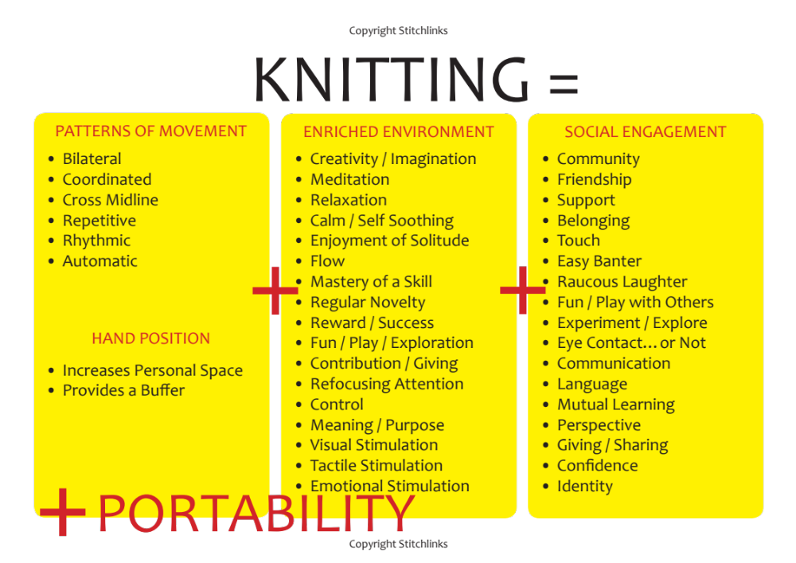

I’ve been researching the meditative, creative and social benefits of knitting since 2005 and within this developing the idea of therapeutic knitting. In my work with people living with long term health problems as a former physiotherapist and now as a Health and Wellbeing Coach, I’ve observed that those who struggle with long term health problems become somehow fractured / fragmented. Stories I’ve collected from knitters around the world told of how the rhythmic bodily movements helped calm the mind and were somehow ‘unifying’. The combination of rhythmic bodily movement, thought and feeling seemed to be important. I began to explore this more, and to look at body or bottom up approaches as a way of influencing the mind because it’s difficult to change the mind with the mind, particularly in a crisis. You can’t instruct your mind to RELAX! or CALM DOWN! but you may be able to facilitate change through the body.

My work into knitting led me to explore Tai Chi. Further motivation came from people attending my ‘Wellbeing for People with Pain’ programmes. We’d have a session on movement and the feedback would invariably be “We know it’s good to move but we don’t know how or where to start. How much to do. How to keep motivated?” It was felt that physiotherapists tended to focus on the body part that was painful in quite a mechanical way over a limited time frame, whilst personal trainers, through exercise referral programmes and gyms, in general, didn’t know about pain and started off too intensively and too fast causing a crash with increased pain, so the person living with pain often didn’t return. Of course, there are exceptions to this.

This all led me down the path of Tai Chi but that soon became a bit daunting as there are hundreds of thousands of different Tai Chi moves and it takes tens of years to become a Tai Chi Master. In 2019 I came across the Tai Chi Movements for Wellbeing (TMW) organisation based in Herefordshire and founded by Tai Chi Master, Richard Farmer, with his wife Marigold.
I trained as a TMW trainer in 2019 and now run regular classes. Most of those who attend my classes have some form of health issue. Many have mental health issues, most have pain, many have fibromyalgia, some live with ME/CFS, functional neurological disorder and more recently, long covid. I also run classes for the Carers Association. Carers carry a huge number of life’s loads, particularly over the last few years having had little to no support during the pandemic, and their own health is suffering. At the moment, all my classes are online, and it works well, particularly for those living with fatigue as they don’t have to exert precious energy getting to a venue.

The practice can be done standing, sitting, visualising or simply watching if they’re having a particularly challenging day. The structure of an hour long class is typically a movement sequence followed by a discussion about the Principles and Understandings of TMW and how they can be transferred into their everyday lives, then a closing sequence.

Tai Chi integrates body and mind. Body movements are coordinated with rhythmic, conscious breathing and multiple cognitive and emotional components, including focused attention, heightened self awareness, visualisation, imagery and intention.”
Peter Wayne – Assistant Professor of Medicine, Harvard Medical School

When I first began my practice of TMW I thought of this sequence as a collection of 12 moves that had been chosen for their simplicity, and then taught alongside the Principles and Core Understandings of TMW. However, the more I learn and teach it to people with a wide range of issues, the more I realise how deep the practice reaches and the depth of thought that went into choosing these particular moves out of hundreds of thousands. Although the moves are simple, they hold great meaning, and as a mind/body approach it’s complex. Teaching classes for people living with long covid, in particular, has taught me so much because I’m working with people who are newly (8-24months) complexly unwell.

At about the same time as I was investigating Tai Chi, I came across this statement from psychologist and founder of the Optimum Health Clinic, Dr Alex Howard.

You need to be in a state of healing in order to heal.

It had a profound effect on my thinking. It’s one of those statements that seems so obvious but I hadn’t properly considered before. Suffering from long-term illness is stressful for many reasons and it’s an even more stressful experience when it’s ‘medically unexplained’ as in pain, fibromyalgia, ME/CFS, long covid and functional neurological disorders. You’re afraid because you don’t know what’s wrong, why it’s wrong and whether you’ll ever feel better, let alone recover. In addition, there are the societal pressures such as poverty, poor housing, trying to live life on benefits and the discrimination that comes with it, to factor into the complex mix.
Most, if not all those who seek our help are in a state of stress or distress and are often stuck in this ‘ON’ state even when they don’t need to be. This is the opposite state to what is needed to heal and repair. These systems need to learn to slide again. We need a state of stress to survive. We also grow and adapt when under stress, but then those systems need to return to balance. It becomes a problem when that system gets stuck on ‘ON’.

When I came across Alex Howard’s statement I began asking if we were wasting our time using current methods of treatment in people who are stuck in as state of stress / distress? Should our first step be to help them find a state of healing? That state where balance, homeostasis and a parasympathetic calming response is dominant – a state where we are optimising the potential for healing. And if this isn’t possible because of their circumstances (the context), enabling them to find ‘moments of balance’ throughout a day where they experience ‘moments of calm and safety’, I suspect that any other treatment or medication we offer in addition will then work more effectively in this state.
I’ve also realised that it’s not about ‘trying hard’ or ‘pushing’, or ‘working hard’ at recovery. It’s about making or creating a space that optimises the potential for healing. It’s about putting measures in place to optimise the potential for healing and recovery.

TMV for long Covid

More recently I’ve been running TMW classes for people living with long covid. When we first met they talked about ‘trying hard’, ‘working hard at recovery’, so at first it was more about stopping them from pushing and trying hard to recover, to get back to their previous lives. It’s been more about slowing them down to create that space where healing can happen. If you’re trying hard you’re probably pushing yourself into a stressed state. One lady told me that she was now ‘trying softly’ and I like that idea.

“Nothing in the world is as soft and yielding as water. Yet for dissolving the hard and inflexible, nothing can surpass it. The soft overcomes the hard, the gentle overcomes the rigid.”
Lao Tzu

TMW is movement with softness, safety, fluidity, rhythm, calm, relaxation and intention.

Modern life encourages us to be hard, to push hard, to be bigger, better. TMW teaches us that less is more.
When an illness is invisible or poorly understood there is a lot of pressure from society to get back to work, to life. Individuals and groups within your immediate environment and on social media can be cruel, increasing the pressure to ‘get out there and do it’. We need to recognise as a society that we need to take the pressure off. Recovery needs us to create the right circumstances. It needs time, our respect, kindness, knowledge and support.

Give time, space and respect to convalescence if you can.

Dr Gavin Frances, Recovery

Post Exertional Malaise

I need to address the subject of Post Exertional Malaise (PEM) because the moment you mention any form of movement-based approach for long covid or ME/CFS it gets aggressively shouted down for being dangerous. And if it’s done in a Graded Exercise Therapy (GET) format where the intensity is increased in a fixed way over time or if the person isn’t listening to their body and responding to its needs in that moment. PEM is a very real problem that can severely limit what some people can do, both physically and mentally. I find it sad that, because of the fallout and harm experienced as a result of GET, feelings are running so high on this subject that it’s difficult to have a reasoned discussion about movement. All those attending my long covid classes are screened and referred appropriately.

A lady with longstanding ME/CFS who suffered harm through a GET approach has been attending my classes for several months. She practises TMW most days and says it is the only thing she’s been able to do without crashing and she is sticking at it. It’s truly wonderful to watch her moving with fluidity and flow. Recently she also told me, “I’m having moments where I feel healed.” When I asked what she meant by this she replied – “Moments where I feel whole, at peace, safe, where I’m not running on super high, where I’m at peace with being me.”

It’s about learning a new language of the body and listening to it with care.

Gavin Francis, GP and author

One lady with ME told me that TMW has shown her that she is constantly vigilant and “I don’t need to be because I’m not in constant danger.” This constant vigilance was reflected in her tight, tense posture, ready to run or fight at any moment. TMW teaches people to listen in to their bodies and to do what feels right for them in that moment. Just because you did it yesterday, doesn’t mean you’ll be able to do it today or improve on that. And that’s not only OK, it’s normal because normal life is up and down.

Soft limit

We also teach the concept of ‘Soft Limit’ which is life changing for many, including me. Soft Limit is the third Core Understanding of TMW which I’ll explain more fully later. When TMW is practised within Soft Limit it doesn’t trigger a crash. I think another explanation is that conventional exercise stresses the body so, when attempted from a position where your systems are already stuck in a stressed out state, it causes more problems. TMW’s gentle, rhythmic approach calms those systems through rhythmic movement and engendering a sense of safety. If energy levels are low then participants can visualise or watch and still benefit – it’s soothing to simply watch. We teach that it’s perfectly OK to do that and I encourage everyone to have a go at visualising from time to time for a different experience. I once had a class where everyone was visualising which was a bit strange!

The biggest problem we’ve encountered in long covid is recruitment. I’ve heard comments like “Can’t they see I’m ill?” “Is this all the NHS has to offer?” “I need proper treatment.” People are still stuck in the idea that the only ‘real’ treatment is medication and that the NHS needs to ‘do something to me’ or ‘give me something’. These are perfectly understandable feelings that we also come across in the world of pain and they need to be addressed with understanding on a wider scale.

This is what one person told me – “I remember going along to the long covid clinic and hoping for answers and for some sort of magic pill. It’s crazy really but I was so desperate and had felt so sick for so long, I came away feeling really disappointed. The doctor recommended TMW and I thought, what is this going to do for me? I was willing to try anything so agreed. It turns out that was a great decision on my part.”

There has been a big fallout affecting recruitment from the harm done by GET. This has become an ‘anti all movement-based’ approach which is very prominent on social media particularly on platforms such as Twitter. We do need to be able to have a reasoned discussion on the topic. We also need more clinical awareness of the benefits of an approach such as TMW and sufficient time to explain it during the clinical consultation. Most people seeking our help have multiple issues going on with their health and in their lives and clinicians just don’t have the time to explain ‘Why Tai Chi?’

A young woman with longstanding fibromyalgia and now long covid who has been on several pain management programmes over the years told me this – “TMW is one of the most useful life skills I have ever learnt.”

Principles and Understandings of TMV

People find TMW helpful as a movement sequence but get huge benefit across all aspects of their lives when they take the Principles and Core Understandings into their lives.
TMW is a 12-move sequence taken from the practices of Chi Kung and Tai Chi, and whilst being simple it still retains all the benefits of these practices. It can be taught purely as a movement class or to get the full value as an introductory six-week course that also teaches the Principles and Core Understandings which can be taken into the rest of your life. This is where you get the full value which can be a real catalyst for lasting change.
Following the initial six-week course, participants can attend ongoing classes which build on their practice and understanding. As I mentioned previously, the sequence can be done in standing, sitting, visualising or watching or a combination of these and we explain how to visualise effectively.

TMW has three Principles and four Core Understandings.

The first of these Understandings is ‘The body reflects the mind’. This is a recognition that the mind and body are intricately and intrinsically connected. An example, in simple terms, is if you are stressed it will be reflected in bodily tension, although the relationship is a lot more complex.

The second Core Understanding is – ‘Gestures have an atmosphere that make a difference’. This is a recognition that bodily movement changes the atmosphere of the mind. This becomes a circular, intertwined process of mind and body interacting and working together in a way that cannot be separated. I’ll mention the other two Understandings a little later.

The first Principle of TMW is ‘Embodied Presence’. This is a state where mind and body are in the same place at the same time. We use the sequence to bring people into this state in a gentle way. Learning to connect and live life from the present moment, directly encouraging the mind/body as a unified ‘whole’ into a healing state. This can be challenging for many particularly if they feel pain but I’m convinced it is THE foundation of the change that then begins to happen.

The reality is that most people live in their heads most of the time. I certainly did before I encountered TMW. This is particularly the case if you have unpleasant or painful bodily experiences. It immediately became evident in the long covid classes that people were turning their backs on their symptoms in an attempt to get on with life. They didn’t want to be ‘in their bodies’. There was a general recognition that they’d been doing this, as well as a general feeling of putting their life on hold until ‘I’m fixed’. One lady said – “I’ve realised my mind and body are disconnected, very far apart and I realise now that’s how I’ve been coping. Turning my back on pain, blocking it out. Coming back into my body has made me aware of it again but I don’t think turning my back on it will help in the longer term.” Another said, “TMW has made me realise I’ve been living outside my body in an attempt to escape the symptoms.”
We talk about how Embodied Presence can help them make the most of each present moment. Philosopher Havi Carel describes it as finding moments of wellness or wholeness within illness. We talk about finding safety, stability and feelings of wellness even within illness and adversity as a better option to putting life on hold. Nurturing a feeling of ‘In this moment, I am safe’.This approach of creating moments of wellness and safety also seems to work for people who carry a lot of life loads – for example poor environment, poverty, living with or caring for family who have mental health issues. I see a number of women who are caring for partners or children with serious mental health issues that cause constant ongoing stress. Covid, and problems in Social Care and mental health services, have increased their burdens and I really don’t know how they keep going.

“Pain is social. Pain is almost always worsened in those hurt by society: the lonely, the marginalised and the voiceless.”
Monty Lyman. The Painful Truth

I believe their pain is directly linked to what are unbearable life loads. This can be multigenerational. Some have elderly parents, partners, children and grandchildren with significant health problems. I would challenge anyone not to have pain or other health problems in the same situation. This will only get worse with the cost-of-living, health and Social Care crisis we are currently facing. We don’t achieve anything by filling these people with drugs and medicalising these issues.

Learning to find moments of safety and wellness in each day enables them to put those loads down for that moment; to find balance, safety, stability and, hopefully, healing in those moments. It’s not an answer to those life problems but it helps a bit and gives them a place of safety within themselves that no one can take away.

“TMW is not something I do, it’s a place I go to.”

Kangaroo Tail

TMW uses the concept of Kangaroo Tail to bring people into Embodied Presence. People are taught to take their attention to the base of their spine and visualise this extending down into the ground. This is your Kangaroo Tail. A kangaroo uses its tail to maintain balance. It’s strong and enables the kangaroo to sit on it even when all four limbs are off the ground. Even when all else is up in the air and chaotic around you, your kangaroo tail will support you and keep you safe, stable, grounded. People like this image and they like the idea of Kangaroo Tail which can also be visualised as anchoring them to bring their mind and body together in the same place at the same time. We learn to create a habit of finding your Kangaroo Tail by linking it to everyday activities such as boiling the kettle, cleaning teeth and you can eventually learn to live your life from this grounded, present space.
Participants have used it in many different circumstances – to ground and bring themselves into a state of Embodied Presence, to help with sleep when the mind is elsewhere, and, importantly, to cope with situations outside their control such as being in crowds or social situations when anxiety starts to rise. One lady uses it on her commute to work as covid had made her highly anxious on tube journeys. Another was experiencing frequent ‘tremor’ attacks which had been diagnosed as non-epileptic seizures. She was a previously fit young woman who suffered multiple complex health issues immediately post covid vaccination. She had one of these ‘attacks’ in an online TMW class. All four limbs were shaking and she became very distressed because she would sometimes also lose control of her bladder and bowels during these episodes. The first thing I had to do was find my own Kangaroo Tail because I immediately felt my mind going off into a whirl. I was able to talk her through using visualisation of her Kangaroo Tail, and the whole thing lasted less than a minute. The shaking stopped with this visualisation. Interestingly, and excitingly, since this episode she has been using her Kangaroo Tail a lot particularly when she feels her anxiety levels rising. When we last spoke she hadn’t had an attack of this nature since. This has transformed her life. Another young woman who has fibromyalgia and problems with wrist and hand weakness commented that she couldn’t open a jar – “I remembered my Kangaroo Tail, found it and things settled. Then somehow, I was able to open the pot. I felt more strength in my hand.”
I’m aware that ‘coming into your body’ can be difficult for people who have been through a traumatic experience. Coming face to face with the real state of your health and life can be challenging but it can uncover some important realisations. This lady told me – “I’m really not very well am I? This is the first time I’ve realised this. I really have to start being kind to myself. I need to slow down, to give myself time to recover.” This person regards this realisation as a positive one and as a result took the decision to stop trying to push through and to give herself time to recover.

TMW brings people into a state of Embodied Presence in a really gentle way through Kangaroo Tail as well as through the flow and rhythm of the simple moves. I say simple but only in terms of the actual moves. As a mind-body approach it works in complex ways. The flowing rhythmic movements soothe the process of coming into that embodied state. Kangaroo Tail takes them into an imaginary tail so those living with pain or past trauma find it easier. This has worked well in many different scenarios.
When a person begins to come back into their body they can experience an increase in symptoms. Those with long covid experienced this at first but then it eased off. I think this is because in this state of Embodied Presence, people are coming face to face with the real situation. This can be a shock. I think if you’re constantly trying to ignore your symptoms they eventually tend to shout louder. It also takes up a lot of energy so is exhausting.

“In order to get over a problem, it helps to look at it. You can’t climb a
Mountain that you pretend isn’t there.”
Matt Haig

In this state of Embodied Presence, you can make a true assessment of your situation and what you need to do to improve. Those who practice Tai Chi often talk about ‘coming home to yourself’.

The paper ‘An Embodied Predictive Processing Theory of Pain’¹ (Kiverstein, Kirchoff and Thacker 2022) proposes to explain pain in terms of processes distributed across the whole body from cell to whole. The authors theorise that the nervous, endocrine and immune systems function in a coordinated and coherent manner as a single complex adaptive system to maintain homeostasis. They refer to this system as the Neural-Endocrine-Immune (NEI) system. It captures some of the complexity but perhaps the danger of highlighting three systems in this way is that we will forget that these are always interacting with all other systems, those eco systems (eg gut biome) within us, in complex ways as well as our immediate environment and wider world. I was particularly struck by the following paragraph –

“If health is (in Gadamer’s words) a ‘condition of being involved, of being-in-the-world, of being together with one’s fellow human beings, of active rewarding engagement in one’s everyday tasks’, pain can be thought of as a disruption of this ‘being-in-the-world’. The result of such a disruption is that the world appears both threatening and alien to the subject.”

I’ve discussed this with people living with pain and long covid. They agreed that they no longer feel at home in their body or at home in the world. I think TMW is helping people to feel at home in their body as it is, but also to feel at home in the world as they are. The ‘as it is’ and ‘as they are’ are important.

“It’s OK to be me as I am.”

Over time you can learn to live life from this place of ‘as you are in the world as it is’.

Feeling safe

Feeling safe is fundamental to being in a healing place. However, I don’t believe you can think your way to a feeling of safety. You need to feel it. You need to experience it. TMW encourages feelings of safety in a few ways. In a state of Embodied Presence there is a natural relaxation and a feeling of calm, of being at home. A feeling of safety. Kangaroo Tail gives us a means of achieving this. When we are in a state of Embodied Presence, we can learn to find that safe space within us. Learning to find this safe space within us is important because it’s always there regardless of what chaos is going on around you. No one can take it away.
The sequence begins with hand rubbing as a way of bringing your attention to your hands and into your body. Then we place our hands over our eyes. Crucially when you are covering your eyes you are giving your systems a signal that all is safe in this moment. Initially, some people feel too unsafe in the world to do this but as we move through the weeks they are able to do so.The rhythmic movements of the sequence also enhance feelings of safety. Rhythmic movement is predictable. The brain likes things to be predictable. It makes it feel safe. The idea that you can find safety within yourself can have a profound effect on your life, whatever else is going on within it. It helps people deal with the uncertainty of life and fear.

“You can relish a rainbow and a cup of tea, sunrise and a flock of birds, a cemetery walk and a friend’s newborn, the first blush of wild flowers in a patch of dirt and the looping rapture of an old favourite song. You can’t tidy up the White House, but you can tidy up that neglected messy corner of your home: you can’t mend a world, but you can mend the hole in the polka-dot pocket of your favourite coat. They are not the same thing, but they are part of the same thing, which is all there is – life living itself through us, moment by moment, one broken beautiful thing at a time.”
Sophie Blackall, The Marginalian (Maria Popova)

It helps you realise that although you may not be able to fix the world around you, you can mend yourself moment by moment, bit by bit – they are part of the same thing.

Release and Flow.

The second Principle of TMW is that when you are in a state of Embodied Presence there is a natural relaxation. Movements become more graceful, they feel caressing, and you can see this happening as the quality of their movement becomes more flowing over the weeks.
The second Principle teaches self-kindness. In my classes we learn that self-kindness isn’t about sitting doing nothing with a box of chocolates, although on some days it might, in small doses. We talk of self-kindness as being proactive in your health and wellbeing. This is difficult for many living with health problems as their own health and wellbeing is often at the bottom of their priority list. We talk about putting it as their top priority. Talking to themselves as they would to a best friend. There is usually a general realisation that this is not something they naturally do, particularly if all their energies are going into caring for a partner or child. It’s interesting and wonderful to see their self-respect grow and the impact this has on their behaviour. One man told me “I’ve found I don’t want to put junk food into my body any more.” When your self-respect grows you are less likely to behave in a way that is detrimental to your health and wellbeing

“I’ve been sobbing all morning, so I painted my nails as a treat to myself.”
“I’ve stopped punishing myself. I’m learning to be kinder to myself.”

Returning to the sequence: after covering our eyes we move into a stroking or tapping element, encouraging them to listen in to their body and applying the pressure that’s needed in that moment. Listening in to their body and asking what do I need in this moment, today? Using stroking as an act of self kindness and compassion can be highly emotional. Stroking your head as if it is the head of someone you love with kindness and compassion emanating from the heart can be a powerful experience, particularly for those who rarely, if ever, experience the touch of another. Stroking the abdomen whilst taking thoughts to those organs and giving them thanks for keeping you alive can be a highly emotional moment. Most think of their body as ‘letting them down’ but this quiet act of thanks helps to change their perspective to one of realisation that actually ‘My body is doing its best to keep me alive.’

Tears

In classes for those living with long covid there have been a lot of tears and participants are encouraged to let them flow.

“It’s awakening all these emotions in me that I now realise I’ve been holding tight inside me.”

People recognise that they have been holding their emotions in tightly. One young woman told me “When I first started to practice TMW the tears flowed freely and I let them, where previously I would have tried to hold them in. Now I can do the sequence without tears.
I feel letting them flow was important.”

“Tears are the medium of our most primal language in moments as unrelenting as death, as basic as hunger and as complex as rites of passage. They are the evidence of our inner life overflowing its boundaries, spilling over into consciousness. Tears spontaneously release us to the possibility of realignment, reunion, catharsis, intractable resistance short-circuited…it’s as though each one of our tears carries a microcosm of the collective huma experience, like one drop of an ocean.”
Rose-Lynn Fisher, The Typography of Tears

We decided that allowing their tears to flow freely was an important, and often necessary part of their healing journey – “Tears are evidence of our inner life overflowing its boundaries spilling over into consciousness.”

I wondered why I wasn’t seeing this with other classes. The difference could well be that we are seeing people with long covid much earlier. We are validating their stories much earlier. I think this is something we need to be aware of with those who have been living with pain, fibromyalgia and ME/CFs for many years. Over many years, many have become adept at hiding their emotions and holding them in tight.

This is what one lady told me – “Many people with fibromyalgia live with the symptoms for years before diagnosis. They are so used to a different life they are often resigned to it. They daren’t let go after this length of time as they may totally lose control. I know that’s how I feel; I daren’t relax at keeping my emotions in check. I am terrified my chronic pain and fatigue will overwhelm me and suck me into an abyss from which I can never climb up from.”

Perhaps we should consider how we can provide safe places and ongoing support to enable the release of these emotions because this may be necessary before healing can happen.

Soft limit

Soft Limit about which have already said something is the 3rd Core Understanding of TMW and it is crucial to the 2nd Principle. It has been life changing for many. It is applied to the sequence but also to life and it applies to us all, so we’re not stigmatising those with ill health. It’s also better understood because it applies to us all. Health professionals will be only too aware of what it feels like to be pushed beyond your Soft Limit over the last few years, in particular.
Soft Limit encourages us not to over extend, but to move and live life to the limit of our softness. It is also about not restricting yourself or holding yourself back for fear of failure, of being confident of your Soft Limit in that moment. If you are constantly holding yourself back or over extending yourself, living beyond your Soft Limit, you are moving against tension and living life in a state of stress which will eventually make you unwell. It's not about staying in your comfort zone; it’s about knowing where your Soft Limit is in each moment and operating at that limit. We spend time talking about the process of exploring their baseline of activity and Soft Limit in the sequence and in life, and they are encouraged to think about their Soft Limit across a day, the week and their lives. I think Soft Limit is a kinder, more positive approach than Pacing. Most are familiar with the term Pacing, particularly if they have lived with pain for many years. However, they often don’t fully understand it in terms of bodily systems that have become more sensitive, or how it doesn’t simply apply to the amount you ‘do’ in a day; it applies to all your senses. People in my long covid classes have emphasised this as they have found issues such as bright light, loud noise, watching action films and air temperature affects their Soft Limit. One man found watching action films exhausted him, another found cold weather drained his energy whilst another found watching the bug eating in I’m a Celebrity caused a huge spike in her covid pain. We discuss how Soft Limit can be applied to work, commuting, and the importance of telling family, friends and employers. We have found that because it applies to everyone, people understand. Most people know what it feels like to be pushed beyond Soft Limit and the feelings of stress/distress this causes.

“I’ve got the confidence now to say ‘NO’ to family and friends when I know something will push me beyond my Soft Limit, to say I need to sit down or rest now. I’ve realised that they’ve always been OK with this, it’s not a problem for them. The problem was in me because I felt guilty at saying ‘NO’, at not being able to do what I was doing previously.”

Having the confidence to say ‘no’ is good. As author Matt Haig says “No is a good word. It keeps you sane. In an age of overload, NO is really a YES. It’s YES to having the space you need to live.”

Soft Limit doesn’t imply limiting your life as I think Pacing does. Rather it’s about self kindness. It applies to everyone so you’re not stigmatising people who live with pain or fatigue. People understand it and learn to apply, and physically explore it in the sequence and then translate it across into their lives. Exploring it physically helps them to better understand as they can feel the tension that occurs when moving beyond their Soft Limit. Importantly, Soft Limit recognises that normal life is up and down, so you learn to assess your Soft Limit from moment to moment.

“I feel like life is possible again, I know where my Soft Limit is and how far I can push that Soft Limit and not have the three day crash I used to have. Of course, I still get it wrong on occasion, but having tools, such as Kangaroo Tail to use and lean on when I’m out and starting to feel overwhelmed has helped massively. There has been real progress and I know that TMW is a big part of this.”

People find it transforms their lives whether they are fit and well or living with health problems. It’s about listening in to your body, exploring and knowing your Soft Limit, recognising that it’s not static or fixed. It varies from day-to-day and moment-to-moment. An activity can be OK one day and not the next so it’s very much moving away from the approach of Graded Exercise Therapy. It’s about moving with relaxation rather than against tension. It’s about learning to live life to your Soft Limit, not over extending or holding yourself back. Recognising when you’ve gone beyond and putting measures such as extra rest and self kindness in place to counteract this. It’s also about recognising that external events outside your control will push you beyond, so knowing what to do. Recognising that there will be events, such as a family wedding for example, in your life where you decide it’s worth going beyond your Soft Limit and planning these and the days around in advance. When they are comfortable with their Soft Limit we encourage them to explore nudging at it gently.

“The idea of Soft Limit and Kangaroo Tail as opposed to Pacing or getting through has been a huge relief. I can now see that it could be possible to live a more stable settled life instead of having to drag up energy to get stuff done and push from one thing to another with some things getting abandoned. It’s made the future seem much more positive and open.”

In our movement sequence we explore our Soft Limit physically which helps us to better understand it because you can feel the physical tension when you move beyond or restrict yourself. This physical exploration in 3D space might also help them to better know where they are in space. Pain can distort the image you have of your body and where that is in space.

Being slow, kindness and rest

Modern lifestyles encourage us to be constantly busy, to push harder and further, to be more, to the extent that we learn to push through. Society measures our success by how busy we are. Rest is no longer valued. As I mentioned earlier, those in my long covid groups were taking this into their recovery and ‘working hard at it’.

Rather than separating activity and resting, it’s a combination of the two, in my experience, that is a more helpful approach for everyone. A greater respect for the importance of rest can coexist with an understanding of how vital it is that we remain active and engaged in the world.
Gavin Francis

It’s OK to be slow, to take time. It’s OK to stop and rest and to show yourself some self kindness. We shouldn’t feel guilty for resting. Appropriate rest is an essential part of a healthy, balanced life that is needed for the ‘whole’ to make sense.

Just as we need pauses between notes for music to sound good and just as we need punctuation in a sentence for it to be coherent, we should see rest and reflection and passivity as an intrinsic and essential part of life that is needed for the whole to make sense.”
Matt Haig

Mirroring

Mirroring is the 4th Core Understanding of TMW and is also important to the 2nd Principle. If you have restricted movement on one side – for example your shoulder – when you move through the sequence you match it with the other. Conventional exercise will encourage you to push the restricted side to match the unrestricted one. You create a lot of tension, pain and imbalance when you do this. TMW is about moving with relaxation and balance. If you repeat this to the Soft Limit of your restricted side, over time your range of movement will improve. I admit I was a bit sceptical at first, but this has been incredibly effective for improving shoulder range in all my classes because they are moving with relaxation and flow rather than against tension. All participants attending my long covid classes had restricted shoulder movements as do many who live with pain.

Hearted connection

The 3rd Principle of TMW. This is about the quality of your engagement with yourself and the world. It’s about connecting to the heart of who you are and teaches us to be compassionate towards those parts of ourselves that are challenging and to accept the imperfections of humanity. It’s about feeling at peace with who we are and knowing that we are enough as we are in this moment. We work on connecting to the ‘you that is you’, connecting to others around you, to the outside world, nature and the Earth with compassion that emanates from the heart.
We talk about connecting to the ‘essence of you’ – that ‘you that is you’ without the labels world gives you. Some of the people I see have 8-12 health labels and it’s easy to see how you can lose sight of who you really are. They get buried under these labels. As Matt Haig says, it does us all good to “Check that our emotional armour is actually protecting us and not so heavy we can’t move.” It’s about recognising those layers of life’s armour that we have accumulated to protect ourselves from life’s challenges and trauma and learning to find ourselves under those layers, ensuring that armour is not so heavy we can’t move under all those labels we’re given in life. It’s about learning that the person that is you is still there. They may be well hidden but they are still there. When you connect to that safe place within you, you begin to grow confidence in yourself.

“The best thing is that you’ve taught me that it’s OK to be me. I am enough as I am. It’s been a revelation to learn that it’s OK to be me as I am.”

Learning who you really are is important for knowing how to nourish yourself. At this point I might introduce David Reilly’s question “If you were a plant, what would you need to do to make your plant flourish?”; expanding on this by asking “Are you doing anything that is detrimental to that flourishing?” This has been such a valuable exercise but you have to know who you are before you can answer these questions effectively.

As classes progress, we work on developing this sense of connection and identity. In the sequence there is a move called ‘Here am I’ which we can use specifically for this, and people can get quite emotional when practising it. They often feel a sense of empowerment as they say to the world ‘Here am I as I am’ ‘I am enough’ ‘I have a right to be me’ ‘I’m OK as I am’, It’s OK to be me within my Soft Limit. I don’t have to be any bigger, or any more, and I don’t have to restrict myself, I can be me and be proud of it. This is such an important message.

You don’t have to continually improve yourself to love yourself…you were
born worthy of love and you remain worthy of love. Be kind to yourself.
Matt Haig

Modern life and social media are constantly pressurising people to ‘be more’, to do more. It makes people feel inadequate. This is made worse if you’re living with a long-term health issue. TMW helps people to have confidence to be in the world as they are regardless of their symptoms and labels they’ve been given.

The Five Elements move (Fire, Air, Earth, Wood (life force), Water) takes this connection deeper and out to others in the group, the wider world and the elements that keep us alive. We are intrinsically connected to other people, animals, plants, the elements, our planet Earth. We aren’t just part of Nature, we ARE Nature and the covid pandemic has given us a bruising reminder of this. Five Elements encourages us to feel this connection.

Breath

“Moving with my breath has helped let go of the tension around my shoulders which means I can lift my arms a bit higher.”

In week four of the six-week introductory course we introduce breath. There is no breathing technique in TMW, the moves follow the natural breath. As part of this session we take them through noticing where they are breathing. They are taught diaphragmatic breathing and are encouraged to practise a few times a day. If they are unable to move to their natural breath at first because of breathlessness, they are encouraged to let the movements do this naturally, to focus on the flow and rhythm of the moves and over time, breath becomes naturally longer and slower. In our long covid groups there was an improvement in breathlessness scores across the board at the end of the six-week course.
As participants progress into ongoing classes they learn to sync their breath with their Soft Limit and leg movements which takes them into a deeper meditative-like state. With practise they learn to move as a ‘whole’ – the whole of their body/mind/breath moving and flowing as one. I think this is really important because pain pulls your attention to the body part where you feel pain and I think this body part becomes ‘separated’ from the ‘whole’. Moving rhythmically as a whole mind/body in sync with breath enables you to reach a point where you are no longer ‘doing’ the moves but are ‘being’ them. When we go deeper in this way we start to experience ‘being’ the moves rather than ‘doing them.

In weeks five and six we bring everything together. Each time they practice the sequence they are encouraged to notice how they feel before and immediately after. To notice the contrast as proof that change can happen.

Comments at the end of a sequence often include –

“I feel calmer and slower”,

“It was nice to be slow”,
“I feel as if I’ve had a whole body massage,”

“It’s a strange feeling, it makes me feel relaxed and calm but energised at the same time”

“It always makes me feel better than before”.

Learning to move with rhythm, joy and safety as a unified, whole mind/body can enable people to experience a sense of peace and safety within themselves, creating a space that optimises the potential for healing. I would argue that this should be an essential step in our treatment of those who seek our help.

Discussion

I got interested in Galenic medicine some time ago. Galen is sometimes held responsible for holding up advances in medicine for several centuries, but one of his interesting principles was that you should listen to your body and the response to this was according to your constitution, and different people have different constitutions. And therefore what is right for them to use to find their peace of mind is variable: for some it may be more exercise, for some different sleep patterns and for others a change in diet; for each according to his constitution rather than ‘one size fits all’ . One of the things that bothers me about the huge number of different approaches that are put forward as being the answer to pain are ‘one size fits all’ So does this (Tai Chi) work for everybody?

That’s a difficult one to answer. It depends …. What my Tai Chi master said was ‘if people don’t understand what you are talking about, trust the sequence. as we move through the sequence the movements tend to do that for them. It’s been a difficult journey for me as a former physio to have to start thinking in different ways.

… it’s as much about how people feel … people take away from this that it is more useful for them … it’s not presented as a way to help pain … it’s not a thinking thing it’s a feeling things …

For people who find it really difficult not to be thinking about what they are going to have foe supper etc. it takes a skilled practitioner to take them into that state. Tai Chi is actually offered as a social prescription in NHS Wales but a lot of it is done by personal trainers who just do the movement bit.

A lot of it seems to be similar to The Feldenkrais Method*.

Everybody’s pain is different and it can’t be one size for all … it’s about listening to that person and helping them to listen to themselves and working put what the information is telling them. We are taught that pain is a sign that we need to rest and not do anything and it’s about learning that we need to move and there are safe ways of doing this. Rhythmic movement is particularly important because it makes one feel safe as you are doing it.

*a body-oriented pedagogical procedure whose goal is to improve basic human functions and reduce pain by training kinesthetic and proprioceptive self-perception. The procedure should generally lead to movements that are perceived as lighter and more pleasant. Wikipedia

People who come to my Tai Chi class as part of the pain service in Torbay come because they have been told to but not how it might help their pain; but actually have been shocked to find how accessible it is – they can do it sitting down - and they all got something out of it. So the answer to Paul’s question is that if you are prepared to give it a go it does work …

… It may that we are just seeing the people who are prepared to give it a go … If you are working with a clinician whom you trust you are more likely to be prepared to try it .

We were talking earlier about growth and development through suffering and there is a lot of work that refers to resilience. You haven’t talked about that and your vocabulary is very different and although what you have been saying makes perfect sense it is in contrast with a lot of other wisdom.

I do get quite cross when people talk about resilience ….

… [chorus] so do I!!! …

We send people on courses to improve their resilience but you can only do that to a certain degree; and even the most resilient person has a point where systems need to change and life gets so hard that you can’t cope. It’s good to have those skills but we do need to recognise that other, outside, things and systems need to change.
This is more about experiencing the feeling of safety, rather than learning it top-down. Your systems can learn to thrive again. If you look at pain and stress being on continua that you can get stuck on all the time, you can forget how to thrive and you need to be given the experience of what it feels like to be safe again. In the moment of doing the Tai Chi people don’t often have pain but if they do they are taught to take their attention through the pain to the ground, and their systems can learn to thrive again when they know what it feels like.

I totally agree with you but when people hear soft limit and compare it what people are saying about pain signals and so on it does require your message to get out …

… and the message that normal life is up and down – there are some days when I don’t feel like getting out of bed –and you don’t have to obey this continual : ‘ I have to do the next bit … and the next ..and the next …’ and if you don’t there is something wrong.

[inaudible question]

I agree but it’s still OK to be you as you are, not to force yourself to be any better , but most people in that situation do want to change. But it’s not about feeling so bad about yourself that you will do anything …

What that means to me is that this is a starting point; if you are not OK at the moment - which obviously you’re not if you have chronic pain - but it’s a starting point. If you are beating yourself up for not being OK you have to come up from that low level to a neutral position and then move up. So I see this as the beginning of a transition

It affects all of us. You can be comfortable as you are and want to stay there that’s OK

When I first encountered Tai Chi I was at my worst; I was grossly overweight – 25 stone – and had difficulty getting out of a chair. Then I started Tai Chi: I started part sitting, part standing and it was wonderful to be moving in what felt like a really safe way which was within my capabilities. And although I hadn’t learned many movements, by the end of the session I felt I was floating out of the door. There were six of us in the group for six weeks and we all got so much out of it we wanted to go on and find another. So for a lot of people who haven’t moved much and this is their introduction to moving it is a real eye-opener

… A lot of people I see feel they have no value or worth …

… and you are striving to be the person you were but that’s not going to happen and it takes a long time before you realise that you have to let that person go and accept what I am now.

I don’t think I have ever met someone with chronic pain who doesn’t experience fragmentation and disconnection from aspects of themselves: their physical, biographical or social selves, and usually on all of those levels. And it is rare to see someone with chronic pain who hasn’t a deep sense of shame and unworthiness. I also see – by the time they are in trouble and come to me - maladaptive behaviour like addiction, excessive exercise or social isolation and self harm; strategies that they have found …

… and pushing hard is one of them …

… and also they reinforce the disconnection by numbing themselves with alcohol or some other addiction like shopping. The language of disconnection and fragmentation is really important … and putting people back together again I firmly believe that this and other forms of bodily and bottom up psychotherapy helps people to repair. In other words it is extremely trauma-informed and addresses other problems when they have been focussing on the pain itself. Pain medicine can reinforce that disconnection if it says: ‘don’t worry, we can cut you off from your pain … ‘

… and physios can if they focus on a single body part…

… [?] is really important and reveals stuff about pain that other […] conceals or gets missed

I have come across two people whose minds and bodies are so far apart they have tried to kill their bodies so that they can be free.
When part of the training for Tai Chi was to have someone we could work with I chose a friend of mine who has an autistic son, now in his 30’s. He was watching and started to do it and she said it is wonderful for him as his mind is completely out of his body, and he had tried to take his own life as he felt his body was holding him back. She said “he’s much calmer now since he started to do it with me.”
Another young girl had attempted suicide several times and had been given label after label. She had been abused terribly and developed this skill of keeping her mind out of her body so that this terrible thing wasn’t happening to her mind and only to this shell of her body. She was given a diagnosis of fibromyalgia and tried to take her life again within two days because she had another incurable thing. When you looked at her collection of labels you wondered why no-one had looked at her history and noticed that it was all coming from the same situation. She had been in a psychiatric unit for a year with anorexia and nobody had learnt anything about this. This was before I started Tai Chi but she did my wellbeing and pain programme and she learnt a lot in that but halfway through the course she was given the fibromyalgia diagnosis with this consequence.

[partly inaudible] People I work with who have been extremely traumatised … we use this word ?terrified? … they don’t know what it means they have never … have a lot of the work I have done and taken it back to our supervisors we have been told not to use the word [?] because it terrifies them

I wouldn’t use the word but so they experience the feeling. If I see that someone in the group is struggling I invite them for one-to-one sessions

You mentioned twelve moves and almost a different intent behind each one. It seemed very experiential which one you like. Do you think the learning … how much of the learning comes from mood itself as opposed to the way you have framed it and the content of your words

The words I use during the moves are important, and people like, but there are silent sequences as well when they get to reflect on what they are feeling. The words point them in the direction of what the moods are choosing to do. In other classes they will do a sequence for an hour and then talk about the principles and soft limits and how they will take it in to their hearts. It very much depends on the individual. In one sequence the ‘goat’ move – moving forwards – is deliberately followed by ‘gaze at the moon’, and there are lots of different directions you can go in and why certain moves have been chosen; for instance your upper hand gazes at the moon while your lower hand keeps you grounded in a safe place that you can explore things from, or we turn our hands round and return to centre to settle down. One thing I have found valuable for stressed clinicians to ground themselves between patients is just to breath in and out and ground themselves so they are fully present for the next person

You say long Covid people cry a lot. In your other groups you must have seen hundreds of patients over the years and …

… I have neve seen that level of emotion before. I think it is because we are seeing them early and movement enables the release of emotions. A lot of people didn’t really believe in long Covid for the first year but we have validated it. But the people who live with chronic fatigue didn’t have that validation and have had 20 or 30 years of trying to get on with their lives. All of those emotions are still there but they have been holding them in and getting good at that. Several people have said that if they let the floodgates open they are terrified that they will never get them closed again

[inaudible questions]

… they eventually have to go back to work if they are to be paid but even the graded back to work approach involves, much the same way as graded exercise, going on to the next step regardless of how they feel , and they get too exhausted. Some people are doing really well but pushed beyond their soft limits by their employer they make a he step back. That is a huge problem

A philosopher’s view of Pain and Suffering

Jennifer Corms

I’m going to talk about pain and epistemology (the theory of knowledge) and how we know we are in pain, and how I see pain and suffering – and so you can tell me why I am wrong!

But first I am going to say a little about philosophy and the role it can usefully play in thinking about these things

Pain and suffering are theoretical and practical problems. Theoretical because we need to figure out what they are, and address the questions: what is pain and what is suffering? Then there is the practical challenge of reducing pain and suffering: how we get rid of them or reduce them. Pain and suffering are problematic on both of these counts.
So you might wonder how a philosopher can help with either of these things? Don’t we need scientists for the theoretical problem and clinicians for the practical problems? What is worse is that of course philosophers themselves disagree! We disagree about our role and even what distinguishes us as philosophers – we spend our time disagreeing.
So against that background I am going to talk a very little about philosophy, the kind of philosophy I practice and why I think it can have a useful role here, and a little bit about both the theoretical and practical problems thrown up by pain and suffering, and offer some final reflections.

Philosophy

Philosophers have a bad reputation as being abstract, narrow, and divorced from the real world and sometimes that is true! I sometimes think that in some ways philosophy has lost its way, but it can play a useful and practical role. The best definition I have come across is:

The aim of philosophy is to understand how things in the broadest possible sense of the term hang together in the broadest possible sense of the term.

If you can call that a definition! So you might say that philosophy is unique only in its
generality. It’s like philosophers are trying to get the biggest synoptic vision that they can which in practice means we are trying to harmonise our theories. Philosophers can usefully play a role whenever diverse specialised theories and interest need to be harmonised to develop an overall coherent and useful theory, model, framework , approach or policy; anything that requires stringing together specialised disciplines to give an overall synoptic view. It has a very privileged and unique role which is not just stepping on other peoples’ toes and we have to use our skills with some humility given that we are actually quite specialised. At our best we are listening to people who are experts in their fields and trying to figure out how the different expertise’s can come together, so we can help develop overall coherent theories, models, frameworks and policies concerning pain and suffering that harmonise our everyday understanding of theories in medicine, science and any others which are relevant.

Pain

The theoretical question ‘what is pain?’ may seem obvious even if the practical question seems hard. We think we all know what pains are; if I were to say I have a pain in my tummy and you were to ask – “what is that??” – that would be weird! We all talk about it in everyday life and it is important that that is not strange. So to figure out what pain (or anything else) is we start with our everyday way of thinking and talking and then we revise it and fix any problems that come up as necessary for our particular purposes. This is the beginning of philosophy. You might apply Plato’s core questions: what makes a human a human?; what makes democracy democracy? What makes a chair a chair? – to our present one: what makes a pain a pain? These are all tricky questions : we all think we know what a chair is but if we then ask ‘what makes a chair a chair?’ we are doing philosophy: trying to get an overall coherent picture of what the thing is, all the different ways in which we might use or talk about the chair and get an overall synoptic picture of it. So as for pain, you don’t have to go far to see that it is very tricky. There are a lot of questions that arise in our everyday thinking about pain that show we need some specialised help. Some of these are:

Are pains in the body or in the mind?
Is there pain without bodily damage?
Are there pains that don’t hurt?
Are there pains that aren’t bad?
Can I be wrong about whether I am in pain?
Are unpleasant emotional episodes ever pains?
Does pain even exist at all?

(Some philosophers think that the answer to the last is no, and that we should replace the term)

Philosophers disagree about all these questions and until quite recently scientists and clinicians disagreed about some of these things and to some extent still do. Our ordinary notion of pain has been the source of controversy for science throughout history. “… the like of which has never before, nor since, appeared in the scientific literature” (Dallenbach). This debate which is still influential began in the 1960’s with recognition of its complexities involving the brain and the mind, the gate control theory, and recognition of all the biopsychosocial influences. But it goes back before that. Our ordinary notion of pain has been a source of controversy for science throughout history. There has been debate about intensity theory: whether pain is an intense sensation of any kind (like intense sound or pressure); sensory theory: that pain is a distinct kind of sensory state; and affective theory, that pain is just an affective kind of thing, just an unpleasant kind of experience. People who liked this story made much of the similarities between unpleasant emotional experiences and physical experiences. There has been further debate about whether pain is something involving specific or convergent neural pathways, or convergence of things that are not specific to pain.

In the decade between 1886-1896, these different opinions clashed … controversy ensued, the like of which has never before nor since appeared in the scientific literature
Dallenbach, 1939

He said this because we had the experts both in the clinic and doing research fighting about the nature of pain. But now we have a dialogue and much more agreement in light of the revolution that started in the 60’s. I take it that most people doing any kind of research including clinical agree with this now, and recognize that pain is complex with multiple dimensions only poorly correlated with any identifiable biological markers in the body, and that this is a non-controversial thing to say. For that reason we have in medicine what I think is the rather strange situation in which the pain report is the only valid marker for pain. But, perhaps fortunately, in the clinic, at the end of the day, we continue to accept that pain is whatever you say it is. That is a strange situation. In every day life, of course, we continue to talk about pain as if it is unproblematic, much as we have always done. And here I think it is for philosophers to try to make sense of these different specialized theories and our everyday understanding and bring them together, and to harmonize theory and practice.

I’m going to give you no arguments but lots of impressionistic things to talk about in the next few days.

So I would contend, firstly, that pain is a diverse class of mental episodes which paradigmatically has those features posited by our everyday theory: that you and I and everybody else would think of as pain, viz. It hurts, it has an identifiable body location, it indicates some damage in that location, and it motivates us to try and get rid of it. But of course some pains may be lacking any one of these features and still be pain. So it is not useful for the purpose capturing a coherent overall picture of pain to specify some particular essence or feature – be it sensory, motivational or affective - which unites all pain. (Sorry Plato!)

Secondly, pain results from the complex activity and convergence of multiple mechanisms.

It is now becoming increasingly evident tha virtually all of the brain plays a role
in pain.
Melzack and Wall 1988

Or – at least - it depends on many different mechanisms. It is also idiosyncratic: all my memories, thoughts, desires, feelngs and more will feed into whether and how I feel pain on a particular occasion. To capture that we need to identify the multiple mechansims that converge on each occasion and understand which they are and how they work.

Thirdly, since science rightly offers generalisations, it is not appropriate to seek to have a science of pain – to put it as provocatively as possible! Pain is idiosyncratic but science is general. Although of course we can and do have such a science and it can appropriately generalise about the mechanisms whose activity may be converging to connstitute a particular person’s pain at a particular time. You can have a good and appropriate science of nociception, interoception or exteroception (things to do with peripersonal space), how particular kind of drugs work in the body – all these kind of things you can get quite general about and do of course matter - but we have to figure out which of them matter in a particular case. But alhough pain doesn’t generalise well but these other things do.

Lastly, to quote Pat Wall (1996) “since medical interventions rightly target mechanisms, it’s not appropriate to take pain as a treatment target.” Instead, clinicians can take the pain reports as invitations to identify an appropriate treatment target. This is not that revolutionary an idea: if a person comes it and says they are in pain in ordet to make an effective intervention a lot of listening has to happen to figure out what to target. Just saying someone is in pain tells us almost nothing.

So first to try to answer the theoretical question: what is pain? I would suggest that it is a diverse range of mechanistically complex and idiosyncratc episodes. But if you find that unsatisfactory I am happy to talk about my impressions of something more specific if not particularly helpful in addressing the full side range of the problem. On the practical side – the need to get rid of it when we want to – we need to break the complex apart and address the particular things that might be best treated in a particular person’s case.

Sufferiing

Pain and suffering are often lumped together but they are very different things both in legal arguments but also in philosophy and indeed much of the literature. Sufferinmg is sometimes thought to be very had pain or very bad experiences of any sort. I want to start by using our everyday theory to tease the lump apart. In everyday life we treat pain and suffering as disctinct but we may suffer without being in pain: when we are heartbroken or rejected, fearful or anxious. Sometimes when people are having unpleasant emotional experiences they will say they are in pain, and in my view sometimes they really are. So with everyday theory, and our everyday way of speakiing, suffering and very unpleasant experiences are different; we may have either one without the other. We talk about pain without suffering all the time, of course, but describe the pain of a cut as suffeing only hyperbolically. This is our everyday way of talking and we only need to revise it if there is a problem.. Again you can have a really unpleasant experience such as a horrible smell (like the New York streets in the summer) without suffering and to describe it as such would be hyperbolic.
On the other hand you can suffer without havng a very unpleasant experience. The nursery closed because of Covid just as my daughter was about to start it and it was very upsetting for her father and me but she was delighted to be spending more time at home with her mum and dad! But in everyday speech we might say that she suffered from the nursery closure as regards her education and development etc. We talk about suffering in many contexts like financial losses … but I want to capture it.

So we want an answer to the theoretical question about suffering that respects its distinctiveness from pain and unpleasant experiences and captures its other features. Incidentally it is shocking to me … David (Bain)and I ran a project together on the nature of suffering, and we thought there would be quite a lot of work in the literature, but it turned out that there were only four analyses and very few explicit theories of it in the last few years.

So I am going to talk about suffering and our everyday way of thinking about it, and the way it interacts with pain, why it is important to identify it and treat it separately. Here is the big idea: Suffering it the significant disruption of agency. Does this answer Plato’s question: what makes suffering suffering ? – not quite. But my goal is somewhat different: it is, rather to capture the key features of the way we talk !bout suffering in our everyday life, and for specialised purposes. Even if it tuns out that there are a few strange counterexamples (which philosophers love!) on the fringes, as long as this is useful for our general purposes, I am OK with that. So what, then, is agency? This is a big question. There is some technical work which I will take you through, but in everyday language [?! ed.] an agent is a distinct something that acts, in an environment, in ways that keep it acting as that kind of something. When an agent’s ability to act in this way is significantly disrupted they suffer. There are two key points to bear in mind when we are talking about suffering: first: we - adult human persons - have very many agentive forms. For instance I am a biological, psychological and social agent, and many more like aesthetic and familial. These are things that make you a distinct something when you operate in these your environments.

Agency can be disrupted in man ways. ‘Central’ ways include changes in my abilities or environment: (biological if t there is no water to drink) and what matters for being a particular kind of agent or fulfilling a role, such as mother, doctor or wife.
Regarding, for instance, headache: there is pain, but suffering comes when there is disruption of your agency and you become unable to function, to focus, to concentrate, to move, to act in your role as father, doctor or thinker and all these ways that may cause you to suffer and constitute your suffering. These are some of the different things we might think about when we try to manage or treat the headache. The suffering involved in grief may be quite terrible because agency has been destroyed: I could no longer act as a wife if my husband had died. That is my social agency, but my other kind of agencies would come together in the way I function as an overall person. My loss of social agency can cause problems for my psychological agency: my ability to think or plan. And of course my biological agency is also disrupted - I can’t sleep or eat properly which further disrupts my psychological and social agency and so on. So you want to be able to look at these different kinds of disruptions and the way they interact to get a sense of what kind of suffering is involved. It’s not just my conscious experience - my ability to function is disrupted. These are not just practical issues but important when we are thinking about theoretical problems like the difference between standing on a nail and heartbreak. Of course there are also important similarities but one thing we don’t have to do is call them all pain in order to recognise the suffering that might be in common across them both. If we are careful about distinguishing pain from suffering then we can think about what is going on in those cases and the similarities without being able to say they are the same.

So on this view, to alleviate suffering we must enrich agency. Something needs to change in how I am able to act in my environment as that kind of agent. I need to figure out what is preventing me from doing that; which agentive forms are being disrupted and what the disruption is. We may start with the most significant disruption; maybe this needs to be removed – it is sometimes possible to get rid of a pain , for example – but if my husband dies I can’t get him back. Sometimes my environment needs to be altered to facilitate my action. Sometimes my capacities or my ability to act need to develop. A key practical trade-off of all this is that we can understand and explicitly choose suffering or enriching trade-offs across agentive forms. ‘This is very important not only for our behaviour when thinking about treatment in lots of contexts. We can make these trade-offs not only as individuals but also in policy and practice. So what do I mean by trade-offs? Last night I didn’t go to the pub (which is uncharacteristic) as I wanted to go over my talk and thought I would be too tired when I came back. But I could have gone. What I was trying to decide there was my biological agency and my social agency wanting me to but if I stayed up too late and I drank too much I should have sacrificed some of my social agency today. So there was an agency trade-off there between choosing to suffer and my ability to flourish in one of my agentive forms. We make these trade-offs all the time but when we are thinking about helping people to make decisions – or respecting their decisions about their suffering – it may help to think about them. So if we are considering whether a certain pharmacological intervention which as well as its biological effect will have an impact on psychological and social agency, it is appropriate in a certain situation to respect the person’s decision about what kind of agentive trade-offs are required. For instance between not wanting to suffer - even if I know the drugs are hurting my body - and being able to continue to act in the capacity of a mom.
So I am hoping to build a framework for thinking about that. As far as I can tell things seem to be moving in a better direction, but if you get to a point where no agentive form is left to flourish it can be very hard to figure out what to prioritise. On the other hand, priorities can sometimes change at the end of life. If you listen to the ways people talk about these things, sometimes there seems be an acceptance that biological agency is ending and there becomes a new emphasis on psychological and social agency – even that this is the best time of their life despite the personal threat: people they love come and see them and they are thinking about closure instead just about suffering at the end of life which is what we do. In the context of end of life care and assisted suicide we need to ask if the person really is suffering and how much, and acknowledge that there are different kinds of suffering .

There are also some theoretical upshots. First , we can distinguish between the pain and the unpleasant experiences which are suffering and those which aren’t. We can recognise the suffering of any agent be it non-human or even non-biological. We can recognise the many different ways that agents like us suffer. We can recognise the dynamic relationships between the different ways that we suffer. We can ask the theoretical question: what is suffering? – which we have identified as the significant disruption of agency, and the practical one how to get rid of it when we want to. We can enrich the agentive form in which we choose not to suffer, at a particular time in a particular place and we can choose to suffer in one agentive form in order to flourish in another

Two final reflections:

First, pain and suffering are both idiosyncratic and diverse. Pain which involves complex convergent mechanistic activity is idiosyncratic. Suffering, for beings like us, has agency which is complex and idiosyncratic, such that disruptions will likewise have some idiosyncratic effects. You function as the agent you are in ways that are particular to you. So our interventions have to be idiosyncratic too. We can and should respect this idiosyncrasy and diversity for any practical interventions. As for pain, we have to identify which mechanism should be targeted and for suffering and which agentive trade-offs are involved and preferred.

Secondly, distinguishing pain from suffering can help us appreciate some of suffering’s positive features. Some suffering is just plain awful. When we did a project entitled ‘the value of suffering’ someone who came angrily accused us of not taking it seriously. And I am indeed taking it seriously. But although you might say there is nothing ever good about it, and suffering will always be bad for the functioning of some agentive form, and from the perspective of that agentive form, it could be argued on this view that not all suffering will be bad, all things considered, or, taking the person as a whole, from another agentive perspective. It might perhaps turn out to be good for you to have suffered. When my agency is disrupted sometimes I can adapt because I have to or sometimes I can change and grow through suffering. I can change my environment or the way my different agentive forms as a whole need to change. We can sacrifice our agency for growth and the things we care about. Think about people who have volunteered to go to help in Ukraine who are willing to undergo certain kinds of biological, psychological or indeed social suffering for their overall flourishing, in accordance with their values and being the person they think they should be.

Obviously there’s far more work to be done on the theoretical and practical problems of pain and suffering. Making progress requires bringing together what we’ve learned from a wide range of disciplines, inquiries, and everyday experiences. I hope I’ve convinced you that philosophy can usefully contribute to your work with people in pain.

Discussion

I think suffering can be constitutive of agency and what it is to be human rather than a disruption. With that in mind your account is quite a privileged account of disruption of somebody who is otherwise acting as an agent in their environment. But that goes against the experience of children born with painful congenital conditions or in severe adversity for whom enduring suffering is constitutive of their identity and agency. I knew someone who was very prominent in the pain advocacy world who had chronic pain from early childhood who then recovered in her thirties which didn’t go down well with her community; it was seen that she could no longer fulfil her role as an agent which she had done since her teens. So I am challenging with the idea that pain is a constituent of suffering and not just a disruption.

… my personal history but I will say that there is nothing that I have said that is inconsistent with the idea that certain agentive forms had norms that complied with … because of ubiquitous suffering. For that reason we think about our identity in a way that might be indistinguishable from suffering in various kinds of ways. You made it sound as if it were an either/or, but I want to say that suffering is a significant disruption of agency but sometimes disruption to my agency can become endemic to the performance of that kind of agency. And indeed that is actually true for all of us. To give a cheap example, everybody gets tired; that is just part of being the kind of biological agent we are – at a certain point you can only stay awake for so long. Different people will have other things that are built into their functioning as that kind of agent, some of which we might colloquially call suffering and I want to be able to capture those … what is going on in those cases is a disruption to the kind of functioning that they have either as a biological agent or … The way I want to separate them has to do with the norms: what makes a human human, a mother a mother, a chronic pain researcher a chronic pain researcher and what makes a good one … those are important for thinking about how well the agent is performing. I definitely think that disruption either in the environment or capacity can be part of how we understand their functioning. Nothing I said is incompatible with that, but you have sort of moved up a level. Certain kinds of disruption are just part of life and a ubiquitous part of what it is to be that kind of agent, and indeed gives you the shape of that kind of agency but it doesn’t change the nature of suffering as disruption of agency.
Suffering is part of life and some people may have more suffering than ….

In his book Man’s Search for meaning Victor Frankl talks about suffering, how you face it by actually praising agency for yourself; however desperate the situation, if you can find a way to create agency for yourself by finding meaning it can in some way ease the suffering.
The other thing is that what you have been describing is to me is a theory for why suffering occurs as opposed to first person experience of what suffering actually is….

… From what I recall of this book you don’t get much theory but a lot of how it can transform and the value of it, but he does say you shouldn’t have to …

… and how you face it … you can always find some choice and decision …

… I don’t want to go too far in that direction … I don’t want to say that suffering is necessary for any kind of growth (which could take us into theology); and I also don’t want to say (as my theory might suggest) that suffering always has some beneficial agency and of course sometimes it doesn’t. But sometimes it does and when it does that is something to be embraced and ….. but I wouldn’t want to go too far down that route.

A lot of people have thought about this and you are not at all confused to admit to uncertainty. Suffering is an experience … maybe I have a suffering experience where my agency is disrupted but although the experience may be part of suffering, I don’t think suffering is itself an experience. Of course I might suffer from an experience, and the unpleasantness of an experience can itself be a disruption. In most cases of prolonged intense suffering such as grief, torture or deprivation – all of these will involve a lot of nasty experiences. But suffering itself is more than just an experience. It is the condition of the [?…?] in the environment. Sometimes I might not even be aware of it but it is still important to thinking how we react to suffering and taking some of it seriously. And some of it like whether or not the experience part is important for my suffering or the thing to be addressed if it is disrupting my ability to function. And other things, even if they don’t feel so bad, may be important for my overall functioning and I may want to recognise those as suffering.

Would you agree that there has to be a temporal element to suffering, in the context of the ability to escape it or have some control over it. We might suffer something temporarily in the expectation that there will be some reward – like physical training for an athlete. The sense of control or possibility of escape strikes me as fundamental.

I do think there is one, and one nice thing about theory is that it tells you how long the temporal dimension has to be … at what point when one of my agencies is disrupted, whatever that duration is, do we talk about suffering. Regarding escape and control, one reason I might suffer or one way in which my agency might be disrupted is if I am trapped in something I can’t do anything about and I feel hopeless and helpless. Agency is about being able to act and when this is restricted there is a problem. When there is a change in my environment or the norms that are operating, there is going to be a period where although there is still there is nothing I can’t do or anything I can’t escape, but after a certain point I will stop being able to function as a biological or social agent

I have been thinking about your theory of suffering and how it hangs with autonomy, and how some kinds of agentive forms are privileged over others. I’m thinking of someone tormented by drug and alcohol problems who became quite agoraphobic with the collusion of his mother, who had kept him mostly in his bedroom since he was a boy and he is now a middle-aged man. His mother has recently died, so his agency is entirely attenuated and his life looks like one entirely of pain and suffering. His ability in the world is to manipulate a very localised environment to maintain his life as it is so he need never go out. His doctors have been desperately trying to pitchfork him out into the world for years but he defends his life aggressively to his profound diminishment – if you want to know what suffering means you need to confront him at his front door and become aware of his pain . But his agentive form is what it is. So to the extent to which one as a therapeutic agent has a responsibility not to collude with his suffering and pitchfork him into the world, and massively accentuate his suffering, in order to privilege some theoretical imaginative agenda, is to say the least debatable.

I didn’t say much about how norms get into the picture. I wouldn’t say that his agentive forms are attenuated as such; but I would say that he is not flourishing. So how do we decide what makes you keep acting as that kind of agent? The idea here is that there are certain norms: applied to biological functioning there are certain things that are good for you to eat; you can evaluate them from a biological or sociological perspective , for keeping you functioning as that kind of agent. In this case the norms that are at play in his different agentive forms are one thing, and what he thinks those norms are, if he’s wrong, are something else. He might say something like: “I am functioning perfectly well as a biological and psychological agent”” (of course he wouldn’t use those words) and then someone else says “oh no, you’re not because here are the norms; here is what it is to be a good father, brother, a good person”. It’s not easy when there is disagreement about those norms to decide who is right. I didn’t go down this road because I have a theory - or at least a view - about whether we should be objective about whether people can be wrong or right. We need a theory for when you have to provide an answer to a questioner about a problem for their agentive form, which flourishes them and avoids de-flourishing them. We need to be very humble about that: you have to spend a lot of time with the person to figure out whether or not it is better for them as a whole person to adopt different norms to enrich their agency, or to help them to continue to act in accordance with the norms that they already have going. There is no one size fits all. I feel that I have grown over the years and the kind of norms that I operate, using what I think it is for me to be flourishing, are different and I think are good. But in other ways I have changed and adopted some other roles.

I love the emphasis on the term flourishing. I want to come back to the point about meaning because, not just Frankl, many people have emphasised that to deal with problems in life you have to find meaning. So I wonder if you need to extend your models from biopsychosocial to spiritual, using the word in terms of what is the meaning of life for you. So do you think that that is a terribly central component of the whole way we deal with adversity and suffering?

As long as you are a certain kind of something and there are certain norms that involve your action as that kind of something then you have that kind of agentive form. I use biopsychosocial as a kind of shorthand for those we recognise quite quickly but I think you have many more. And if you think that we have spiritual agency and that you are a spiritual something and that there are certain things that you do to either flourish or not as that spiritual something then everything will apply to that agentive form as well. I didn’t want to weigh in on whether or not we are spiritual agents, but for anyone who thinks we are …

I have met the patient ---- ‘s twin brother just the other day and he had a very similar story of severe experiences in life. … but we were confusing him a bit because he was sort of saying that these are things you may not touch in any shape or form so the suffering is inviolable – “I will never stop suffering; this is me”. But he was still there and wanting something. So he has this small charge of impossibility: “ I know you will never fix this but I’m still here”.

Something I want to be able to explain is how you can be perfectly happy from the first person … I might be really be enjoying my suffering in some form but because of the way that my different agentive forms interact at any given point in time it can cause problems elsewhere. We are not operating in a vacuum because we are all in a conflict and when we have norms in a certain agentive form operating in such a way that that makes them really problematic it can cause bigger problems in functioning in another agentive form. Unfortunately , you might want to fix these other things that we do hear and not want to touch the things we [?] don’t hear. That might not be a choice you have depending upon the particular case. That of course is not an answer to what do we do but it is a feature of the situation.

I was thinking about meaning – you don’t necessarily have to talk about a spiritual component because sometimes that frightens people. But the context of their behaviour has changed and if you can change the context you can change the meaning, and that is when you get this inner conflict that we have been talking about. And my job as a psychotherapist is to think about that whole system and explore that context and that meaning in the hope that they can make different choices. We are talking about people where that meaning doesn’t fit any more, but it is all they know and they are hanging on to it. And it’s tough. I had an email this morning from a lady who had had untold trauma and her values which had been shaped when she was little don’t fit with what social care expects from her. It’s simple to say: help them explore their new context and meaning will come along but this is much easier said than done. And that is the essence of what we are talking about.

I would just like to add that one thing I think can be helpful is thinking about change of agency and levers. One thing that might be going on is a change in the environment; another is a change in capacity; another a change in the norms and often all these things are going to be involved but you want to figure out in a particular person’s case where is the most significant disruption coming from and what can be the first target for agency enrichment and which is the first lever to pull.

We have been hearing descriptions of tragic characters for whom suffering is constitutive. Suffering can be part of your identity and tied up with this suffering person whose agency is wrapped up in this world of pain hopelessness and despair. These can be the patients who are hardest to help. I was talking recently to a pain therapist who said “my private patients do all get better but my poor NHS patients don’t”. And I do think there is something about grinding poverty and deprivation and trauma that creates learned helplessness and low self expectation – expecting so little of oneself and one’s agency. I worked with a charity looking after young Black men in Hackney and a huge part of the work in mentoring these involved helping them to change their ideas of themselves of what they are worthy or capable of.
In a way we were not trying to restore some kind of pre-disruptive agency but to help them to imagine a future agency they never thought was possible. So I want to challenge the idea of suffering as disruptive rather than constitutive.

Have you seen the movie Princess [?…?] And the line “life is pain”. People don’t like this and when I give a talk to philosophers the objections are all on the other side. If you are right suffering is everywhere and everyone is suffering almost all of the time. But not all suffering is the same or has the same reasons and consequences. I don’t know what I said that made you think I am othering in that kind of way. It seems to me that the othering comes when you say that for these people suffering is an essential part of their life, whereas for some privileged people it isn’t. On my view, for every agentive form part of what it is to be a complex agent is to suffer because all that is is a significant disruption to my agency, and that is just part of being an agent . Of course some significant disruptions are different: some of us feel more hopeless, some are such that people want to hang onto them so we can’t get in there to help them to let go. Nothing I am saying has the inference that for everyone, not just for some poor souls, suffering is part of being an agent in the world. When you say something like suffering is constitutive of agency, as soon as you elaborate what you mean it suggests that being that kind of an agent means having to suffer. I can agree with you about that, but being an agent as such just means being an actor. There is nothing built in there about being a good or a privileged actor or being free from certain kinds of impediments. There is nothing built in.

Pains that don’t hurt.

David Bain

I am going to talk about “pains that don’t hurt” for three reasons:

I think it’s intrinsically interesting whether there really are such pains, but the case of pains that don’t hurt might cast light on pains that DO hurt. My discussion will illustrate the kind of thing that philosophers who think about pain get up to! - and I should acknowledge that when people theorise rather abstractly about pain they risk seeming to have forgotten the awful reality of pain in people’s lives. I hope it will be clear that I haven’t, but I do I think addressing pain requires getting clear about what it is, and I think this is something to which philosophers, alongside scientists and clinicians, can contribute.

The Hurts Claim

Let’s start with this (philosophers love “claims”) which claims that all pains are unpleasant, at least a bit. in my experience a lot of people assume this is true — perhaps even by definition – though I find there are a fair few also who think it’s rather obviously false. For my part I think many are too quick to endorse it but I also think many are too quick to reject it.

So why do I think some are too quick to reject it? Well, let’s consider four cases of apparent insensitivity that might seem to refute it . But I don’t think they do.

First: congenital pain insensitivity.

When the body of a pain insensitive is damaged they might feel pressure and sometimes temperature but they do not feel pain. Does this show there are pains that don’t hurt? No!
Pain insensitivity is real of course but what pain insensitives feel in the relevant contexts, I take it, are not neutral or non-unpleasant pains but no pain at all!

Second: Soldiers and shark victims

Seriously injured soldiers will claim to feel no pain at all while still in the heat of battle. The same is said of shark attacks who often report pressure etc, but not pain. Does that show that there are pains that don’t hurt? Again I think not for the same reason. These cases look like temporary pain insensitivity, but they are not examples of neutral or non-unpleasant pain, but no pain at all. The term pain insensitivity suggests that you have pain but are not sensitive to it but it is misleading in some ways: the point of the term is not that you are insensitive to pain but you are insensitive to damage.

Third: lobotomies.

I understand these were once done on some chronic pain patients. The literature reports that after the procedure some of the patients would report that they could still feel the old chronic pain but it no longer bothered them. That’s a bit more promising if you are looking for a refutation of the hurts claim. But does this show that there are pains that don’t hurt? Arguably it doesn’t. To see why, I think it’s helpful to distinguish between two kinds of unpleasantness, both of which are involved in ‘ordinary’ cases of pain. First of all there is pain’s primary, its ‘own’ unpleasantness. Secondly and contrasted with that is what is sometimes called secondary, emotional unpleasantness. That is the unpleasantness of the emotional state caused by the unpleasant pain, for example anxiety about what the pain might indicate, or the worry that the pain might last or get worse. Or anger and frustration about the way the pain limits you. The unpleasantness of a pain will sometimes cause other emotional states downstream: worry and anxiety etc. which are themselves unpleasant. Arguably what lobotomy eliminated was not the pain’s primary unpleasantness but the downstream emotional unpleasantness, in particular the downstream consequences of chronic pain for which the lobotomy was done. Arguably these patients still feel the pain’s primary unpleasantness; the reason to think that is that they react normally and aversively to non-chronic pain: the novel pain of pinpricks and the like, by withdrawal etc. which suggests that the primary unpleasantness is still there, but the emotional consequences of chronic pains are diminished.

Fourth: Masochism

This is usually thought to involve someone wanting to be whipped painfully by a sexual partner but it might only be wanting to eat a curry so hot it’s painful. So are these cases of pains that don’t hurt? Not obviously; masochists sometimes speak as if what they seek is precisely the hurt, and unpleasantness and they behave as though the whippings hurt and they flinch and grimace. But if they hurt, why do masochists seek them? Perhaps because those pains are a means to other ends they seek or enjoy What might those be? I suspect these are different things in different cases, but in some of the sexual cases for instance it may be a desired feeling of subordination. In other contexts it may be the struggle some want to test the limits of their endurance. Arctic explorers may come into this category and what I have heard about Amundsen, for instance, who didn’t seem to want to do anything that wasn’t tough makes me think of him as a masochist. So it is at least not obvious that masochists are undergoing pains that don’t hurt.

So, in short , it is not obvious that any of these cases of pain insensitivity, heat-of-battle painless injury, lobotomy pain, or masochism refute the hurts claim.

Pain Asymbolia

But now let’s turn to a case that arguably does refute it., and suggest that there are indeed pains that don’t hurt or are not unpleasant.
In 1928, Austrian psychiatrists Erwin Stengel and Paul Schilder, after observing a series of patients with very unusual deficits took themselves to have discovered an exceptionally rare condition apparently arising in previously normal adults as a result of strokes and brain tumours which they named “pain asymbolia”.
Investigating this, Stengel and Schilder inflicted diverse “noxious stimuli” on their patients. They pinched them, pricked them with pins, gave them electric shocks, and immersed their hands in hot and cold water. The curious thing was that on the one hand their patients reported pain, as you might expect but on the other hand they said and did nothing to indicate that the pain was unpleasant.
They said the pain did not “bother” them, that it was “nothing”. They did not grimace or wince, or withdraw from the pinching or pricking. Nor did they appear to resent those who pinched and pricked them.

Let’s call these atypical responses to noxious stimuli, even while reporting pain, “pain-indifference”. And, for ease of reference, let’s use the name “Abe” to refer to a paradigmatic asymbolic. So we can now say this: Abe is pain indifferent.
So can we finally say this is a pain that doesn’t hurt? Well, Abe’s case does look quite different from the 4 cases we’ve considered. Unlike pain insensitives and heat-of-battle cases, Abe reports pain (which they deny) and note that he appears to grasp the concept, since, until his stroke, he was entirely typical in relation to pain and pain language. So he doesn’t seem to be insensitive to it in the sense of not experiencing it but, rather, he seems indifferent to it. What about the lobotomised? Unlike them, Abe doesn’t seem to be missing only the secondary, emotional effects of pain; he is missing them, but if that were the only thing he was missing and the primary unpleasantness was still present we’d expect him to withdraw from pin pricks, as the lobotomised do, and to say that his pain is unpleasant - but he doesn’t! So it looks like, unlike the lobotomised cases, both the primary and the secondary downstream unpleasantness is missing.
What about masochists? Unlike them it’s implausible that Abe is seeking pain as a means to something else he wants or enjoys since it’s quite unclear in his case what those wanted or enjoyed ends might be.

Arguably, then, asymbolia is indeed a case that refutes the Hurts Claim and a pain that is not unpleasant. For here is a plausible explanation of Abe’s pain indifference: what in typical pain cases one responds aversively to is pain’s unpleasantness, while when he is in pain, his pain is quite simply not unpleasant and there is nothing to drive an aversive reaction. So again, Abe’s pain-indifference arguably undermines the Hurts Claim (that all pains are unpleasant) Again, why when given noxious stimuli, does Abe report pain but not grimace, withdraw or say it’s unpleasant? Because, this idea suggests, he is in pain, but his pain experience is not unpleasant, so there is nothing to provoke an aversive reaction. And this says something interesting about typical pains that are unpleasant and suggests that each unpleasant pain has at least two dissociable aspects: on the one hand a distinctively “painy” sensory experience and on the other an affective or hedonic aspect: the pain’s unpleasantness. Normally those go together but Abe’s pain still has the former, but not the latter.
Now, for what it is worth, I think that picture is right and typical pains are composite. So not all pains are unpleasant and in particular asymbolic pains are not.

But I also think, when it comes to asymbolia, we need to say more than this.

Threat indifference

Colin Klein, an American philosopher now resident in Australia emphasises something other people seemed to have missed which is that asymbolics appear to be not just pain indifferent but more generally threat indifferent. So, on the one hand, there is the pain indifference I’ve already mentioned: the indifference they exhibit when given noxious stimuli they claim are causing pain, but, in addition, they have further deficits which don’t seem explained by the absence of unpleasantness, and which I’ll call general threat indifference. For example they self-harm placing their hands in flames, pricking themselves, and jamming things into their eyes. And, in addition, they are unresponsive in some cases to the sight or sound or verbal warning of threats to their bodily integrity. For example when Stengel and the other scientists came at their subjects with hammers, knives, and needles, for instance, they didn’t respond fearfully or aversively. One of Stengel’s patients was almost run over because, although he recognised a noise as the horn of a truck bearing down on him, he failed to respond. In sum: Abe looks to be not just pain indifferent but more generally threat indifferent.

So what?

Well, Klein claims that given asymbolics’ threat indifference the idea that asymbolic pains are not unpleasant is at best incomplete as an account of asymbolia. Again, Klein’s thought is this: The idea that Abe’s pains are neutral or not unpleasant might seem nicely to explain his pain indifference: his failure to respond aversively when he reports that noxious stimuli are causing him pains, but it does not obviously explain his threat indifference which occurs, after all, even when he is not in pain e.g. even when some threat is seen or verbally presented rather than felt. It is tempting to disagree with Klein at this point, for you might think the non-unpleasantness of Abe’s pains could explain his general threat indifference.
After all , might we not say that the reason Abe doesn’t flinch from a seen threat is simply that, being asymbolic, he doesn’t expect the threat to result in unpleasant pain – indeed he knows it’s not going to be unpleasant, so he doesn’t care about the threat. But, in response, Klein points out the following: In typical cases, avoiding threat is not all about avoiding unpleasant pain. Again: the rest of us (non-asymbolics) do not avoid threats only in order to avoid unpleasant pain. Even pain insensitives who are incapable of incapable of experiencing pain try to avoid threats to their bodies, albeit often unsuccessfully. So if all we knew about Abe was that his pains were not unpleasant we would expect even him to try to avoid threats like the rest of us, yet he doesn’t! Hence Klein sticks to his guns: The idea that Abe’s pains are neutral or not unpleasant is not enough to explain Abe’s threat indifference. And Klein goes further: What explanatory simplicity requires, he argues, is that we seek a single, unified explanation of the different kinds of indifference that Abe exhibits -both his pain indifference and his threat indifference.

Care-lack

So what might a unified account be that explains both the asymbolic pain indifference
and threat indifference? Klein thinks it would be nice if there were a simple explanation in which one thing explains both of these and why they go together. He makes what I think is a really intriguing suggestion that Abe has been rendered by his brain damage incapable of a basic kind of care about his own bodily integrity that the rest of us have; a natural primitive disposition to care about our bodily integrity which Abe’s brain damage has eliminated.
So Abe, on this hypothesis, is suffering from ‘care-lack’.
But we have to be careful, by the way : Klein’s point isn’t (or at least shouldn’t be) that Abe doesn’t care about his pains; it’s true that he doesn’t seem to but that’s part of what we’re trying to explain, not itself the explanation. Rather, Klein’s point is that Abe doesn’t care about his bodily integrity, unlike the rest of us who do, and that this explains both his threat and pain indifference.
But, for all that Klein has said, I think his care-lack explanation has a problem. Indeed, it has the opposite problem from the neutrality explanation which seemed to explain Abe’s pain indifference (i.e. that he doesn’t perceive his pain to be unpleasant) but not his threat indifference. But it seems to me that Klein’s care-lack explanation explain an asymbolic’s threat indifference but not their pain indifference.
Start with threat indifference: Why doesn’t Abe flinch when a pin is jabbed at his eyes? Why doesn’t he react when told he is about to be harmed? Why does he self-harm? Because, Klein says, Abe’s brain damage has caused care-lack. It’s caused him to lose the basic kind of care we have for our own bodily integrity – that seems pretty plausible. But what about pain indifference? Why does Abe seem indifferent to his pains? If they’re not unpleasant, why is that, according to Klein? Well … on the face of it, care-lack doesn’t seem to explain that. Why should Abe’s ceasing to care about his body make him indifferent to something mental: his experience of pain? Why should Abe’s ceasing to care about his body make his experience of pain not unpleasant? After all we react aversively to pains even when we know they don’t arise from injury. So why should Abe’s not caring about injury stop him from reacting aversively to his pain? Klein doesn’t say. And it’s simply not clear.

At this point, I’ve got a suggestion that I hope is helpful,. What is not obvious is why care-lack would explain Abe’s pain indifference or the fact that his pain is not unpleasant.
But this explanatory gap can be filled if by one or another theory of pain’s unpleasantness; in other words one or another theory of what makes a pain unpleasant - what constitutes its unpleasantness? Perhaps one of the theories of pain’s unpleasantness that philosophers debate might cast light on why care-lack (Abe’s not caring about this bodily integrity) would eliminate his pain’s unpleasantness.
So here’s what I think we should do to try to bridge that explanatory gap: to consider three of the main theories of pain’s unpleasantness and see if any of them “make good” on the care-lack explanation of Abe’s pain indifference by showing why care-lack might eliminate pain’s unpleasantness

The Second Order Desire view.(SOD)

A pain experience being unpleasant consists in you, its subject, wanting it to stop , or more precisely, directing it at an intrinsic desire that it might not be occurring.

This is the most popular view of pain’s unpleasantness among philosophers. The thought is that all it is to be undergoing a pain or another kind of painful experience is that you don’t want to be undergoing it. The idea, to be clear, is not that pain’s unpleasantness causes you to want it to stop but that your pain being unpleasant is just a matter of your wanting it to stop. This might seem a non-starter since it might seem that we sometimes have unpleasant pains we don’t want to stop (masochism) or non-unpleasant experiences we do want to stop; but SOD theorists have clever things to say to block such putative counterexamples which we can talk about later , and it remains a popular view
But, for now, let’s just ask: If SOD were true, would it make good on the care-lack explanation? Would it reveal how care-lack might eliminate pain’s unpleasantness? So far as I can see, the answer is: it would fill that gap if ceasing to care about your body made you cease to want your pains to stop, but it’s quite unclear why that should be true. Why should not caring about your body stop you wanting the end of your pains? In short: it’s not clear to me that SOD does “make good” on the care-lack explanation of Abe’s pain indifference or the neutrality or non-unpleasantness of his pain, or close that explanatory gap.

Imperativism

A pain experience is an interoceptive experience representing a part of your body as damaged or threatened and consists in its conveying a message from your body demanding you to do something to stop that threat or damage.

On this view, it is the ‘demandingness’ of the message that makes it unpleasant. Some experiences, e.g. visual experiences, tell you how things are in the world beyond your body. But some experiences, instead – or in addition - tell you what to do. Pain experiences do both these things: they are pain experiences because they tell you (perhaps inaccurately) that your body is threatened or damaged and they are unpleasant because they tell you to do something about that threat or damage. Now, whatever else you think of this view, would it make good on the care-lack explanation? Would it reveal how care-lack might eliminate pain’s unpleasantness?
Well, so far as I can see, the answer is: it would, if it were clear why care-lack would prevent your body ‘issuing’ the commands of which unpleasantness consists, but it’s quite unclear why care-lack would prevent those commands
To put it too quickly and rhetorically: your eyes continue to present a half-submerged stick as being bent, even when you know it is not bent, so shouldn’t we expect your pain system to continue to command you to stop the damage/threat even if you don’t care about your body? If your eyes can continue to give you misleading information, why should not caring about your body stop it from issuing the commands it typically issues given noxious stimuli? So, in short, I don’t think Imperativism does bridge the explanatory gap.

Evaluativism

A pain experience is an interoceptive experience representing a part of your body as damaged or threatened. Such an experience being unpleasant consists in its representing that damage or threat as bad for you.

On this view (which I hold) what makes an experience a pain experience unpleasant is that it’s telling you (perhaps inaccurately) that your body is threatened or damaged. What makes a pain experience unpleasant is that it is additionally telling you that that is bad for you. It’s not just that you want it to stop but it is your evaluation of it in this way that constitutes its unpleasantness.
Now, whatever else you think of this view, would it make good on the care-lack explanation? would it reveal how care-lack might eliminate pain’s unpleasantness? At last, in this case, I think evaluativism does indeed help.
To see why notice that we represent things as bad for us only to the extent that we care about them. Suppose, for instance that I start kicking a car in front of you: Is that bad for you? Well, you’ll think so only if you care about that car, perhaps because it’s yours. Again, you’ll fear that stone hurtling towards a vase and represent that as bad for you only if you care about that vase So, plausibly, you’ll experience some damage or threat to your body as bad for you only if you care about your body
And, notice that if something about that is right about the connection between on the one hand care and on the other representing a threat or damage as bad, and if evaluativism is right that pain’s unpleasantness consists in representing damage or threat as bad for you then we can at last see what care-lack might have to do with pain-indifference: If asymbolics don’t care about their bodies then they’ll still feel pain since they’ll still undergo experiences represent damage/threat to their bodies. But those pain experiences won’t be unpleasant since not caring about their bodies means that they won’t represent that damage/threat to their bodies as bad for them. That, the idea goes, is why their pain experiences are not unpleasant and why they are therefore indifferent to their pain experiences.
Another way to come at this is to contrast me and Abe. On this story, like most people I do care about my own body so I experience bodily damage as bad for me, hence my pain experiences have an evaluative dimension and present themselves as bad for me and are unpleasant since that’s what the unpleasantness of pain consists in. But, the idea goes, Abe does not care about his body so he won’t evaluate damage to his body as bad for him, hence his pain experience won’t hurt since experiencing such damage and threat as bad is what it is for them to hurt. He will still experience the damage and the threat so he wiill still feel pain (since pain is an interoceptive experience) but by not experiencing that damage as bad for him his pain experiences won’t be unpleasant. Hence he will be pain indifferent.

In sum: if evaluativism is true, care-lack may indeed, as Klein claimed, provide a single, unified explanation of asymbolia and do the double explanatory job of explaining both pain and threat indifference. Care-lack explains threat indifference directly: Asymbolics are threat indifferent and they don’t get out of the way of trucks and don’t flinch from eye-bound pins because they don’t care about their bodily integrity. Secondly care-lack explains pain indifference indirectly: Given the connection between caring about something and representing it as bad for you and the connection between representing injury as bad for you and unpleasant, care-lack explains why Abe’s pains are not unpleasant and thereby explains his pain indifference.
So I like Klein’s care-lack idea but I think we can get it to do what it’s supposed to do
only if we adopt an evaluativist view of pain’s unpleasantness.

Conclusion

So what does asymbolia tell us about pain? Arguably, two things: firstly that there are indeed pains are not unpleasant and secondly those pains that are unpleasant are unpleasant for the reason EVA says because they involve representing bodily damage/threat as bad for you.

Discussion

[The quality of the recording of this was sometimes poor and transcribing it involved some guesswork, which may be inaccurate, and some of the contributions were perforce ommitted]

I’m a masochist! – and I swam too far in the lake this morning and experienced the pain of cold water, but I didn’t perceive that as bad for me. My friend who lives in Majorca hates cold water swimming; he doesn’t perceive it as being bad for him and yet he is averse to it. If you were to take a cold shower in winter you would experience it as unpleasant, but for it to be painful is it necessary for it to be perceived as bad for you?

What you said is not necessarily That this morning you experienced pain as not bad for you even though it was unpleasant and that even if true wouldn’t counter the evaluative view which isn’t what makes the pain unpleasant is not that it is bad for you but the pain itself is representing some threat of damage to your body. So what you might find equally implausible is that when you were swimming this morning, assuming that the pain was indeed unpleasant was that that pain was presenting a threat of damage to your body as bad for you. Just to draw the distinction again, on the second order desire view for any experience to be unpleasant is just you not wanting to be having it or it to stop. By contrast, the evaluative view isn’t just that having this unpleasant experience that represents the damage to your body as bad, but how you evaluate that experience.

There are lots of other issues here – don’t forget illusion. Don’t forget that it is one thing for an experience to present some information to us but another for it to be true. Our visual experiences present the world to us as coloured but there are a lot of people who think that our visual experiences are systematically illusory and all the colour information is wrong. Whether you think that […. Inaudible…] present false information and continue to think so even though you know it’s false; that might be true of pain experience like that of your morning swim presenting some damage or threat to you. There may indeed be a threat, or is your pain system just getting it wrong there? Your evaluation of the pain might be wrong but nonetheless it is that that makes it unpleasant.

I struggle with the idea that the pain can do the evaluating apart from me.

That’s an unhelpful way of putting it – the suggestion that the pain may covey some values information….

You can have spatial or colour information – why not pain?

…[laughter drowning contributions] …

I’ve been wild swimming throughout the winter and my body has become habituated. So when I went into the water I felt cold but my body didn’t represent a threat to me any more. My mind had previously experienced it as potentially threatening but didn’t any longer. So I have two systems in my head with beliefs: my body registering discomfort and initially representing itself as a threat, and my analytical brain, one notch up, now no longer represents a threat - there seem to be too many moving parts here.

… Just enough! … [laughter] You’re right that we have to keep up with multifactorial phenomena – cases were you’re not in pain but experiencing unpleasantness and others where you are in pain etc. etc. There are others where you are experiencing a threat and realise you shouldn’t be, or pain that is not unpleasant when you think it should be… it is a complicated picture but I don’t think these cases necessarily invalidate the evaluative view. So you were experiencing the water as a threat a while back and now no longer do. You didn’t put it this way but this is beginning to look as if your attitudes - your mental state - is affecting your sensory experiences as opposed to the other way round from the bottom up.
There is a good deal in that: there is evidence that a cognitive state can influence your senses, even vision: if the yellow thing you are looking at is a banana you see it as more yellow than something that isn’t a banana. But you didn’t put it in those terms anyway … the body might change evaluation

This idea of traffic being reinforced with ? is immensely helpful for a clinician’s attitude to people’s problems of chronic pain. That idea of non-independence offers different ways of doing …… cognitive system of caring or not caring being in some ways separate dimensions of thought. One’s clinical life …..

It’s also like when you go to a dinner party and take your host a cheap bottle of wine and put on an expensive looking label.

I just want to understand this thing about care. To me when people talk about care they mean some metacognitive process, whereas what we are talking about is framing and to me that sounds like somebody has got their predictive processing mechanisms – non-conscious mechanisms – [ disrupted …. conscious …. not bother about things … ] but if pain is an imperative state then that will be disrupted at the same time, and you have parallel disruption; but when we start using words like care we are neglecting the fact that these things occur at a reflex level. Therefore a very simple predictive processing disruption automatically explains everything

What is this care that we are talking about? Is it supposed to be a condition of having unpleasant pain and you don’t want it to be too demanding … subconscious thoughts about my mind and body. Part of what your question is a real threat to what I am saying and proposes a dilemma for me. On the one hand what is this attitude – this disposition of care?
If you construe that as very much as conscious attitude it might seem implausible that that should be a condition of any creature having an unpleasant pain experience. I’m saying that this is conditional on pain states being motivational. This might be too demanding. Or you could say that pain states are something less demanding: something neural, sub-personal or in other terms. Then I get the worry that the more we do that the less useful it is for me to appeal to what I was presenting that we all know that there is a connection between care, evaluation …. That story becomes less obviously relevant if we pass care out as something other than the kind of thing we all know about in our conscious lives.

…… get rid of metacognition – thoughts at a conscious level about your conscious state …. Still the pain experience …… the care comes in at that level …

It sounds as if you are suggesting that the care and evaluative idea requires you to think about your own mental state. I don’t think it does. That care is supposed to be about your bodily integrity, not your mental state. I was trying to explain pain in the asymbolic state. It isn’t the pain that is the threat and so on.
I also worry – you mentioned reflexes: it’s odd that the reflexive responses to injury seem to disappear …

One of the problems with 1920’s philosophy was the assumption that babies and animals didn’t feel pain - that there was no pain without metacognition.

It is an interesting question as to whether there might be other conditions that are like asymbolia. It does seem that asymbolia cases eat and toilet normally and so on, so they do seem to care about their bodies. Perhaps there are different kinds of care: protective care against threat and care that bodily needs are met. On the other hand if we are looking for simple explanations …

You have talked about fear and care. Those are fundamental emotions. A thought has crossed my mind is whether asymbolics have different caring in terms of empathic responses to others?

It’s an interesting question and I don’t know the answer and I don’t think there is much on that in the literature

It seems to me that the value of this discussion is not in the extremes like pain insensitivity but in the shades of grey that might exist in our complex spectrum of human beings in which we have degrees of threat recognition and pain sensitivity. So it seems to add a layer of understanding of the complexity of pain, and suggest why some people seem to us medics to be in much more trouble than others for not very good reasons.

Yes – these extreme cases do seem to throw some light on typical pain cases at least by way of suggesting that these are cognitive, and that there is an interesting connection between pain, threat and evaluation. And there are all sorts of threat responses which don’t seem to involve unpleasantness at all, such as response to visual threat to one’s peri-personal state, which involve responding in quite automatic ways. So this is uncomfortable for me as I am suggesting that unpleasantness is in the motivational engine-room but there seem to be cases like pain where there is no unpleasantness at all.

…… I work hard at dissociating my painyness from my emotional response to that pain. But that doesn’t take away the painyness and I have been trying to convince myself that it’s not unpleasant - it’s just pain - and to divorce myself from it. We are trying to show people how to normalise their pain as an experience which doesn’t have to come with all the interference and distress. I have been trying to practise this for ten years but I still can’t dissociate the unpleasantness every time ….

…. It’s not straightforward or simple …. the progression from primary unpleasantness to the downstream emotional effects of distress and worry can be disrupted I all sorts of ways, but it will be hard. But absence of care can sometimes break the link between the pain and the unpleasantness too
But were you saying that when you see a visual threat you experience it as unpleasant? – or as feeling like a pain in your body somewhere?

[response inaudible]

Pain and Poverty

James Matheson

Before I start on this I have been asked to say a few words about my own experience of pain.

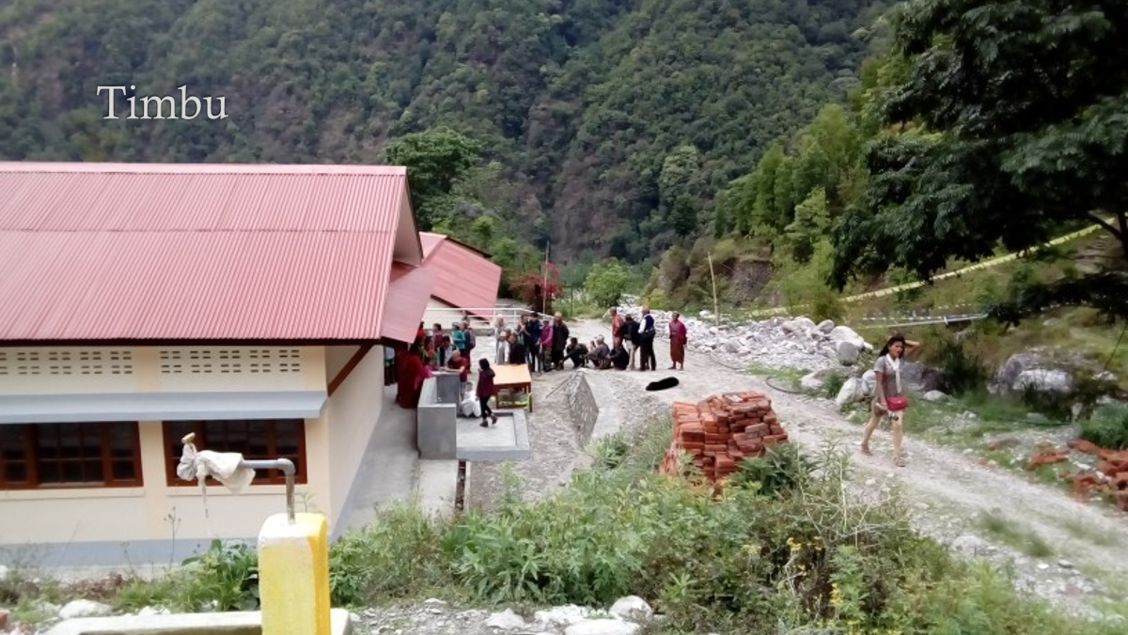

This is a village called Timbu in lovely Nepal where I was about four years ago, doing some pain-related stuff based in Kathmandu. The people were living a hard life up in the hills with little access to health care. There was nothing like physio and limited availability of analgesic medication, but the local healthcare providers were doing steroid injections. Before I went to Timbu I had been living a really privileged kind of life, basically free of much pain or illness. While I was there I caught typhoid. The symptoms didn’t start until I was on the way home and I felt really ill back in the UK. Neither I nor my doctor knew much about tropical diseases but I got the classic rose-spot rash. After about three weeks I got really bad chest and abdominal pains and headaches and ended up in hospital. They did some blood cultures and I had some antibiotics but I was still very unwell, so I consulted a doctor in Nepal who advised azithromycin and I had some in my bag which was slightly out of date but I took those and got better. I thought I was completely better and was even able to do some running around Rydal Hall. But the headaches restarted, at first quite mildly but got worse and worse and never went away, and since then I have had a permanent headache 24 hours a day. It was partially controlled with lots of different things, including and injections of … and I made some lifestyle changes which helped a bit. But then I started to get some joint issues, at first some small joint inflammatory pain in my feet and some balance problems. And then bigger joints got involved as well, in my knees, back and neck, which was really debilitating and even though I was living in a bungalow it was very difficult to get up the steps to it and even walking the 20 yards from my car to work was a major challenge. I took a load of pain supplements and had some physio and it got better and I was able to start running again.
So when Maureen asked me to talk about my own pain I was a bit doubtful but then I thought that could be rather refreshing. Much of the time when I am talking about inequality in healthcare and injustice I am painfully aware that as a middle-aged, middle-class, privately educated person, I am preaching from the top of a mountain of privilege. So talking about myself as a person in pain, as it were from the receiving end, could be different. But then I reflected that in recounting my experience I am taking that same mountain of privilege with me, especially as a healthcare professional. I have a different experience from other people. I have had at least three long-term headache treatments for at least two months each at the maximum tolerated dose and continuing for at least six months if you can tolerate the side-effects. But I got side-effects with everything, some quite bad. When I saw the neurologist he said let’s try something more interventional and suggested Botox injections. I agreed and he referred me to a colleague; he dictated the letter in front of me and finished up by saying I would be really grateful if you could see Dr Matheson super-urgently because he is a colleague. I was quite shocked by that and although I appreciated it I said I didn’t want to jump the queue just by virtue of being a doctor. But my colleagues told me it was just a matter of professional courtesy. So I told my trainees about it and they thought it was terrible.
Another experience: most of the time when I was seeing doctors and nurses they were really engaged and asked for my opinion more that I wanted to give it but occasionally I heard something like this …
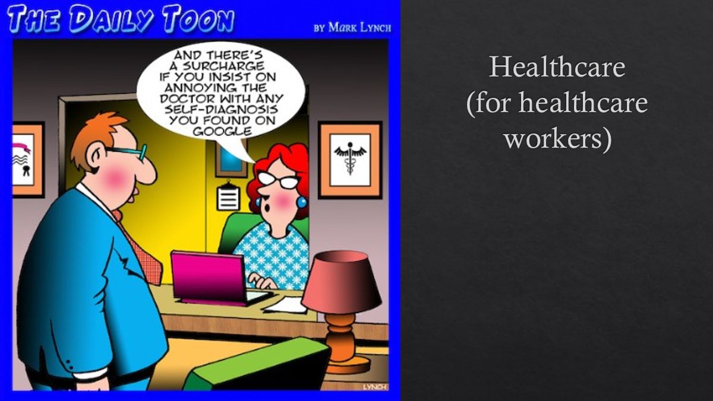

… and I realised what that meant for the patient experience. We are encouraging people to find out about health care and what is going on with their bodies but when they do they get this sort of patronising attitude from some clinicians.
But with a few such exceptions, in general my care has been absolutely brilliant.

We have been talking a bit about this in the context of long Covid. What happens when things go off grid? When I had typhoid it was like reading from a textbook: the symptoms came in the exact order that they were supposed to in the correct timescale. But once it was finished and the headaches and joint pains started that all changed. Things didn’t fit well with textbook diagnoses and weird stuff started happening. Jonathon came to visit us one day in my office in Manchester at a time when my memory was doing weird stuff, and I couldn’t remember proper nouns and peoples’ names. I could remember a drug’s generic name but not its brand name. I introduced Jonathon to the people I worked with, some of whom I had worked with for years, and got their names wrong. Which was very embarrassing. I even introduced my wife by someone else’s name. (But she didn’t notice!) There were other strange things like the rashes that briefly covered me from top to bottom. I would get effusions; I would swell up from my knees to my feet like and 80-year old in heart failure but two hours later it would be gone. I also had problems with my toenails. When I told doctors about this … [their response drowned by laughter!] But that is important as well, because that is peoples’ experience.

Before I went to medical school my mind was totally closed to anything that wasn’t a prescribed medicine, to the extent that when one of my friends said she was studying herbalism alongside scientific medicine I accused her of witchcraft! But as I went through medical school my brain kind of opened up as I learnt more and met people and heard of their experiences of medication or things we don’t normally think of as medication, and when I became a doctor and my knowledge grew and grew it really helped me when I got ill because I suffered totally from side-effects from prescribed medicines, so I tried everything else like Tai Chi, Yoga, osteopathy, cranial osteopathy, acupuncture, every kind of herbal stuff, vitamins, dietary inclusions and exclusions. And I ended up with a concoction that really transformed my life. So it occurs to mw that many of my colleagues still think of anything they don’t prescribe as witchcraft.

Pain and poverty

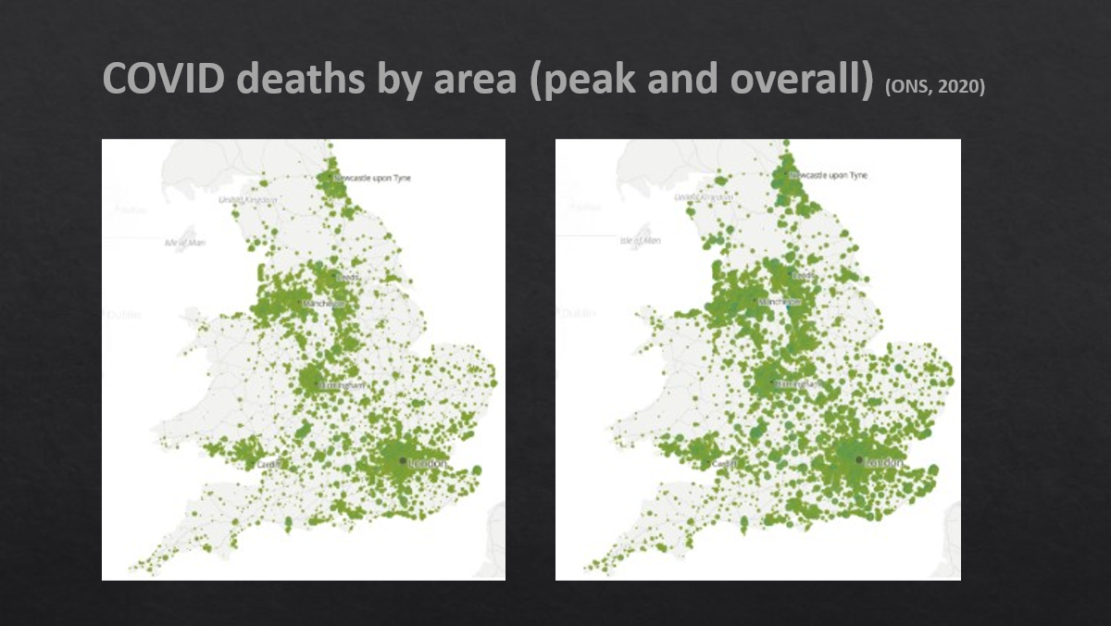

This is from the first wave. Each of the green dots represents the number of people who died in that area. If you did it now the whole of the UK would be one green circle. But note the distribution: a lot in the north-east around Newcastle, in the north west and across Yorkshire and the Humber, around Birmingham and London and some coastal areas.

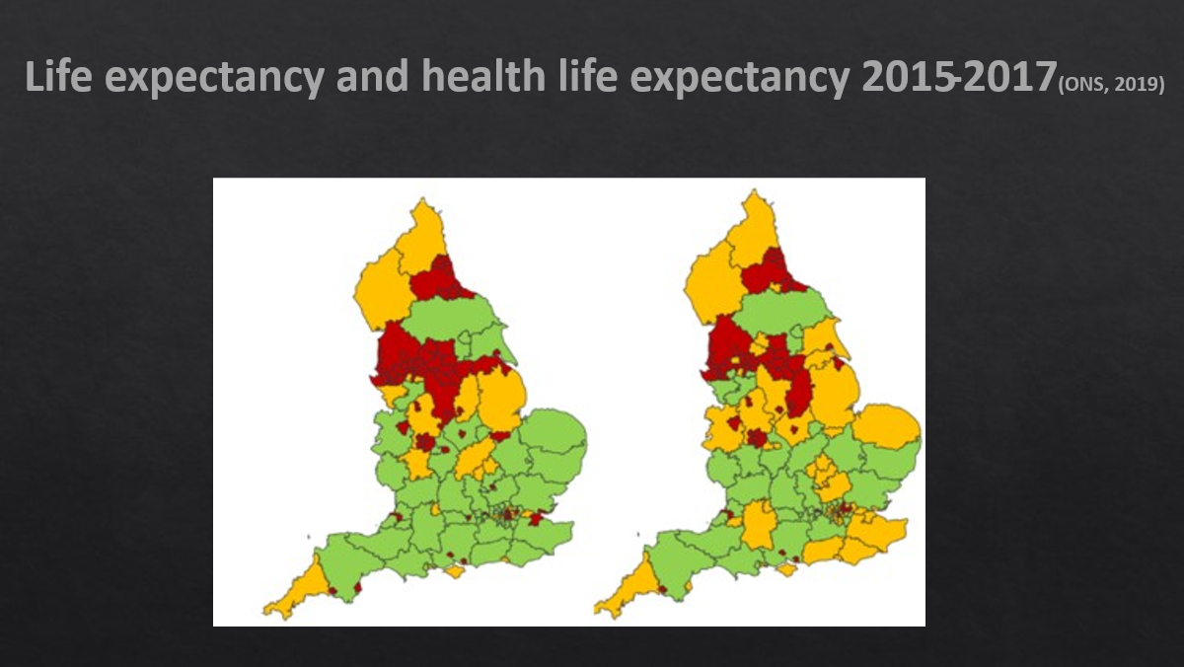

This shows a similar distribution.

It’s not just physical health:

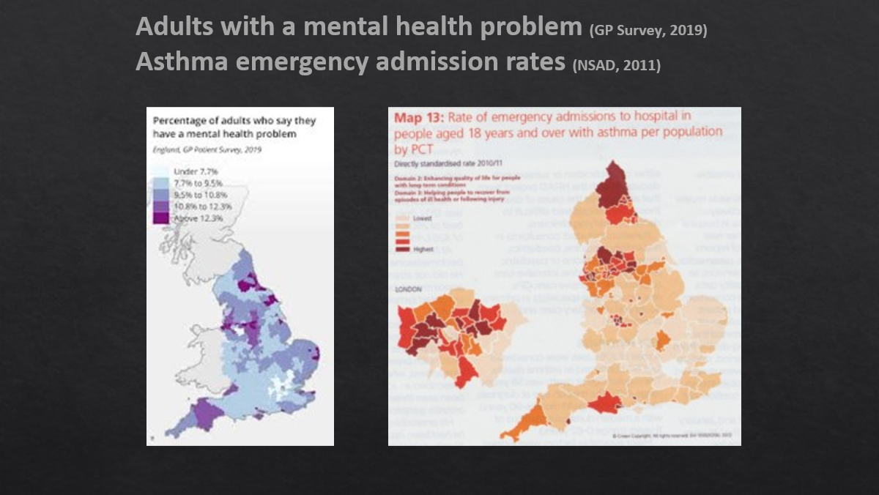

It’s not a new thing. The orange map of emergency asthma admissions is from ten years ago – again highest in the north-east

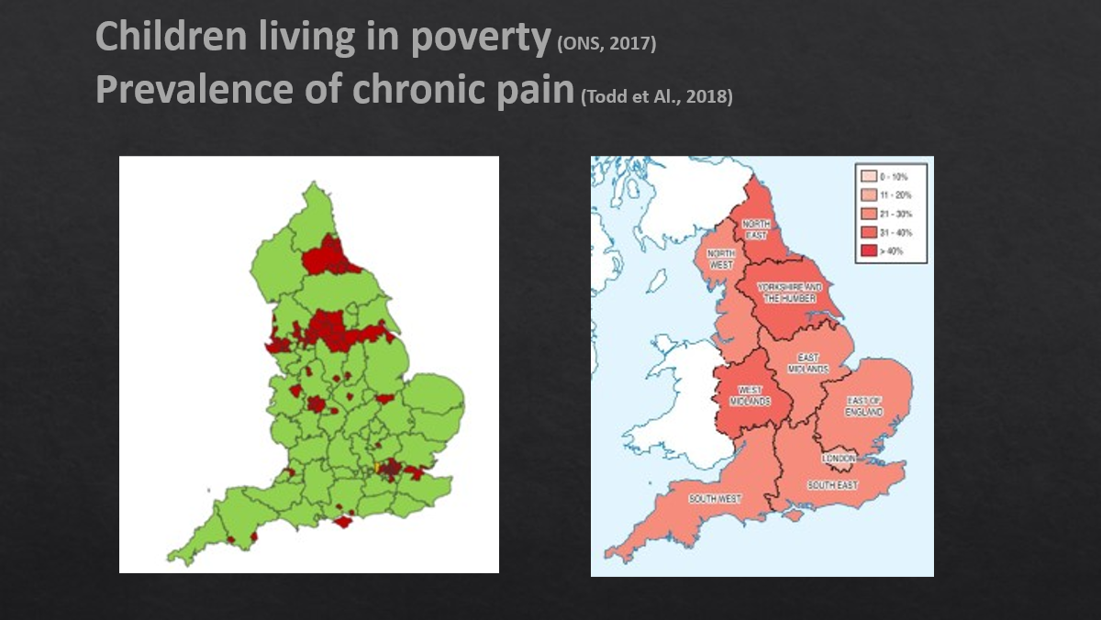

Again we can see that the areas with the highest incidence of poverty have the highest incidence of chronic pain.

So we are seeing similar patterns across all these maps

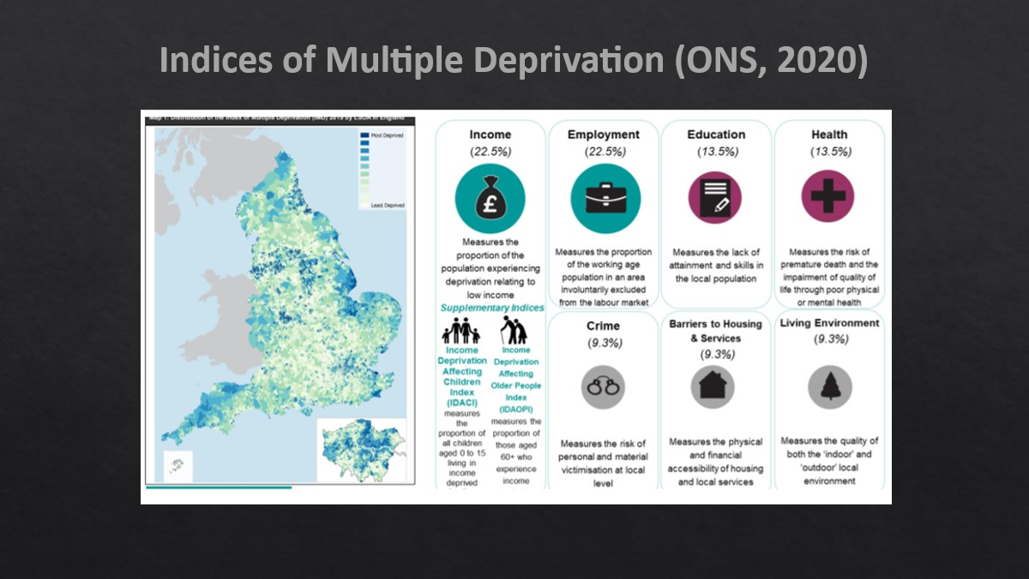

We see here the effects of poverty and everything that comes with it: unemployment, crime, poor education, poor health, housing and living environment.

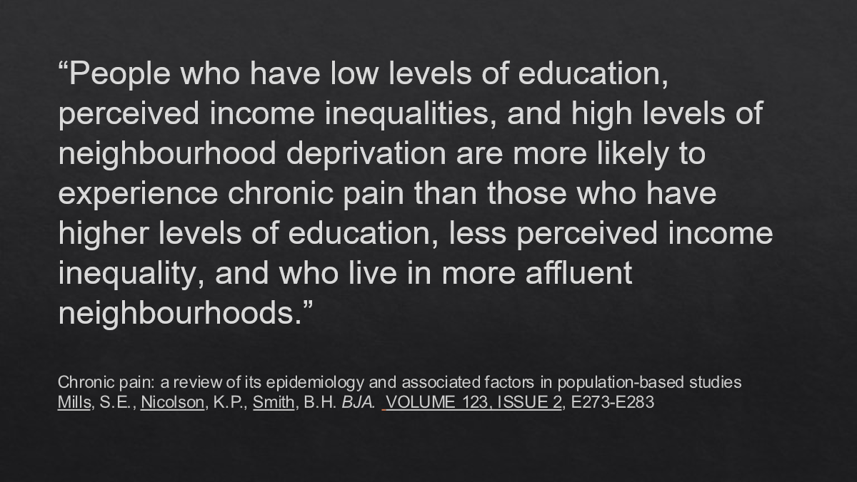

The injustice doesn’t end there. Not only are people in disadvantaged areas more likely to have chronic pain but this is likely to be more severe and associated with a greater level of pain-related disability. Inequality is by no means confined to the UK. In Russia there are big income disparities in different regions with the highest in the west and south and the lowest in the north and east, and casualties in the first months of the Ukrainian was come from the poorest areas

Why is there this association of pain levels and poverty?

I am going to try to shine some light on this problem by telling you about some of my patients who suffer with headaches. One such is a lady of 36 with a really sad story: she suffered with headaches after a burst aneurism; she was found to have another aneurism which was treated and her headaches got worse. She also has memory problems and, understandably, massive health anxiety. Her medications, as well as co-codamol and Tramadol, include buprenorphine patches and oramorph prn which she probably swigs from the bottle but even on the prescribed dose she is taking well over 100mg of morphine equivalent in 24 hours. There is evidence that if you are on 100mg a day your risk of dying is seven times greater than on 10. She is also on Amitriptyline, Fluoxetine Gabapentin (which the NICE report encourages us to use rather than opioids for chronic pain) and Mirtazapine. And when we prescribe a drug for depression we reflect that even if we control suicidality they all have a mortality risk. And that’s just with one! – this lady is on three, two of which potentially depress the respiratory centre which puts you at increased risk of death. But you might be thinking that it is a vanishingly rare occurrence that this lady has had two intracerebral bleeds in a short time, and wondering what this has to do with poverty. But it has!

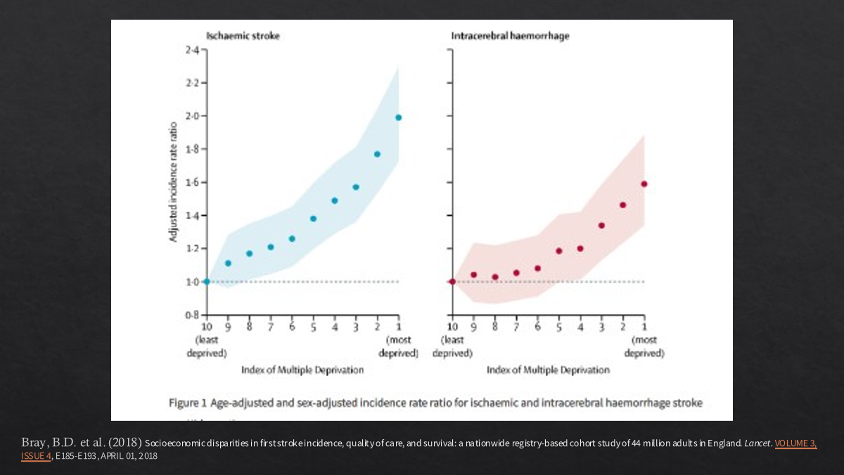

You can see a remarkable positive correlation between multiple deprivation and both ischaemic strokes and bleeds.

What about skull fractures as a cause of headache?: again you might be forgiven for thinking this is pretty rare. A doctor came to join our practice who had been working elsewhere for decades who said, one day when he had only been with us a few weeks : “do you know, before I came here I had never had a patient with a skull fracture, but since I have been here I have seen six!” Which again is poverty putting you in the way of harm.

One of the first patients I saw with a skull fracture within the first few weeks of my joining the practice was Roy, in his sixties, a bit of a hard guy who had done some security work . One day he had a call to say that his niece had been kidnapped by a drug dealer. He knew where this guy lived, so he called his sons - also tough guys – but didn’t wait for them. He knocked on the door and the dealer invited him in, and hit him repeatedly on the head with a hammer. His sons arrived to find their father unconscious and bleeding. They dealt with the dealer rather roughly and got Roy to hospital. He was left with severe headaches, balance issues and auditory hallucinations. He was not a person that dealt well with healthcare systems but we saw quite a lot of him in the practice.
Cherry had broken her skull falling down steps under the influence of drugs and alcohol. But before you are tempted to get judgemental about the drugs and alcohol and her responsibility for her own injury I will tell you her story. She had been doing well in the methadone clinic, off all drugs, not drinking. She had had a bad start in life with childhood sexual abuse. Then her teenage daughter announced that she was going to leave her and live with her dad from whom Cherry was estranged. She stopped going to work, lost her job, couldn’t pay the rent and lost her flat and had to move back with her mum who physically and verbally abused her. Then her schizophrenic brother was released from prison. In this toxic environment she started using drugs and drinking again, fell down stairs, fractured her skull and ended up with bad headaches and dizziness.

The Alcohol Harm Paradox

Who do you think drink more – people in the most affluent fifth of the country or in the poorest fifth? Actually it is the former by quite a long way. But the difference is in the amount of harm they come to as a result. For instance in Wales the most deprived quantile had nearly double the rate of hospital admissions due to alcohol and double the mortality than the most affluent quartile. In Scotland it is even worse: if you are living in the poorest areas you have ten times the risk of alcohol related mortality than the rich areas.
We see a similar picture with drugs. There are a lot more drugs in disadvantaged areas as in one estate which was essentially controlled by four pairs of drug dealers. We see the same distribution as before:-

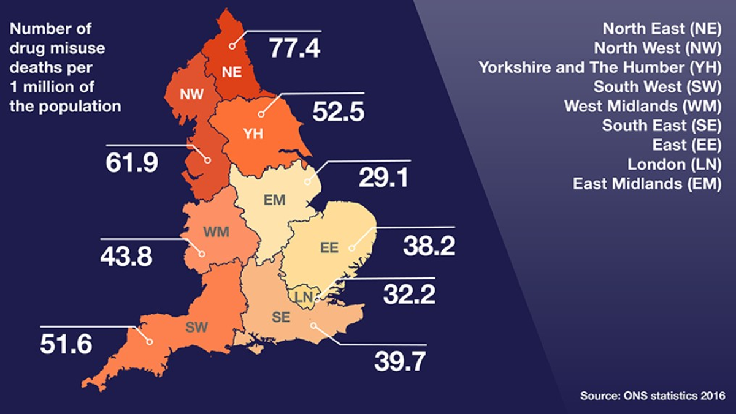
This portrays the situation differently:

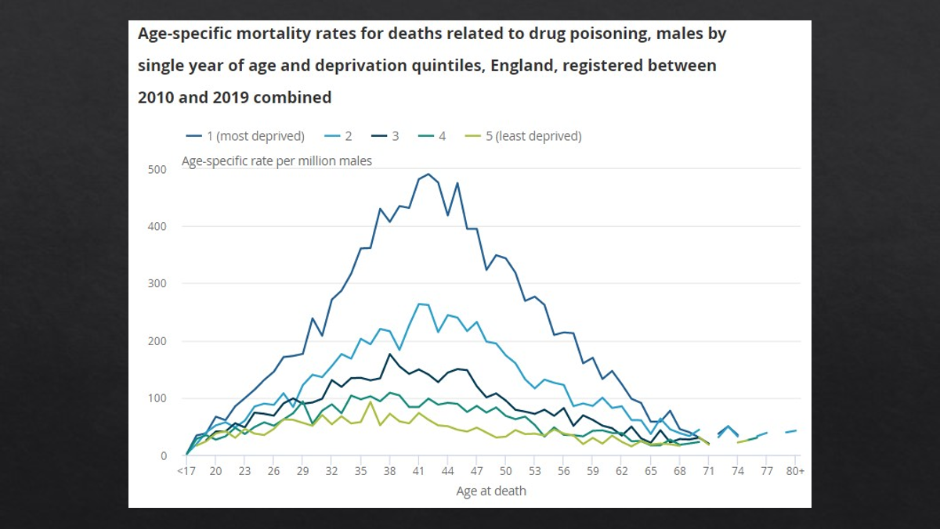

These are tragic deaths – people in their early 40’s and below.

A lot of these problems stem from trauma. Firstly physical trauma:

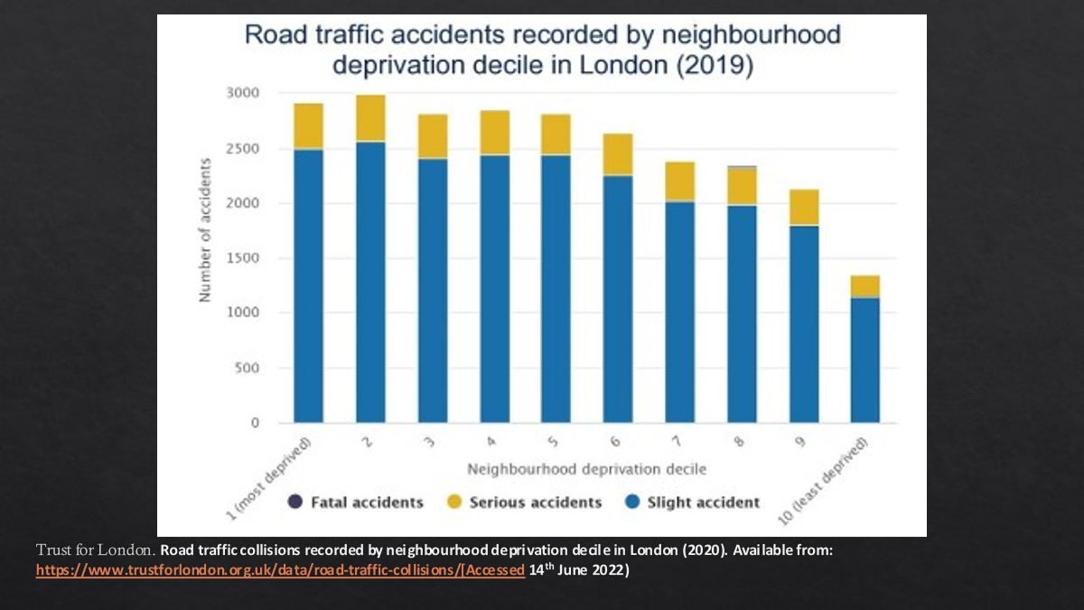

Again nearly double the numbers from deprived areas than from affluent ones.

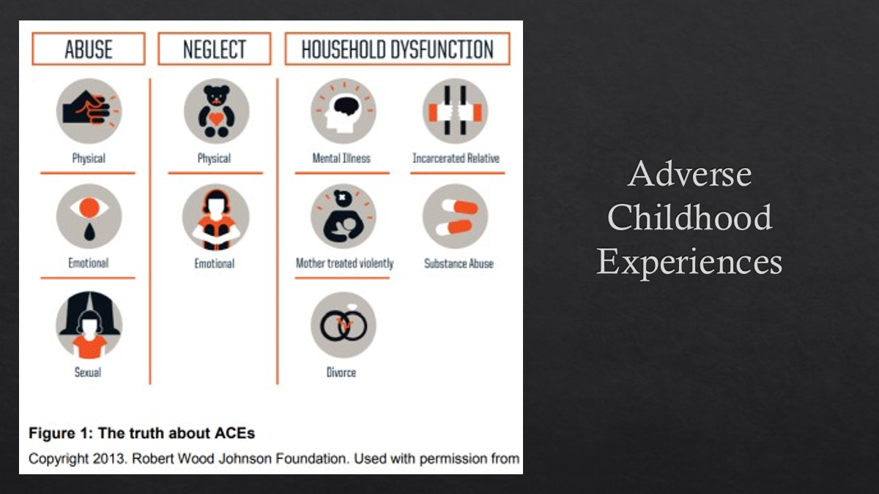

We have been talking a lot about this today. You can find this anywhere in the country but once again it is much more prevalent in deprived areas, and almost ubiquitous in the experience of patients with chronic pain and other persistent symptoms.

Here are a few examples from the same practice in one week:

N. is a 7 year old girl. Found by teacher attempting to hang herself - fortunately with knitting wool - at school after father’s conviction for child sex offences. We were unable to follow this up as her mother moved away with the children, and we don’t know if the child herself was abused.

S. is a 13 year old girl. Told teachers she was going to kill herself at school after bullying and mocking about her body shape, although she told us she didn’t really mean to do it. She is a carer for her mother who is a variable attender at our persistent symptoms clinic with chronic pain and ill-health with mental health issues, and seemed to use these as a pretext for getting her daughter out of school and spend more time with her. So there was a lot of obligation on that poor girl’s shoulder.

M.is a 15 year old girl. She told her mother she was suicidal prior to attendance at court as a witness. The story had started more than a year ago when she came with a septic knee joint where a junior doctor found out that she was in a sexual relationship with a middle-aged man. Social Services and the police intervened. A later she was in her bedroom with a boyfriend when the middle-aged man came in and stabbed the boyfriend. She had to go to court to witness to this.

At that time getting access to CAMS (Child and adolescent mental health services) was very tricky (although having been in the news it has got a lot better) and when we referred people there would be a delay of between 12 and 14 weeks before they were seen, or we would get a reply saying unfortunately your referral doesn’t’ meet our criteria so please ask them to see the school nurse. None of these three were accepted. You wouldn’t believe it, would you? So after this I audited the first hundred referrals I had made and not a single one had been seen by CAMS. Later on lots more did but only after a lot more drama in the news .
In the context of my topic, you will not be surprised to hear that both S and M developed chronic headaches later on.

So this is what we have been seeing:

“Pain was entangled with and shaped by: social locations and identities, experiences of violence, trauma and related mental health issues, experiences of discrimination, stigma and dismissal, experiences of inadequate and ineffective health care, and the impacts of these intersecting experiences.”

Wallace, B., Varcoe, C., Holmes, C. et al. Towards health equity for people experiencing chronic pain and social marginalization. Int J Equity Health 20, 53 (2021). https://doi.org/10.1186/s12939-021-01394-6

In all those experiences that Roy, Sherry and those lasses shared; we see the interrelation of violence and trauma that is implicit in those relationships and that kind of environment, and inadequate access to healthcare.

What do we do about it?

When I say we I mean doctors and specifically GPs. I am aware that we are an unusually enlightened group here but a lot of my colleagues are less so. Also we have a lot of time constraints; sometimes we do what people ask or expect us to do; and we prescribe stuff., which can be the risky stuff we have been talking about.

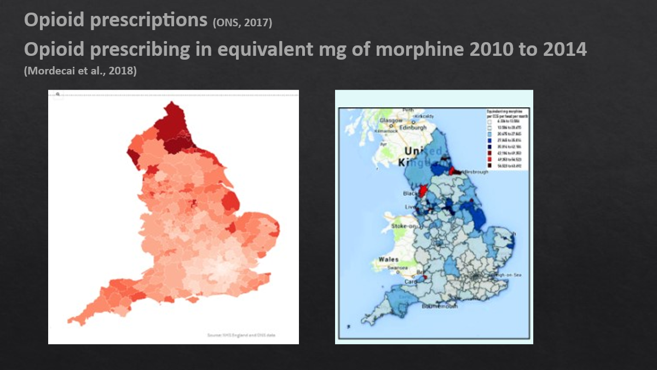

A similar sort of distribution to that in all the other maps we have seen. The right hand map shows the amount of opioid being prescribed. And it goes on for longer – long term opioid prescribing shows the same pattern. It is the same with Gabapentinoids, despite the increased risk of dying. We have talked about switching to antidepressants but there is enough of that already.

How big an issue is poverty?

A total of 4.1 million children live in relative poverty in the UK after considering housing costs, approximately 30% of the population.
That means over 500,000 more children are in relative poverty in 2017/18 compared to in 2011/12.
This is projected to rise to 5.2 million children by 2022, which would mark a record high in relative poverty rates for UK children
From the Royal College of Paediatrics
A lot has happened since they made that prediction; we have the Covid epidemic and the cost of living crisis (0r as someone has astutely called it ‘the cost of greed crisis’) We have seen a fall in life expectancy associated with widened health inequality even before the pandemic and which is worse now.
I would like to finish this talk on a positive note but I am totally challenged at the moment as to how to do that. We have this hideous situation of a government that came to power promising levelling up but systematically working against that agenda, with the number of people living in poverty expanding.
So what are we going to do about it?

Discussion
I live in Bath, which is relatively affluent. My son is a first aid officer for local train stations, and he spends most of his days now dealing with people with mental health issues; people who are unable to cope with life. He walks the platforms looking for people who appear to be preparing to jump in front of a train. Last week they had three such people and one of them did. They had drugs and alcohol problems and nobody to call on for help. Last week he spent five hours sitting with one woman who was wanting to end her life. Sometimes all they can do is call the transport police who put them in a cell for the night and let them go. The ambulance service won’t send an ambulance to the station because they know they will be dealing with someone with this sort of problem or having a panic attack because there is nothing the paramedics can do. If they take them to A&E they wait there for a few hours and are discharged. It just seems hopeless.
It's spectacularly sad. There is a lot of criticism at the moment of people like the railway workers who go on strike. People often don’t understand what the matter is. Government is pushing the line that the median salary is such and such, but they don’t mention the people on the lower end of the scale who are often dealing with stuff like this – stuff that keeps people alive.
One of the features of these negotiations is that they are trying to get rid of the platform staff. So people will jump.
I have got into a habit – which I used to blame on medication when I was on Pregabalin, but continues since I came off it – of shouting at the TV when the news is on! Last week there was a minister who was decrying the rail strike and saying how terrible it was that people wouldn’t be able to get to hospital and would die, children wouldn’t be able to get to school etc. etc. So I wanted to shout: “yes! … these people have such valuable jobs that people may die without them but you don’t bother to pay them adequately!”
But it’s also it’s also a reflection on the lack of fundamental mental health services. When I was struggling with this sort of problem I had this mental picture of CAMS (Child and adolescent mental health services) not existing – I had this image of a big empty warehouse and a lady approaching retirement age with a massive stack of referrals; every now and again she would take one and recommend the school nurse, but of course it’s not like that. It’s really overstretched and overstressed people working their hardest to meet the massive demand.

I always worry a lot when people, particularly in Government, almost routinely say there is terrible underinvestment in mental health services and if only we had more of them it would make things better. But since you asked that question… you gave very recognizable and representative examples of the toxic ecology that we have in this country for young people. And the epidemic of mental health crises for young people is constantly developing and evolving; so there cannot be any knowledge about its nature, let alone its treatment, and almost by definition there can’t be any evidence base for any intervention. And yet we still have this reflex: if only we could increase CAMS tenfold, then we could deal with the problem. But I suspect that it is wishful thinking that if only our referral to CAMS worked we would be doing a better job of handling these mental health crises, and we have no evidence for this.

The whole NHS is set up that way: we wait for people to get unwell and treat them but we don’t have enough resources to treat all of them

We need to give people proper housing, adequate wages … but we need to ensure that people are cared for right from the bottom up. Even if they do have a better environment it’s not going to be like that …

… that’s absolutely true and we see the evidence from other countries that take that on board…

And the whole country is happier; which makes me wonder … it has been shown that in countries where people are looked after and cared for, that the whole of the population are happier.

I have arguments with psychiatrists sometimes when trying to get them to see a suicidal adult. One said suicide isn’t always a mental health problem. So I said OK – it’s not orthopaedics? [laughter]

There is a danger here for healthcare professionals laying all the responsibility on somebody else. It’s important to think what we can do and what privileges we have. Advocacy is something we can occasionally do but don’t do nearly enough of. It should be embedded into our practice. As people working in pain services or with an interest in pain we have a lot of really important data that we could present to the Government, social services, public health and the media about the underlying causes and problems involved in creating the conditions that lead to chronic pain and prevent recovery. But we don’t do that as advocacy is somehow seen as not part of our job. I asked a question at the BPS ASM last week; I said that the Royal Society of physicians did a report on deaths attributable to pollution, and the medical profession has done great things about the harms of smoking. But where is that advocacy role around pain and poverty?

[inaudible contribution]

Advocacy can be a powerful tool. The first time I really appreciated that was when I had a patient come in who was in the methadone clinic but hadn’t shown up for a while. She told me her husband had died very young from a heart attack. He had done a lot of cocaine in years gone by. Her life had gone a bit off the rails including her finances and it was in that interval when they were changing people to Universal Credit with a six week interval perfectly timed to cause difficulties with paying rents. She came in in great distress because she had two children and the family were facing homelessness. She had begged her landlords [the council?] in tears for more time to pay but they were intransigent. So I rang them myself and while I was on the phone they called the Universal Credit people and five minutes later they said “that will be fine – no problem”. Of course it shouldn’t have been necessary.
That is advocacy at base level, but we have been talking about higher level advocacy Michael Marmot* did a report on health inequality ten years ago and another later at the start of the pandemic. There was to have been a massive release accompanied by a big fanfare and all the Royal Colleges and associated professional healthcare bodies got together as the Inequalities and Health Alliance and had a letter published in the Times and sent to the Prime Minister saying please could you do what Michael Marmot has said. Do you know what the Government did? – up until that point Johnson and co. had been trying to ignore the pandemic, but they saw a press opportunity to distract from this report. Maybe that is a cynical suggestion.

I don’t have a clinical background but some experience of living with pain and talking to others with the same problem and I think that even though some of the information has been out there for twenty or thirty years it has failed to reach people living with pain. If you spoke to most people on the street now they know the dangers of smoking, but that doesn’t apply to people living with pain and the links of that to poverty. Living with pain is another form of trauma. For people who have had adverse childhood events and general struggles in their lives, when pain comes along which is unexplained it only adds to the mountain of issues they are dealing with. If information about the meaning of pain was more readily available I hope that would make a difference to those with chronic pain.

I think it would. Why hasn’t that happened?

The BPS could do more in this line. People still think that [chronic] pain is [always] linked to tissue damage because there isn’t a wider knowledge of pain …

* Studying health inequalities has been my life’s work. What’s about to happen in the UK is unprecedented | Michael Marmot | The Guardian Control plus click to follow link

After 300 plus years of ignorance and false narrative about the complexity of pain we are in a way a minority in not having a one-size-fits-all approach. This is wonderful for us but it needs to happen across the board for there to be meaningful change.

And why when people are suffering pain their first assumption is that they need to see a doctor who will prescribe drugs – that is all they know because they haven’t got the information about how else to deal with it. But when you have that information you are empowered.

Talking of economics, if complex pain treatment is rolled out in the next ten or twenty-five years it will make a significant dent in health expenditure as there will be a lot less prescribing. So it is in Government’s interest to get that information out there.

We are all victims of the system – it’s not doctors or anyone else’ fault, it’s the way it is set up; this is how it has always worked – and trying to change that is very hard

Talking about politics: as doctors, on the whole we tend to be reasonable and wise etc. in contrast to politicians of the right who seem to be most in interested in looking after their rich friends and are very good at getting people to vote and staying in power. The Pain Society can’t be political in that sense ( because it wouldn’t work?) but as doctors we do have the power to be political and join political groups to put these things across and pursue political solutions.

The terminology around politics is probably quite important where it shouldn’t be. In medicine, when you go into a leadership or management role, especially in general practice the term politics is not always regarded in a positive light.

Doctors who go into Politics (with a big P) often get spat out because they don’t want to play the dirty game.

There are other obstacles. I used to be in the Health Inequality Standing Group of the RCGP. We were for ever badgering the College to take issue with the politicians about various things in the name of health justice; sometimes they would and sometimes they wouldn’t and when they wouldn’t the reason they gave was that as an organisation with charitable status they can’t go in one political direction or party view or they would lose that status. We railed against this – I don’t know how true it is …

… but we can as individuals and maybe we should be doing that …

Hands up anybody who would like to be involved in politics? ….

… [inaudible] … channels of access to politicians … we are missing out a lot of people who don’t have the information … people who are actually in poverty are wiped out of the conversation… top-down view … need to help people to have their voices heard … increase democracy.

It’s also that when you start talking about these wider aspects of pain people seem to hear the toxic underlying message: ‘ it’s all in the head’ and ‘not physical’

Some of that is because the message is rushed; health professionals don’t have enough time to explain what things properly and it’s easier to prescribe and send someone away.

We had a real issue with this in our practice with an old-school kind of pain clinic where you saw an anaesthetist who injected you somewhere. By and large, people had good experiences of that. But the guy died and the Trust took the opportunity not to replace him, and we got a more modern persistent pain clinic which relied more on CBT and lifestyle interventions. The few people who really engaged with this had good outcomes but because that first appointment was too rushed the vast majority came back and said they told me its all in my head and I am never going back - how could you send me to these bastards! So we got together our own pain group to be run by the patients. I went on some training courses and learned how to facilitate this sort of thing and got people together - they were a bit reluctant at first but they got into it and we established a schedule and some of the local services came in. And then the pandemic arrived and we couldn’t have groups meeting here, so it all fell apart. But some of them told us that it had made a change from us preaching to them about the dangers of medication!

THINKING OUT OF THE BOX: Chronic pain as flashback

Genevieve Roulin

Chronic pain is a challenge for any caregiver.

When the full investigations are negative, when no treatment works, when the symptoms remain identical over the time and the patient in addition complains of anxiety, insomnia, hypervigilance, deep weakness, low self- esteem, ,addiction , problems at work and at home,. It is particularly confusing and the physicians don´t feel comfortable.
However it is not uncommon that this picture reflects previous psychotrauma. Pain is then a flashback and has no organicity.

To understand these patients ,it is necessary to know their past and the adverse events in their life.. In this article. ,the reactions to danger (both the appropriate reaction and the psychotrauma) will be explained same the long-term consequences .

HISTORY:
The disease was described in 1889 by the German neurologist Professor Hermann Oppenheim (1858-1919) as traumatic neurosis. It has then been popularized by Louis \CROCQ (1928-2022) while the mechanisms have been detailed by Muriel SALMONA (both of them psychiatrists).
Hermann Oppenheim was probably the best neurologist in his time (he was a founder of neurology).He was a contemporary of the industrial revolution .With the train came the railway accidents. .People injured as the result of these accidents developed strange neurological disorders.
Oppenheim noticed that the etiological agent is outside the patient,. It is not an individual weakness, nor a mental illness (this disease reaches normal people).It is not faking (to many symptoms),There is nothing favorable to get from this.. It is not psychogenic .These are disorders after psychotrauma. .He concluded that there are neurologic damages behind the symptoms..

The disease is very debilitating .German people got a pension before WW1.
In the great war, soldiers got baffling symptoms. It was called obusite in France and shell shock in the UK. In Germany, ,Oppenheim certified that it is traumatic neurosis and said that the soldiers had to receive pensions. There was a great opposition from the other doctors saying it was faking, and cowardice, These patients got a name:«Rentehysterie» in Germany and ,malingerers in the UK.
In 1916 Oppenheim was excluded from the German neurology society that he had founded in 1907 and was president because he was a jew. The disease has since been become mental illness (psychiatry).All Oppenheim´s work is forgotten.. He died in solitude.
The disease is forgotten too. .It came back with every war since with another name such war neurosis and it has long been known along military psychiatrists.

PTSD (post traumatic stress disease) appeared as a disease in 1980 in Diagnostic and Statistical Manual of Mental Disorders (DSM III) although it is as old as the world (antiquity ;,Plato). The definition has changed with each new edition of the DSM.
The symptoms of the disease changed between WW1 and WW2 from motor disorders (paralysis,..) to sensory disorders (pain without any organicity as well called somatic symptom disorders SSD ).

Louis CROCQ has highlighted that there are different definitions of psychotrauma both in the traumatic neurosis, in the DSM V (Diagnostic and Statistical Manual of Mental Disorders and in the ICD 10 (International Statistical Classification of diseases and related Health Problems: PTSD ) which add to the confusion.
Muriel SALMONA affirms that 60% of psychiatry is psychotraumatology and has very well explained the mechanisms involved in psychotrauma and common symptoms occurring after such events .

WHAT IS THE APPROPRIATE REACTION TO DANGER?

The amygdala (alarm) becomes active. All body´s resources are mobilized to escape the threat. Stress hormones (adrenalin and cortisol) are released. This reaction takes a lot of energy.
At the same time the message reaches the cortex .The cortex looks for information in the hippocampus (memory) and processes information .This is the appropriate response.. Then the cortex neutralizes the alarm and :stress reactions disappear.. It is then archived in the hippocampus. .It becomes a memory .This is the biographic memory.
Example: I´m on the way to work at 6 a.m. It´s winter and bad light in the street .I see something long and dark lying on the road., I think it can be a snake. My breathing and pulse are increasing, my muscles are becoming tight, I’m ready to run away.
At the same time ,the information goes to the cortex, the object is in the database (the hippocampus).It is a branch. After processing in the frontal cortex (these branch isn´t a danger),the amygdala is switched off and secretion of stress hormones stops.
It becomes a memory.

WHAT IS A PSYCHOTRAUMA?

When the normal reaction cannot occur, an exceptional mechanism of survival becomes involved.
As Oppenheim wrote , there are neurological mechanisms behind the symptoms: sideration and disjunction leading to dissociation and traumatic memory. Consequences (with and without treatment) will be explained.
The secretion of stress hormones is briefly positive for the body. Too much adrenalin in a long time is dangerous for the heart, ,Too much cortisol (hyperglycemia) in a long time is harmful for nerve cells. It has been described until 30% cerebral lesions in the involved areas (dendritic lesions, neuronal death in hippocampus and cortex).
At this time, an exceptional survival mechanism occurs : the cortex becomes paralyzed to avoid its self-destruction, it is what is called sideration .
Concomitantly amnesia begins. It can last a short time or a long time ,sometimes for life .It can be complete (40%) or partial (70%), it is very variable. .It can be partial in the beginning and then complete or complete at the beginning and then partial.
Epilepsy (GM), loss of consciousness, coma has been described coming with sideration.
With sideration the possibility of switching off the amygdala (and by this the secretion of stress hormones) disappears. The alarm goes wild and cannot be neutralized. Stress reactions escalate .
If this condition persists, it becomes deleterious for the victim. It is like a car: when smoke is coming out of the motor ,something should be done. Lest both the engine and the rest of the car will be destroyed.
This exceptional mechanism of survival is disjunction and has two consequences: dissociation and traumatic memory.

The brain is an electrical circuit. Think about your electrical circuit at home. When there is too much voltage in a device, there is a safety acting on and the device becomes isolated from the rest of the circuit to save the installation and avoid its destruction.
The mechanism in the brain is not mechanical but chemical. .It is disjunction.
The brain produces endorphin and ketamine-like substances ,making the amygdala to be isolated from the brain and stress reactions stop. This leads to dissociation which is physical and emotional anesthesia: people are like automatons, they no longer feel anything. ,They are no longer able to react and don´t defend themselves).

The victim is dissociated so long as he/she is with the abuser.. People living in constant violence can be dissociated all their life
But there is also traumatic memory: raw information remains in the amygdala and the alarm becomes dysfunctional. It works all the time. .From time to time ,all or part of this information reaches the cortex via the thalamus,. This is what we call flashbacks. .It is permanent sorrow, it is like walking on a minefield. People feel in constant danger and don´t understand what is happening to them.
They have invasive thoughts repeating the abuser´s talk.. Because of the flashbacks the thought is colonized by the abuser´s acts and people are no more able to do the tell the difference between their own thoughts and the abuser´s talk. It leads to low self confidence.
For example: the abuser says: you are nothing, ,you don´t deserve anything,, you are a bad boy/girl. The victim thinks, it comes from him/herself: I am nothing, - I don´t deserve anything. ,I´m a bad boy/girl.

Being dissociated (physical and emotional anesthesia) does not prevent the injuries and traumatic memories because it involves the limbic system which is involuntary. It´s like being stunned and putting your hand on a hot plate.. Being stunned doesn´t prevent burns.

Flashbacks are always the same. .It ´s reliving psychotrauma in full or in part with the same emotional burden, and helplessness and distress. .At the beginning there is a triggering factor, then it happens at any time. .It is Important for the clinician to know i about previous psychotraumas .If not flashbacks become hidden and a patient with complete amnesia is not able to tell you if ,he/she has been exposed to abuse.

Evolution:

With diagnosis and help in the 12 hours after a psychotrauma there are no consequences ad the reaction is reversible. Without diagnosis nor help: the symptoms become chronic and disabling.
People treat themselves:

- by avoiding situations that may trigger reliving flashbacks -:avoidance behavior.
- Exposing themselves to danger to cause spontaneous dissociation .
- Taking dissociating substances so to become addicted to the violence that reproduces from generation to generation.

Subjects who have experienced repeated physical, psychological, sexual abuse tend to repeat either as victims (90 %) or as perpetrators (10%) the situations they have experienced. It is the literal repetition.

What leads to self-dissociation?
- Wild driving
- Substances abuse (90% from the worse substances abusers has been previous exposed to violence)
- Attempted suicide
- Self-harm
- Sex: unprotected sex,,multiple partners, sex with unknowns, pornography, prostitution, compulsive masturbation
- Anorexia ,bulimia,
- Dangerous sport
- Dangerous games: money games, ,violent CDs
- Impulsive purchases
- Escape from home, tramping
- School absence
- active participation in violent, satanic, sectarian movements
- Theft, destruction of good
- Violent behavior (delinquency, criminality).10% people having been exposed to violence become abusers

When there is a will to hurt (inter-human violence), the psychotraumatic consequences are more important. This particularly concerns sexual violence and torture.

80% of victims of sexual abuse develop psychotrauma (100% in children) instead of 24% in non-human abuse .

The consequences of ACE are well known (including up to 20 years less life expectancy).

Children having been exposed to sexual abuse have a greater risk to become abusers (x 16 in boys) or be exposed to violence later in the life (x 19 in girls).

Somatic complaints after psychotrauma:

The most common expression is depression (50%) .

The following somatic complaints are noticed too:.
-chronic exhaustion,
-pain,
-abdominal, gynecological, urinary symptoms
-heart disease
-Breathing problems, epilepsy,
-endocrine disease ,diabetes
-decreased immunity
-other symptoms: ENT, Teeth ,skin, allergy

Mirror neurons

- The alarm is dysfunctional and has become hypersensitive, reacting to anything. The patient describes the other person’s emotions very well and is not able to regulate his own.
- Due to mirror neurons, the patient interprets emotions ljke doubt and uncertainly,…) very sharply and is not able to cooperate nor think rationally.

What can we do when we meet such a patient?

The most important thing is the trust relationship between the carer and the patient

We have to avoid new traumatic events. Therefore we need

- Knowledge of psychotrauma
- Knowledge of pain/Anaesthesia
- Empathy and adaptation skills. It can be difficult because the victim of repeated violence initiates counter-attitudes of rejection on the part of all his interlocutors and especially of health workers

Potential causes of PTSD:

-domestic violence
-sexual abuse which can be either physical or emotional)
-war
-terror
-Witnessing or experiencing mass disasters or a serious accident, bullying, medical procedures, robbery/burglary

MRI can show radiological damage such as hippocampal atrophy which can be reversible with treatment.

Treatment:

The treatment is to turn traumatic memory into biographical memory and to rewrite traumatic history through psychotherapy.
The carer has to show active empathy stressing that It is not the patient´s fault, it is the abuser’s. There is nothing wrong with the patient; ,it is what happened to him/her which is wrong

It is necessary to have a multidisciplinary team including a physician, a psychologist, a physiotherapist, a lawyer and social worker .

The treatment should be a flexible frame with adjustments and should help the patient with control of emotions .Treatment breaks should be prevented.

Conclusion:

Flashback pain is the pain occurring during the trauma and not felt because of dissociation.
In our experience it is not uncommon and can often lead to erroneous diagnoses (all of these patients have a psychiatric diagnosis).

A lot of patients in our gynecology department having been exposed to sexual abuse have complete amnesia of psychotrauma and do not get the diagnosis and treatment for PTSD They just don´t remember it . This is the reason why we prefer to use Oppenheim´s definition which takes into account amnesia without duration of time.

Violence creates violence and increases in intensity with the time. It does not stop if it is not stopped. It is always a choice.

Bibliography:
- OPPENHEIM Hermann :Die traumatischen Neurosen nach den in der Nervenklinik der Charité in den letzten 5 Jahren gesammelten Beobachtungen. 1889; second edition, 1892; 3rd edition, 1918.
- OPPENHEIM Hermann: Stand und Lehre von kriegs- und Unfallneurosen. 1918.
- CROCQ Louis: Traumatismes psychiques,prise en charge psychologiques des victimes,Elsevier Masson 2014
- SALMONA Muriel : le livre noir des violences sexuelles ,Dunod second edition 2019
- LOPEZ Gérard : Prendre en charge les victimes d´aggressions et d´accidents,Dunod ,2014

Understanding Others

Metaphor and its Use in Medicine

Peter Dorward (Family Physician and author, Edinburgh, Scotland)

Metaphor is a powerful tool toward better understanding and healing.

‘It’s a debt that just gets bigger. Like a bad loan from the happiness bank…’
Today Margot is talking about cocaine. But we’ve had this conversation before: heroin, alcohol lately, fake valium. There are a lot of street drugs around where I work. There are a lot of desperate people.
‘I start off just to get a wee bump, but then an hour or so later I’m feeling even worse, needing more, then more, and then I’m just chasing my tail. And there’re always folk happy to give you a wee chucky bag when you’re rattling!’
Margot is thin, wide eyed, shaky, tired, withdrawing. Her eyes plead. For help? In truth, there’s not a lot of help around for Margot. A ‘chucky bag’ is a loan: of heroin, or cocaine, or anything really, for anyone that’s desperate. It’s a pretty common business model. Drug dealers need to keep their clients happy, just like anyone else.

But I liked this line of hers-- the metaphor. I like its power, its flexibility.
I try it out myself, a little later, on another patient. Slightly different context. Big Tam needs something for his ‘anger management’. Big Tam has issues with alcohol, gambling, cocaine, violence, his past, his future, and his personality. He’s trembling with rage. He’s barely holding it together as he stares hard at me through little pin-hole eyes. He wants me to prescribe him more of the valium that the junior doctor in the ER gave him the other night, to ‘calm him down.’
I won’t. I just won’t.
‘Why the F not!?’
Tam can be pretty intimidating.
‘Because valium will make everything worse.’
Tam’s getting angry. Think ‘Raging Bull.’
But I have an emergency response button somewhere. Under my desk. I think.
‘If I prescribe this for you, it will work, a bit, for about a week. Then you’ll not be able to manage without it. You’ll need more. Then more. Then stopping will be out of the question. The longer you take it, the worse it gets. It’s like…’
Pause. Think.
‘It’s like a debt. A high interest loan. From the happiness bank…’
Tam pauses. Tam has been in debt most of his adult life. Gambling, drugs, rent. How could he be otherwise? Tam’s been in and out of prison. Tam knows how men, left wild, use debt to coerce and control. He’ll have done it himself to others, no doubt. But to my absolute surprise Tam responds. Nods a little, still skeptical.
‘So what can you do for me Doc?’
Now for the hard part I think.

*

It’s not words, nor their attendant facts, that make us human. Animals communicate. Even computers have language, after a fashion. It’s our ability to think of things in terms of other, unrelated, things that makes us special. Our use of metaphor. The power to imagine: to think of ourselves, potentially, as other than we are.
How could there ever be transformation, without this language of imagination?

Margot’s compares her cocaine habit-- the tenor of her metaphor-- to a debt. Debt is the metaphor’s vehicle. Our shared world of mutual understanding—that which connects tenor to vehicle-- is the metaphor’s ground. In this case, the false friend who traps you— in crippling, worsening, dependency. We all recognize him.

A good metaphor is flexible, arresting, immediately and effortlessly understood. It is creative, a little unpredictable. Does it apply here to the slavery of addiction? Or to the coercive financial relationship between the addict and her dealer? Or to something deeper? Her fear of being owned? We don’t know. The metaphor is pregnant with meaning, and the meaning is undefined. Metaphor entails risk: we can’t always know what powerful change it might produce.

Metaphor requires that we understand our patient: her language, her history, her culture, her humour, her education, how her imagination might work, what we must, at all costs, avoid saying.
Like all good medical practice, metaphor demands that we listen.

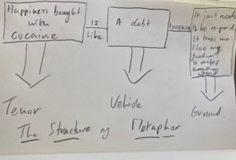

What does Chronic Pain mean to GP’s?

Tamar Wildwing
.

My interest came from working with GPs in the commissioning role but also as a chronic pain patient myself. So, for my PhD I interviewed 11 GPs across the UK from a wide variety of backgrounds: They included both new GPs and some with 20 or30 years’ experience, working in large & small practices, single-handers and large group practices, serving rural, urban and varied socioeconomic areas. I interviewed a few before Covid but most during the first year of the pandemic. My aim was to explore their perceptions of their role in supporting people with chronic pain. My hope was that understanding GPs’ views could inform training and policy development in chronic pain management for them. To understand their views it became important for me to learn what chronic pain means for GPs.
So in this presentation I am focusing on this aspect of my PhD research, illustrated by quotes from the GPs I interviewed (with pseudonyms).These are my own interpretations and I would value your views as to their validity.

I found four key issues:

Firstly, the GPs interviewed appeared to find it difficult to understand the experience and impact of chronic pain. They held certain assumptions, mostly believing that people with chronic pain are demanding, complain too much and don’t help themselves.

For instance one GP expressed the expectation that:

“I know what this man’s going to be like, he’s going to be very demanding, nothing will ever work, we won’t be able to get on top of his symptoms and he will be a real drain.”

It was interesting that they mostly saw only unexplained pain as chronic pain. All of them discussed only this; they didn’t talk about pain from known, ‘uncontested’ conditions such as MS or arthritis: For example, ’Gillian’ explained that:

“Whenever you say chronic pain I usually think of functional pain; I didn’t think about this category of patient [with a known condition.] One of the challenges would be recognising that they have chronic pain.”

I did notice that the IASP new definition of Chronic Primary Pain wasn’t used by any of the GPs I interviewed. They used terms such as Medically Unexplained Pain and functional pain, suggesting that they were unable to keep up to date with new concepts about chronic pain.

Interviewees were often sceptical of people’s accounts of pain. For example, ‘John’ said of one person:

“She can’t sleep, apparently, yet she can go on holiday and drive a car, and you know, walks in and out the surgery fine. And there is an addictive nature to these people”.

This was typical of many – but not all - of the GPs’ views: even if they weren’t being outwardly judgemental they didn’t seem to understand the changeable nature of chronic pain, or the impact it can have. Perhaps for this person, pain stops her from sleeping but driving distracts her? And going on holiday relaxes her, thereby reducing her pain? Perhaps she does these activities to try to continue to take part in life, despite her pain. But John, like most of the others I interviewed, seemed to judge her for her behaviour.
On the other hand, there were a few GPs such as Dinah, who said that they believed people’s accounts of their pain:

“ I’m not that cynical, so I don’t think that people make up their pain for benefits
or anything like that.”

The second issue is that the GPs deemed it difficult to find effective treatment for people with chronic pain. They wanted a diagnosis so they could feel certain about what approach to take and what to offer.

For example, as ‘Claire’ stated:

“They need a diagnosis, then you manage their symptoms depending on what you’re dealing with”

It is likely that their biomedical focused training and medicalisation across the health system contributed to this view, and obviously, this became a problem when people didn’t have a diagnosis.
However, some, such as Sarah, felt a diagnosis was not required:

“It’s much more of a formulation of a problem, rather than a specific diagnosis”.

Overall though, the biomedical focus led them to struggle to follow the ‘personalisation agenda’ and adapt their approach to people’s needs and circumstances and support them in choice and control of their conditions.

In some cases, however, they did purposely explore people’s wider circumstances, as ‘John’ explained:

“You want to find out about the triggers to their life that might have brought on
the pain”.

Sometimes, however, this seemed more informed by their scepticism about people’s accounts of their pain; suggesting that they were reacting to stressors in their lives rather than actually having pain.

‘Harry’ signified a reliance on the biomedical approach, and only turned to psychosocial approaches when he’d run out of biomedical options:

‘We’re now being taught that we’re running out of options really, and that’s becoming more of a problem. And therefore having to refer more for interventions and multidisciplinary support because we’re running out of safe and effective painkillers that can help from a biological and medical point of view. I guess it’s more focusing on the psychosocial aspects of chronic now’

Thirdly, the effect of poor success in treatment. My interpretation of these findings about this is that struggling to understand the experience of chronic pain and to find successful treatment options challenged a GP’s sense of identity as an expert healer, or at least helper. They expected to have the knowledge and skills to be able to help.

Some of them, such as ‘Eve’, felt a bit out of their depth:

“The medically unexplained symptoms thing is a whole new area that we’re just sort of skirting around the outside of and I don’t really personally feel that I have the tools to start moving into that”.

For many, there was also an emotional burden of supporting people with chronic pain.
As ‘Dave’ reported:

“The burden of care, the emotional burden of caring, sharing, walking with these
people is huge. It’s underestimated and you can’t cost it”

Other terms people used were ‘very distressing’, ‘despair’ and ‘really exhausting’.

The fourth issue was that all the GPs interviewed described the feeling that they lacked support from the healthcare system. They felt under pressure to meet targets and massive time pressures; and they did not feel valued.

‘Peter’ compared GPs to psychiatrists:

“I kind of think that GPs should have more supervision or support, you know in the way that psychiatrists have supervision: they have time to offload and debrief. GPs don’t get anything like that.”

and ‘Sarah’ described:

“A lack of … well, it’s the whole thing: lack of people, lack of money to fund peoples’ time in addition to what they’re already doing; lack of support, I think, high up”

Participants of this research also felt unsupported by other services. They felt that for chronic pain there were few helpful services to refer people to. They were reluctant to refer to the pain clinic in particular as the service sometimes made things worse.

“ You actually didn’t want to refer there because you felt that actually that might do the patient more harm’ (Sarah).

And even when they did refer elsewhere, the services were almost always time-limited and the patient returned to the GP- it was ‘back to us to manage’ as Eve reported.
These burdens had, of course, been worsened by Covid: pain services were postponed and waiting lists for surgery increased. Chronic pain has even less priority than the low priority it already had. Medication and self-management support was reduced, and GPs were coping with the change to remote consultations including having to still read cues without face-to -face contact.

These beliefs, and the meanings of pain the GPs had developed, informed their perceptions of their role in supporting people with chronic pain. Overall my interpretations are that because they had difficulties understanding the experience of chronic pain, influenced by their assumptions and scepticism, they saw people with chronic pain as demanding and a burden. They had more of an issue with MUPS pain, most likely because there was uncertainty in the best approach, but also because of their scepticism. If they didn’t believe in a person’s pain, or understand the experience of having chronic pain, they then found it difficult to support these people, to find effective treatment or approaches or what to do with them. These were also impacted by their biomedical training and their difficulties in being able to implement the personalisation agenda offering true choice and control. This could lead to control issues with medication or ‘compliance’ with treatment. These beliefs, and the poor success in treatments, (affected by identity issues and the emotional burden of care), along with the perceived pressure and poor support from the healthcare system often led the GPs to feel emotionally overwhelmed, at risk of providing poor care and eventually burnout or leaving the NHS, which of course would have a negative effect on patients, causing worsening pain and reduced quality of life, and further economic pressures on the NHS and society.

So what has my research found: what indeed does chronic pain mean for GPs? Obviously this was qualitative research, based on interviewing only 11 GPs across the UK, so cannot be generalised. But I would make the tentative statement that: GPs see supporting people with chronic pain as a challenging and difficult part of their role, and the meaning they develop about chronic pain greatly influences their perception of that role.

There are many implications of this, which I am exploring as I write up my thesis. My thoughts are that improved understanding of the issues faced by GPs can support GP training. Policy developments designed to assist GPs in this way can ultimately improve services for people with chronic pain. Issues relating to medicalisation and the priorities of biomedicine over psychosocial approaches and personalisation impact how
GPs think, their expectations and society’s expectations of them. Furthering understanding of these issues is not just relevant to GPs working with people with chronic pain but for all health professionals in primary care, and people with all long-term conditions.

The findings of this research indicate a need for GPs to be better supported in their role in working with people with chronic pain. They need increased training in psychosocial approaches, and they need to be better supported by the wider healthcare system, so they can apply these approaches without being under such pressure to deal with people as quickly as possible. These changes could contribute to more effective support for people with chronic pain, as well as better job satisfaction for GP’s.

Discussion

Speaking as a GP some of what you have been describing make for quite hard listening, but is familiar to me. So I think you have nailed it….

… I understand that it is a massive issue for GPs….

… I like the idea of the meaning of it for GPs. You internalise quite a lot of this negative stuff but you don’t have the language or the perceptual tools … I’m not sure that anyone does have those to understand chronic pain or to share empathetically in understanding what is going on.

Your conclusions are excellent.

I want to say something about chronic primary pain. I don’t find the concept useful at all. If you have widespread osteoarthritis and you cannot bear your pain the approach is pretty much the same as for chronic primary pain. If you have cancer or inflammatory or autoimmune disease or you have had a catastrophic injury you still treat the underlying problems but you are still left with pain that cannot be tolerated. So I don’t find it helpful and I don’t know any other GP’s that do. Our computers don’t have a code for CPP even if we wanted to.

Would you find MUP more helpful?

I don’t use this. I have audited all 7000 of my patients with hard-to-manage chronic pain and searched for anybody on long-term opiates, gabapentinoids or tricyclics, searched their notes and coded them with the type of pain they had in my best estimation.
Secondly, the impact of the NICE guidance that we should stop prescribing these drugs if they don’t work. We have a specialist clinic within my practice for people on gabapentinoids especially when co-prescribed with opiates with safety first and working down from there.
This whole realm of psychosocial interventions … we are taught to do that but they are simply not available. The pain clinic maybe sees about 10 of our 700 patients at a time and this is unlikely to change very much, and is only suitable for people who are willing to buy into that kind of model of treatment. So pain services aren’t the solution to the problems GPs are experiencing with Patients with Chronic Pain.
But I totally endorse the emphasis on meaning, and I would like to bring in Havi Carel’s work on epistemic justice where the doctor gives greater credence to the patient’s story and interpretation; and GPs need to be taught this as well as about long-term psychosocial approaches, alongside the role pf medicalisation of their conditions…. the long-term impact on society and GP expectations of what is possible …

Thank you for a fantastic presentation which accords with what my colleagues say and my own practical experience. But I would like to make one observation … I understand your caution in terms of the limited number of GPs you could speak to and so on, but I had the impression that the vast majority of the things they were feeding out were really quite negative. I think that if you had spoken with other GPs working in this field like Jon Tomlinson (and some of his patients) you would appreciate that there are positive aspects to this when people are doing well and you do feel that in some way you are helping them to manage - and it’s usually them rather than you managing their condition. There are real positives in that longitudinal relationship. The other thing is: wouldn’t it be good to hear from those GPs’ patients about their experience of consultations with their GPs at the same time. I wonder if there might be more positives in there than you got from those negative feedbacks … or maybe not?

I have picked out particular quotes to make a point but there are positives and there were those who talked about the importance of continuity of care and how beneficial that was.
I was going to interview patients as well, but you have to narrow down for a PhD and focus on one aspect of your subject, and there is already quite a lot of research into patients’ views and their relationships with their doctors. I am going to compare that a bit in my discussion chapter.

The pain services don’t come out of that very well , do they?

Mostly not. Again there were a couple who said their services were really good and there was one who had moved to a different area where the services were much better – but mostly not .

Some of you know Deepak Ravindran who is in charge of the pain services at the Royal Berkshire Hospital in Reading. He has taken the pain services out into the community and actively training GP’s and community physio ‘s; and setting up pain management type programmes in the community. But he does that in his evenings and weekends, and runs sessions for people who live with pain from all over Berkshire on Saturdays with at least 150 participants. All this on a voluntary basis …. but he shouldn’t have to …

For more of Margot’s world, and the rich world of metaphor in medicine, try ‘The Human Kind’ Peter Dorward 2018, Bloomsbury Publishing

