Webinar January 2024

The Global Opioid Crises and Why They Matter to UK Clinicians

Clare Roques

Consultant in anaesthesia and pain management. PhD in social science and medicine on global aspects of pain management. Founder member and previous chair of the Essential Pain Management (EPM) Advisory Group at the Faculty of Pain Medicine of the Royal College of Anaesthetists, and the current chair of the Pain Management Committee of the World Federation of Societies of Anaesthesiologists. Since leaving clinical practice in 2022 she has worked  as a consultant for the global health partnerships charity the Tropical Health Education Trust and as a clinical adviser to the NHS Injectable Medicines Guide.

I gave a talk last year about overseas pain management and the work I have done teaching overseas and how that relates to things in the NHS. This was at that time very much focussed on the way both in low income countries and in the UK we were operating in a constrained environment. Although obviously the practice of pain management is very different the principles are very similar. But the more I reflect on things – and I actually touched upon this in my PhD thesis – I realise that a lot of the stuff is much more cross-cutting and a lot of the things we see on a daily basis are relevant to the global picture; what I want to get across is that we need to embrace the global challenges as well as looking at our own work in isolation.

So I am going to talk about a couple of cases which are really made-up but are the sort of thing you see all the time and reflect how this relates to some of the global issues.

Case 1: 20 year-old on the orthopaedic ward with several fractures and an external fixator referred to the pain team on Oramorph 5-10 mg., and the junior doctors say he is still in pain and can they prescribe some oxycodone. To me this conveys a lack of understanding about opioids; obviously that dose is very low for a young fit patient in severe pain.(If Oxycodone does work probably only because it is twice as potent ) So this is a patient being underdosed – a straightforward problem you see all the time, probably complicated by the fact that he is on the geriatric ward which is something else you see all the time.

Case 2: 90-year old with a fractured neck of femur given 5 mg oramorph and is too drowsy to do physio; The pain team are asked: ‘Can we try some morphine patches?’ – which don’t actually exist but if they did might not be very suitable for this patient and the most sensible thing to ask for. Another thing you and I see all the time. But I think this again shows how much misunderstanding there is about quite simple aspects of pain treatment and specifically about opioids.

Case 3: again a very common example; a middle-aged woman with of chronic pain for which she is already on a high dose of opioids in hospital with a flare-up. The clinical staff are insisting that she should have a fentanyl PCA for this. They are aware of the problems with high dose opioids and not used to using fentanyl lollies; they ask the palliative care team who say this patient is not really in their remit, so they ask the pain team who give some fairly straightforward advice that increasing opioids is unlikely to be helpful in someone who is already on a high dose. We have this same conversation a week later and a few weeks later when we give the same advice ….

So I wanted to illustrate this problem that although we from a pain management point of view are more and more familiar with the idea that chronic non-cancer pain patients don’t in general respond well to opioids , and even though the wider medical community know that, it is really difficult to convince everyone not to just go on giving more and more opioids to these patients; the message doesn’t seem to have got through. So in sum: most of the patients that I was seeing were either not getting enough opioids or too much, which betrayed other clinicians’ limited understanding - or lack of appreciation – of the variation in opioids needed for different patients; and of the different opioids that were out there, and how crucial it is to be aware of the different requirements of patients suffering acute pain, chronic pain and pain at the end of life.

The final point that I have been reflecting on is our co-ordination with palliative care. I have very often met young junior doctors who have had training from palliative care teams and say they knew their opioids and the formulas for working out breakthrough doses, and were quite confident about the guidelines, but were much less sure about when *not* to use them. Although I have felt that throughout my career that we have collaborated well with palliative care teams it seems that our training and work was not embedded in a very co-ordinated way. But such co-ordination is very variable across the country.

The global picture

Thinking about the global perspective very broadly, on all different types of pain the picture is quite similar across the world. Although we don’t have reliable prevalence data on acute pain, research evidence suggests that 50% experience severe pain after surgery or trauma, and 10% of the world’s deaths are due to injuries. It has been estimated 143 million more surgical procedures are required to address unmet needs in Low- and Middle-Income countries every year. Acute pain is universal and likely to become a bigger problem in LMICs. The prevalence of chronic pain is of course difficult to get reliable figures for but it seems to be pretty equal across different countries.

The Lancet Commission on Global Access to Palliative Care and Pain Relief (20150, a very big survey, estimated that there were 61.1 million) in need of palliative care worldwide and 80% of those were in LMICs. There is obviously a huge unmet need, even in this country. The focus of this talk which is really about opioids very much overlaps with palliative care.

The main problem with global opioid distribution (other than the crises of prescribing too much or too little we have been talking about) – certainly in terms of the number of people affected – is *lack of access*. 5.5 billion people (over 80% of world’s population) live without access to treatments for moderate to severe pain. Of 298.5 metric tonnes of morphine-equivalent opioid distributed per year, just 0.1 metric tonne goes to low-income countries

All Countries have to report their opioid consumption data annually to the International Narcotics Control Board. The data I am showing is a few years old but there is no reason to think there has been much change. The website <https://walthercenter.iu.edu> is very interesting and you can find all sorts of graphs from different countries and regions and well worth a look

This graph shows the glaring inequalities in opioid consumption between the most and least affluent countries

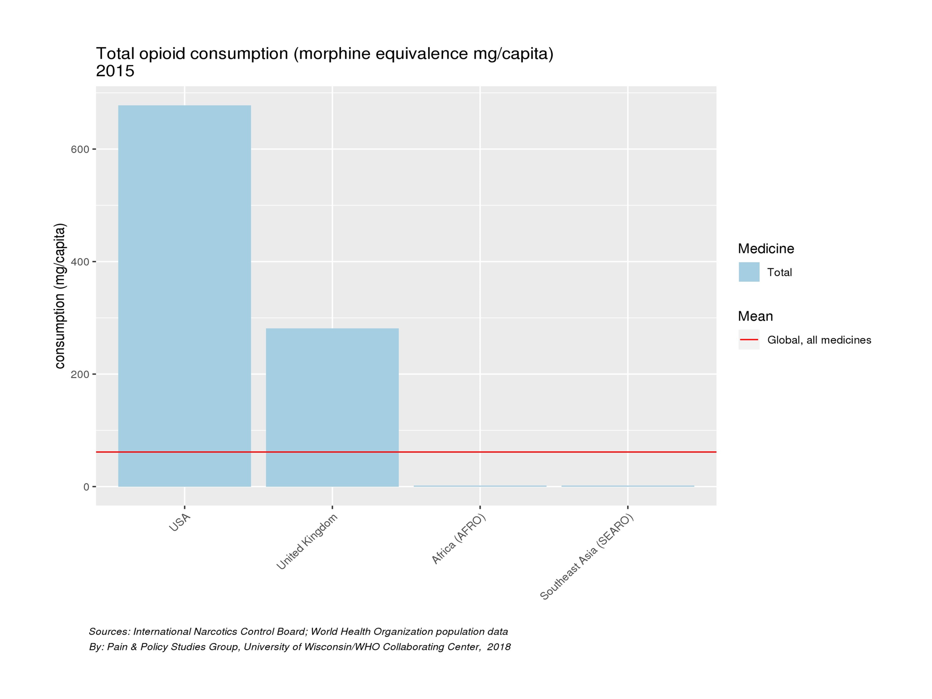

You will see that consumption in the USA is very high and in Africa and Southeast Asia it is barely visible. The UK is somewhere in the middle - does that mean we have got it just right? – this is debatable , but the more important points are that the USA is too high and the LMIC’s are too low.

The opioid epidemic

These are some statistics from the CDC (Centers for Disease control and prevention) in America:

opioids-infographic_1.pdf

These figures include data from non-prescription drugs but even so they are pretty alarming and there is some debate over the relevance of the opioid epidemic in the USA to other countries. Among the reasons for this situation , it is clear that overzealous prescribing in the treatment of chronic non-cancer pain is a major factor in the USA at least and something we can learn from. Specific to the USA are the issues of having multiple prescribers and direct marketing to patients.

One point I want to make from this, and certainly something I noticed when I was in clinical practice, is that there has been a ,lot of revised national guidance. Something I have found rather disturbing is the idea of opioid free general anaesthesia; I am no expert on this but it seems to me that the total abandonment of opioids is unlikely to be the answer to the problem. If we have too narrow a view of things then we tend to one extreme and I doubt that there is what the answers lie.

Reasons for Low levels of use

Thinking again about global issues and what might be relevant to us here: the first thing that comes to mind is what has been called ‘opiophobia’. In countries where there is very little use it becomes even more of a problem because people are very inexperienced. They don’t use opioids for acute pain or pain at the end of life as they are worried that people might become addicted although it is very unlikely in those settings. But we do have problems in our country; although we don’t see opiophobia as such we do see a limited understanding about the appropriate use of opioids in different age groups and different scenarios. We do have a problem with education in this area; for the whole of my career I failed to see any significant changes and I was always teaching the same things.

Legislation and policies in LMICs are often overly stringent and bureaucracy can be very problematic. There can be problems with medication availability where there is a lot of bureaucracy to overcome. There may be a lack of incentive for the pharmaceutical industry to make cheap preparations available and because this can be complicated companies don’t do that. Fentanyl patches might be available but oramorph might not be and that essentially means that opioids are not available to people with little money who really need them. We have a different relationship with the pharmaceutical industry in this country from North America but we shouldn’t think that we are out of it. Some of the issues around Oxycontin - some of the research around the use of long-acting opioids will have come from the pharmaceutical industry and we do need to be aware of how they affect what we do.

This is an interesting paper:

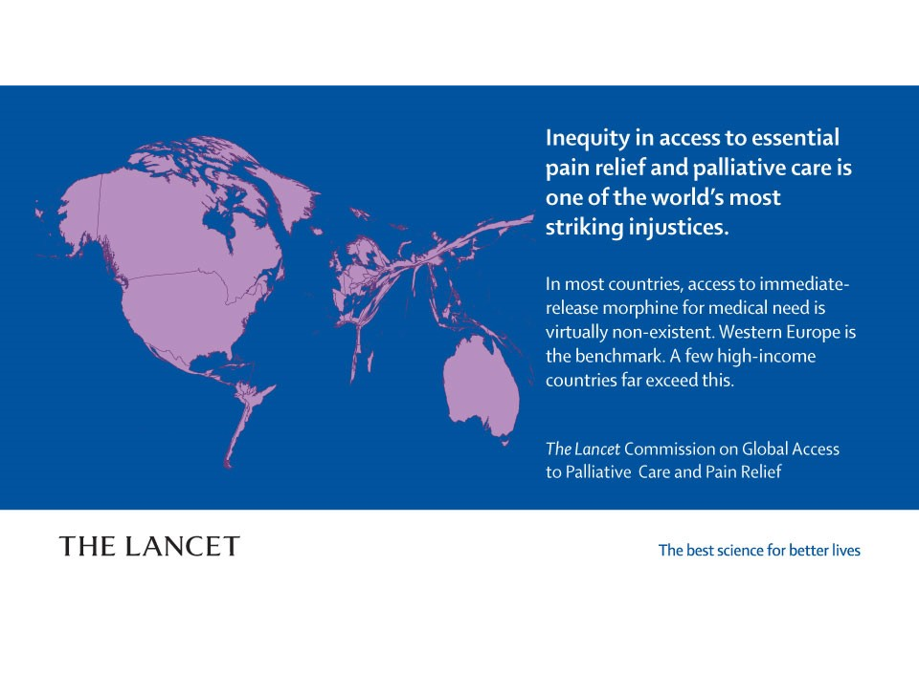

Global initiatives

I want to talk a little about these, and why I think it is important for us to understand what is going on and who is doing what and what we can do:

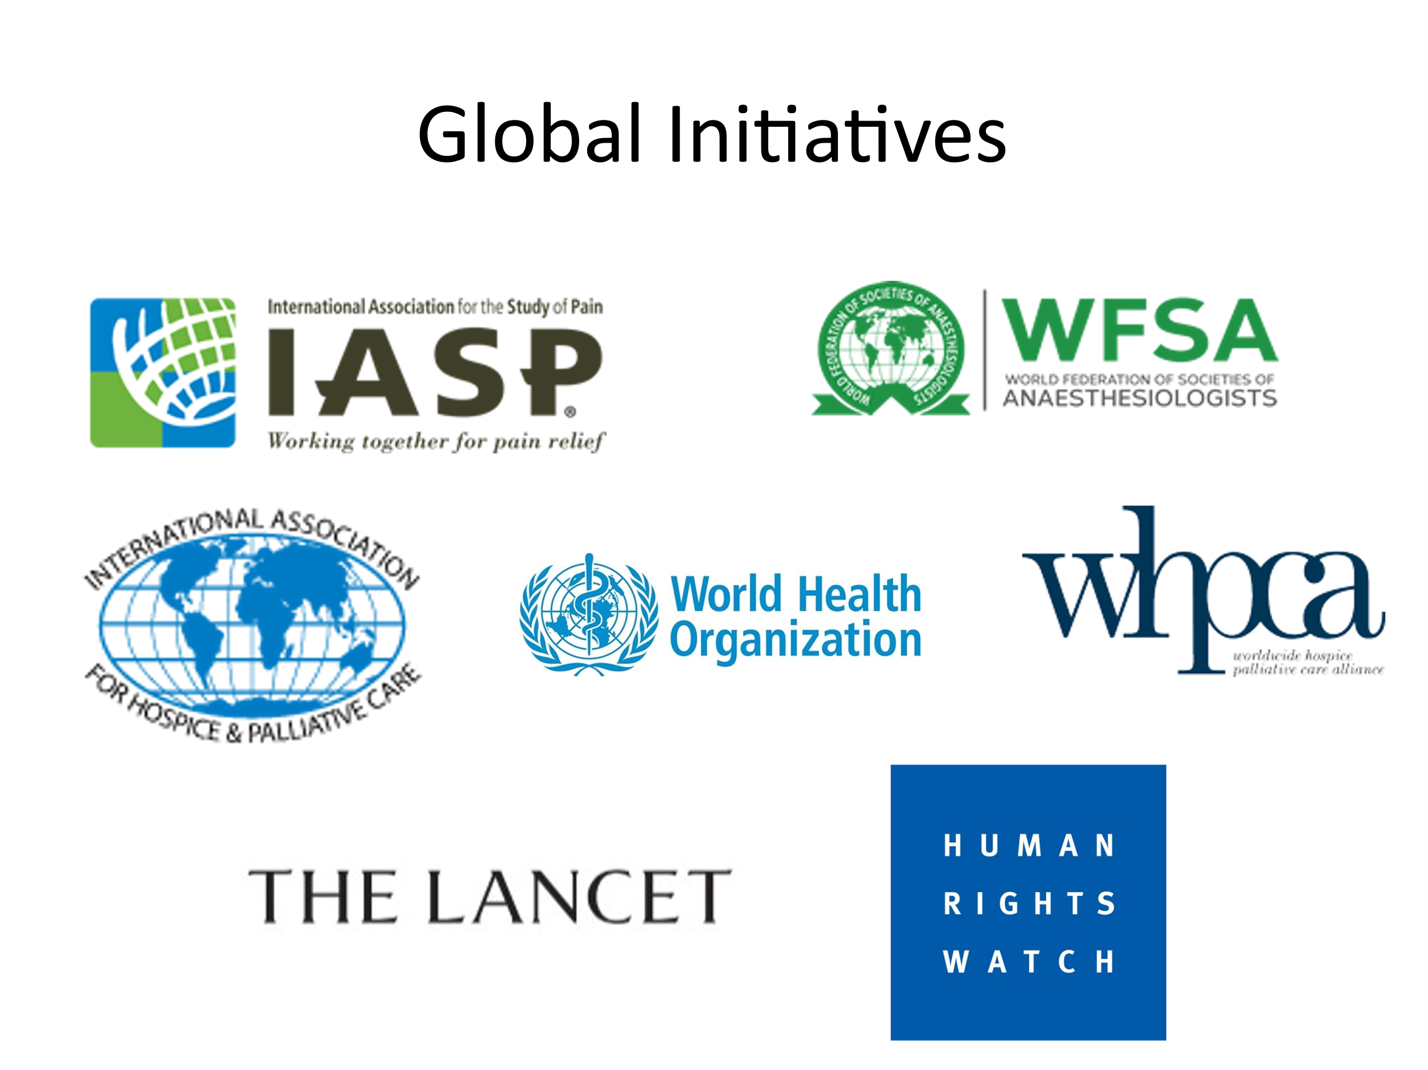

The WFSA (World Federation of Anesthesiologists) which I have been involved with tend to take a broader approach to pain management because of their membership so they will look at acute and chronic pain and pain at the end of life. But their initiatives have been relatively small and they haven’t been involved in big highly funded work. Whereas the other organisations listed here like the palliative care community are very much focussed on lack of access to opioids. Now, that is a really important thing to be doing but I think it is important to understand that it has come from the palliative care community and there has not been enough mixing with people treating non-cancer pain.

The Lancet commission on Global Access to Palliative Care and Pain Relief I was talking about earlier headlined the grotesque global inequalities in access to pain relief . I always think it was a shame that these statistics were not more widely publicized before this project. I want to talk through a few of the words they used in the report and to highlight some of the potential weaknesses which stop it being as successful as it might be. They talk about the concept of ‘Serious Health-Related Suffering’ as a way of identifying people that warrant access to palliative care and opioid medication. They list : All health conditions associated with end of life’ but I don’t think this should be restricted just to people with cancer. They also say we should be looking at ‘Chronic or acute, life-threatening or life-limiting health conditions, diseases, and injuries. They also ‘Explicitly reject any time or prognostic limitation on access’. This is where it starts to get much more difficult.

They say they have decided ‘not to focus on acute or chronic health conditions that are not life threatening or life limiting, including chronic, non-malignant pain’. That may be a good operational way to look at the problem, but I don’t think it is a very realistic way. Of the patients I have seen I would find it difficult to put a lot of them in one category or another. If we say we are not going to look at non-cancer pain but just at palliative care that oversimplifies the problem. It certainly makes it difficult in teaching both in the UK and overseas. If we oversimplify the problem people don’t believe what you are saying and if they have a different problem this doesn’t really make sense. We do have to embrace the complexity. There was a World Hospice and Palliative Care Day on : ‘Living and dying in pain: it doesn’t have to happen’. This was a few years ago now but I still hear people saying that they want their hospital to be pain-free. I can understand where this is coming from, but if we aim for a pain-free world we may end up like some communities in North America which they have been trying to make pain-free when it just isn’t possible. I think some of this comes from the fact that we haven’t worked collaboratively enough to address these problems. I know a lot of people are doing work and talking about a balanced and responsible use of opioids. But there is still a way to go before we achieve that. Going back to the patients I would see on ward rounds, people getting too much or not enough opioids, this is what we see in huge parts of the world; there is a problem with people not understanding the scale and variation of appropriate dose and the problem of the different opioid preparations that are already out there - and continue to be brought out by pharmacological companies to further complicate things. There is still a huge difficulty in understanding how different the management of chronic pain is from other pain. Co-operation with palliative care can be difficult and is a problem both on a local and global scale and the more we can do to work together the better.

So in summary:

Global problems are our problems; we shouldn’t see them as other peoples’.

We need much more awareness of the frequent use of both too much opioid and too little.

We have to embrace the complexities both of opioids and pain.

We must increase our cross-disciplinary work, particularly with palliative care

We need to engage with debates about global issues.

Discussion

*That was brilliant but to some extent a bit depressing!*

*That was a very wonderful talk to hear. However, the data you showed for the USA was for legal opioids which may be the case for most of them in the UK but in the USA deaths from opioids are almost all illegal ones that are completely outside the health system and have no relationship whatever to what physicians do or don’t do. We have been inundated with Fentanyl created in China and smuggled into the US via Mexico. So it is a completely different problem from what you have described in terms of the role of healthcare providers.*

I haven’t brought up the data on opioid use in the UK and I don’t want to conflate the two. Or talk about illegal drugs. The data I have provided on the use per capita is indeed legal ….

*… so the use is even higher and nobody has a handle on how much it is. The pinch of fentanyl that someone may add to the amphetamine they are using can kill them. That is a big issue for the US and possibly uniquely the US …*

… I think we probably have a pretty bad illegal use problem in this country

*My other question is this: there is a value judgment here not really addressed which is that there are some people who believe that the primary imperative for a physician is to relieve pain. But others say – “wait a minute, there is no evidence that long-term opioids are beneficial for patients, and there is evidence that they cause problems”. So where do you place the value – do you want to make sure that everybody has adequate pain relief or are you more concerned with not producing people with chronic pain which is not relieved by opioids, like the example you gave.*

My understanding is that there are a few people who do benefit from opioids for chronic pain and as I said about opioid free anaesthesia I don’t think we should throw the baby out with the bathwater. When I was in practice there was an argument for trying them in a certain amount and if it doesn’t work then you stop it. What you don’t do is keep increasing it. But only a small group may benefit. Is that still the current practice?

*If we are talking about people who have had an acute injury or operation and they need an opioid to start with, there is a point when the opioid needs to be tailed off so they don’t get to go home with a whole bagful of stuff. Is that where the problem begins?*

I am reluctant to try to give all the answers but there is a lot of overlap of people who are likely to have long-term pain and people who are likely to have problematic opioid overuse. I am not now practicing but when I was the advice was just to be vigilant and make sure you stop it if indicated.

*We are only talking about pain and I am surprised that no-one has mentioned disability which doesn’t correlate all that well with pain. I am a sociologist and I observe patients being treated and I don’t treat them myself. In that capacity some of my research is into behaviours including return to work . I did pick up quite a few patients continuing to work on opioids. I don’t know their pain scores but on the whole opioids don’t seem to delay returning to work , rather the reverse.*

That’s really important; it isn’t all or nothing or likely to be and we need to accept that and need to be vigilant about it. Your other point about behaviour is also important; when I was first working we were trying to focus on that and in some areas not to be looking at numbers but be looking at function which may be far more relevant.

*There have been some good data about function rather than pain. But it is difficult for you guys – by which mean pain specialists – to look at function when you have limited time with them; how do you know about their family etc.? Another thing: we have had one guideline after another, at least in the US, but they don’t seem to have much influence on physician behaviour. Too much opioid is still prescribed for back pain here. So how can you change physician behaviour?*

*As a person with lived experience of pain treatment … you have hit upon our problem which is about how and what we get prescribed. I started with co-codamol which didn’t work, nor did the other drugs, Tramadol, amitriptyline etc that they kept adding until they tried morphine which didn’t work either so I ended up in hospital.! I am trying to work with the South West [?] people trying to promote the understanding that we don’t need things added and added and if the first pain medication doesn’t work the chances are that none of the others will.*

*I have had lived experience of this and lost several years of my life just existing in an opiate haze.*

*Are you on any such medication now?*

*I came off it all but my spinal stenosis is giving me awful cramps in the evening in bed and the first thing that was prescribed for me was Gabapentin! I’m not taking it all the time but I don’t know what to do. You come off your medication and try all the other interventions to self-validate and self- manage your pain and they kick you back into it. I don’t know if it is lack of lack of time or lack of education and understanding of chronic pain. I’m not finger-pointing; we know there are people in primary care in particular who are so up against it and I don’t hold anybody responsible.*

*I do have to say that one of the biggest helps to me as an intervention has been moving with Tai Chi. I want to ask* *: what do we do to move people away from expecting to be pain free. We are given the dream of a pain-free world but is that realistic as we get older?*

*I have been a GP in the same practice for more than 20 years. I presented to this group sa couple of months ago on how doctors respond to people in pain, and presented some evidence that the less you feel personally able to provide the caring support you know your patients need – whether it is personally yourself in terms of time and continuity and compassionate listening and so on, and access to the good sources of help and can refer to something like Betsan‘s Tai Chi or any one of the wonderful therapies that the NICE guidance recommends these days - the less you can do that sort of thing the more likely you are to reach for your prescription pad. In the UK opiate prescribing is higher the fewer GPs there are per patient population and the greater the level of deprivation. So I am extremely concerned by the tone of this presentation tonight: that in Low Income Countries where there are few opportunities for any alternatives, the requirement that people should be pain free could lead to vast quantities of opiates being prescribed.. Thomas Main\* studied nurses on a ward back in the 1940’s and observed that the less time they could spend comforting patients the more they dished out sedatives to keep them quiet.*

*I am deeply concerned about the lack of any sort of psychodynamic awareness or concern relating to this - myself included; if you come and see me at 6.30 on a Friday night I am far more likely to give you opiates to get you through the weekend when I have run out of energy and compassion.*

*There is also the problem of rampant individualism: we are disconnected from one another and the sort of social cohesion; informal muddling along in family or neighbourly caring association is so lacking that people are turning to looking for a drug fix, and I see that all the time with people saying they are sure I’ve got a certain diagnosis and demanding drugs to treat it.*

*I am also a GP. A lot of my patients are very socially isolated and love very difficult lives. Many of the people we encounter in our telephone triage service are phoning because they have fibromyalgia or back pain or knee pain and are already on polypharmacy but are still struggling because they are in so much pain, and sometimes we have to make snap decisions about how we are going to deal with it while we are on the phone about increasing opiate dosage or adding something or changing to Duloxetine … .* *In general practice we are feeling unsupported although we do have pain clinics in our hospitals. There is a 26 week wait for physio. We do struggle as to how to help people. I have been able to pick a few people off the triage list and sometimes sit with them for an hour to talk about pain etc.*

*\*https://en.wikipedia.org/wiki/Thomas\_Main*

*I am a retired GP and we had a thing called social prescribing so you could send people to a gym or that sort of thing . It didn’t really matter what was wrong with them: obesity, FM or bad back or diabetes or depression. They got encouraged to move and were in a social group and it was very interesting to see how that worked. Have you still got that?*

*We have at least six or seven outlets for social prescribing in our practice which are very active. We are talking about setting up local fibromyalgia groups and even some sort of holistic pain clinic.*

*I was upset about what Jonathan was saying about people being given sedatives to keep them quiet. Back in the early 1980’s I was a senior physio in charge of the physio department in a big elderly care hospital. There was a massive patient load. We had a long stay geriatric ward where people stayed for years sometimes. We couldn’t do much actual therapy as we were really trying to get people out of hospital. So we went and started a …. on this ward but before we could start any physio we had to get people ready to do that. It was the worst thing you could be faced with; like many care homes there were people sitting around – in those days they used to tip the chairs back to stop people wandering round - and they had the TV on all day and every day. They all wore incontinence pads and they were medicated up to the eyeballs. So we introduced a whole load of activities for them – more OT than physio. We switched the TV off and divided the room up into small groups. If someone has been in a tipped back chair for months on end they have forgotten how to walk so we got the nurses to walk them to the toilet and back even if they have had an accident. We tried to give them some meaning and purpose for the day. We made sure they wore their own clothes and shoes; we gave the women hair-do’s and makeup if they wanted it. And gradually things started to change. They needed less medication. I remember one lady who used to scream all night; she had excruciating hip pain or so we all thought, and screamed every time we moved her. She was supposed to have a hip replacement but we knew that would be a disaster. So we just worked with her and gave her some sort of meaningful occupation within a group. And she stopped screaming! They were able to reduce her medication. I was lucky enough to get an extra physio assistant to help with her.*

*This sounds like violation of human rights - if not torture!*

*Our conversation tonight reflects the complexity of chronic pain. [? The Guidelines? are] relatively simple by comparison. It’s not surprising that we don’t get much out of them in a chronic pain scenario. I suppose this is reflected in what we see. The reality is that , certainly in the pain clinic, although it may be a bit different in primary care where you have more people that are able to use very low dose opioids, perhaps intermittently, as a tool towards maintaining their functionality and quality of life. But once people are arriving in the pain clinic, in my experience it is rare to come across someone who is getting significant long-term benefits form opioids. They are hardly worth trying because it takes so long to find someone that they will help and it’s going to do so much harm along the way. I am sure the answer lies in more community projects returning access to the things people are talking about. We need to change the conversation around opioids and I share what Jonathan was saying about it being a bit worrying when we are talking about back pain being a leading cause of disability worldwide; so a lot of people out there in the world don’t have access to pain relief or the holistic ways of managing it. Of course there are many people who need palliative care who don’t have access to opioids but if you take non-cancer pain out of it, I would be worried that there are areas of the world, where people are very vulnerable, and where we oversimplify the message about opioids, so they hear the damaging side of that message and unfortunate consequences may follow.*

*I’ve always wondered what other societies can teach us about what we could be doing better as a society.. Is there anything that you have seen in other countries or societies that we should be aware of and will help us with what we do here?*

Going back to what a few other people have said this evening: what I have seen is that once you start medicalising a problem we can get an over-simplistic idea of how we can treat very complex things. Medicalisation can be great for some things: it’s great for acute pain and people are mostly pretty good at that, it’s very good for some problems at the end of life and we’re pretty good at treating that. But there are problems with medicalising some chronic pain – I don’t want to oversimplify things the other way by saying it’s brilliant in societies where they don’t need sophisticated medicine because everyone looks after each other but if we start taking out all the social cohesion and family support and the other things that make life worth living and look for all the answers in a bowl of [?] morphine clearly we are not going to get that. I don’t know if that answers your question; I haven’t addressed specifics but in general Western individualism is not great for all sorts of suffering. But we have to be very clear though that there are people in low-income countries who have the most horrific and avoidably painful deaths for the sake of being able to get 2p’s worth of morphine which would give them a much better end of their lives. I think we should be careful - I mean I don’t want to give the impression I think all medicine is bad, but there is a time and a place for using the technologies we have and the more we can appreciate where they should be and the better they can be implemented.

*Clare – you spoke at one of our summer meetings many years ago about pain management in under-resourced countries and my recollection is that the major burden of your talk was the necessity for education. There seemed to be a quite optimistic message that there were world-wide efforts in education that promised a way forward. So I was wondering: to what extent those efforts have been successful in the intervening years?*

I would love to be able to say that there have been a lot of changes that have resulted but there certainly has been a lot of education. Some of the educational groups that I have been involved in like the EPM (**Essential Pain Management)** programme\* ,run by the WFSA, that I have been involved in ha\s gone to 60 countries now and there is huge interest. Issues like the opioid crisis in America have brought things to the forefront in many areas. I’m sure there are changes but it is difficult to see the actual endpoint. There is a lot of educational work going on and we need to keep learning, don’t we? We have had a lot of pain education in this country but we still have a lot to learn.

\* https://wfsahq.org/our-work/education-training/essential-pain-management

*A very interesting discussion about a superb talk but I found some of it very distressing, because [?at one time? Inaudible …… ] I wore several hats; we had really good team communication because we were the same people in the acute, chronic and palliative care pain teams. But what you have described we saw on the wards all the time, although we educated and educated and educated. Since I and my acute pain nurse have retired we feel we are back to square one with under- over- and inappropriate dosing. So we must have something basically wrong with our education, not just because it is a very complex subject but possibly because we keep trying to simplify it too much. But one of the things we did – if we go to acute pain in hospital and trauma and discharge, patients are discharged very much earlier than they used to be so their pain is still in the acute phase and they are often still on opioids; I was an advocate of reducing opioids in anaesthesia which worked very well but they need a plan. House surgeons are under pressure to discharge people quickly and the GPs are under pressure so they just repeat the same script. So we spent a lot of time following some other hospitals’ examples in New Zealand with much bigger teams, preparing a protocol for house staff with patients on a high dose, on a weaning programme and a faster one those on a low dose etc. There was guidance for the patients and for the GP involved in this, so we could actually discharge people with an acute problem with this sort of guidance. Without it people would just carry on with the same dose and there was the same story; it happened in New Zealand as we know it did in the UK and the USA where people were discharged and the doctors were scared that they would be in pain so they kept on taking drugs like lollies. As everyone has pointed out it is much more complex; early discharge sometimes means they haven’t got social support; you can’t get to see a GP for weeks and they are left on their own. So having a protocol that they were*

*Involved in did I think make a difference.*

*Do not be too disheartened. Things are changing in the UK . People with chronic pain are realising that what we do need is some form of social cohesion, which we are beginning to do both online; and we are spreading the word. My local ISB (Integrated Care Board) has given me some money to* *set up* pain cafés which will *be for people in pain to give that support network so they won’t have to be constantly ringing the GP and we can help them with the self-management of their pain. So it will be ‘by the people for the people’! Isn’t that brilliant? And it is happening all over the place: Cornwall, Devon, Somerset, where Tim lives in Salford … they are beginning because we know that chronic pain is complex. A lot of the issues affecting it aren’t just pain: the environment people live in, poverty, low educational achievement etc. We have people coming off medication, not seeing their GPs or going to A&E half as often. Some of it is because they come to believe they that somebody cares about them*

*Pain cafés take several different forms. A lot of them were using the Live Well with Pain, Ten Footsteps Plan and other self-management tools like the Pain Toolkit . They are not necessarily run by healthcare professionals but they often are. You might have some medical input but you might have a health coach or a social prescriber running them. they create a network so that people don’t feel lonely or that no-one understands them*

*Do they just talk or do things like Tai Chi?*

*Any holistic stuff you want. I am working with my ICB to do an event in Glastonbury at the end of January; we’re going to do a bit about medication, about Googling …. Doctors are coming in the morning and patients in the afternoon to introduce the concept of health and wellbeing in order to focus on something other than being sat at home worrying about their pain – all what I could call the soft skills – rather than worrying about their opiate medication …*

*… and their next appointment with their GP or pain clinic …. or going to A&E because their pain is worse. People can get on line and ask whether they should go to A&E – we aren’t doctors but we can ask the appropriate questions. I know a physio who works part time in A&E who says that if it people weren’t coming about pain they wouldn’t be so overworked.*

*I have worked quite a lot in China and I was surprised to see that China doesn’t even show up on the world map of opioid prescription and for people who are in the throes of death that is bad. But as the drug companies get a foothold there we will see a lot more opioids.*

*Can I draw your attention to the excellent chapter Clare contributed to our book* Innovative approaches to Chronic Pain *(a collection of essays by former SIG speakers) entitled Pain Management - an Alternative Global Perspective? There is also a chapter by John Loeser: ) ‘*Why the Opioid Epidemic in the USA?’*.*

*I want to give a little plug to using hypnosis for chronic pain which I have used a lot for chronic pain in patients for whom the drugs weren’t working. Some patients responded very well. It didn’t necessarily take very long, and you could teach them their own self-hypnosis and using imagery like putting soothing cream on the painful area and that kind of thing. You are using the patients’ own resources, their imagination and creativity and they love it*

*The acknowledged world authority in hypnosis research for pain is Mark Jensen of Seattle who has written the book* Hypnosis for Chronic Pain Management*\*, which is absolutely brilliant. He led an excellent workshop in Turkey last October which I went to. He makes it sound so easy.*

*[There is also a chapter on hypnosis and pain by Ann Williamson in Innovative Approaches]*

[Hypnosis for Chronic Pain Management: Therapist Guide (hypnouniversity.com)](https://hypnouniversity.com/wp-content/uploads/2019/06/Hypnosis-for-Chronic-Pain-Management-Mark-P.-Jensen-1-1.pdf)