Holistic Practices for Holistic problems: how yoga and breathwork help people with “total pain” and “total breathlessness” in advanced illness.

Webinar 7th February 2022

Kate Binnie

My breath journey started many years ago. I am a singer and violinist and my first degree was in music, so narrative, flow and melodic line are my home. I trained in music therapy at the University of Bristol, and did mindfulness and Yoga training as well; I was searching around for a set of skills to complement the psychodynamic music therapy training I had done. I became a hospice music therapist and have worked in palliative care since 2010. In 2015 I finished a part-time Masters in palliative care at King’s College London. Since then I have worked on a Wellcome Trust funded project called Life of Breath* with Havi Carel.
.
I am also involved with the Oxford Brookes university centre for spirituality and wellbeing and have helped develop a course in psychospiritual care. I am currently doing a PhD at Humboldt medical school looking at breathlessness.

So I am going to talk about the relationship between mind, body, breath and spirit (whatever that is) and health.

The breath landscape

It has become the norm that we are out of time and out of breath. There are lots of people living with chronic ‘diseases of aging’ such as lung disease, and heart failure. We have Covid-19 and long Covid. We are beginning to recognise the social determinants of breathlessness and the way the pandemic has impacted disadvantaged communities disproportionately.
But there is also increasing awareness of breathing as a tool for wellbeing. We see studies of children doing mindfulness and Yoga in schools. But it’s separate from applied healthcare and you rarely see doctors, nurses and others working in healthcare - apart from physios who are probably focussed on dysfunctional breathing – focussing on breath as a means of improving wellbeing. Covid -19 has provided an opportunity for epistemic re-evaluation and a new way of thinking and talking about breath and bringing it to the fore. This became apparent when people couldn’t be, breathe or sing together. There has been a shift in our relationship with breath.

The psychosocial tasks of breathing

The pressure of expiration supports communication. I couldn’t be talking to you without breathing. The rhythm and depth of breathing and the use of accessory muscles provide non-verbal communication on how we and others are feeling. Breathing is an exquisite barometer of feeling and a very useful tool when working with patients. Learned association and past experience affects here and now breathing patterns. Calm, full breathing gives space for recognising, reorganising and expressing feelings under the level of voice communication. A lot of the patients I work with can’t speak but we can still breathe together. Breath mediates our outer and inner landscapes, permeating the ‘envelope of the body’.

* https://lifeofbreath.webspace.durham.ac.uk/
.

Metaphysical breath and the sacred space

We talked a lot about the Metaphysical Breath in the Life of Breath project which involved people form a wide variety of humanities as well as clinicians. There is a sense that the words for breath imply more than just respiration across different religious and cultural traditions. For instance in the Tibetan tradition Rlung is a sort of spiritual wind that flows through your body which may be health-giving. The Hebrew word Ruach means ‘breath of life’ , and the Latin word ‘spiritus’ means breath. Prana in the Vedic tradition and Qi in the Chinese tradition both have spiritual and emotional connotations. In the biblical account of creation it says ‘God breathed life into the man’s nostrils & he became a living person’.

As a psychotherapist I am interested in what is going on in what Martin Luther calls ‘the sacred space’ between I and Thou: when we sit together with a patient without the usual clinician patient hierarchy and are just two people in a room. Quiet breathing helps us to enter this space.

I am going to do some breathing with you but first I want to share this quotation:

We wish to say that the Complete Breath is not a forced or abnormal thing, but on the contrary it is a going back to first principles – a return to Nature. The healthy adult savage and the healthy infant of civilization both breathe in this manner, but civilized man has adopted unnatural methods of living, clothing etc, and has lost his birthright.
The Yogi complete breath

We can see this in an infant sleeping in his cot with just a nappy on, on a hot night – his belly rising and falling. It’s not complicated - it is a sort of letting go.

[We were then taken through a breathing session , first making ourselves comfortable and softly rolling our shoulders and necks , uncrossing our legs and grounding our feet on the floor, then closing our eyes and letting go with a sigh. Then perhaps visualising a beautiful scene … we are grounded; our eyes neck shoulders spine and legs soft and relaxed … Note repetition of ‘soft’. We don’t notice that a lot of the time, particularly If we are in pain, we hold ourselves and constrict certain areas of the body like the belly; so we were invited to put our hands on ours and notice a slight swelling as we breath in and fall as we breath out – not doing anything but letting go. Then we were to drop down into the experience of breathing, perhaps visualising it as a wave on the sea rolling towards us and into our bodies up to the crown of our heads and then rolling away from us … again , and again.]

So what did that feel like?

From chat: Calming, stilling, spacious, connected and restful

Clinical practice: Embodied Relational Techniques

So when working with people with anything that impedes their breathing, like pain, we can see a way into helping them.

As a music therapist I found that for stress, pain and breathlessness – all forms of suffering including that I encountered working in a hospice - responded to basic human connections.

These include:

Embodied listening; there is listening while you are doing something else like washing up but this is really listening with your whole body. You know when someone is doing it but it is rare because it requires real intention to be open

Co-regulation of breathing and “tuning in” to the body: I have found, particularly with non-verbal or even semi-conscious patients, that you can come alongside and resonate (not copy). You meet someone where they are and bring this down to a place of coherence; this is tuning in – it is very subverbal – to what their body is telling you

Soothing touch (and self soothing): touch that is appropriate and has been permitted. This may involve simply putting my hand on the patient’s or even their foot. This can be very helpful but in addition I sometimes get people to hold themselves (like the way I held my belly when I was demonstrating breathing)

Co-to-self-regulation via integration of the body: we are doing something together so that I can have an experience of it and perhaps do it to myself. If someone is dying you might be doing co-regulation to the other people, perhaps the family, in the room.

Up & top-down processes; interoception and perceptual inference: we are developing interoceptive awareness – what I feel in my body and understanding what it means and what I can infer from it. This is very useful in pain.

These tools can be shared quickly with caregivers and are very useful when you are dealing with families and family members who are very distressed and calling emergency services in the middle of the night.

Being first, then doing
Donald Winnicott

Winnicott talks a lot about being with the patient, and the action coming from that quiet receptive state. Even if we think we haven’t got enough time we can think, as Cicely Saunders taught, about depth of time rather than length of time.

So how can we be present, for instance in a busy ward or a busy GP surgery?

When I was working as a music therapist I found that many people were so distressed that I wasn’t even getting to the music bit, and realise that what I had to do first was to be with that person in the room and help them to downregulate and be calm enough to describe to you what is going on for them, and to start this creative process together; to bring that person back into their body and their breath. And I found that pain and distress were always downregulated – there was genuine reduction of their symptoms and it really worked.
So I asked myself – what am I doing? Not Yoga or even music therapy. I came to call these Embodied Relational Techniques: just a way of being human, and the building blocks of our relationship with each other. These techniques influence the emotional response to a perceived homeostatic threat such as pain or breathlessness, an existential threat such as death, or an environmental or interpersonal threat be it place or perhaps a person. We are influencing peoples’ emotional responses at a very sub-verbal level ; emotional responses which are instinctive & adaptive and necessary for survival, which drive behaviours that involve shutting off or reaching out which might be appropriate or become maladaptive. But you can’t tell someone to “feel safe”…it doesn’t work, the feeling has to be in the body.

Cicely Saunders talked about ‘the psychodynamics of containment’, illustrated by a picture of the mother holding her baby. She writes:

“A child separated from her mother may be quite safe – but feels very insecure. A child in her mother’s arms during an air raid may be very unsafe indeed – but she feels quite secure.’ We have to give all patients that feeling of security in which they can begin, when they are ready, to face unsafety.”

Saunders, 1978, p.6. Cited in Kearney “A Place of Healing” (2000)

The secure base experience

A set of behaviours is activated by threat, which could be pain or breathlessness or being abandoned. These are affected by our lifestyle and experience. There is a response to those behaviours by the care-giver, be it professional or partner or whatever, and a psychophysiological state is co-created. When that state is good enough you get a state of relaxedness, warmth, closeness and soothing; a sense that “all’s well”, accompanied by steady breathing and reduced heart rate. There may even be a sense of playfulness, which in my work is the place of music, such as creating a song together or playing with a xylophone. And in that state there can be a reduction of negative emotions like shame, low self-esteem and fear; and also a reduction of somatic symptoms such as pain and breathlessness¹

Polyvagal theory²

This purports to explain the response of the autonomic nervous system to stress and in particular the role of the vagus nerve in emotion regulation, social connection and fear response. This is involved in Interoception (detection beneath conscious awareness of internal states) and neuroception (detection beneath conscious awareness of external environment). It can be dys -regulated by past experiences. It postulates co-regulation: reciprocal regulation of autonomic states leading to feelings of safety and self-regulation. It affects breathing patterns so calm co-breathing is a way-in to co-regulation.

So in practical terms, allowing and soothing urgent bodily sensations such as pain, agitation and breathlessness) leads to changes in feelings like anxiety, fear and hopelessness. This in turn leads can affect ”hard” outcomes: changes in behaviour and decision making, like medication use and emergency treatment seeking.
This is a ‘bottom up’ approach: from body to emotions to thoughts to actions. It is flipping the CBT model around as it starts at a sub-verbal level and cognition, meaning-making, evaluating & planning come last on this model. It is the foundation for other things to happen, and is the basis of my thinking and the programmes I am developing.

Breath and pain

Cicely Saunders’s concept of total pain – physical, social emotional and spiritual - will be familiar to this audience and this holistic model is central to pain medicine and this is why the metaphysical quality of breath: the way it mediates every aspect of our lived experience and all these components of total pain, can be so effective.

¹ Recommended reading: The search for the secure base: Attachment Theory and Psychotherapy, Jeremy Holmes 2001

² Polyvagal theory - Wikipedia
My MSC thesis involves research into yoga for pain across advanced disease, looking at outcomes, experiences and advancing a theory of change. It is a narrative synthesis of 22 papers which showed limited evidence of effectiveness of Yoga for pain reduction in nine conditions including cancer, renal failure, MS & lung disease, dementia and HIV. These papers are mostly of poor quality, heterogeneous with different outcome measures and where they were attention matched there was a non-significant reduction in pain. However there was a significant improvement in quality of life.
Qualitative synthesis revealed these congruent themes across 8 papers: pain coping, embodiment/self compassion towards body-in-pain, wellbeing, “tool for life”, acceptance, relatedness, spiritual awareness. So this is broader than ‘ouch’ pain and addresses total pain with the aim of restoring some wellbeing

Recovery is possible. Some of these people were living with advanced disease but they were finding a sense of compassion, acceptance and wellbeing. These are important outcomes when you ask patients but are they important to policy makers?

Breath was the most cited tool compared to the other elements of Yoga.

Mechanisms of effect

These include neurophysiological, cognitive and behavioural, and psychological factors. The circular model below is intended to show the flow. Conventional before-and-after pain outcome measures are inappropriate because it’s not like that – it’s changing all the time; there can be a virtuous circle of benefits

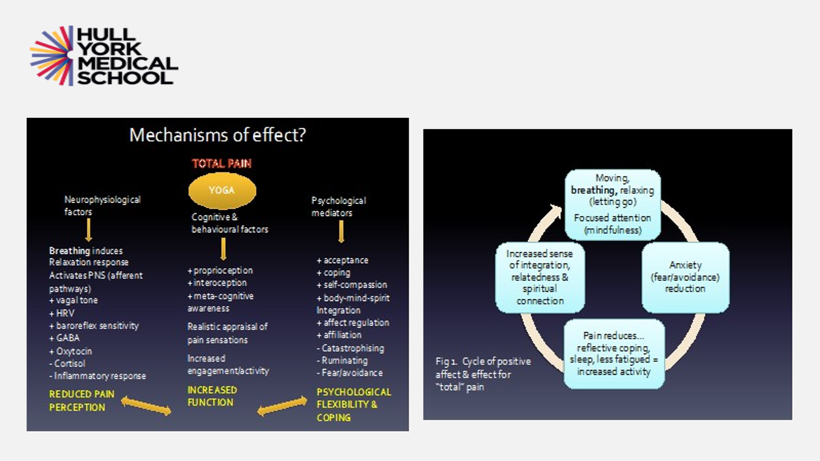
What hospice patients say about my yoga classes:

• The yoga gives me something I can do. I feel in charge of my body
• After the yoga I feel younger, more energetic
• My pain levels are less random and more predictable giving me better coping ability... overall a huge improvement in living with pain
• I have nerve pain in my arm… but the relaxation helps me to take control when the pain is particularly sharp and uncomfortable
• Focusing on my breathing patterns helps my lungs to function with greater ease and more capacity

These were more about the body but there were psychospiritual outcomes:

• … It’s because I feel relaxed and I used to panic about things
• ….compassion to myself and others has helped….
• Acceptance that I’m not going to get better … acceptance of my current situation plus the peace that comes with that acceptance… How long I will live is an open question so I am just grateful for each day that I am alive and here
• A closer connection with the world around me

These were people who may have been wheeled in on their beds – some with end-stage neurological disease and could only indicate with their eyes that they want to come to the class and could only do it in their minds. There were people in pain, people who were breathless … nauseous … I think they wanted to come because we had created this contained state where there was a lot of quiet breathing and a sense of being together.

Dysfunctional breathing

I want to try another little exercise with you to help you understand what this feels like.

[The audience were asked to]

- Block off one nostril, then a bit of the other one to experience breathing through a very small space as in a restrictive breathing pattern

- Inhale fully to the top of your head and exhale just a tiny bit (to collar bones) to experience an obstructive breathing pattern

• Reverse breathe – tummy goes in when you inhale and out when you exhale
(common in asthmatics)

• Clench fists, buttocks, jaw…… and notice if you can do that calm quiet breathing – it’s
not possible, is it?

I do this exercise a lot with respiratory doctors to give them an idea of what their patients’ symptoms feel like.

Reactions from chat:

Trapped; panic, panic, panic; exhausting and anxiety provoking; wuite frightening
A typical patient

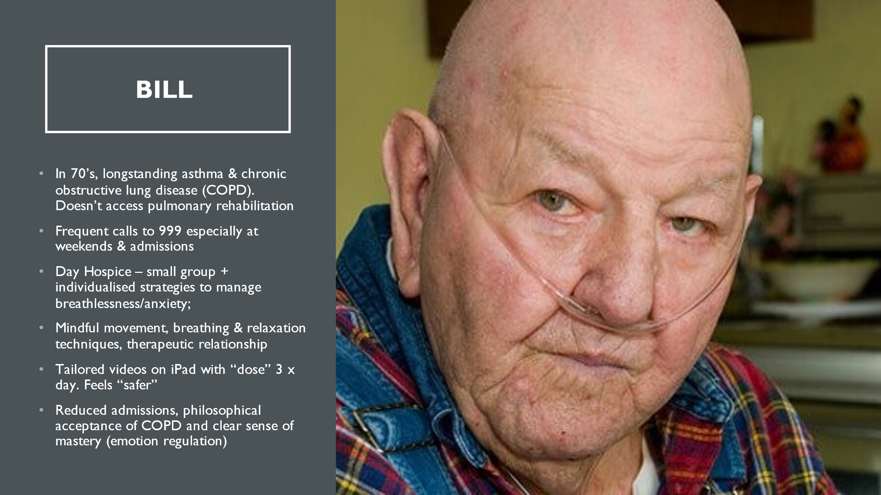

Bill (not his real name) was in his 70’s; he has longstanding asthma & chronic obstructive lung disease (COPD). He doesn’t access pulmonary rehabilitation. He makes frequent calls to 999 and 111 especially at weekends. He is very socially isolated. He was referred to the Day Hospice by his GP and he came to my small group. He was very anxious, on continuous oxygen and continuously demanding for his breathing to be ‘fixed’. Together, we developed some individualised strategies to manage his breathlessness and anxiety; these were embodied relational techniques which included mindful movement, breathing & relaxation . But the crucial factor was our trusting therapeutic relationship. Together with the OT we created some tailored videos on an iPad which he could use as an emergency “dose” before dialling 111. He immediately said that he felt “safer” and stopped going to hospital. I was just a transitional object (in psychodynamic terms): he could see my voice and hear my face and know someone was with him. Instead of constantly demanding a cure for his COPD he started to talk about it in a different way; he had achieved clear sense of mastery. So all was going well until he was discharged from the day hospital; you were only allowed a certain number of weeks, and Bill had two rounds. Shortly after the second he died; he was found moribund at home by the respiratory nurse and died in hospital. He had no family or friends and the nurse and I were the only people at the graveside.
I will never forget this man; he was helped and made me think: there are lots of people like Bill out there – if you work in General Practice you will know them – and you could tell a similar story about someone in pain. I perceived that there is a sink-hole in services for people like Bill; an implementation gap. So he was really lucky; most are not referred to hospital. They are offered pulmonary rehabilitation but they don’t go. They may get oxygen but they may never get appropriate care until they die in hospital. They are mostly from poor socioeconomic backgrounds.

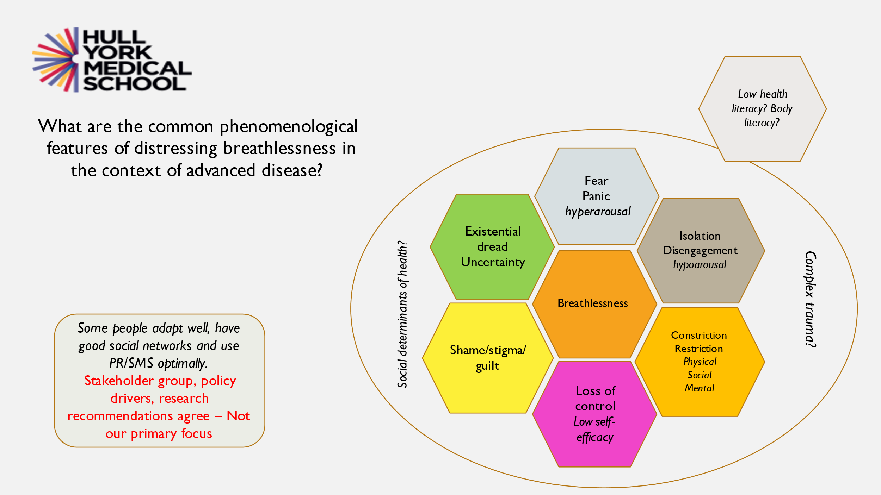

This is the basis for my research: the common phenomenological features and the mechanisms and the triangular model of distress which can be used to support these patients and their family care givers.

Further reading

The Science of Breath: Yogi Ramacharaka 1903

The Breathing Book: Donna Farhi 1996

Compassion: Christina Feldman 2005

The Healing Power of the Breath: R. Brown & P Gerbarg 2012

Mindfulness for Health: Vidyamala, Burch & Danny Penman 2013

Breathing as a tool for self-regulation & self-reflection: Minna Martin, Maila Seppa, Paivi Lehtinen and Tina Toro 2016

The Body Keeps the Score Bessel van der Kolk 2015

Embodied: b Christopher Eccleston 2016

Anything by Thich Nhat Ha
Discussion

We teach the principles of Tai Chi in my classes and the first of these is embodied presence; and we teach them something called a kangaroo tail (A kangaroo can sit on its tail when all four limbs are flailing around) which is a useful way of grounding themselves. So we get them to imagine the line of their thighs and visualise the base of their thighs extending down into the ground, which provides a firm base of support. So every time they feel anxious, breathless or in pain they can find their kangaroo tail. More recently I have been working with people with long Covid. One of the ladies in my group has frequent non-epileptic seizures and manages to control them completely with her kangaroo tail as she feels her anxiety level rising. .She hasn’t had any now for six weeks.
Most of the people in the classes are living with their minds and bodies separated in an attempt to get on with life, but teaching the Kangaroo tail has been an achievable way of helping them to reunite them if they are suffering from pain or trauma; so like the kangaroo you can find that stable base when everything around you is chaotic.

I love that image! Imagery is very important and powerful. I use the image of the tree rooting itself into the earth. Steve Haines has written several books including Touch is really strange and Anxiety is really strange. He talks about OMG: Orient Move Ground* I think these mnemonics are really useful. I am particularly interested ion the relational aspect of this. As health professionals we have been inclined to think that patients are ‘over there’ and I am ‘here’.
But we have all been ill. Covid has flushed out healthcare professionals’ distress. We will all die – life has a 100% mortality rate. But the breath can be a shared space. Your own breathing can affect the person you are with.

[Partly inaudible question about people with different attachment styles …. fearful people … do they have difficulty engaging with this? ]

Yes … I am careful with the language I use when introducing this. I always say something like “it might be a way in, but it’s not the only way …” I have found that even with people who are avoidant or anxiously attached or have chaotic attachment styles, there is something about this modelling of a secure base experience that it may be something deeply needed. It may take persistent and a few attempts to create that space, but in my experience it is sort of like magic as you are meeting a deep longing for a secure attachment, even in the most difficult patients.

Looking at the chat reports of our experiment with dysfunctional breathing the words that came up were frightening, trapped, panicking. And that is what people are living with all the time.

* https://trecollege.com/orient-move-ground/

I am also interested in our reactions as professionals to something we can’t fix. I did some training with GP’s a while ago and I got this email a few weeks later from one of them who said it had completely changed her relationship with the patients she didn’t like seeing:

“I also would like to share a very positive experience I had following your advice. This morning I had a follow-up consultation with a patient with medically unexplained breathlessness who had a significant improvement of her symptoms after I advised her to try the techniques you showed us last month. The impact this had on her quality of life was impressive and left me mesmerised. She mentioned that she felt listened to and thought about our conversation when she tried to relax during attacks. This, of course, made me think about you. I am very grateful for what you taught us on that day. I definitely would like to keep learning about this as I feel it could benefit me as a clinician and a person, but most importantly my patients.”

I have used hypnosis for pain for years – I hadn’t tried it for breathlessness – and it seems completely parallel. You can teach people little anchors like touching your thumb and finger tips together to immediately make you feel calm, and you can programme that in in a hypnosis session. Or you can take them to a beach or up in a cloud to get the same feeling of calm and security if they are panicking. It seems very similar.

Absolutely – and what we both are doing is antidoting pain and stress with positive somatic markers , as on this slide:
- Body-based practices may enable a “waking up” to positive experiences

- Rebuild a repertoire of positive emotions and develop ability to relax in the body

- Body Literacy

- Build foundations to manage more difficult emotions/soma

- Body-based practices may enable a “waking up” to positive experiences
- Rebuild a repertoire of positive emotions and develop ability to relax in the body
- Body Literacy
- Build foundations to manage more difficult emotions/soma

You are giving people these body experiences – waking up to ‘body literacy’ - and a repertoire of positive emotions. People talk about ‘loss of trust’ in the body and the breath so you are literally relationship building.

We used to have a chest clinic with lovely nurses that knew all about inhalers and drugs and peak flow and all that stuff and would see the patient every few months but they were just monitoring the decline of these people but not doing anything about it other than prescribing.

Where is this leading to? In an ideal world – maybe looking forward ten years – how do you see these techniques being taken advantage of in medicine and healthcare generally?

You will always get the people who just prescribe an inhaler and move on, but I do teach medical students. I have to get away from words like Yoga and mindfulness as they immediately put people off. So I talk about relational tools and compassion-focussed care.
I propose that we need to communicate the ‘how to’ of building authentic embodied communication tools. This holistic, humanities based approach needs to be embedded in medical education. The young GP’s I teach are thirsty to know how to cope with things they can’t fix.
But influencing policy-makers is another matter, although reducing emergency admissions must be significant.
I have a big stakeholder group for my research: patients, body-mind practitioners from all over the world and healthcare practitioners. (If anyone wants to join this please get in touch.) That is how I will build something that will be of use.

You mentioned that you started as a music therapist. Do you use music and in particular singing in this context?

Context is an important word. If I am in a hospice and have an hour with a patient I might find myself singing … after all what is song? – it’s just voice breath. If anyone has done any chanting: starting with a hum, then voice on the breath then off you go … we know that singing is very good for lengthening the expiration … But if I’m working in a respiratory clinic I’m not working as a music therapist. If you bring communication back to its most basic – like a mother and baby breathing together – we can build on that experience to something we can use. But safety and breath first, although we might end up singing.

That safety aspect is really important. People think they know their limitations but elite athletes can go much closer to actual tissue damage and govern their shut-down to do amazing things – like free divers who can hold their breaths for prodigious periods and tolerate hypoxia. We have hugely more capacity than we think we have but fear and a lot of our other cognitive stuff limits that.

I am interested in using virtual reality and combining it with breathing and breathing

That was brilliant and totally speaks to my experience as a GP for 20-odd years looking after a population of very deprived, breathless patients in pain.
Do you - or do you have colleagues - who look after patients who are on the same spectrum of hyperarousal, traumatic symptoms: things like irritable bowel, irritable bladder, functional neurological symptoms, anxiety with or without pain, autoimmune diseases and so on? How far is this practice being used and extended? I ask because there is a huge cohort of patients GP’s are stuck with, most of whom have had therapy and didn’t find it especially helpful just to talk about it. Every week that goes by I am more convinced that they need something like this, so how far can it go?

I think it’s good for everything but I would say that! In my experience – and I presume yours – it’s never one thing – one diagnosis – (as Cicely Saunders’s patient said “all of me is wrong”.) We see this with long Covid and people with global symptoms as you describe. I work with anyone. I tell them I’m not going to be able to fix your condition but I can give you resources to live with them better and perhaps have some sense of mastery. It may be that you never get the chance to go into the trauma. You don’t necessarily need to send them for talking therapies which may not help or mindfulness courses where they may get re-triggered. We want to help people to help themselves to feel better and shift their relationship with the body that they don’t like, has let them down or causes them suffering. But you can’t do that with just words: you can’t tell someone to feel safe or change their thoughts. I’m not knocking CBT which can suit many people very well but in my experience is that the body-up approach is so much more powerful.
There are people doing this work – there is a network of us; some are healthcare professionals – doctors, nurses physios and OT’s etc. - with other hats on who have brought the breath/body approach into their practice and found it really works.

How do we access your network? I know of you and one other practitioner who works in London but I have a thousand patients for every one of these.
I have practiced breathworks for the last 15 months; I realised that I couldn’t help patients to be grounded if I couldn’t do it to myself. Doctors want to fix other people but are much less interested in fixing themselves. How do you negotiate that tricky subject?

That’s what I do when I teach healthcare professionals. I get asked to teach a whole team; I get them to realise … they are ready with their pencils for me to give them some tips for treating their patients but I say “put those down – I am going to work with you. If you can get these concepts then you can use them.” I get a lot of feedback about a year later. Half of them just go away and think it’s a load of all crap, but for some of them it will really resonate, and they will realise that if they can resource themselves, then through that interpersonal connection when they are in the room with that patient they can impart some of that knowledge. But the problem is that so many health professionals are so stressed and burnt out – with so many time pressures and boxes to tick – that it seems a near impossible task. I sometimes think I may come over like Pollyanna, always coming up with a lovely utopian world where everyone is breathing and feeling grounded. We all know that it’s not like that, but I don’t think that’s a reason not to try to evidence something – to come up with something that’s not like crystal healing, not scary to the scientists but practical and useful for health professionals and something to be built into the curriculum.

So to answer your question: I can’t give you access to a network to cope with your thousand patients but informally, if you contact me, I can find you someone.

I have just signed up to your course!

You don’t have to believe anything. There is science behind it: neuroscience, trauma science, psychology etc. , but my realist approach is to try to draw all this together, build a new theoretical model and go out and test it. That’s what my PhD is about.

I am a recently qualified music therapist; I am working with someone at the moment who has complex mental health issues and pain, partly Covid-related . I can potentially see something in here for him; I haven’t yet thought much about the pain side. He has a long history of being given different fixes for his different diagnoses. Will this help him?

I can’t claim it as a magic approach. You are already building a relationship with him through music – it’s about flow and reciprocity, deep listening, reflecting and sharing a space together – and you do that by being aware of your own body. I do some training for the BAMT and it interests me how little of this is in the music therapy training – why are they not teaching them about the body? I came to this practice because I didn’t know what to do. I was called in at the end of patients’ lives because there was no-one else to call on except the music therapist. Sometimes before entering a patient’s room I would hear them crying out in pain although they were heavily sedated and I would panic because I didn’t know what to do. But as a Yoga practitioner I knew how to get back into my own body. And that was transformational; I entered that room without the intention to fix anything, but just to be present and grounded to what was happening. That changed the relationship with the patient and created that downregulation.
So I can’t tell you what will fix your guy but you can perhaps come to your sessions with him really aware of this depth process - these hidden mechanisms going on ben

… Music gets into the pre-verbal, doesn’t it …

Before I went into oncology I trained as a chest physician and I liked your juxtaposition of respiratory and brain systems and the neuroscience.
You talked about some of the work you have been doing which showed a reduction in emergency admissions. In hospice work you are dealing with a chronic condition and you have lots of time but there are emergencies. Before I retired I was working on acute on chronic conditions like sickle cell disease. Half the patients that came in with sickle cell crisis probably could have been prevented at the door of A&E or the medical admissions unit, maybe with a package of drugs but mainly by just sitting down and talking to them. The are young people whose whole life has been upset by this crisis. I was just wondering: I can clearly see how the things you have been talking about would work in a chronic situation but have they ever been trialled in an A&E department to see if you could calm someone down, and even if they might not always avoid admission they could make it a lot easier for them. If we had a team of people like yourself in A&E could we reduce admissions?

I would so love to do that! I actually worked … one of my stakeholders is an A&E doctor who is also a Yoga teacher. he uses these techniques all the time; he doesn’t talk about but he is known as the patient whisperer.
When you go into these places they put you in a cubicle and if you’re not dying they leave you alone for ages. I see that as an opportunity for a short intervention. Could that help? – I don’t know, perhaps it needs an RCT. That would be a great piece of research.

I see patients all the time … I was working with a drug and alcohol group online in Liverpool last week and there was one chap with no teeth and a very strong Scouse accent so I could hardly make out what he was saying, but the gist of it was that “I go into hospital because I am terrified because I can’t breathe. They just tell me it’s just emotional – there’s nothing wrong with you and send me home. But I feel like I’m dying”. He was weeping because what he was feeling was abandonment and rejection – and shame. Something isn’t working here. When I draw out process pathways for my research and draw little algorithms I have little red dots for every stage. We could bring this into Pulmonary Rehab or for people who have been hospitalised who have been told you’re better so up you go … So we have to get the evidence that it is a valid therapy – not just fluffy nonsense.

I sometimes see that different parts of the person seem to be owned by different ‘tribes’: the body by the physios and the mind by the psychologists; but this kind of practice sits somewhere in the middle, and that can be kind of threatening to the system.

A big part of becoming a Tai Chi teacher was ‘learning through transmission’, which as a former physio I found really difficult. As clinicians we tend to be all in our heads thinking what might be wrong with this person rather than being present in our bodies, and your approach could be really useful for clinicians as it changes that relationship between you and the person seeking your help if you are in that state of presence and people can sense that. I have a Tai Chi master and the moment he comes through the door I can sense that he is in that state most of the time.

I can see from the chat and the people who want to come to my courses that I am to some extent preaching to the converted and you are interested and want to learn more. When I talk to whole cystic fibrosis or neurology teams it’s interesting that the healthcare assistants are so gone on it but the higher up the hierarchy you go the further people are from that embodied state.
I couldn’t do my work if I didn’t do these practices myself – I would have been burnt out years ago. I work with people and they die – over and over again. There are some days when I am knackered but the practice enables me to keep my kangaroo tail on the ground, and know that their stuff isn’t my stuff.

