Webinar 8th February 2021

Trauma informed pain practice

Deepack Ravindran

Dr Deepak Ravindran is the Lead for pain in the musculoskeletal service at the Royal Berkshire Hospital in Reading. His work involves promoting the understanding of pain from a holistic perspective, and he fights against beliefs unhelpful beliefs in the system. He notes that most medical care has very limited efficacy and advocates understanding of environmental, social and individual determinants of pain problems. He has written the book The Pain free Mindset; seven steps to taking control and overcoming chronic pain. He authors the blog Blog | Deepak Ravindran

This is the drum that I have been beating for the last two to three years since I realised that it fitted the values by which I wanted to practice pain management. Over time, and having had discussions with some of you on social media I realise that this may not yet be the whole thing but I hope our later discussion this evening will help to take it forward.

I have an interest in pain in musculoskeletal medicine and lifestyle medicine. I am responsible for the acute and inpatient service in my hospital. Mine is an unusual hospital in that acute and chronic pain and inpatient and outpatient services are all combined in one service. I also helped set up the community service about four years ago and I am the consultant in the integrated spinal and pain service in Berkshire. More recently I had the opportunity to set up the Long Covid service in the county.

Regarding trauma-informed care, the first misconception I needed to correct was when last year I tried to organise a study day on it and applied to the Faculty of Pain for CPD points When they saw the agenda I was rejected because they didn’t see anything about physical trauma like hip fracture. So although this audience will be familiar with the topic I want to clarify what I mean by it. Trauma is a normal response to abnormal events. It happens in three common situations: a person was unprepared; the event was unexpected and nothing could have been done to prevent it. The three E’s of trauma are the Event, the Experience of it and the Effect it has on them. Each of these is very individualised and personal. So for trauma informed care we need to recognise the prevalence of every kind of trauma and its effects, to respond to it in our practice and above all to be aware of the danger of retraumatising someone under our care.

My Journey

When Trauma Informed Care was introduced in the USA it was thought of as a big system-wide thing - you could introduce it into your own practice but only as part of an organisational system. So this was the situation I found myself in about six years ago with decommissioning in my area. I was told that things like facet joint injections, the bulk of common practice in a pain clinic for a biomedically US- trained pain physician like me who could put a needle into any part of a human body, I couldn’t do any more because there was no evidence for it. And there were other pain services which were decommissioned. So I had to decide whether to go down the route of private or medicolegal practice and stop worrying, or critically examine what I had been doing and should be doing differently. So this has been my journey. All my studies in Oxford, Stanmore, UCL and my MSK fellowship had prepared me for a field in which all of they are only one part of the story. So since 2015 I have had to upskill myself in a number of other fields to make myself useful and to provide value to my patients. I have done courses on nutrition and Acceptance and Commitment therapy, have delved down the rabbit-hole of CBT, and eventually lifestyle medicine. So now I think of myself as an ‘upstreamist’: in the pain clinic I had always been trying to rescue patients downstream after they had fallen off the waterfall, pulling them out of the water and trying to change their behaviour and enable and empower them. But we had little time or resources for this. I needed to be much further upstream, even ahead of primary care, and try to understand what had made them fall into the river in the first place. The more I have read the more the realisation has come to me that 50% of what we learnt in medical school is wrong; but the trouble is that we don’t know which half. We are all stuck in our beliefs and for a variety of reasons find it difficult to come out of them. For example: the relevance of cholesterol and heart disease is very much in doubt, the serotonin hypothesis of depression has never been proved despite what we are told about antidepressants, and although I hardly need tell this audience there are still a lot of people out there that believe in the peripheral focus of pain. That is where a lot of healthcare wastage can happen. We wouldn’t use an obsolete computer operating system, but we carry on with beliefs and strategies from the 1990’s which don’t serve us well.

Evidence Based Medicine

In his 2013 paper Expect analgesic failure pursue analgesic success Andrew Moore reminds us that most drugs only work about in 30% of patients with no more than 30% benefit. In his 2016 paper on intensive patient education Ian Harris records that no surgical intervention for pain has proved superior to placebo, and asks if surgery could be the ultimate placebo. Last year Amanda Williams and Chris Ecclestone , looking at Cochrane reviews, admitted that there was only moderate quality evidence for the usefulness of CBT in chronic pain with only slight reduction of pain and distress.
So as we all know, none of the existing therapies do much. We all talk about pain education, but education alone without empathy is like throwing wet spaghetti at a brick – it isn’t going to stick. One study of a two hour education programme showed that it failed to change beliefs.

The four elephants of the apocalypse

The first elephant is the way we think in our own medical ‘silos’
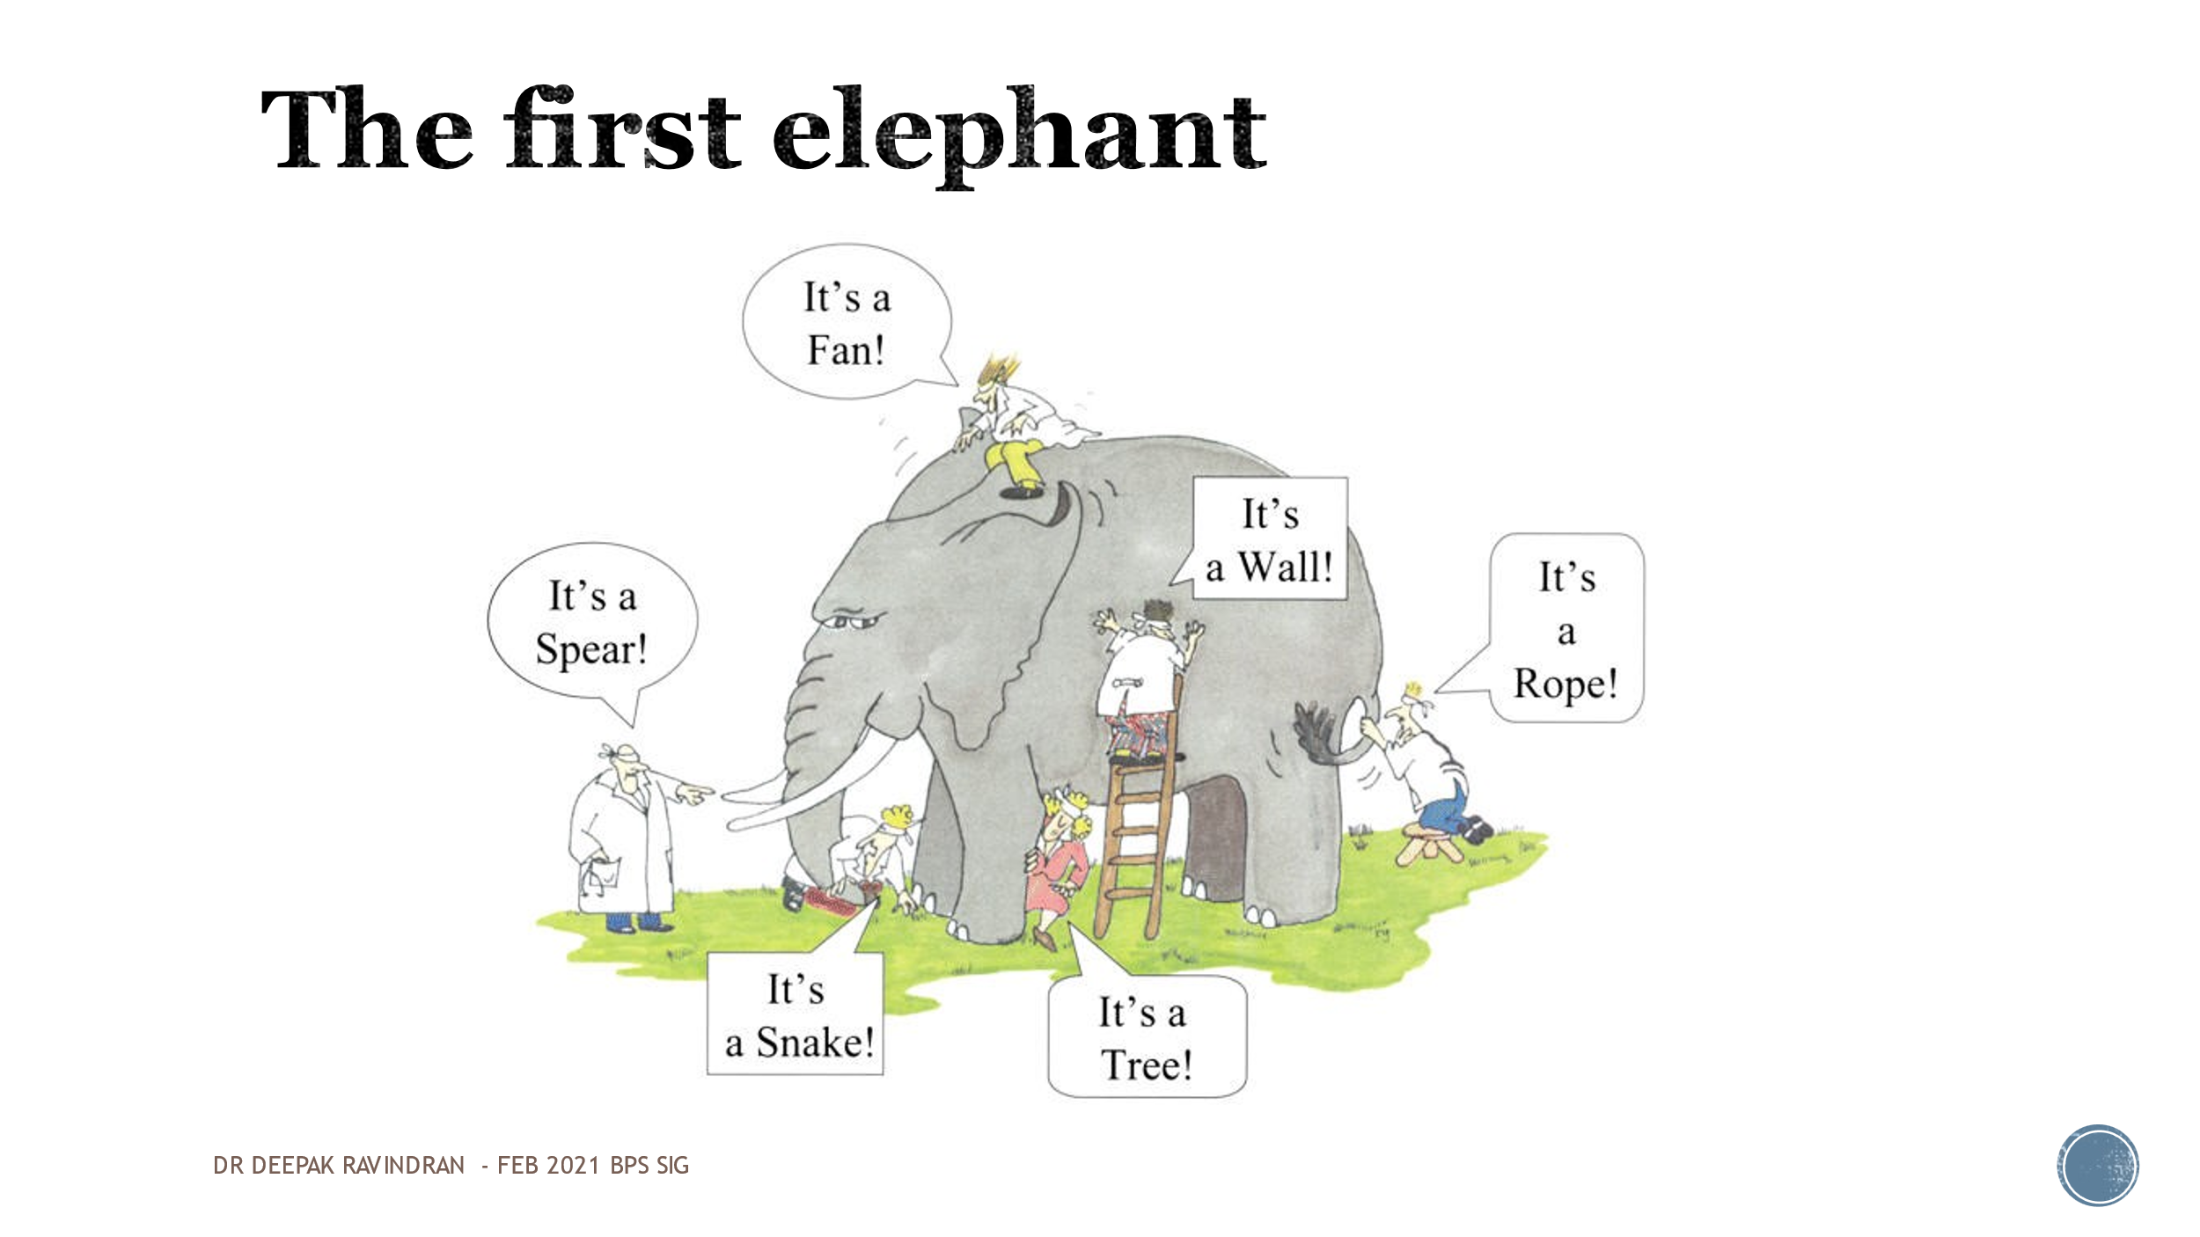
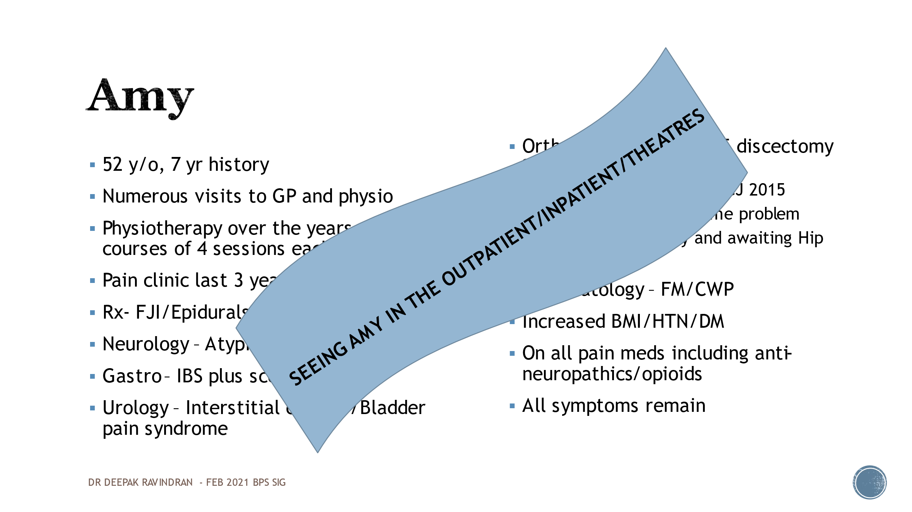 ‘Amy’, a real patient, is typical of so many who have acquired many different diagnostic labels including fibromyalgia and had back, knee and shoulder surgery. In the pain clinic we gave her all the anti-neuropathics and even opioids none of which changed anything. I am seeing Amy’s every day in clinic, the community, pre- and postoperatively and on pain rounds on the wards, all of whom have been seen by multiple health professionals all working and thinking in their own silos.

The second elephant is exemplified by a number of studies in 2016 looking at joints that have been investigated in asymptomatic patients which revealed a lot of abnormalities that might have been diagnosed as osteoarthritis etc. in symptomatic patients and taken them on to surgical procedures. We also know that about one in every five surgeries is not going to work and leave people with chronic post-surgical pain.

The third elephant is the 400 year old Cartesian model. You may be familiar with Bessel Van deer Kolk’s book The Body Keeps the Score which brought recognition to things like post traumatic stress. We can look at pain as a protective phenomenon in an evolutionary sense but we have to get it across to the public that pain and nociception are not the same and the former is a much bigger experience, and make that distinction very clear. Last year the IASP decided that pain associated with central sensitisation would be called nociplastic* pain. This embraces a whole host of conditions not classified as nociceptive or neuropathic like headache, vulvodynia and fibromyalgia

*Defined as pain that arises from altered nociception despite no clear evidence of actual or threatened tissue damage causing the activation of peripheral nociceptors or evidence for disease or lesion of the somatosensory system causing the pain.

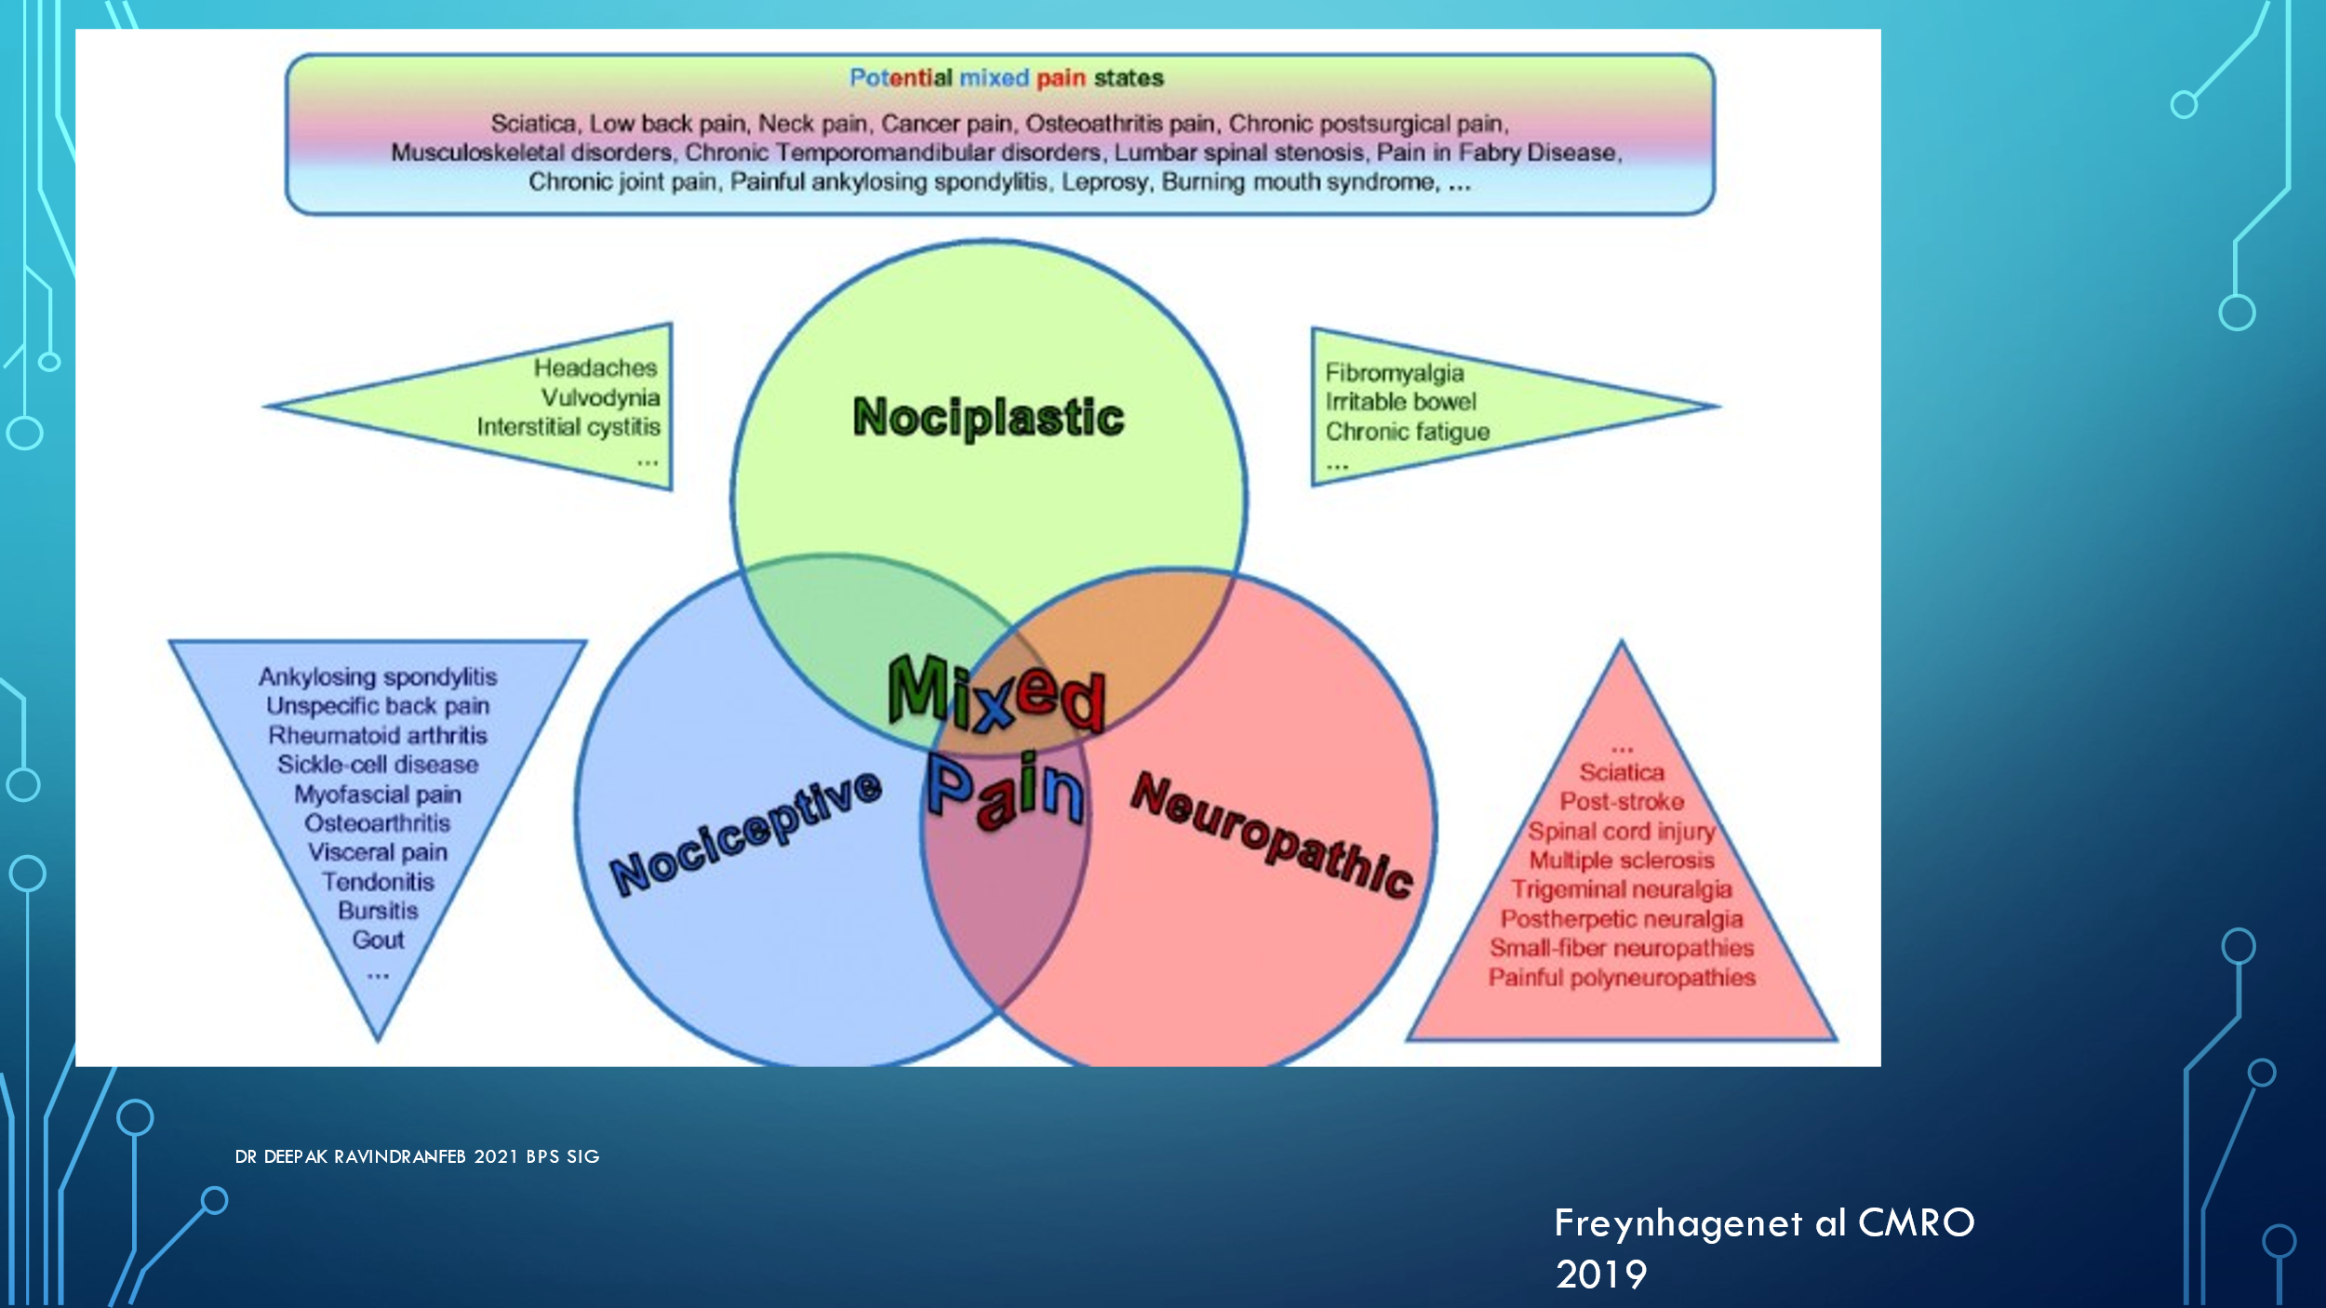

In my practice I see very little pure nociceptive or neuropathic pain and much more nociplastic or centralised pain.

The fourth elephant which is to be found in social sciences and economics is the question of who actually controls our decision making, our behaviour and our biases. We think there is a conscious thinking brain in the frontal cortex but we recognize that there is a subconscious brain (or reptilian or chimpanzee brain, or the amygdala depending which field you are coming from) There have been a whole set of studies which essentially started with ACE studies 25 years with Vincent Feletti’s investigation into the reason why morbidly obese patients were not losing weight in his weight management programme, which showed that 75% of them had suffered some form of abuse before the age of 18. So he expanded his field to his whole GP practice and found that 20% had had four ACE’s.

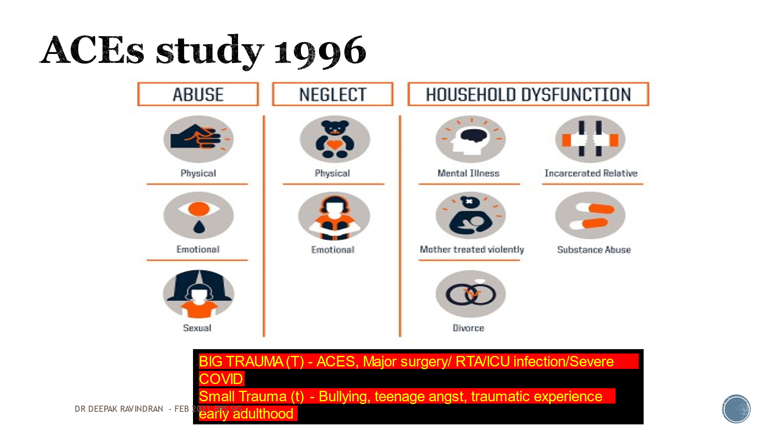

I am aware of the deficiencies of this kind of data but this has been replicated in many countries across the world. It does not take into account the distinction I have made between big and small traumas, but if you look at what a trauma means to a person the effect and experience of both can be very different, both more or less than you might expect. But this aspect was not considered in the early ACE studies. A study in Wales showed that up to 50% of the population had experienced some sort of adversity in childhood and if you include adult experiences that might apply to most of the population. 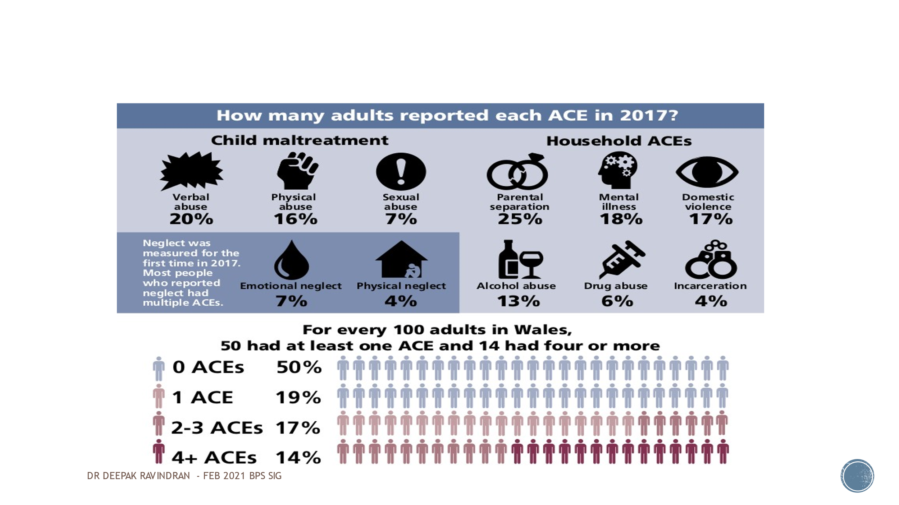 This means that they could die up to 20 years earlier depending on what kind of health behaviour they adopt or what kind of impairment they have. Pain them becomes just one of a big set of issues rather than a suppressed problem to solve. So when you combine all this you will recognise that it applies to your difficult, heartsink patients that Jonathon Tomlinson talked about last month. They have this big baggage to carry but we break it up into small silos and give them six different labels. They use more healthcare facilities, have more surgical and other procedures which may not be required. But what if there is a unifying entity?
So I wanted to ask if this was relevant to my practice. In 2018 when I tried to pursue this my psychologist and my physio and other people doubted its necessity, but I was aware that there were precedents such as research in social sciences. So I got the necessary permissions and surveyed 150 patients who had attended my clinic within a ten week period. They all had lifestyle related problems and common comorbidities: asthma, hypertension, IBS, anxiety depression and panic attacks – what we call the non-communicable diseases of the twentieth century. Further enquiry revealed that 49% of patients coming to a secondary care pain service had experienced a significantly difficult childhood experience that they were happy to volunteer; as Jonathan has said there may be others who don’t want to talk about it.

Do we just talk to people about opioids or intervention, or suggest exercise and psychology – one size fitting all these patients? We can approach the subject from a physiological angle, recognising that developmental trauma can affect the developing nervous system and the development of the hypophysial axis, or talk about it in psychological terms such as increased neuroticism and somatisation or insecure and disorganised attachment.
I found it acceptable both to my biomedically minded colleagues and those of a more holistic mindset to talk about neuroinflammation driven by glial cells which I had learnt were representatives of the immune system. I had been taught as a medical student that the brain is supposed to be an immune privileged organ with no representation from the immune system. We know now that this was flawed; before the blood-brain barrier is formed the microglia are primitive representatives of the immune system which lodge themselves in the brain where they provide the buffering, nourishment and modulation of every single synapse throughout the CNS. So there is immune representation everywhere in this. Psychoimmunology is becoming the prevailing influence on many researchers in this field; they are looking at immune dysfunction and this enables them to associate epigenetic changes with hypervigilance and sympathetic arousal. I recommend the book The Angel and the Assassin by Donna Jackson-Nakazawa on this subject.
My take on this is that we should be looking at changes that have been driven by neurodevelopmental issues in different neural circuits at different stages of development. It would seem that the earlier they happen the more global the problem and the later they happen the more vocal the issue.

So there you have the last piece of the puzzle: the social determinant factors. What we do in the pain clinic and primary care is probably only at best addressing 20% of the issue. What about the remaining 80%? Do we as health professionals have no role in influencing it or at least talking about it and making people aware this? The 30% contribution of health behaviours and 10% of the physical environment to chronic pain is still within our grasp to change even if we can’t directly influence the social aspects.

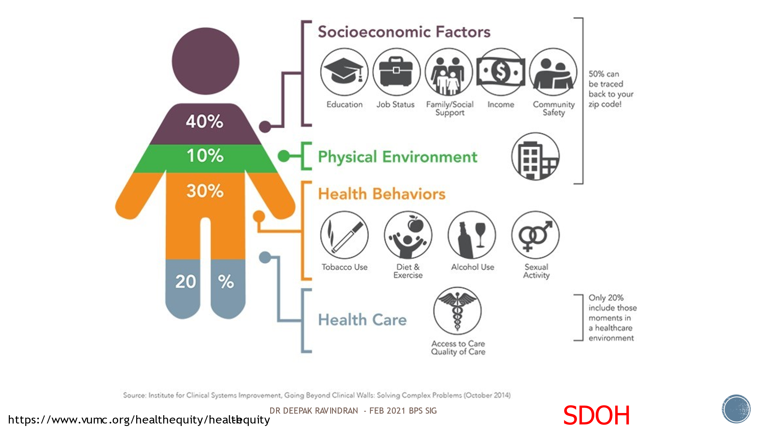

The role of trauma informed care
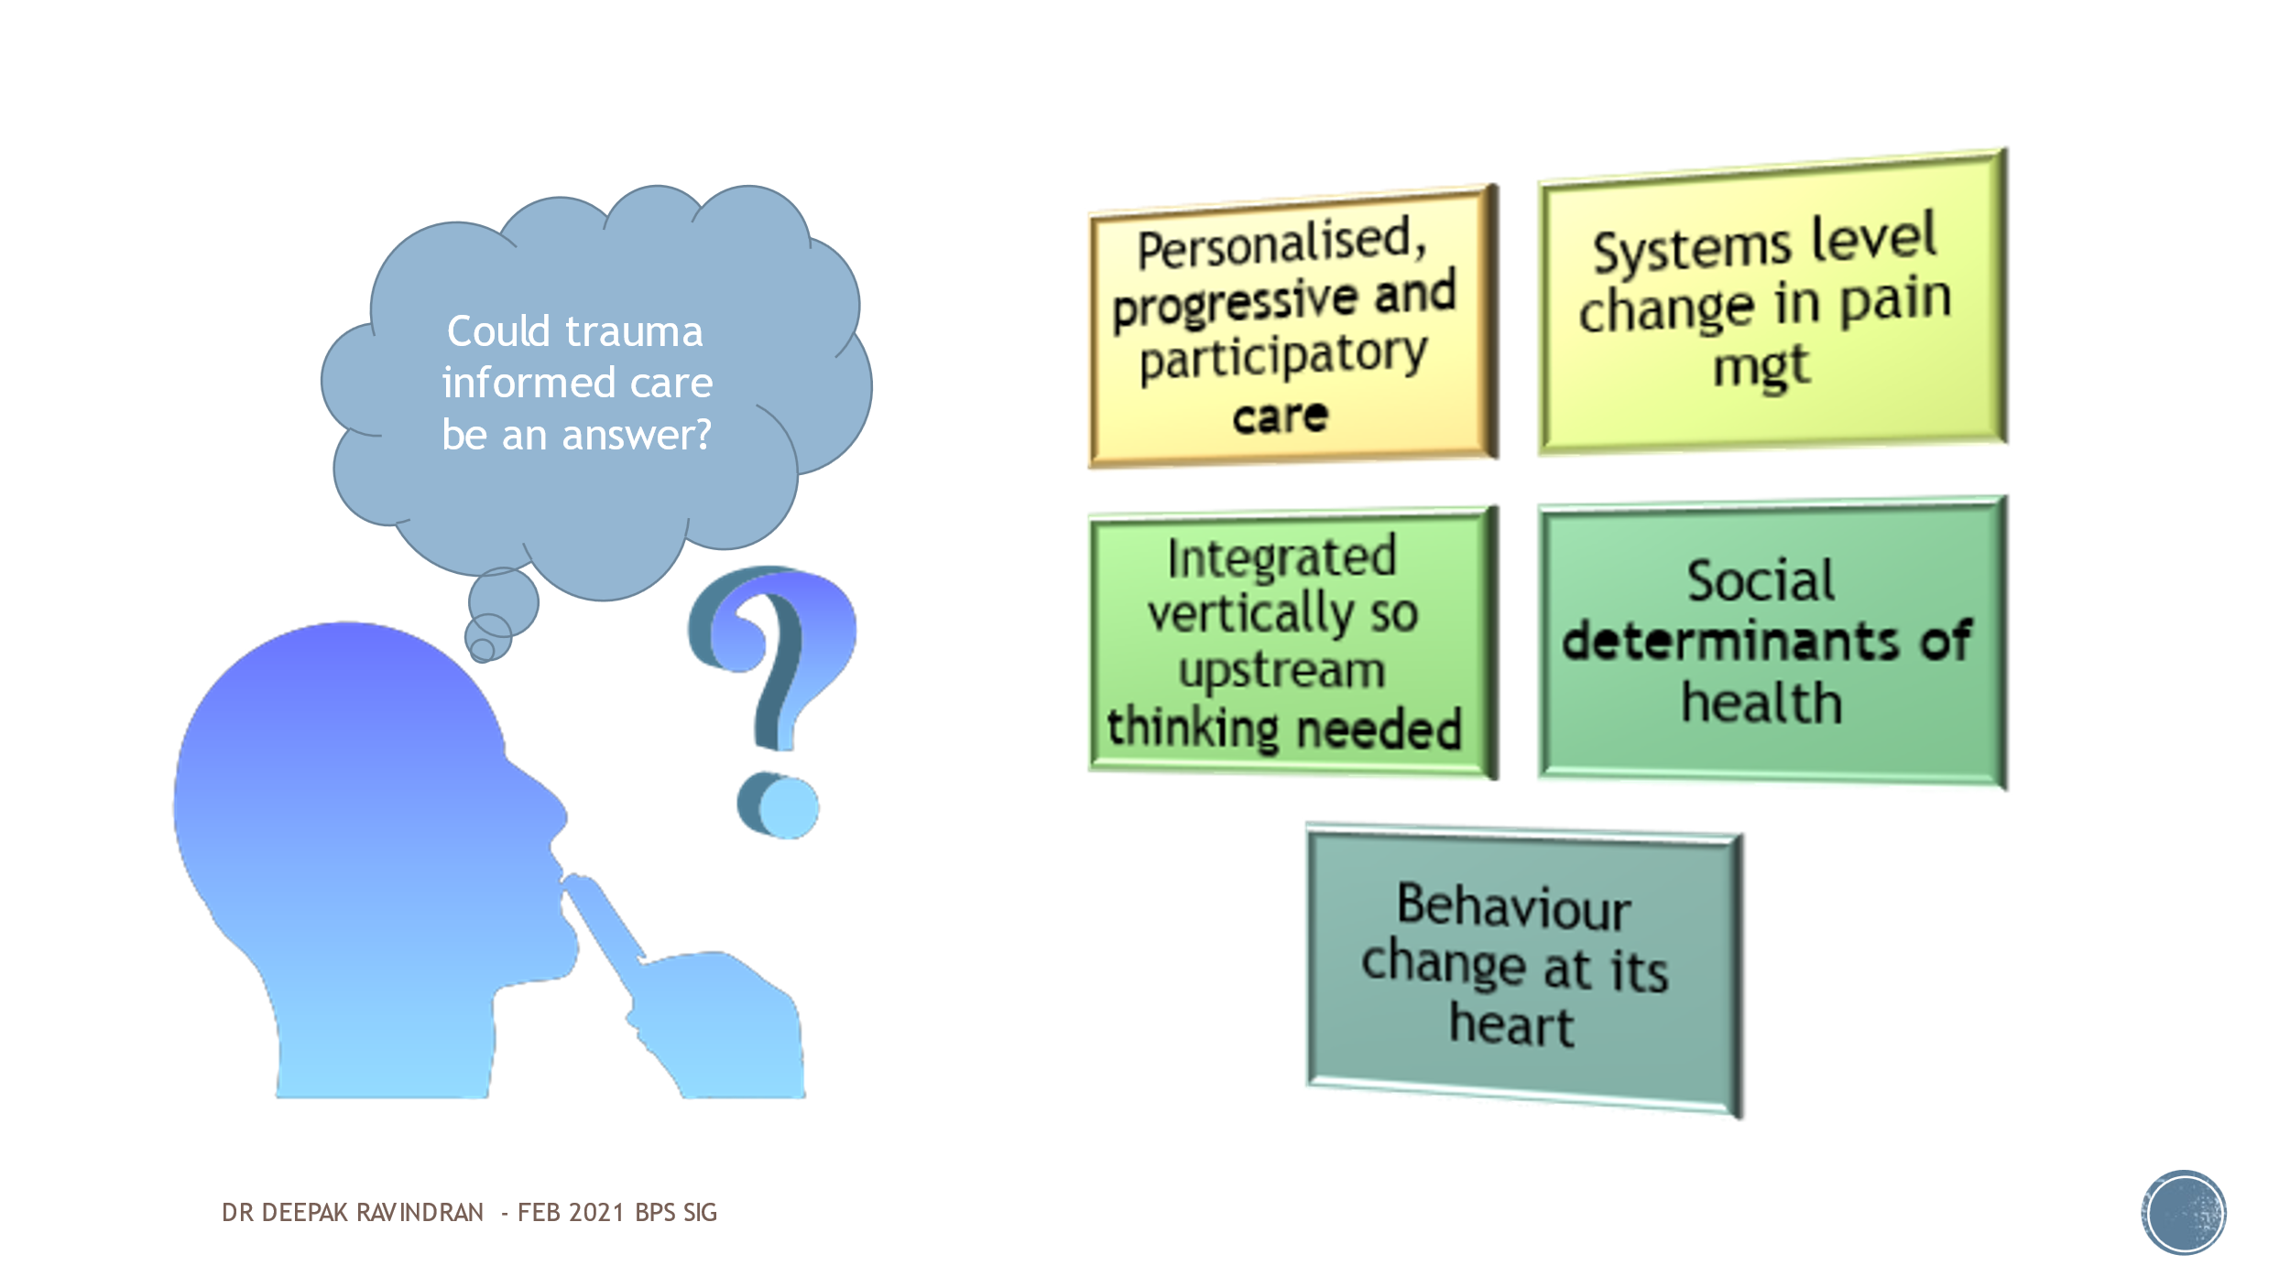

We have reached the point in integrated care partnerships, community or secondary care, or whatever system you are part of, where everybody wants to be on the bandwagon of progressive and participatory care, systems level thinking, integrated upstream thinking, and social determinants of health. We might say that behaviour change lies at the heart of all this; although behaviour change looks as if it is about the capitalist concept that it’s all down to the individual, we learn from behavioural economics that how you shape the environment can make a difference to how a person’s behaviour changes. But can a pain clinic or hospital present a different environment that encourages people to change their behaviour? Could trauma informed care be something that ticks all these boxes? If we know that a patient has experienced trauma it means that we have to reframe the conversation around medication and be cautious about how we investigate them, or whether indeed we should prescribe opiates or any sort of intervention including surgery. Other therapies, if they are restricted to CBT or ACT or physio, may not be enough for that kind of patient if they are not personalised. That is where Lorimer Mosely wants to change pain education to achieve behavioural change by discovering how people learn, what their biases and ingrained beliefs are, how you are going to gain the trust of the person sitting in front of you – for which one consultation is never going to be enough. Only then can you help your patients to change: to rethink their old beliefs and systems.

Being trauma informed encompasses these four points. Instead of asking ‘why are you like this it ?’ it asks ‘what happened to you?’. It gives people the option of being listened to and their experience validated. It gives us the opportunity to respond, to engage spouses and partners, and the leverage to go back to our surgical colleagues and ask them if they will consider doing things differently in this new light . Ultimately it is about communication and avoiding retraumatisation. It’s not new; Scotland has taken the first steps in becoming an ACE aware nation and developing a trauma aware workforce. Opening Doors: Trauma Informed Practice for the Workforce on Vimeo is an animation explaining how changes in childhood or adolescence can spill over into adult hood and the ways people react to care [and well worth a look. Ed.]

There can little argument that the principles we in pain care should be guided by include ensuring that people should feel emotionally and physically safe and giving them choice; that we should be collaborating with them and there should be trustworthiness in our relationship. And ultimately we should want to empower them: to give them the confidence to take some of their care back into their own hands and regain some self-efficacy.

So this has been my journey and what I have managed to achieve in the last three or four years. Locally I have been able to get my team to think about it and am glad to see that when my nurses go on the wards they don’t just talk about which analgesics and opioids need to be started but want to look into peoples’ social and family background. And they talk to the junior doctors about this.

We got approval for an intake questionnaire which as well as basic questions includes scores for Pain Self-Efficacy (PSEQ), anxiety, depression and an ACE questionnaire, complemented by a patient activating measure for deciding what outcomes need to be considered and to help us to decide how we can use them. I ran a pain study day last year just before the pandemic. I am now working with one of our safeguarding champions in the Reading council who are very interested in becoming a trauma aware service, so there is some synergy in Berkshire to drive Trauma Informed practices in social care, education and in the criminal justice system. I thought this would be a good opportunity to introduce this into our secondary care service, and we have managed to get some local funding for training my colleagues in motivational interviewing which is a useful tool for helping us look after long-term conditions including pain along with our patient activation measure.

But I don’t want to throw the baby of nociception out with the bathwater and of course you can still use medication, intervention and surgery when you are sure that there is a good-going nociceptive focus. But you still have to think of pain in the contexts of lifestyle, sleep, mind-body therapies and the roles of the microbiome and diet. Talking about the latter is a nice easy way of introducing other lifestyle strategies.

But there is little point in talking about lifestyle etc. when there is constant hypervigilance or abuse somewhere in their social environment which is why I have written the book The Pain Free Mindset.

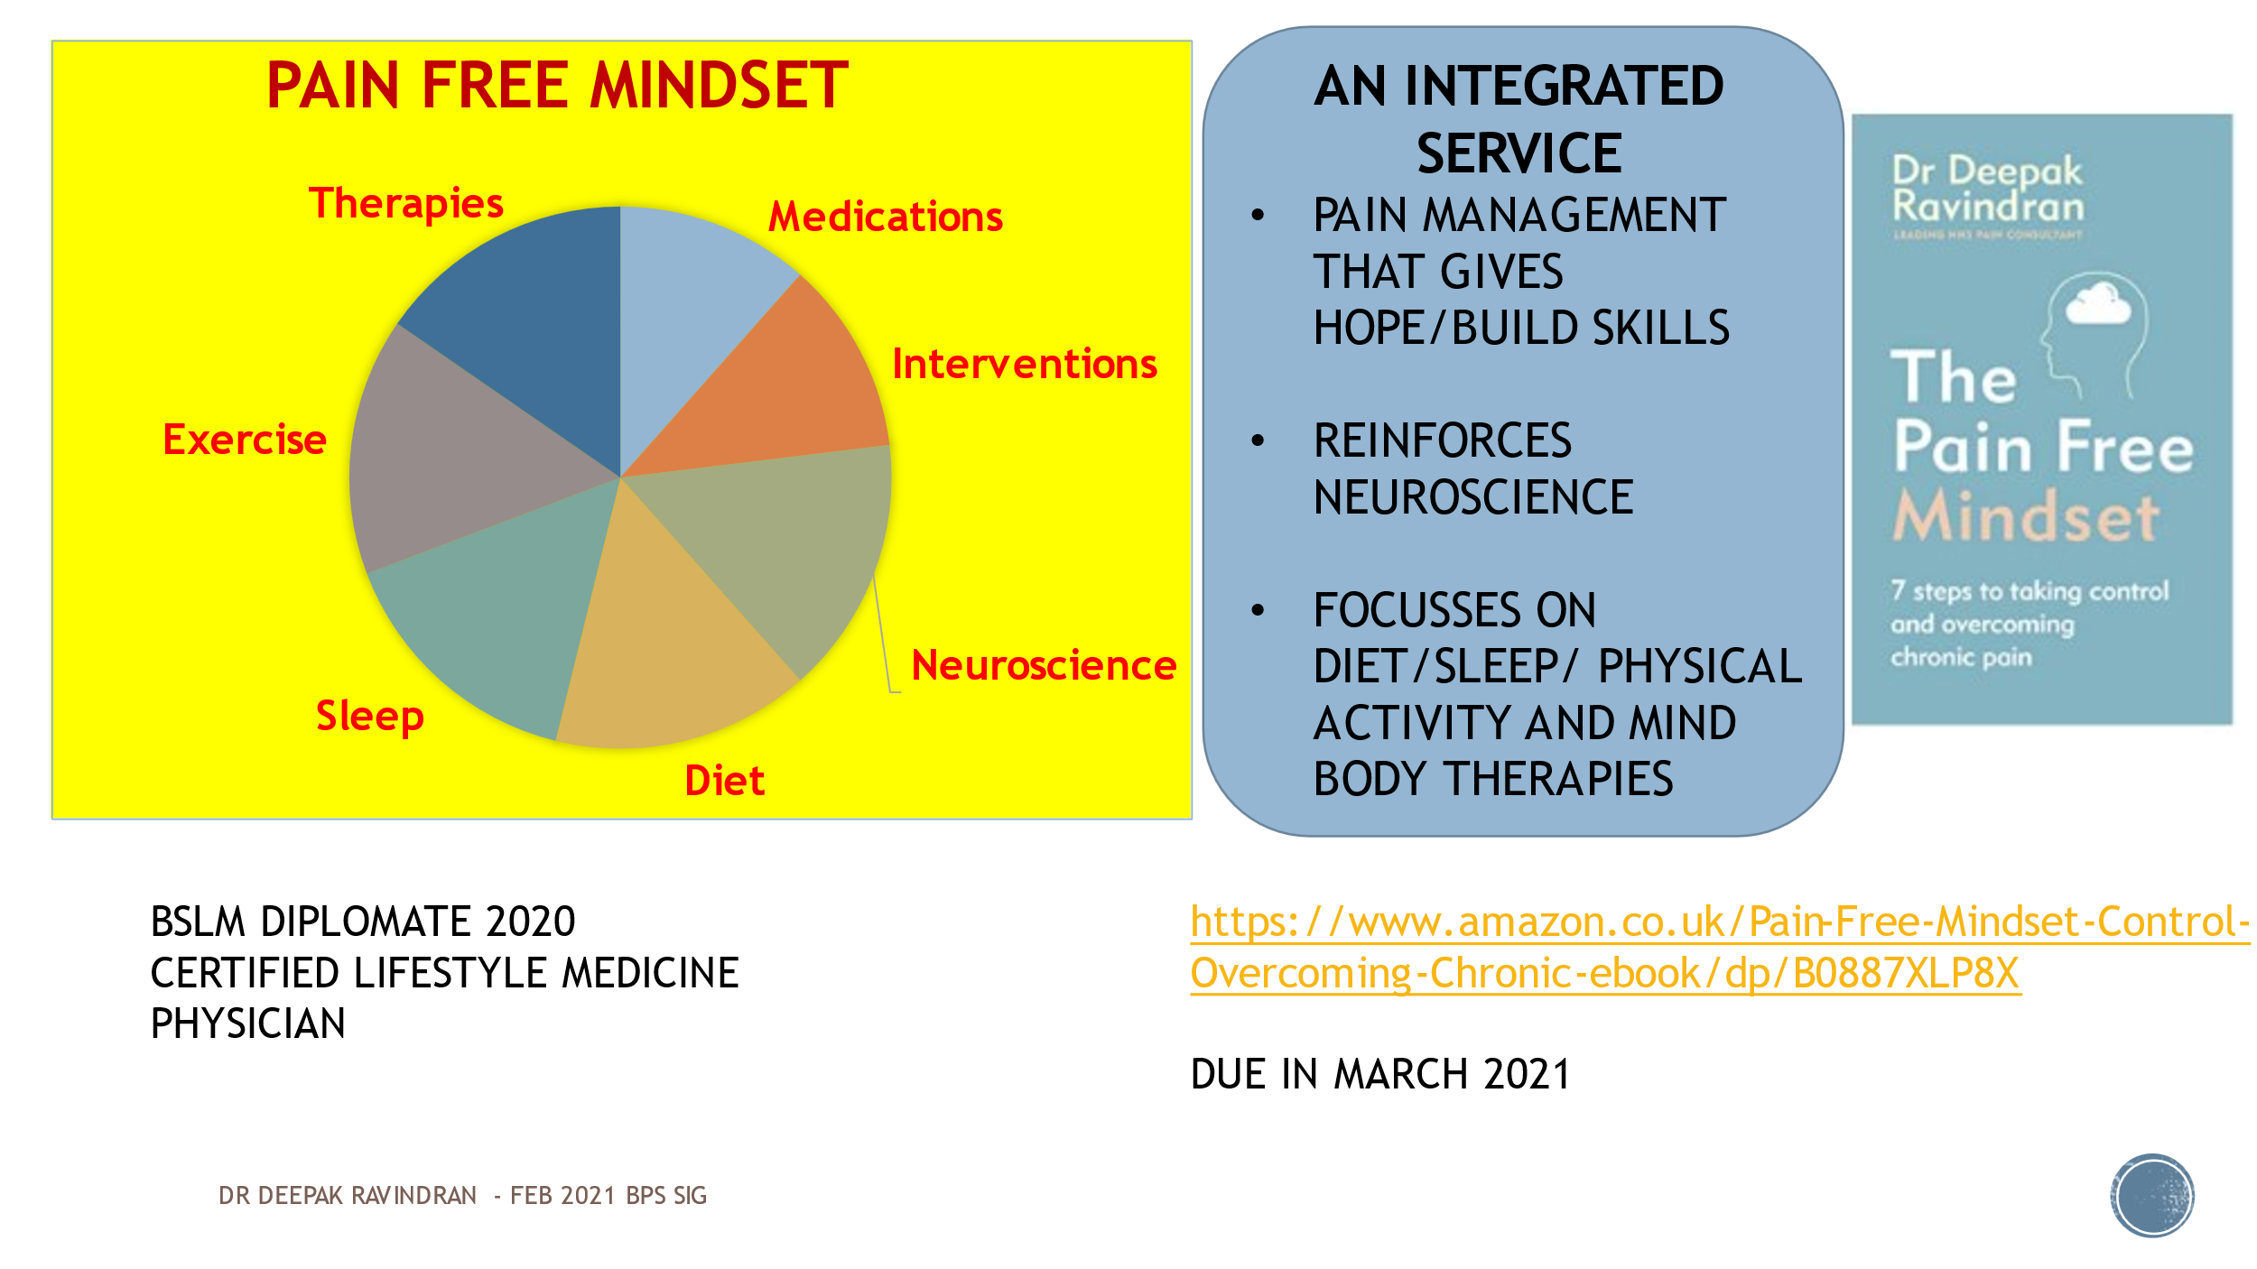

I thought it was the best way to say that this is a pain management service that gives hope and skills. I think a pain management programme should be the first step in a skills building approach rather than as we do now when we teach them and send them off only to be referred back in six months because they have not been able to sustain what they have learnt unaided. So how can we convince the commissioners that there needs to be ongoing support? I don’t have a lot of evidence for the success of what I have been doing but we have had no complaints, we have no wait time for access (patients can be seen within a week of referral and have an intervention within 6 to 8 weeks; although wait time for the PMP has been somewhat extended by the pandemic ) Since 2015 we have moved from a position of having no community service and less than 1.5 WTE’s of physio and psychology time to where we are now in 2021 with 3 WTE each of both in the community and 1.5 of each in the secondary care service. It’s not all about TIC but it is about preaching a different measure altogether. I think it is of value but I am not sure how much. So much of chronic pain is a mixture of trauma and other factors and we in secondary care need to keep that in mind, and when we are thinking about value based health care, social prescribing and what we can do together with the community. There is scope for huge cost saving.

So how do I see our role?

Often we have to walk in front showing the way;
Many times we will walk alongside
Other times we follow and support

From In sensing where to walk lies our art (Daloz 1999)

I have raised some unanswered questions and now I look forward to hearing what you think about the ways forward.

Thank you

Discussion

Someone mentioned ‘nature dancing with nurture over time’ – I rather like that picture

So much of the care of pain and trauma depends on sustained therapeutic relationships. If you visit someone in a pain clinic who is as incredibly compassionate, insightful and empathic as Deepak and you open up about your complex trauma in your terrible past and he helps you to make sense of your pain you aren’t going to go home cured; you are still going to be in pain and have the after-effects of trauma. There will be no cure although the experience may lead to better acceptance and understanding. But you are left with: what are you going to do next? Do pain services then need to be working alongside the GP’s and practice nurses who will be providing the necessary therapeutic relationships? Do pain clinicians need to move out of their clinics and into GP surgeries?

You are absolutely right - that has got to be the way. I have been very lucky in having some fantastic GP colleagues locally who are very compassionate; very focused on looking after such patients and giving them a buffer. One practice has started group consultations and I have been able to join a few of them. These involve a GP, a pharmacist and a social prescriber or counsellor who provide a kind of wrap round care for patients in their practice. One GP runs a group for fibromyalgia and complex pain and I have been invited to talk to them. We integrate with the social prescribers from the Newbury area in the care of individual patients as well as the support groups. So there is good work happening but it is very piecemeal and there need to be more incentives to give this more traction.

You talked a lot about emotions and feelings and psychological approaches but there is a lot of temptation to try to pin problems on some pathology, and you started talking about glial cells. I am afraid that the next thing we will see is some pharmaceutical company coming up with a drug to moderate the glial cells. I just worry about this taking off in the wrong direction and in ten years’ time we will be trying to get people off the glial cell medicine. I know you don’t think understanding people is simple and that there is a lot of science behind the epigenetics and catecholamines and steroid genetics all predisposing to trauma susceptibility or pain susceptibility after trauma, but it worries me when we go from clinical medicine to try and find … we all do it … a thing to blame that we can cure. I hope that poor glial cells don’t get too bad a press out of it.

It’s a real risk - there are already glial inhibitors and glial modulators. Endocannabinoid receptors have been found to involve glial cells so it is probable that cannabinoids will be found to have some role in glial modulation, and the industry will pick up on this so there will be a surge in use of cannabinoids for this indication in the next five or six years when we come out of recession. Which is why we need a unified system to bring in integrated therapies but can still say it’s about personalisation. But some patients will say they want a quick fix from a pharmaceutical drug. I am a little ambivalent: I have changed my thinking and I am prepared to change it again, but I would like to think of myself as a pain guide, and tell patients what their options are: some of which have a good evidence base and can be prescribed on the NHS. Others don’t and can’t, but if you want to spend the money because that is your belief, I can’t change that until you begin to trust me when we know each other better. But ultimately you are the decision maker.

For the last five years or so I have changed my practice away from needles though I was never very keen on them – I felt they were a bit of a con and we were doing them largely to make money for the hospital rather than to make people reliably better. Getting people from one injection to another was an easier thing to do. But now we’re not able to do that; you do have to go deeper and upstream. I have been very surprised to find that if you sit down with people for a good long time and explain the neurophysiology etc. it is an eye-opener for many of them, and enables them to understand the impossibility of what has been tried to achieve for them over the last few years. It does give them a new scope for dealing with chronicity, and many of them go away very happy that they now understand their problem in the way that we do.

I’m doing a review … an exploration of context, mechanisms and outcomes in breathlessness. For everything you are saying I am replacing the word pain with breathlessness, and I am calling for breathlessness services like pain services. I think there is something wrong with the studies we are doing and the way we do research and to get the evidence into policy … the way we are generating evidence and the kind of evidence we are generating.

Trish Greenhalgh in Oxford wrote a paper a few months ago about making a distinction between evidence-based practice and practice-based evidence, in the context of Covid; we don’t have much evidence for what we do in Covid as we have to do so much, but we are basing the evidence on what seems to work. She argues or making this distinction in building research paradigms; wicked problems like chronic pain wherein there are so many complex factors interacting with each other and production of medicines is focussed on biological mechanisms without looking at the other multiple layers, you may not be getting evidence-based practice. If NICE is a synthesis of evidence-based guidelines you are always going to have gaps which will be left unaddressed. So NICE will have to be modified and seek some more practice-based evidence and allow social sciences to guide some of the policies.

She was a sociologist before she was a doctor.

Is there evidence of a link between trauma and breathlessness?

I’ve only just started reviewing the literature on this for my Ph.D. But from my 15 years of practice as a music therapist working a lot with breathing and breathlessness in palliative care I have noticed that the most ‘complex’ patients – the heartsink ones who get sent off to the music therapist because they don’t know what else to do – invariably revealed stories of abuse and complex trauma. And when we worked with that there was relief in physical symptoms. I have been working a lot to try and unpack that and to teach other health professionals to think through a trauma informed lens when they are working with complex breathlessness that is related to stress and doesn’t correlate to objective measurements.
The NICE persistent pain guidelines make no mention of trauma, gender inequality etc. I don’t know why this is but I wonder if a way forward would be to invite NICE to look at trauma as a separate topic, because it may be missed out of every individual topic, and individual specialties don’t necessarily recognise it. It sounds as if there are enough data to at least start an inquiry on the best way to deal with trauma. It may start with psychology and psychology but spills over into many other areas including pain and respiratory medicine, urology, gastroenterology where trauma won’t usually be addressed. It was interesting to hear Deepak’s experience of finding that the Faculty of Pain were apparently unaware that there were different meanings to the word trauma in different contexts. NICE occasionally send out lists of proposed topics and it might be possible to get trauma into that.

My insight from NICE is that trauma is like a homeless ghost looking for a body to inhabit. It’s everywhere and nowhere, so it doesn’t fit with your pelvic pain gynaecology, your MSK chronic pain, your functional neurological or your rheumatological service or whatever. My perception of the NICE chronic pain group is that they fought it off and said that belongs under PTSD

Behaviour change is something that comes up for me all the time. The individual approach is something we need to do. But piggybacking onto Jonathan’s question of how much we can change individuals without taking into account their social environment or whether they have been systematically disadvantaged or discriminated against, I want to ask how much can we change individuals without focussing on societal change as well? And perhaps reconceptualise healthcare in ways that also support […?creating equity?] And not keep judt trying to make people more resilient in the face of all these things … Thinking especially of people who have experienced trauma or are marginalised in some way or experiencing poverty or homelessness.

I completely agree. If the canaries in your mine keep dying you don’t go out and get tougher canaries, you change the air in the mine and make it safer. Toughening up your patients isn’t the answer. I would go further and say if you combine all the pain clinics in the world and systematically collect data and find, say, that 90% of women with fibromyalgia have experienced domestic violence what an incredible advocacy tool that would be. There is a huge untapped reserve of information within pain clinics which could be used to campaign for better lives and safer environments in which women live.

We have to start looking at these kinds of problem not just a function of the individual but very much a function of the environment they have grown up in or are a part of, and ask what kind of support they have.
With regard to collecting data: do we ask about ACE’s as a routine measure? It took many years for us to be comfortable with talking about depression. Do we now want to say it’s OK to talk about trauma? It may start coming out everywhere and become a snowball that public services will have to acknowledge and do something I have not yet seen one rheumatology patient who has been referred to the pain clinic with a diagnosis of FMS or autoimmune disorder, and have picked up a history of adversity in adulthood or childhood, with any mention of it whatever in the rheumatologist’s letter. So how do we get to a position where it is OK to talk about trauma? Or are we going to say that that is too personal and a territory that shouldn’t be approached unless it is absolutely necessary?
With regard to screening: I have been doing it for about six months. I am not sure if it can be done safely in a secondary care service without opening Pandora’s box and having to decide what to do about it. I would like to think it has made our team more aware of the problem and that our decisions and our language will change for the better, and decision-making more thoughtful.
Screening does however allow me to say to my more biomedically oriented colleagues: “Do you really want me to a geniculate nerve block of the knee in someone with a Pain Catastrophising Score of 50, an ACE score seven out of ten and a self efficacy score of 6 out of 50? – let’s think about something else.”

Regarding behaviour change: I realised I need more skill around this. I wasn’t sure what it meant and how I could empower my team members as none of us knew how to effect it or the science around it. So that was why I did the lifestyle medicine course which was a quick way of learning how to bring about behaviour change in individuals. But as well as that we have to talk about bringing change in society. That is a conversation which will continue for many years.

To continue the discussion about questionnaires: whether they can or should be used. Jonathan has suggested that you have to build a therapeutic relationship first. I have often found that you need the opportunity to explore the whole of somebody’s life – and you need a long first assessment with patients for this, where it seems perfectly natural to talk on the lines of “take me back to your early years: did you have growing pains? – what sort of things were happening to you in your early life? etc. And at that point it is very easy to ask the right questions or for the problems to fall out if they are there. Going back after you’ve done a couple of nerve blocks doesn’t feel right, and the trauma-informed approach should be adopted right from the start. A lot of it depends on how clinics are set up and the amount of time we have to build a therapeutic relationship. Perhaps this puts GP’s in a very privileged position, because they have access to a lot more of the records. That is something we could explore further: how intrusive it is and what we should do about opening that discussion.

If you are going to ask people to talk about it has to be with a clear idea as to what the next step will be. I have used a questionnaire which makes it in a way neutral – it’s up to them if they want to fill it in or not. Is that right or wrong if neither I nor my colleagues are going to bring the subject up otherwise?
It’s very political – we’re just mopping up the floor without turning off the tap (or whatever metaphor you want to use). Inequality has become extreme; it got less in the 70’s and then Thatcher and Reagan came along and since then it has gone through the roof. And that drives all these negative experiences in families of poverty and violence, drugs and alcohol.

I guess many people with trauma have spent many years suppressing it or putting it to one side. It takes a lot of trust to bring that out to talk about it. It can happen in the pain clinic and there are good ways of dealing with it. It’s not surprising that people will say “it’s not about that – I’m here to talk about my pain, not what happened when I was a teenager”. And we need the understanding that that might be the mindset.

You have to be careful – you can trigger off all kinds of flashbacks and retraumatise people. Sometimes it’s safely in the box and bringing it our can be very complex and involve a long-term therapeutic need and I’m not sure how many GPs or pain clinicians would be able to manage that. You could acknowledge that there was trauma without going into it chapter and verse.

In my experience even when you have had a discussion around trauma it can be difficult to get any help from mental health services. A long-term relationship is beneficial but sometimes it feels as if you are trying to stem a tide There are social factors involved but how as clinicians do we have the power to change these huge problems in society other than with our votes.?

I’m wondering about going to NICE; there have been a couple of comments about bringing TIC out into the open … as with the link between smoking and cancer perhaps NICE could be used to bring out the link between trauma and poverty. Having closed down pain clinics this could be something positive they could do like directing research and appropriate management and addressing some of the questions we have been addressing this evening.

I am a psychologist in a pain service but I worked for a long time in psychosis services and I am really struck by the similarity of conversations I have heard in the two situations , in terms of the role of trauma in complex mental health presentations , in which that role isn’t acknowledged and the problem had become medicalised. As well as the gamut of physical health conditions that we have talked about we need a broader map. I wonder, regarding NICE guidelines etc., whether collaboration between physical and mental health services and how we work could be valuable as there are lots of similar pathways that people are trying to tread; and result in more trauma-informed work in all these different services.
I was also curious about EMDR (Eye Movement and Desensitisation Reprocessing) training and whether that is available in any pain services. People with pain who have had ACEs may have difficulty in understanding the link between the two. Although I haven’t actually practiced EMDR with pain patients I am trained in it and my understanding is that it may help people make a link which comes out of their experience, rather than trying intellectually to understand what their pain has to do with their childhood. I’m not suggesting it could be the whole solution but it could perhaps be useful in this way.

My local community trust has a number of NMDR trained therapists that I occasionally refer patients to. But that is a fundamental construct: if we assume that chronic pain [? is related to trauma?] we need to open the door to all forms of therapy. I am happy to be proved wrong but it is my belief that the reason why ACT and CBT etc. have not got where they need to be is because the behavioural model involves the assumption that the frontal cortex is always capable of overcoming issues. Even if you have trauma focussed cognitive therapy the expectation is that cognition can exert an influence higher than the amygdala or the subconscious … We know that that is not the case; the deeper the trauma the more challenging and complex the effect on mental development is.
Any service that comes across these patients should be fully informed about what is available for them. You know what you know but you don’t know what you don’t know; few of us know about somatic experiencing, EMDR or grounding therapies, so how will clinicians refer people to where they need to be. My desire is to have an integrative service that has access to these therapies and can help in choosing what will work best for an individual’s particular problem.

The question was raised earlier about screening; is it necessary? It is a standard of practice in California and about ten American states across general health and in other fields as well. Maybe we are not ready for it. How can we make [?] care more approachable? I think screening is irrelevant.

What sort of experience have you had from your colleagues? Has there been resistance? You mentioned your experience with the Faculty.

Once I had explained to the Faculty what sort of trauma I was talking about they give me the CPD points. I have been fortunate with the Reading council with their co-operation in incorporating trauma awareness into setting up long Covid care. I have talked to my colleagues in physiotherapy, psychology, pain, anaesthesia and perioperative care; I have not experienced any resistance but I have not had any evolution. It takes trust and time to get this sort of thing going.

Is it just you operating in your service? You refer to yourself a lot but do you have colleagues that are operating in a similar mode? – or are they still sticking needles in people?

I don’t think my team would have been able to achieve this kind of outcome and operate in a pain service without any access delays even in a pandemic were not all of us thinking more carefully about how we make decisions.
The reason why I have been talking in the first person a lot is that TIC is something I have been trying to push but my lead nurse and my physio are very much into the concept. But the latter told me recently that it is misunderstood and needs a different word for it. But that is the term we have. So is there any other model which would be suitable?

Compassion focussed care has been suggested.

As most of you know I ran a therapeutic knitting group alongside a pain clinic for 12 years, and I was sent all the patients that people could do nothing with – people with the most complex problems. We would sit for two hours and I would hear their life stories in a very easy and relaxed way. Some of them had been coming to the pain clinic for 15 or 20 years and the clinicians had no idea of their traumatic background, although it had had a massive impact on their behaviour and their life choices. Nearly 100% of them had some sort of trauma in their background
Knitting is a kind of mind/.body approach, using the two together. If you can combine CBT or mindfulness with some sort of bodily movement it can be more effective. The therapeutic mechanisms of knitting are thought to be very similar to those of EMDR. It is very helpful in PTSD

It’s always been a mistake that in a hospital we have mental health in one building and physical health in another, which seems to reflect a Cartesian mind-body split. In most ancient cultures they didn’t divide the two….. It seems to cement in the attitude that it’s either all in your mind or all in your spine

… but everything has a biology ….

… it is kind of all biology in the ultimate sense

In my service which is a tertiary one we haven’t been able to get involved in the community. But we do know that some of our patients have difficult lives and you can identify trauma etc. The problem we have is that although we are very aware of the psychological and social issues, and we have psychiatrists and a psychologists, the amount of intervention they can give to individuals is limited; we try to get patients into local mental health services but these are very stretched, so they end up going back into a social situation which is often very traumatic. So even if we can restore better psychological services we are still in an environment which is quite centred on the biomedical model and we don’t find it easy to have any kind of social integration. This is where the politics start to come in. I still feel I’m in a silo here … at the end of the day the resources are limited and the interventions we use are expensive. Mental health intervention needs highly trained people to do it and patients have to wait a long time. So they end up going back into these difficult environments. There are solutions but they are big social and political ones. These problems are engaging our colleagues in psychiatry and a psychology and other areas of medicine and social care; I wonder about the whole big picture that this is part of.

I think we do have a role as doctors and health professionals in influencing policy and this needs be bigger. We come with the advantage of being trusted as a source of information, especially in this Covid time. We as consultants we have a little more leverage with [?MSC?] and all the other channels and networks that can be utilised to influence policy.
My desire locally is to get a small group of interested and like-minded individuals together. The first step is to continue to get my organisation trauma informed. The second step would be to talk to the Faculty of Pain Medicine or the Royal College of Anaesthetists about Perioperative Medicine in this context. So many people are waiting for surgery and the time could be used to give them a different option, for instance a behavioural intervention to make them look at their lifestyle differently. There are all sorts of possibilities we can implement at that level. I hope in twelve months’ time to have data from a thousand people coming the Reading pain clinic and the number facing the sort of adversities we have been talking about, and using the information to challenge the commissioners about what they are doing to support these people. Healthcare is about good management of resources. If we know that peoples’ social systems are not in the right place and their resilience factors in the community are not optimised, then healthcare is only 20% of the conversation. So we must play a role in deciding how the 80% is shaped. We may feel worried that there is a risk involved in asking for the transfer of 20% of secondary care resources (which could be used for intervention) into primary care, public health and social prescribing, but it may money better spent than putting them on a waiting list for an injection. For instance: helping people with their DWP forms, some sort of assurance behaviour coaching or someone to take them round the supermarket to show them the healthy food they should be buying
.We have a role to play in that. It is data like this that is going to make it possible and we have enough social sector support to make that happen. Do we want to be in this or stay out?

