+++Realism and Complexity

Webinar 23rd January 2023

Kate Binnie

I am a beginner philosopher without any formal philosophy training. So I am just presenting my thoughts, something about my PhD and an explanation of the basic concepts of critical realism and how they might be useful in exploring complex problems. All problems are complex and in medicine we tend to try to reduce that complex messiness; we like nice neat positive research; double-blinded RCTs etc. to minimise complexity and keep everything under control. But we know that doesn’t really work with social programmes and complex problems like chronic pain and breathlessness. I’m not going to talk about chronic pain per se because you are going to see parallels which we can talk about in the discussion – when I hope you will have some philosophical insights to help me.
.
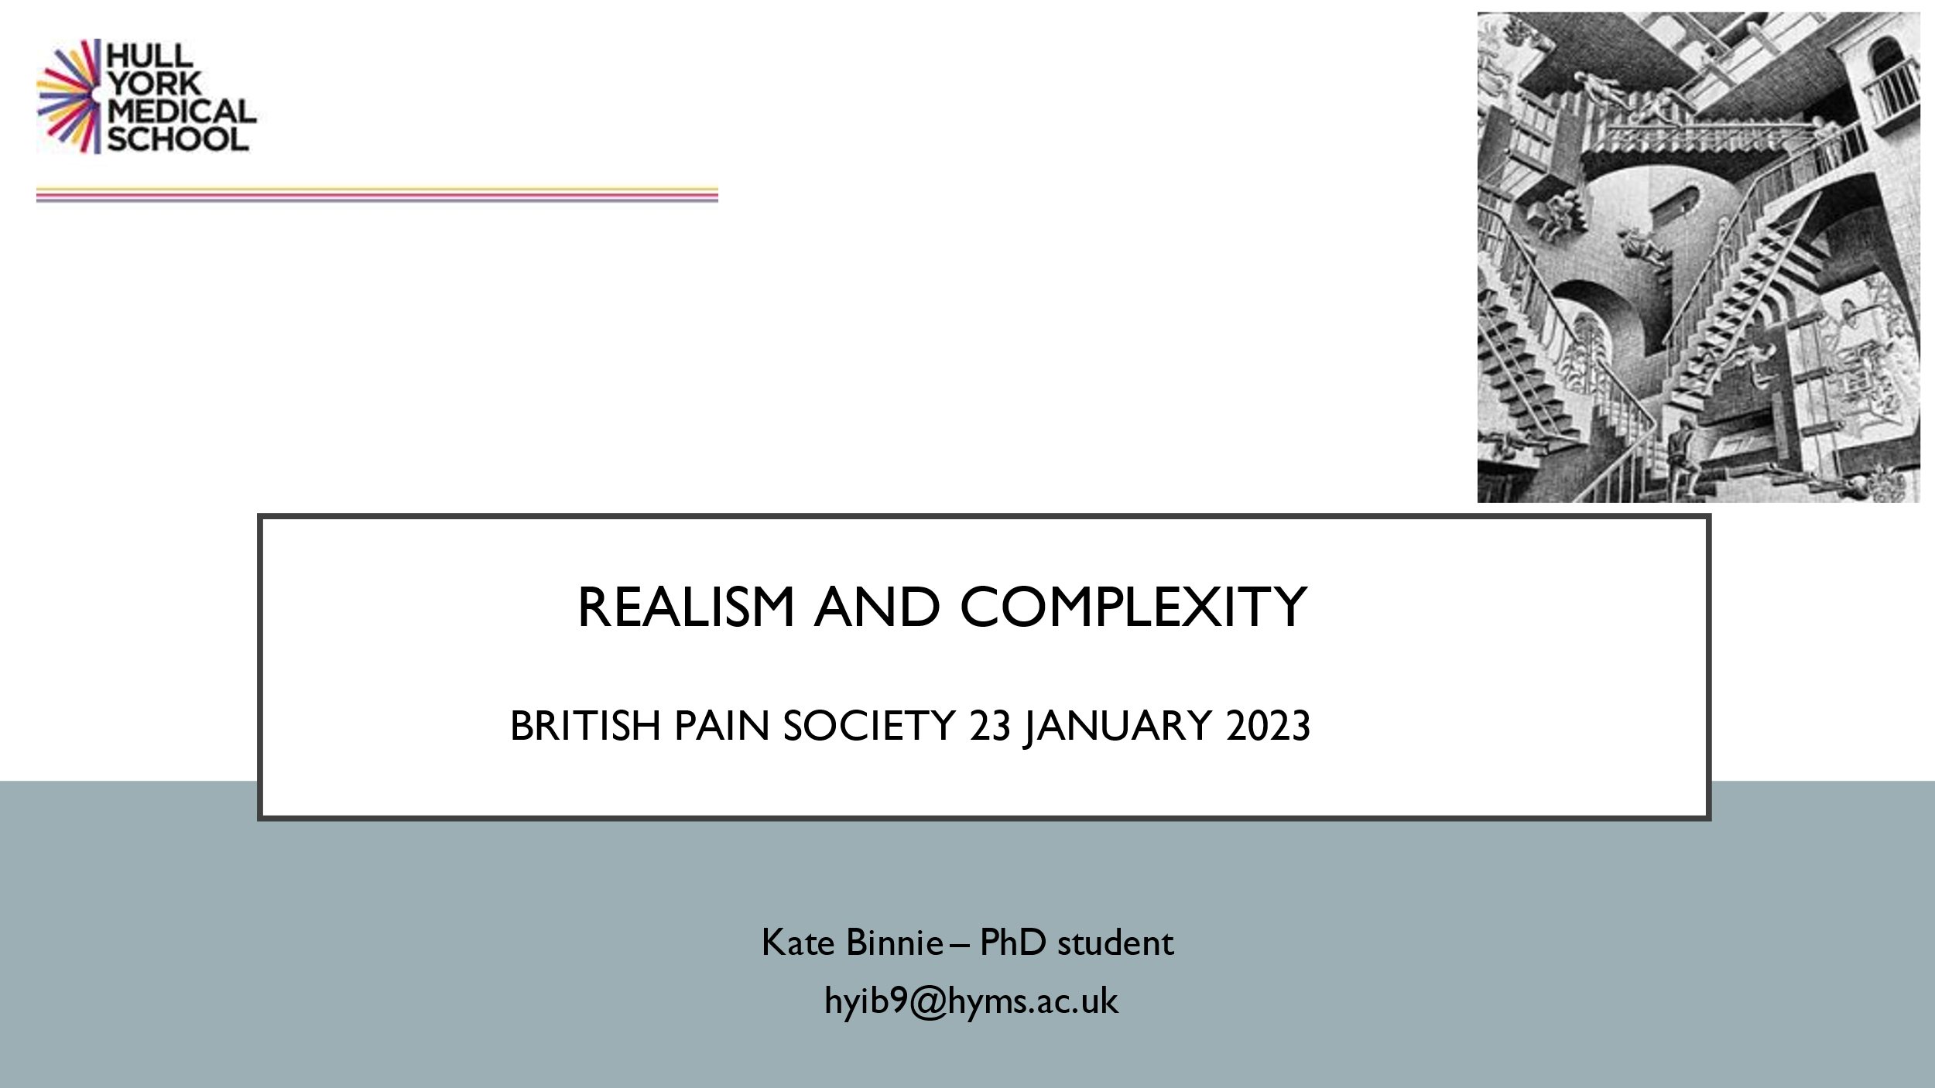

Doing a PhD is a bit like this well-known picture: upstairs, downstairs and oh dear I’m back where I started. I have found this a complex methodology but I think it’s the right one. Last year I gave a talk in which I spoke about some of my clinical work with chronic breathlessness which underlies the approach that I am developing. My background is very eclectic but it does revolve around breath. I was a singer and chorister from childhood and my first degree was in music and English. I worked for a while in the music business and then did my postgraduate training in music psychotherapy in the university of Bristol. I worked in lots of different settings including Sure Start. I was interested in Attachment Theory and working with families; I have worked in mental health, neurodisability and found myself in Palliative Care from about 2010. While I was working in two hospices in Oxfordshire where I live I also did my training in yoga and mindfulness. So there were many different things going on that met together in my work: psychodynamic theory in my music therapy and using music as a communication tool (which is particularly useful with nonverbal patients)
And I became very interested in the relationship between the body and the breath and the mind. I did my Palliative Care masters at Kings College London in 2014-15 and got a scholarship to study Yoga for pain in advanced disease. I have some undergraduate medical students who are re-running some research which I hope to publish this year. Between 2016 and 2020 I was working on the Life of Breath project, funded by the Wellcome Trust, which was an interdisciplinary project exploring breathing and breathlessness. We had neuroscientists, historians, philosophers and literature scholars all looking at the phenomenon of breath.
I’m now doing my PhD but also running groups for people living with chronic and life-limiting illness and I am teaching them mindful yoga. Some of them have advanced cancer, some Parkinson’s, some COPD – it’s not about what disease they have; it’s for people who want to connect with their bodies and their breath. Working with such people has been really informative in formulating my research questions. I am also working with the Oxford Centre for Spirituality and Wellbeing ( https://www.oxfordhealth.nhs.uk/oxcswell)
- a really amazing group who are holding a conference later in the year.
We are interested in exploring psychospiritual care (not religious care) and have set up in Oxford Brookes University the first ever postgraduate certificate in psychospiritual care and I teach on that.

I am doing my PhD at Hull York Medical School and funded by UKRI (UK Research and Innovation) The broad topic is ‘mind body interventions for chronic breathlessness in advanced disease - a realist exploration’. I am hoping that this evening’s discussion will help me to get back on track with this after a long break!

Looking back on my work and the development of my role as a ‘breath practitioner’: it has been said that breath is ‘the barometer of our emotions’. I feel a little bit anxious talking to you so my breath is high up in my chest, so I am going to take a long expiration and let my shoulders relax and feel myself coming back into focus. When I was thinking about the axiology – the values - behind my search, I wanted to maintain my practice/theory/research consistency. This has been quite a challenge in a medical school. I am not in a practice based environment. I have met researchers who do an expressive dance as their research methodology. I am trying to hold on to my practice and incorporate that into my theoretical approach to my research. I am trying to be pragmatic because ultimately what I want to do is to get mind-body practice into a UK context. This is particularly relevant post pandemic. Breathlessness is the poor cousin of pain: we have many pain clinics but breathlessness clinics are few and far between. There was one in Cambridge but this is poorly funded and on the brink of collapse. But post pandemic there has been a re-evaluation of the breath and people have begun to think about it in a different way. They have been touched by it – when I had Covid last autumn I was really breathless for a couple of nights and it was very frightening; luckily I had the tools to bring myself back and not panic.
I have also been influenced by Havi Carel, her work with phenomenology and her concept of health within illness – ideas of eudemonia and wellbeing and the ways in which objective measures of illness don’t necessarily don’t necessarily reflect people’s perception of wellbeing. So phenomenology – lived experience – is important to me. I am not a quantitative, positivist kind of person. All the work of Cicely Saunders, who founded the palliative care movement, was grounded in phenomenology and the importance of living life fully till the end. My work also has an emancipatory kind of focus so I am interested in freedom, and understanding what structures restrain us. This is key to the critical realist mindset: critical realists are activists and interested in research whose ultimate purpose is to relieve pain and suffering

So my aim tonight is to explain why critical realist philosophy might be the best way to study complex phenomena and underpin work to alleviate these oppression and suffering in a structured way.
There are three key concepts in critical realism: experiences, events and causal mechanisms. Roy Baskar who was the originator of critical realism called this a layered ontology. Critical realism bridges lots of different areas of research and the key is that we are looking at complex social problems. Social science research must consider structure and agency and their relationship. I intend to illustrate a scientific method of realist synthesis of literature and realist evaluation, to understand how mind-body interventions ‘work’ in the context of breathlessness in advanced disease, and explore the barriers and enablers to implementation in a UK context. This will be a realist review, not a systematic one. Realist evaluation assumes that the same intervention won’t work everywhere for everyone. Realists are particularly interested in context. One reason why we come a cropper with complex social interventions is what works in London might not work in Bangalore or Glasgow, so we need to understand how context affects outcomes. Our key questions are about causation and attribution: what causes things to happen the way they do, and to what complex interactions can we attribute outcomes. So it gets really wordy and I think this is why it is difficult; the concepts are quite difficult to understand.

To sum up so far: scientific realism is about concepts, mechanisms and outcomes. Quantitative and qualitative evidence are given equal weights. Critical realism is both a philosophical orientation which fits with my axiology and a pragmatic methodology. It is an open field for transdisciplinary exploration and reaches out across social sciences and humanities. You can look at pain as a physiologist, a psychiatrist, a physiotherapist, as a person suffering pain or a pharmacist - etc. – we can bring them all into the picture. They all have ways of looking at the same thing: biological, social and even spiritual strata.
Realist methodology is focussed on evaluation of interventions, gathering data from published sources, interviews and case studies. The key questions are what works for whom, how, why and under what circumstances. Which is quite different from the positive approach asking does something work or not according to the meta-analysed data; which is always unsatisfactory for social interventions.

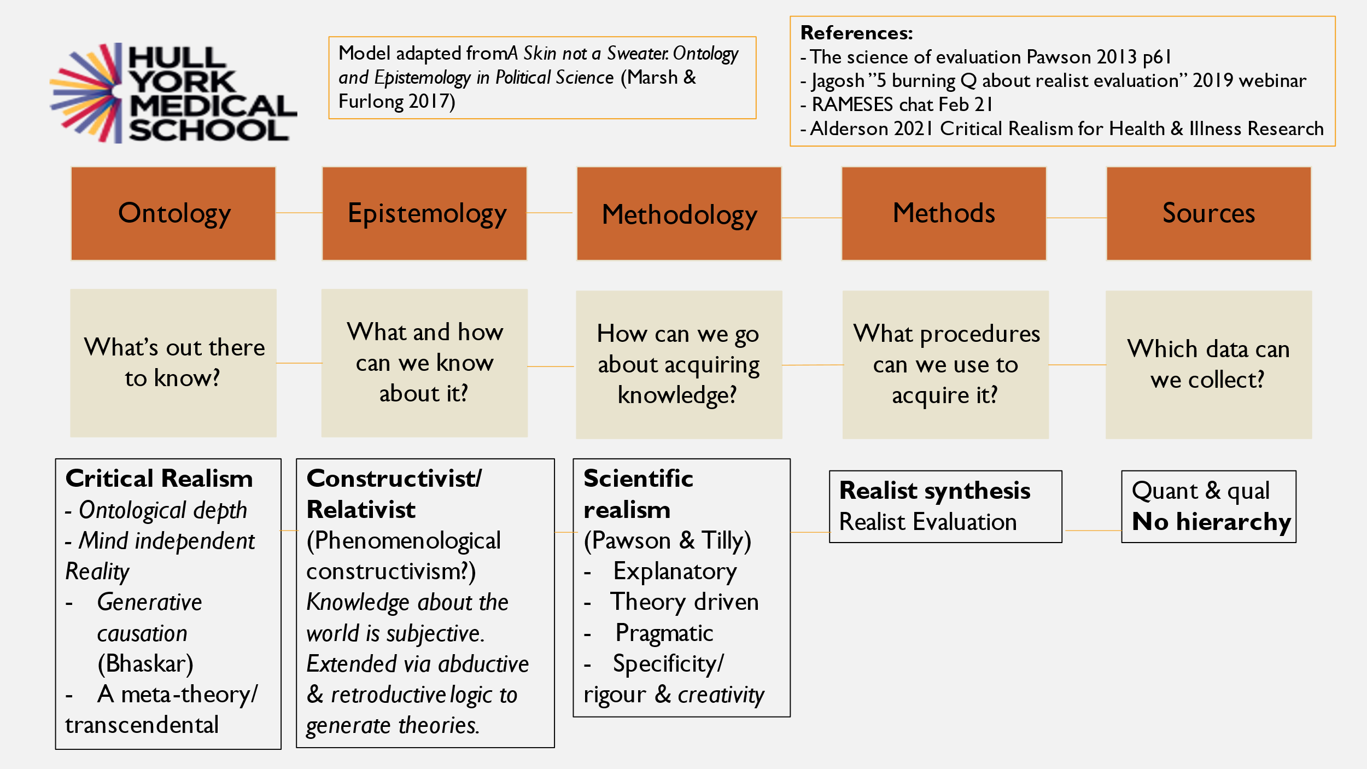

This is my attempt to show how things flow between Ontology to Sources. We can extend epistemology by abductive and retroductive logic. We all use those to explain things that happen. For instance if I leave my lunch on the kitchen table and when I come back into the room it has gone, and my dog is looking guilty, and it keeps happening so I can imagine that he been eating my lunch and I can produce evidence by setting up a camera to prove it. We do this all the time; we are always piecing together what has happened and what we imagine has happened and use evidence to confirm the theory that we have built. I have already talked about our methodology. Form our sources we may discern patterns in the data, experiences etc.

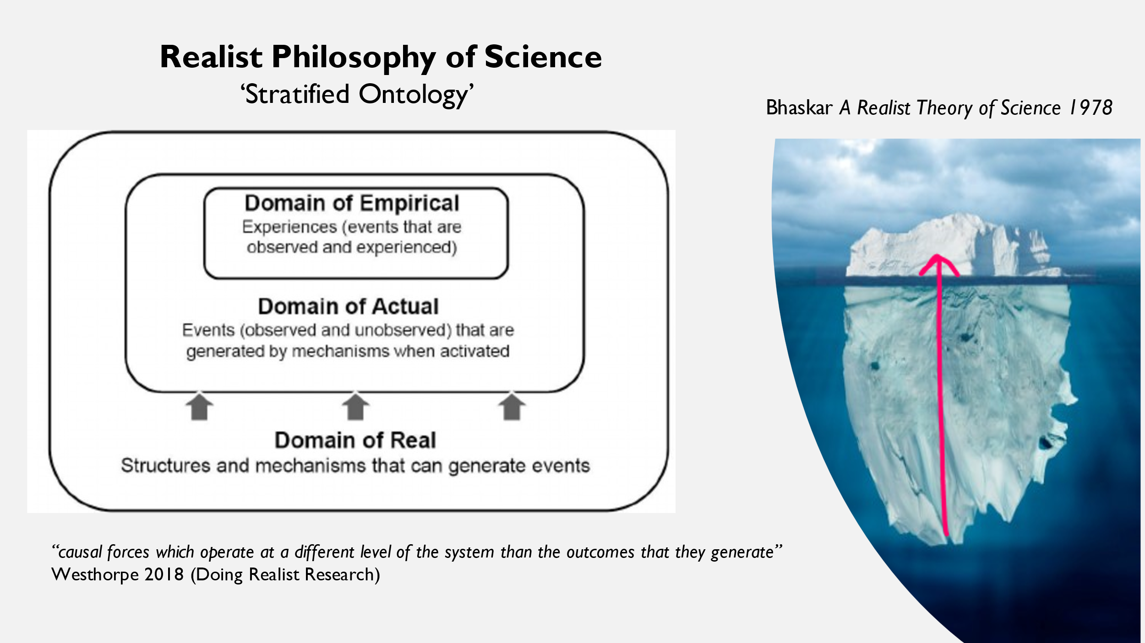

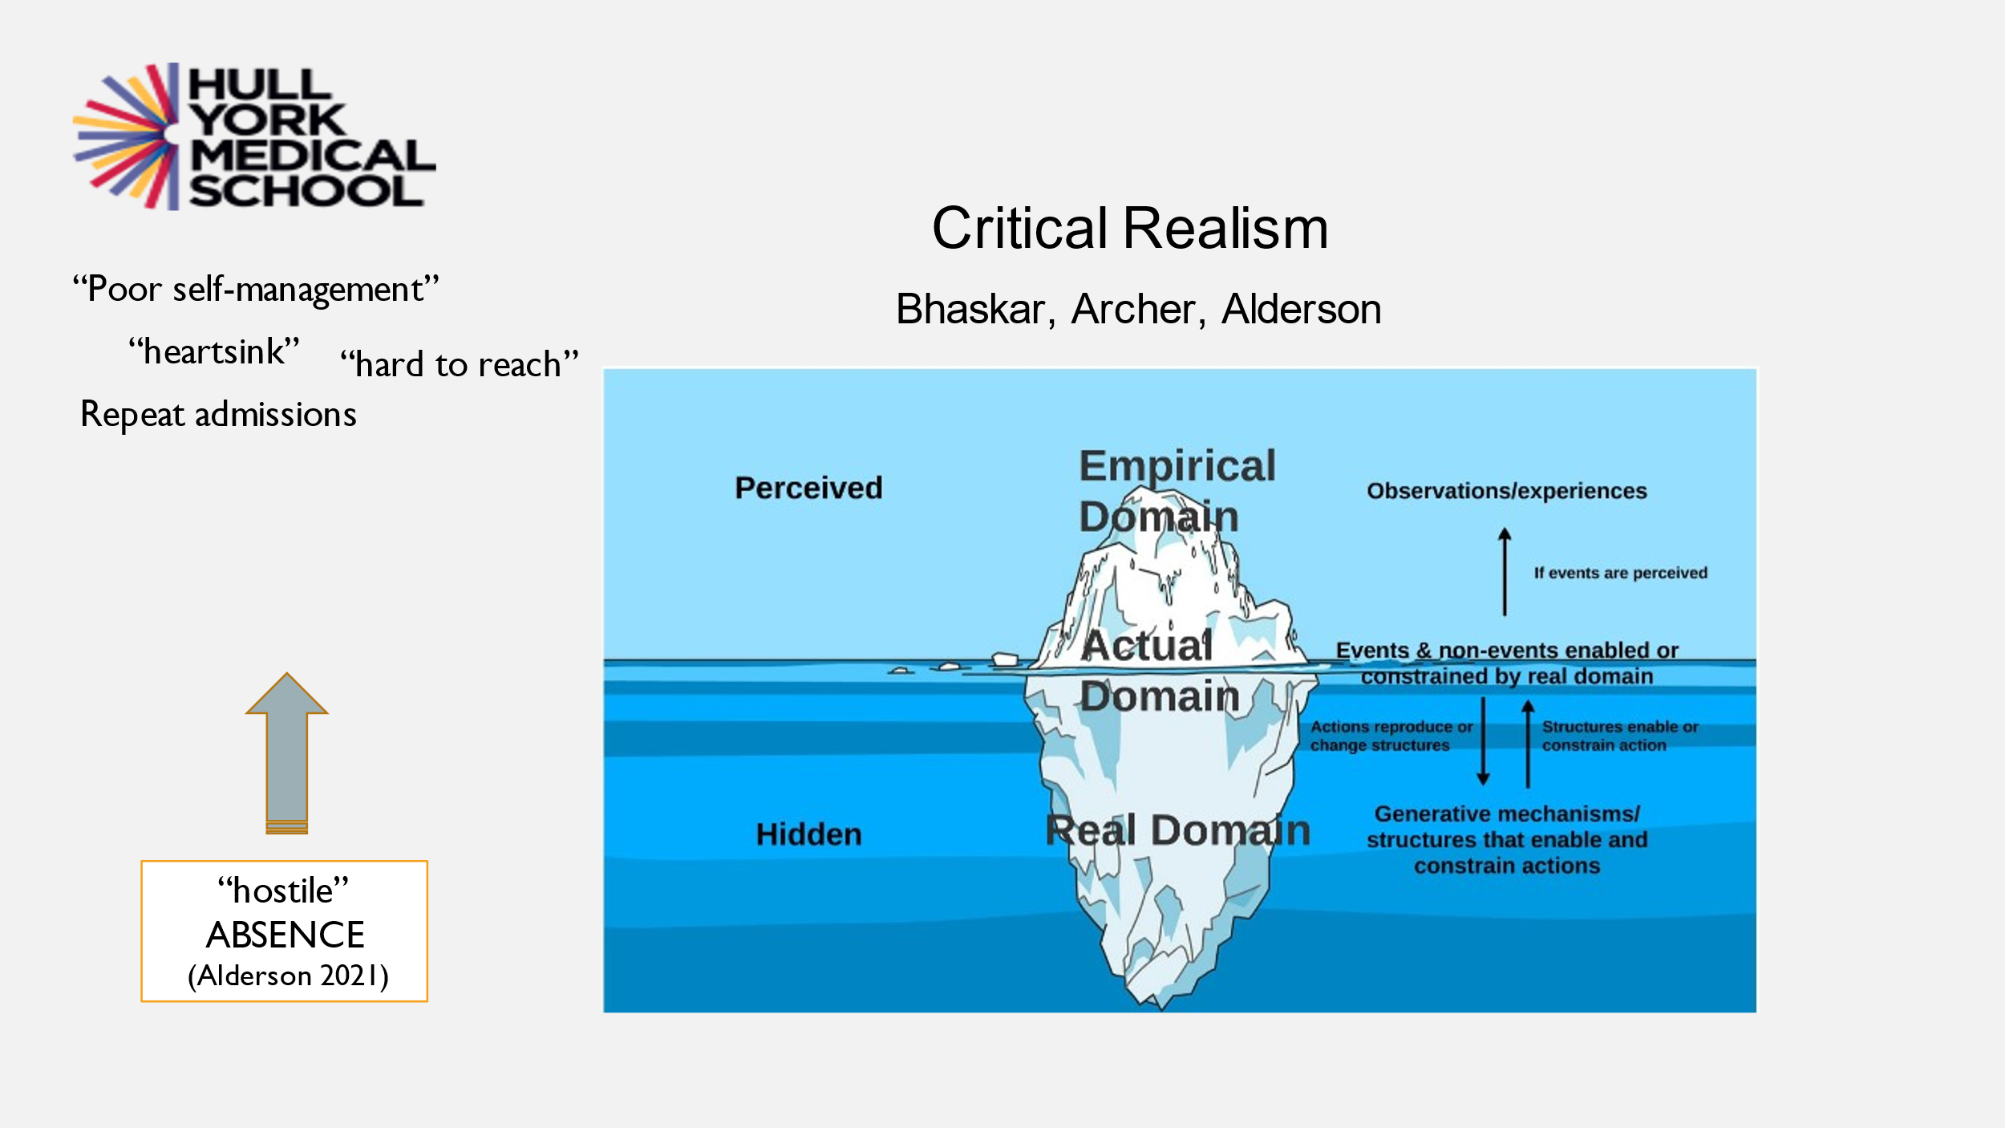
The bit of the iceberg above the water is the domain of the empirical, the things we can see and the things we can count, peoples’ experiences. A lot of research stops here. The domain of the actual is at the waterline: things you might or might not be able to see. The domain of the real is all the stuff underneath the surface; the structures and mechanisms that generate events – the causal forces that operate at a different level of the system than the outcome that they generate. For example: class – you can’t see class and the British class system. But it generates events like private schools having charitable status and people having had a
private education running the country.

There are important things that relate to people in chronic pain, like poverty and inequality and complex trauma, below the surface and what you see on the surface are things like poor self-management, heartsink patients, hard-to- reach patients; pain scores and prescription opiate overuse and events like A&E attendance. Critical realists would say that this is happening because of absence which is hostile. Mind-body interventions are the opposite of hostile absence and perhaps involve loving or kind presence. These things are happening in the above water part of the iceberg because something is not happening in the underwater bit: where there is not care; where there are not services etc.

How do we access this ontological depth ? We can’t see them but we can know or imagine that things like hostile absence are there. We can see hostile absences in our services – delayed and rushed consultations etc. We can use abductive and retroactive theorising – imagining or creative insight - and explain patterns in the data by theorising what is causing x to occur and then using best evidence from a variety of sources to refine or test our theories. Critical realists don’t have a theory of everything, they say that at this time we think we have an insight into why something is happening, so we are going to look at the evidence to see whether that is the most elegant explanation for something we can see happening. For instance if some people are persistently turning up to A&E we think that something is happening at that deep ontological level; causative factors that we can’t see. Then we would build a theory and go and test it. But we are only building on something that was there before. Transitive theory building means that this is not so for ever but this is what we can know now within limits, which necessitates a degree of humility It is evidence informed rather than evidence based. The rational process of retroduction which gives us our theories which we can then compare using judgemental rationality is an inherent process of cognition. Abduction and retroduction (which Bhaskar calls ‘transcendental theorising) is just how we work out what happened or how something played out. Scientific disciplines and rules constrain such creative thinking across borders. Darwin, for instance, scandalized people by imagining how evolution might work. But he put together all the evidence for his now accepted theory and pinned it all together. So for us involving a wide variety of stakeholder evidence is key to accessing ontological depth and improve rigor in research. My own theories might be very biased so we go out and involve different disciplines and stakeholders.
Interdisciplinarity is very important which is why I find critical realism attractive. Nowhere is this more important than in health research. A human being is a totality and cannot be studied as a congeries of parts and needs treatment in interdisciplinary ways. When I was doing the Life of Breath project we had a room full of people from different disciplines looking at the problems in different ways. This tends to be lost within the structures we are imprisoned in. How much agency do we have within those structures?

Going back to the Life of Breath: When I first found critical realism I didn’t know anything about it but I realised that my thinking was critical realist. People living with breathlessness were being looked after by their doctors who diagnosed what was wrong with their bodies and their lungs – their ventilation and perfusion imbalances etc. Physiotherapists were dealing with their physical side with a very functional approach to the body as a machine. On the mental side, the neuroscientists were interested in brain mechanisms and what they were doing when people are breathless – what was going on in the limbic system, connections between the prefrontal cortex and other parts of the brain etc. The psychologists would be thinking about individual mindsets, and what kind of thinking about their breathlessness could be changed so they were not so frightened of it. So you have this split between the body and the mind. But in the Life of Breath we came to something perhaps deeper by thinking about the spiritual and emotional aspects of breathlessness; how breath is so redolent of spirit across time, cultures and traditions: the Chi, Ruach (Hebrew) and Prana from the Veda etc. So breathlessness is much more than a physical or mental phenomenon, which may make it a bit difficult for clinicians…. It is sort of fluffy with squishy qualia. There is a hermeneutical gap: “a significant area of experience obscured from understanding owing to prejudicial flaws shared resources for social interpretation.” (Fricker) There is no shared language or understanding for this spiritual and emotional area. People may talk about their six minute walk tests or lung function; they might be able to talk about the way their thinking affects their functioning, but this other stuff is really difficult to talk about, even for doctors. There is a hostile absence; a lack of understanding and awareness of the deep causes of the fear and anxiety that perpetuates breathlessness which has not been brought to the surface.

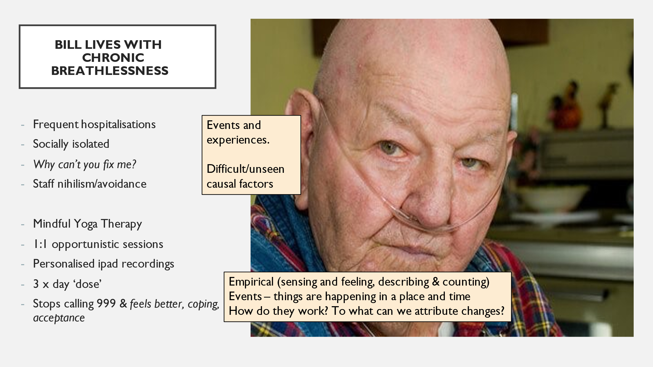

Bill is a classic patient. He has frequent visits to hospital who spends every weekend in a hospice. Staff find him very difficult. He lives on his own and is isolated. I started working with him with mindful Yoga therapy in one-to-one ‘opportunistic’ sessions and made personal iPad recordings tailored for him. He practiced this tds. He felt better, was coping better, accepted his situation and stopped calling 999. But this was only a short term intervention, the benefits were not long lasting and he died very badly.
So this was something that was very helpful but inadequate, and is not widely available because of the structures of the system don’t allow for it. It was from this that I started to build up my critical realist questions and thinking.

Discussion.

So to boil it down to within my limited grasp: basically you need a personalised, custom-built, ongoing care approach for each person.

One of the criticisms that is levelled at critical realism is that it is utopian. But …there is a really good book: Critical Realism for Health and Illness research by Priscilla Alderson. The author is a social scientist at UC London – she has devoted a lifetime … She says that if we don ‘t uncover the causes of the empirical ills that we see we can’t do anything to change them. We have to bring to the surface these unseen generative causes and then work to change them. I practice an interventional way of working with people that helps them to feel safe and cared for so that they can start to care for themselves. The empirical thing might be a quality of life score, or just saying they feel better and in control like Bill. I don’t know the answer a health economist might ask like does this reduce hospital admissions – maybe in ten years’ time I can do this research - but at this stage my research is about theory building. What I have discovered from all the literature searching on mind body interventions is that what they lack … they are very keen to explain how they work biologically, because they want to be accepted by the scientific community. But the mechanisms they are talking about are actually social

I did a narrative synthesis of the literature for my Master’s because of the incongruence of the qualitative and quantitative literature. My topic was Yoga for ‘total’ (physical, emotional and spiritual etc) pain in advanced disease. I now realise was looking for scientific realism but at the time I didn’t know it existed. But it is a great methodology for unpicking complexity. I wanted to look at mechanisms but not from layered ontology. So I looked neurophysiological, cognitive and behavioural factors and psychological mediators. But you could say that acceptance and coping, self-compassion, bod-mind integration affect regulation. emotional regulation and affiliation are also mechanisms which enable people to start to engage with their sensations rather than reacting to them. So instead of being different and happening at different times it’s this mad ontology: I could write that in a different way and explain what is happening – what I think is happening – I’ve imagined it - I can use retroduction to theorise about it. It’s really hard to make this stuff simple

I have just published an article … I am simple minded … and I am trying to fit it into your- schema. It is an anthropology kind of article. It is about my year’s stay in China. There, acupuncture works for pain – within the context of China. They readily apprehend all these Chinese categories of Chi etc. I think acupuncture is a mind-body modality. How can I put that into your framework?

I have thought about this a lot. Going back to the idea of pragmatism. When I looked at the literature I asked myself why exclude acupuncture from mind-body modality? I had to contain something massive. When you set out on a critical realist project you have to decide how to contain it with a pragmatic stance, so you talk to your stakeholders,, in my case patients living with breathlessness. What then was the most pragmatic thing to explore in the UK
context of people with breathlessness in advanced disease? Acupuncture is one-to-one and not so applicable for research into communities as things like Yoga Mindfulness and Tai Chi which all involve an element of movement and a focus on the breath. This is of course arbitrary so I checked with my stakeholders and a group of practitioners and they all wanted to involve a focus on breath. Acupuncture is passive - when you are receiving it you don’t ‘do’ anything as you do when engaging in a mind-body practice. In my realist synthesis I excluded papers that were not relevant to a UK context.

In acupuncture there is an engagement with the mind of the patient so the patient is doing something. The pain from the needle isn’t necessarily the therapeutic agent in itself but a way of bonding with the acupuncturist ….

…. that’s the key mechanism – relationship …

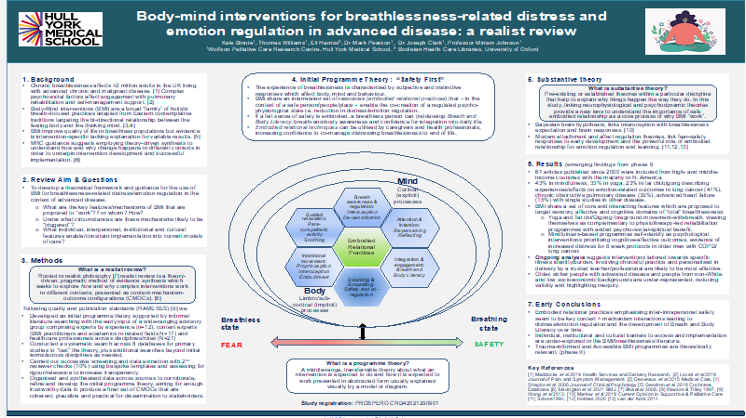

This poster has just been accepted for the World Congress of Palliative Care in Rotterdam in May.

There are a lot of words on it!

… and is very context specific. This is why RCT’s are not apposite to this sort of thing. Thinking of Betsan and knitting the therapeutic relationship counts for a lot - is that in your model?

The concept of mechanism is very bio-behavioural and means different things to different people in different disciplines. If you are looking at a drug mechanism - a biological one- it is different from what we are talking about which is a relational mechanism. We can’t see it but it is absolutely real and has an effect at an empirical level. If somebody believes that this is going to help them and they trust the therapist there is something underneath the surface and they come back. I have been looking at the concept of placebo in terms of belief in something having an effect at a physiological level…. Western researchers who try to investigate mind-body medicine have got terribly stuck in a rut thinking about biobehavioural mechanisms. But relational mechanisms are important in every interaction that we have with healthcare professionals. Compliance, behaviour change – it’s all relational.

A patient goes to see a clinician because they are alarmed about a painful condition. A good physician can, on the spot, relate to the patient and redefine the symptoms …. “You can still play with the grandchildren and go on walks – even though you still have pain” If the clinician is positive that is good pain practice.

Betsan isn’t just a listening therapist – she is so much more. It comes back to trust and context and setting. Many years ago I was told to try a Tai Chi class for my back pain and other issues. I used to come away breathless and in more pain, and I thought this it’s was it’s all about. Come forward a few years and I am now doing Tai Chi with Betsan and she has put together an amalgamation of breathwork, movement and relaxation as well as talking. What you were saying about trust is so important. If you have a chronic illness the biggest thing you need is trust in the person that is supposed to be helping you.
Regarding breathwork: I used to feel that I was constantly holding my breath, and became breathless whenever I was doing anything. Whereas no I am able to monitor that; and then it doesn’t allow your feeling of stress to get more and more and hype up the volume of the pain. It’s all these interactive things that go together. This is so good for the patient because you are getting back to person centred medicine .
I also used to work with Sure Start and this opened my eyes: I couldn’t take things to do with adult literacy and numeracy from the classroom as I was teaching at college out to Sure Start. That more than anything taught me that you have to change things depending on your audience.

Absolutely. One of the things I have uncovered in my synthesis is that pure mindfulness as it is taught seems to increase distress in a lot of breathless people. I doesn’t feel safe. It isn’t good for everybody. I go to conferences on breathlessness where people are writing guidelines saying it is. But this is without context specific research looking at the context between context and realism. But you are right: the bottom line is relationship with a safe person who is sensitive to your needs.

Mindfulness for me was delivered in a way that because of the quietness opened a Pandora’s box of things I had subdued.

I didn’t like it at all on its own but combined with movement it is very calming. My Yoga practice is like sucking my thumb.

[partially inaudible] Thinking about your Venn diagram of the biological social and psychological and spiritual: we divide people up into these different … it’s all the person’s life …. important to tell people that it’s their experience … When we are talking about trust in the practitioner and acupuncture working in China we are very much depending on the therapist rather than the person finding the way… flipping pain approach that everything matters and you have got to figure out for yourself which is the most important.
I wonder if you have looked at negotiation theory? Because what you have is the therapist wanting the patient to do something and they say they have tried that - tried mindfulness and I hated it, Tai Chi made my pain worse etc. You have to find a way of the patient saying ‘‘that’s right” – something they really want to do rather than being forced or therapized. There is a very interesting book by Chris Voss, who used to be an FBI negotiator, called Never Split the Difference. I use it a lot and try to use it with patients.

I absolutely agree with you and one of the things I am interested in is trauma informed approaches, which is one of the things have we talked about, and one of the key elements of that is choice. When you do a realist synthesis you start looking at something quite obvious so I did a literature search looking for things that seemed really important to these complex mechanisms and configurations that would lead to outcomes we were looking for. So you think - hold on a moment – there is an avenue here that seems important like the trauma-informed approach. We must not force or impose out ideas on somebody. Harvey Chochinoff, a palliative care practitioner in Canada, talks about dignity therapy in people’s last days and not what I think is right for you but what you think is right for you. We need more choice – there is very little for breathless people and they are limited by the structures that are available. The critical realist approach allows us to look at the relationship between structure and agency. Patients are limited by structures and so are clinicians. My clinical stakeholders have been trained in a certain way and are constrained by guidelines so there is no agency. There is a need people for like Betsan and me but we work outside the NHS

This is going to become a generalist rather than a specialist matter. GPs see a lot of people with chronic pain. But we can see that that sort of pain specialist will become a sort of Sherlock Holmes looking for the key and we have to think about ourselves as guides for the person themselves to find the key. But if we suggest something like EMDR the response is often “but I want to know what the trouble is!” - I hear this all the time – “but you want to talk about trauma” - it’s the last thing that people want to do.

You don’t need to talk about it - they just need to feel that it is something that is right for them. You don’t want people to get hooked on any sort of complex and expensive therapeutic relationship. You want people to discover their own route to wellbeing themselves. There will always be people who can’t do that. But, specially towards the end of their lives, people get given up on. If you have a horrible cancer you may have access to palliative care. In one hospice I know there is no hierarchy so the medical director and the massage therapist and the nursing staff and the complementary therapist are all equals and all working towards helping this person in any way they can – morphine to therapeutic touch. They have the common aim of treating the person with dignity and ensure that they live well until they die. But from my experience of hospices that is pretty rare.
So have found all this unseen stuff coming to the surface: horizontal and vertical hierarches, mutual respect across epistemologies – these are the things I want to surface – these are the things that are really working in some places and I want to work everywhere.
How do we change the context for people aren’t getting palliative care because they have a creeping chronic illness? They are not going to die of it so are not getting access to hospices.

“I did some work for Berkshire long Covid clinic, running Tai Chi Movements for Wellbeing classes. These were funded by an NHS charity.
You are you and you matter till you die. In the Tai Chi sequence that I teach there is a move called ‘Here am I’. That is a powerful one for most people. As we do it we say ‘I am enough as I am’, ‘I am proud of me as I am’ ‘I don’t have to be any more, I don’t have to hold myself back, I’m enough as I am,‘ ‘Moving and living with confidence in who we are, as we are’. We visualise this as we are moving.
We work on connecting to the essence of you, the you that is you without the labels of the world. We learn to listen to our body and to treat ourselves with self-kindness. In this way you of get the full value of Tai Chi
It is an embodied philosophy and an embodied spirituality. You are describing embodied self-compassion and these are the kind of mechanisms I have been looking at. You can’t measure them but they are qualia – they are real. They have causal power. That is realist thinking.

You mentioned Darwin and how his methods … he was looking at something incredibly complex – explaining how all creatures on Earth are different – and it turned out that it was quite simple and he devised a theory that was incredibly simple using the methods you have described. Listening to you as a non-researcher it all seems to make common sense. But how much have we lost with all the reductivism and NICE guidelines based on all that reductive nonsense that gets published as science. So I just hope with these sorts of methods with chronic pain and breathlessness we will end up with some simple explanation like Darwin’s that will help us.

Here I can be myself. But when I went to scientific conferences about respiratory therapy, I was a sort of amuse bouche. It was a bit like trying to explain why love matters. But if people wanted to talk about cytokines and immunity etc. … I’m not saying they are not important but as a realist I wanted to ask what were the causative factors that were leading to high levels of inflammation in this population and where were they coming from? They are coming from a hostile absence such as inequality. If could get hold of the microphone and explained this stuff you could see people nodding but it was like nobody wanted to go there as they wanted to do things like cutting lungs up and looking for pathology. We are all siloed. And here is something wonderful about what Bhaskar calls multimechanicity. I wondered how the hell I was ever going to get on top of this complexity. So I have tried to remain pragmatic, do my best and hope that it is something.

Being a bear of very little brain I am still struggling a bit with the terminology. So I am wondering if it might help me to think about defining critical realism in terms of its opposite, and what it might be to be uncritically unrealistic. And I wondered whether an example of this might be the attitude that a lot of pain specialists still seem to have that the answer to all chronic pain is some sort of intervention?

Can I refer you to my slide of ontology and epistemology (page 3 above) – and the implications of not being a critical realist You can get stuck in a reductionist paradigm, looking for a universal law of everything and not looking at the mess, pretending it’s not there and that everything can be enclosed in a tight system or going to the other extreme and being a constructivist just looking at peoples’ lived experience …

The science is coming together. There is a very interesting book Brain Energy by Christopher Palmer, looking at the ways mitochondrial function underlies all these issues and the effects of trauma and PTSD on stress hormones etc. So I think the idea is being more accepted that there is indeed an underlying big scheme of things …

… and that is the language that I use with a particular audience. What I learnt is that transdisciplinary approach and to use different languages for different audiences – neurophysiology for neuroscientists, respiratory physiology for respiratory physiologists, psychology for psychologists etc. They are all right but they are partial.

Thinking about Peter’s comment (about uncritical unrealism) : how do we get this over to the pain community? I have been working with very interventional guys in the Highlands and interviewing patients who have had many injections and radiofrequency lesions etc. for many years and talking and negotiating with them and a lot of them have said “oh – I have never thought about that, and could try something else“. But on the other hand they really believed in these procedures as they have been very convinced by their clinicians that doing things to them with X-rays and things is important. And some have really worked albeit with some dangers and drawbacks and very temporary effects. How are we going to get this sorted out? There are about 50 pain specialists in Scotland and they all disagree with each other.

One of my Yoga students is a professor of anthropology who has written a book about magic, and how modern medicine is the magic of our time. A researcher in Southampton has suggested that it’s like acting: You enter into a kind of role with your white coat and your stethoscope like the magician with his magician’s hat and starry robe, and the patient knows what they are supposed to be expecting. When I am a patient I can observe myself adopting a special demeanour as a polite middle-class patient who has already looked up my condition on the internet, but I defer with a particular tone of voice etc. Everyone is playing a role. If I were to say I was a professor of immunology I would be treated completely differently from a yoga teacher or a music therapist.

