In Pain’s Presence: how doctors respond to patients with chronic pain.

Jonathon Tomlinson and Jens Foell

Jonathon has been a full-time NHS GP in Hackney, London since 2001 with time out for voluntary work in Afghanistan in 2003/04 and an academic fellowship in 2014-6. His special interests include the social determinants of health, patient advocacy and the relationships between doctors and patients.

Jens is a GP in North Wales who previously worked for 18 years in London. He trained as a rehabilitation doctor in Germany. He is a GP trainer.

Jonathon

In 1996 I was newly qualified. I had completed my training as a doctor without being taught anything about chronic pain. As a junior doctor, how to do medicine was my overwhelming concern and this mostly meant knowing the rules and the protocols and sticking to them. Samuel Shem’s book the House of God was our guide to when and how to break rules to protect ourselves from the toxic culture, our seniors and the patients. The House of God’s Golden Rule was ‘do as much nothing as possible’ which was an explicit acknowledgement that hospitals are dangerous places where all interventions are risky, but almost any intervention can be justified, meaning many patients would be better off if they were sent home, perhaps with some extra social care rather than risk medical interference. Patients were referred to as GOMERS which stands for Get out of my emergency room. Patients with chronic pain encountered in Emergency rooms or A&E departments were GOMERS and we did what we could to turf them. Turfing means sending them home or referring them to another specialty. This being the mid 90’s the department had a cupboard full of little boxes of Tramadol kindly provided by a pharma rep. and it was a quick and easy way to send someone home, with a new potent painkilling drug that we had been assured was more effective, safer and less addictive than pretty much anything else at that time. It made our lives easier and so we didn’t question it. Our involvement with patients with chronic pain was so transient that we had little sense of the chronicity of their pain and even less of their lives
As I rotated through different hospital specialties there were a few occasions where I encountered patients with chronic pain. I remember a woman whose stomach was criss-crossed with surgical scars where surgeons had repeatedly explored her abdomen and pelvis looking for the cause of her pain, until eventually the internal scarring became a cause of pain in and of itself and they stopped looking.
Patients like this were frustrating to their surgeons, to put it mildly, but more bewildering than frustrating to me because I felt less responsibility for their recovery. I think that this is one reason why patients with chronic pain sometimes experience more empathy and sympathy from medical students and junior doctors than experienced clinicians. Once we start to feel more responsible for our patients’ recovery things get more complicated. People become doctors because they want to make a difference by relieving suffering. Writing in 1959 about doctor-patient and nurse-patient relationships, the psychoanalyst Thomas Main, noted that if this desire to relieve suffering is not satisfied, “they tend to become more passionate, to be reinforced with aggression and then to deteriorate in maturity, with sadism invading the situation.” I knew a gynaecologist whose attitude towards her outpatients – about 50% of whom have unexplained pelvic pain, verged on the vengeful. Writing about nurses caring for patients in pain Main noted that “[she] would only give a sedation at the moment when she had reached the limit of her human resources and was no longer able to stand the patients problems without impatience, anxiety, guilt, anger, or despair”. The use of sedatives went up, the more understaffed and stressed the nurses were. These days we know that GPs prescribe more opiates where there are fewer GPs, less continuity, and shorter appointments. In these situations, medications are more available and dependable than doctors.
For many doctors, especially those working in hospitals, or those in general practice without the long-view, favourite patients are often those who massage their ego, whose diagnosis or treatment is a bit of a challenge, who recover from serious illness, ideally after a bit of a battle, and are grateful for it. Patients with chronic pain are rarely like this because recovery is not in their repertoire and they are usually as frustrated by their lack of progress as their doctors. On those rare occasions when they do recover, they are among doctors’ most favourite of all because the battle has been so long and hard-fought and also involves an interesting quest or journey.
Medical sociologist Arthur Frank described three kinds of illness narratives. The classic restitution narrative follows a satisfying illness-diagnosis-treatment-recovery trajectory. A quest narrative involves a coming-to-terms with a long-term condition and a journey of acceptance; “Quest stories carry the unavoidable message the restitution narrative will, one day, prove inadequate”. A doctor likes a patient on a quest because they’re no longer pestering them for a cure but sharing updates from their travels. The third kind of narrative, and the one that typifies chronic pain, is chaos. People live in chaos, but, says Frank, “chaos in its purest form cannot be told” Chaos tears up narrative. Listening to patients in chaos is hard to follow, there’s a very real sense of going nowhere. Philosopher John Berger wrote that patients who suffered without a diagnosis couldn’t separate their illness from themselves, but a diagnosis gave their illness an independent existence so that doctor and patient could struggle together against it. Chronic pain is a kind of diagnosis without diagnosis, there’s nothing to show on the scans or blood tests. In chaos, there is no thing to be treated, or cut away, there’s nothing like cancer to provide an explanation, attract sympathy or entitle benefits. Patients in chaos can be deeply frustrating for doctors because they’re repeatedly confronted by suffering and reminded of their failure to make a difference. Writer Hilary Mantel, who suffered with chronic pain wrote of her “concern with the doctors and nurses who have to deal with patients who are in pain, I think it must be a depressing and unsettling business unless you are well-trained and supported.” And of course we are not well trained in chronic pain and we’re even less well supported. Like Thomas Main 50 years before, she experienced that frustrated medics can be callous.
A lot is made of studies that show that medical students lose their empathy as they go through medical education. This is because they learn to listen before they learn to diagnose and they learn to diagnose before they learn to treat. By the end of their training they listen selectively, if at all, mostly to make a diagnosis and set up the treatment protocol as quickly as possible. But as students, to begin with at least, they listen without judgement, without steering the conversation towards a diagnostic end point. Being under no pressure to make a diagnosis or relieve their patients’ symptoms, and given much more time than doctors, patients are often more at ease with students and in my experience, rate them highly for listening. The experience of being seen and heard is validation – and the importance of validation is the most consistent finding of all the studies looking at the experiences of patients with chronic pain in their interactions with medical professionals.
In the documentary, Cracked Up, Actor and comedian Darrell Hammond described trauma as ‘not being seen or heard’. Invalidation from healthcare professionals is traumatic, worsening the isolation, shame and self-doubt that so often accompany chronic pain. One question doctor and patient may have, but rarely admit is, ‘what role is trauma playing here?’ It’s not a question of root causes, but if I can stick to the analogy of actors depicting chronic pain, there will be many, and trauma will play their role, alongside a cast of others including the careless driver, the anxious mother, and the incident with the stepladder on the ice. Potent as a medical student’s validation may be, validation that comes from someone more powerful than the patient has an added potency, and where there has been childhood trauma the impact of validation from a powerful adult can be revolutionary. Clinical judgements are inescapably moral because some patients are found more worthy of medical care and concern than others. The fear of being labelled or treated as a fraudster or malingerer is ever present. Medical sociologist Daniel Goldberg found that chronic pain sufferers rate the alienation they experience from their physicians as qualitatively worse than alienation from loved ones.

If not being believed is one concern that patients have, another is that of being of little interest to their doctors. Anatole Broyard wrote of his duty to be an interesting patient:
“I would also like a doctor who enjoyed me. I want to be a good story for him, to give him some of my art in exchange for his. If a patient expects a doctor to be interested in him, he ought to try to be interesting. When he shows nothing but the coarser forms of anxiety, it’s only natural for the doctor to feel an aversion. There is an etiquette to being sick. I never act sick with my doctor.”

Broyard was a writer and a critic, an American who had enjoyed robust health until he got prostate cancer. He was an interesting guy who played with language for a living. Imagine if you’re uneducated, female, dependent on others to interpret for you, and suffering from an illness that’s hard to describe, hard to diagnose and unsatisfactory to treat. Most of my white, English-speaking patients know of the importance of giving a little to their doctor to sustain my interest, and make me feel as if I’m making a difference. They give a little, but also remind me that they don’t dare tell me how bad it really is, they don’t like to disappoint me … too much. It’s not unusual for them to admit that they’ve been afraid to tell me just how awful it has been, what terrible things they’ve sunk to in order to cope, how acutely suicidal they’ve been. But my Turkish and Bengali patients appear to believe that the best way to keep me engaged is to insist, every time they see me, that everything hurts more and nothing works, apparently unaware of Thomas Main’s warning that a despondent, frustrated doctor will at best lose interest and at worst become mean and sadistic. A doctor wants at least a little bit of a quest in their patient’s chronic pain narrative to sustain their interest. Frank understood the challenge for doctors was “how to honour the telling of chaos while leaving open a possibility of change; to accept the reality of what is told without accepting its fatalism”.
How I respond to patients with chronic pain has changed over the years. John Berger wrote about Doctor Sassall in his book, A Fortunate Man:
“Thriving on medical emergencies, impatient with non-specific symptoms and the absence of clear-cut physical diagnoses and underlying pathology, Sassal moves gradually towards and empathic listening and companionship with his patients and their families, striving to recognise who they are and the meaning of their illness to them. Physical and psychological intimacy is central to his relationship to his patients”.
These days I have consultations where patients come in with chronic pain and leave, after a time, with less pain that is a little easier to bear. This depends on my availability, or presence, which I would like to conclude this essay exploring.
Anatole Broyard wrote,
“I see no reason or need for my doctor to love me – nor would I expect him to suffer with me. I wouldn’t demand a lot of my doctor’s time; I just wish he would brood on my situation for perhaps five minutes, that he would give me his whole mind just once, be bonded with me for a brief space, survey my soul as well as my flesh, to get at my illness for each man is ill in his own way”

And American family doctor, David Loxterkamp writes:

“The barriers to ‘being there’ for our patients are not bound up in red tape … they lie in our presence of mind, our inclination to linger and listen, our rigour to pursue some grasp of the patient’s narrative and there9by catch a subtle signal for help”
There are subconscious barriers to presence. At a physiological level, openness in the presence of another involves neuroception – a neurological mirroring with hypervigilance, tingling, and hypersensitivity, raised blood pressure and heart rate, shallower breathing, tightening of skeletal muscle and slowing of digestion; all subtle changes, but enough in total to create an unease and a desire to bring the consultation to an end, perhaps with another referral, prescription or investigation, anything to buy some time before the patient can come back. Other strategies are for the doctor to stop listening and start pain-splaining, or offering advice. At a psychological level the doctor lacks confidence in his ability to negotiate the electrically charged boundaries around empathy; poised between gift and invasion – between seeing someone as they are and between cracking them open. Chronic pain is like a wound. You can’t change whatever it was that caused the wound, but to help it heal, you may need to cut away the scar tissue so that it heals from the bottom up. Historian of pain, Joanna Bourke, reflecting on her own painful experiences with doctors, observed that it wasn’t that pain was hard to talk about, so much as it pains others to listen to people talk about pain. Doctors have a tendency to dissociate when patients talk about pain, and Broyard feared that his doctor would lose interest and wrote of his need to be an interesting patient and not to act sick. But there is, at the same time, an unspoken need to be seen, beneath the demands for pain relief or another MRI scan there is panic and aloneness. I have on the wall of my consulting room a picture of ‘A woman with attitude’ – a reference to all the women I see who remind me of this whenever they come in.
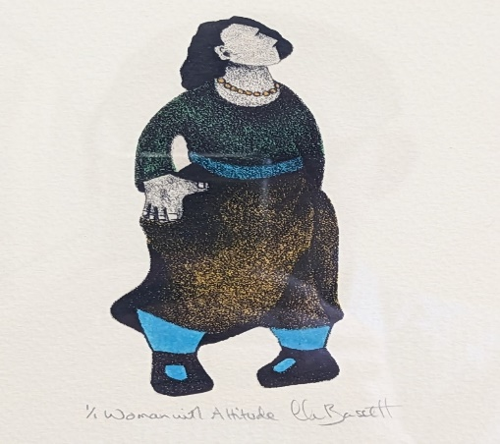
Empathy is an art where the doctor can acknowledge their patients’ capability, vulnerability, courage and terror at the same time as they appreciate the humour that so often accompanies serious illness.
In conclusion, doctors are poorly prepared to take care of patients with chronic pain. Education is improving, but they are under-supported and there are few organisational or financial incentives for the long-term work care that patients with chronic pain need. If you find a good one, then commit to continuity and nurture the relationship. Find one that believes you but will challenge your shame and self-blame, and be interested enough to explore your stories with you rather than accept them at face value. You will want one who can appreciate the dark and the light side of suffering. Your doctor needs to be accessible and boundaried – better five minutes of whole-hearted presence than a half-hearted half-hour. Above all find one that believes that things can get better, not with false hope or through futile interventions, but by perseverance and imagination.

Refences and links to blogs etc. can found at the end of this transcript after the discussion.

Jens Foell

You suffer

I want to share two stories about this.

Story 1. It is afternoon clinic. A woman tells me that she has been abused by her husband who is stalking her. The situation is very tragic, high stakes, highly emotional, involving high organising and administration, a high cognitive load and high danger. It took 45 minutes to speak to a women’s refuge. The next patient was sent to me because with my musculoskeletal background I attract people with chronic pain (or my colleagues think I should) This woman had many allergies. Nothing ‘worked’ for her. She started telling me her story; she worked as a cleaner in a hospital . I had nothing to give her and didn’t know what to do next. I kind of automatically listened to her; I knew I could do some acupuncture eventually but not now. The vibes were getting worse. Do you remember MAD magazine? There was a cartoon ‘the shadow knows the truth’ where the shadow tells what is really going on and what vibes are leaking. I think it as always the case that your vibes are leaking; you want to conceal them but everyone picks up on that very quickly. So when she asked me what I could do I hesitated. She had allergies against everything. So I said “you suffer” – come and see me again on Friday. It was a time when my patients had to complete a questionnaire and I could see her relevant answers. When I saw her again I did some acupuncture but left a needle in her neck. The practice manager called me to say he had an angry man with a needle in a bottle. I was very apologetic. But it turned out that it was a good visit because he was abusing his wife and their son.

Story 2. I am duty doctor. This means that you don’t have time to listen – you have to do one task after another and work very fast. A woman who I knew from the past with diagnoses of fibromyalgia and diabetes and all sorts of problems with her eyes etc. came in. I knew I had to do something different. So I said “if you come another day I will have time to listen to your story”. She did come and I moved away from my computer and sat and listened. She told me that for years she had been a domestic slave; her rich London employers had taken her passport so she could never go home to her family in Morocco. She had been beaten, she lived in an upstairs room without heating and so forth. I was speechless as was she. So I just said “you suffer” and we sat in silence for a moment. We had had lots of appointments for this and that but this was a key moment which taught me to recognize that my vibes had been leaking and that lip service was not good enough.

So now I am inviting you to come on a little journey because I think that the spiritual and caring dimension of the organisation really matter. I am from Germany and I did a placement before university in a hospital run by nuns

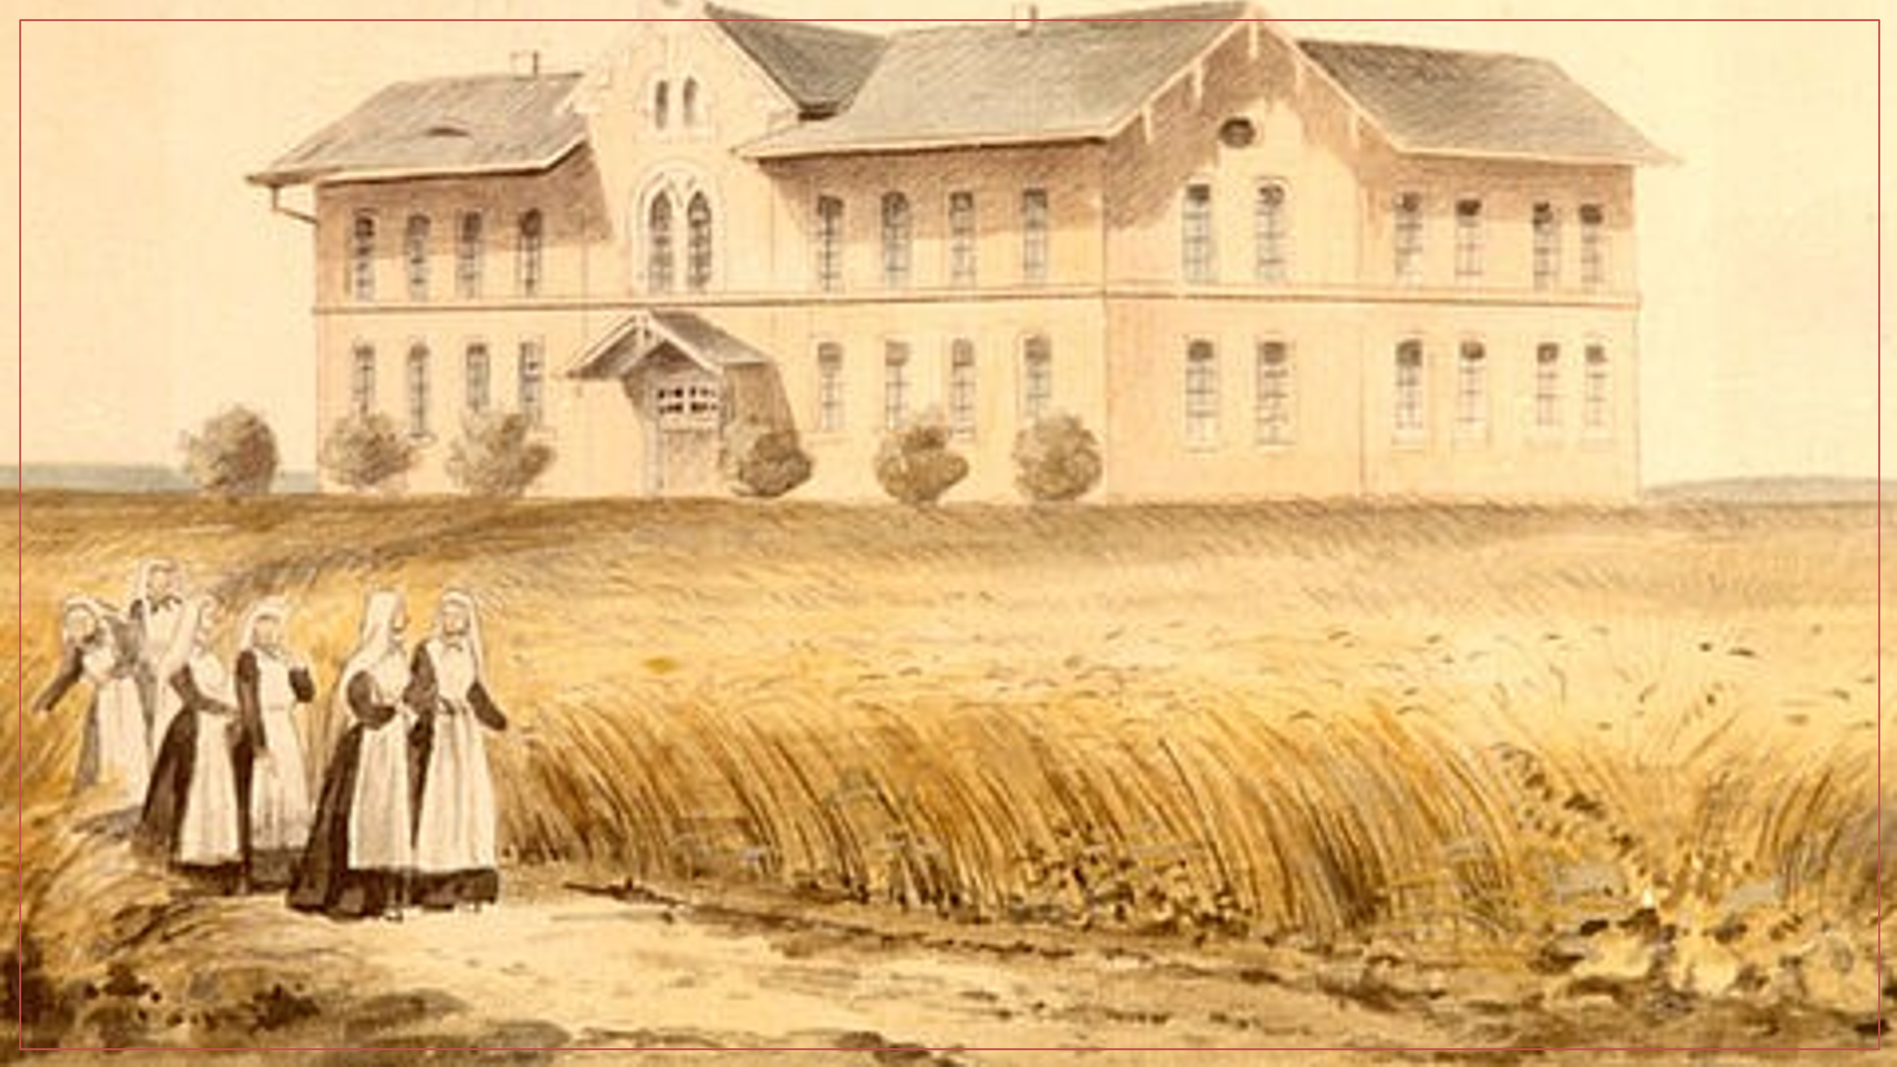
There were rituals including bible sessions in the morning which I didn’t like but provided an order which is really important. I did another placement in an establishment inspired by Rudolf Steiner teaching Knowledge of the Higher Worlds and its Attainment. It was like the Freemasons and opaque and I never felt ready for it. But it was interesting because it brought a kind of order to dealing with suffering. I really 1liked the caring environment. But I couldn’t bear being so different there and the world outside seems so much better. So I went to Berlin. While I was studying medicine I worked as a taxi driver which I liked quite a lot and in these moments listening to a passenger but not making eye contact I learnt how nice it could be to listen to a story without having to answer or comments like “oh, that must have been difficult for you”. I learnt this stuff later in communication studies in the UK. But I must confess that as a taxi driver I did it because I wanted a tip, so I knew how to manipulate the passengers by seeming interested and picking up on details in the story. And I am still doing the same if I want to get people to open up. This is very much to do with organising myself to see pain or suffering as something in the interface between me and the patient and this plays an important role in how I respond.

This brings me to rituals and healing. In Germany I learnt manual medicine and did a lot of massage, hands on work, care work in which body contact plays a major role. This unleashes the unconscious or subconscious of the carer.

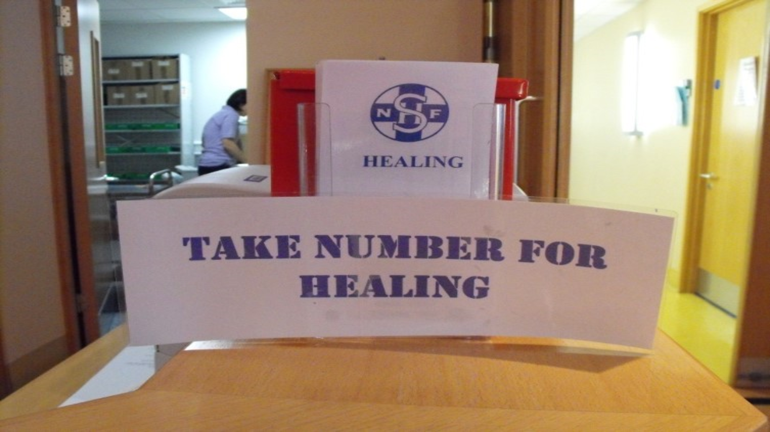

I saw this in the Royal Homeopathic Hospital in London and thought ‘how ridiculous’ – as if it was as simple as that

Does healing work in the restitution paradigm, part of the quest paradigm, or can in it be a way into the chaos paradigm? Paul Dieppe described healing as ‘ focussed attention with good intention’. I thought that was doable. I remember situations in which I was busy examining a patient to find out what was wrong and they thanked me for ‘working on their knee’ So I learnt these techniques of manual medicine which helped me in every little house job – on staff as well as patients – even if I was not supposed to as in psychiatry.

I think the biopsychosocial model is wrong because there is a hierarchy in it and sometimes a competition: the ‘bio’ doctor will try to shift the patient and their problems into the psycho which is seen as shameful so into the social which nobody understands unless you are a GP with a long term perspective. So if you are in a hospital anaesthetic pain clinic using a biopsychosocial model it is perhaps not the right environment, I have worked in such a setting.
If we look back at the history of what has been written about the doctor patient relationship it starts with growth in taking care of the painful patient, the dependent clinger , the manipulative demanding patient. We moved on to the ‘difficult’ patient in 1996 but in 2006 we find the difficult doctor. I worked in an organisational climate
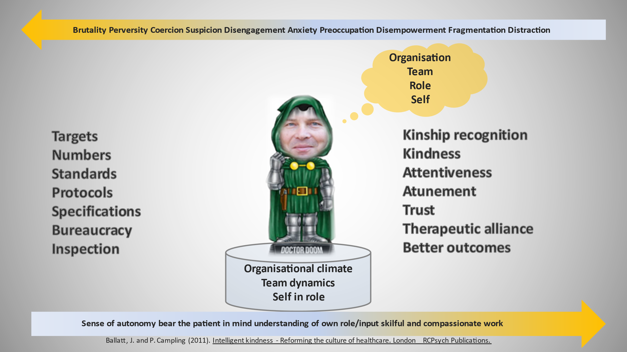

All of these played a role - to treat people as parcels or puppets. That is the key feature of this talk Analysing this is very difficult – it can take years. I have consciously arrived at the notion of a holding relationship over time, but it is not a romantic relationship or always nice. People may want restitution which may not what they are expecting from me. Referral may feel like giving up; sometimes it’s just a breather but it may be part of the journey. I have done lots of acupuncture in community settings and this is never just a matter of inserting needles; it can be a time to listen and talk. It is often an opportunity to reduce medicines such as gabapentinoids because to quote Joanna Bourke “Pain does not emerge naturally from physiological processes but in negotiations with social worlds”. People tell a lot without eye contact in grooming procedures, which any hairdresser can tell you. All of this played a major role in the NICE guidelines and more or less recommends this conversation after a systematic review.

Discussion

JT: We wanted to invite people who wear patient hats rather than clinician ones to respond first.

I have been bowled over by what I have heard. The challenge to the biopsychosocial model of pain is quite disturbing in some ways because it is the kind of thing that patients involved in the self-management of chronic pain have had drilled into them, and this has been a lifeline in gaining a sense of agency in their own pain experience. I have never really considered that there was a hierarchy and a push from one rung to another. I had kind of taken for granted that it was something new and fabulously all-embracing that linked holistically all the elements of chronic pain together.

I am a doctor but speaking as a patient now. When I was in hospital the nurse always came and asked me to rate my pain from 1-10 but I thought I cannot answer this and it was really annoying. I thought ‘do I have fear about what is coming? – yes. Am I psychologically distressed? – yes. Do I think this will be different with Oramorph? - no. So I couldn’t answer and I had to apologise. But I think it’s important because I knew at that point that’s how it starts with having medication as the only possibility. As to the biopsychosocial; at the moment I am hoping everything will be OK … socially I am OK because I am supported and get full wages for three months so I am not under additional pressure. It would be very different if I weren’t a doctor and I would be in a precarious situation. So I am pinning everything on the social and that everything will be OK even though my leg leg looks very ugly and swollen at the moment and I take the social seriously as part of … like eating and relationships and so forth which is nor directly in my model.

So are you on medication for the pain?

No. Jonothan recommended that I should try Pregabalin and everything available to enhance my user experience for this session but I was too scared so I didn’t!

Jonothan : your story about people going to A&E with chronic pain being given Tramadol – I know from my MSK physio who I see at my doctor’s surgery that this is still going on. They don’t have time to do anything else for people who attend with chronic pain which is sad all these years later. I started my pain management journey in the early 1990’s and it is depressing that nothing has changed since then. But what I was interested in was the way you acknowledged that healthcare professionals often do not have an insight into chronic pain and that’s why we sometimes feel that our diagnosis and our stories are invisible and unheard. What you have highlighted today for me is that it’s not just me that feels this way.
How do you see health professionals and people with lived experience working collaboratively?

JF: in mental health after recovery you have peers and community support. Regarding A&E – there should be some teaching – I believe that Tramadol (and other opiates) are ‘rationed’ and you get nothing in A&£ [I can find nothing about this in a brief online search Ed] It is a cultural and organisational issue.

There was recently an advertisement for a senior management position in an NHS trust … [?? which suggested that a person with lived experience of illness and suffering would be suited for this role?? – partially audible, editor’s guess] … which in many ways is quite ground breaking but it is disappointing to see the deriding response in social media from many healthcare professionals – ‘Why would we need that? it’s ridiculous, you could pay for x number of nurses’ – as healthcare professionals we need to work on our attitudes and acknowledge that there is a lot of knowledge and expertise outside our training which could be very valuable and help change the direction.

JT: whenever you start to think that problems in the world arise because of human psychology you have to ask what is the sociological and organisational stuff behind it. One of the great myths of the day is that you can reduce social problems to psychological dysfunction, and the issue of how to treat chronic pain comes down to the attitudes of doctors and nurses. I think I may have over-egged that particular pudding in my talk without pointing out the fact that in my practice chronic pain is as prevalent a long-term condition as asthma and diabetes. But we are paid lots of money to take care of patients with these and there are training and certificates advertised all the time, there are specialist nurses based in practices; enormous sums of money for charities, public health engagement etc. for asthma and diabetes. But chronic pain is hidden in plain sight. There is none of the institutional scaffolding, resources and education for pain patients who consult my practice twice as often as asthma and diabetes patients, and they are far less likely to be signed off long term with sickness and they are much less likely to have mental health problems. So it is a massive problem that there is a kind of social and medical wilful blindness. I am super-keen on raising the status of the kind of chronic pain that I see: patients who are on multiple medication and really debilitated. 70% of my practice are in on average 20 times a year, are on long-term medication. And demanding huge amounts of medical attention. And until this becomes part of the institutional framework of medicine and for which doctors are incentivised to provide care it’s always going to be hidden in plain sight.

JF: The shift to primary from secondary and tertiary care was exactly for this. Having a cure or an input programme is great but it is what happens afterwards – it is like an alcoholic in rehab. Long term care can only be an ongoing process in the family and the community. Pain is like hunger and thirst - you cannot ignore it. You can’t say “now you have done your thirst management programme don’t ever come back!”. That is crazy. There is so much holding work out there; so many things to be addressed: mind, body biology, relationships, welfare, crisis planning … A lot of the mental health model fits perfectly with chronic pain and the social antecedents are anyway the same so it has to be something primary care addresses proactively saying yes - that is our core activity, that is what we are trained for. We have sophisticated consultation techniques, we have at least the ability to provide longitudinal care. It is for the patient, the doctor and the practice management

[Partially audible… ] I think it is a public health approach that is really needed … GP appointments for chronic pain …when I talk to GP’s and say my pain is terrible … don’t see patients with chronic pain. … We had some really good patients who pretend and go and do education for medical students and physios.
This is where we are stuck as a lot of treatments people are given like Tramadol are wrong, unhelpful, increase chronicity and reduce the chances of people getting any better. We definitely need the perspective to be turned round and to recognize that the social is often the most important and responsible for a majority of chronic pain patients’ problems and the biomedical usually the least. We are all going through investigations and referrals. Chris van Tulleken made a great TV programme ‘ The doctor who gave up drugs’ which featured a patient who had put her back out and was on lots of drugs who has a GP who just told her “there is nothing to see on the MRI scan” and she was just going round on a cycle of specialist referrals and trying one thing and another, and it is really sad. I showed medical students the video – it’s rubbish, terrible medicine. It’s condemning people to a life of pain. There is a lot that can be done but it will take a lot of effort to turn it round.

I would like to ask you guys what you think of continuity of care - what part pre-emptive care plays in this setting. I burnt my hand badly a few years ago; I had six weeks of not being able to work or drive and having to go to hospital every day by bus. I was close to tears with them quite a few times trying to explain that I was really struggling and didn’t know why but not once did anyone address that with me. Over the next six months that injury had a profound effect on the way that I saw myself and the world, although I was lucky in having good friends around me and the sort of job I had. Since then I have tried to tell people in A&E that this injury has a potential to come back and frighten them in the future – not to scare them but to try to start raising the possibility that it could be a problem in the future. But I have never found a sustainable way to do that. So have you found a way to see something coming and try to lay the groundwork to prevent it developing into chronic pain?

JT: It’s a great question. Of course chronic pain is a retrospective diagnosis. You rarely see it coming. I saw a patient not long ago and said to her: “every time I see you the pain is the worst it’s ever been and surely that is impossible?” She replied “the only time I get to see you is when the pain is at its worst – you never ask me to come in at any other time”. I thought - that’s a really good point. Imagine if you only saw your diabetic patients when they had had a ketoacid crisis or the asthmatics when they had an attack – and try to teach them how to manage their condition! But, at least in primary care, we do that with chronic pain; we see them in a crisis and then talk about pain management! - Instead of keeping a register and inviting them in when they are not having a crisis. We ought to do proactive, preventative care in this way. A physiotherapist recounted that he had been to a meeting and described how he had been in acute pain after a bed lift and the other physios laid into him. apparently blaming him for being irresponsible. But he said how much he needed and appreciated sympathy although he is a guy who prides himself as being tough and manly.

What changes from your characterisation of the listening sympathetic medical student to the ‘door closed’ attitude of the qualified physician? What is going on? Is it experience or time pressure? This was one of the key elements that stood out of your talk.

JT: Paul Dieppe describes ‘focussed attention with good intention’. Van Segal is an American psychiatrist who write a lot about mindfulness and ‘open awareness with focussed attention with good intention’. Medical students have this open awareness because they don’t yet know what they are listening for. More experienced clinicians listen in order to make a diagnosis and get the patient on a treatment pathway. The student doesn’t know what they need to know so they still have that open awareness; everything could be important and they can’t ignore anything the patient says.

JF: I would like to endorse this speaking as a GP trainer who has to look at the RCA videos etc. The taxi driver small talk is the key to connecting with people. I learned from an actor who said when he plays baddies he has to look at the character to try to find something he likes about him. And an addiction psychologist, when I asked why he wanted to be in that field with the meanest people who lie and manipulate, told me that he was looking for the bits that he genuinely liked. So I came to the conclusion that it genuine goodness is not an acting technique but something that can be learned and practiced which involves non -symptom talk, picking up on cues, maintaining curiosity about the background because you are overwhelmed by cues which are everywhere if you are open to noticing them. But once you become a clinician you have to be a detective for deductive diagnosis and that will not happen. Getting lost – a tiny moment and with pain it is not only getting lost but also getting stuck and not having a smart answer to anything, which annoys people. People are stuck for a reason and just telling them to go to the gym won’t do. If it feels really uncomfortable then you are in business.

[partially inaudible] …. … pain is seen functionally as something that would elicit care from others but it is not necessarily an emotion like anger that would instinctually bring up a response. And it matters how you relate to a person. So there are a lot of different things that come into play in the kinds of emotional reactions, feelings and sensibilities which are involved in a relationship with someone.
‘Enjoy the patient’ was something my trainers used to say: you have got to enjoy your patient.

You can get nearly everything you need from a patient if you let them just talk without interruption. One study found that the longest any GP allowed a patient to talk without interruption was four-and-a-half minutes.

Betsan – you have looked after people with chronic pain for a long time, not in a one-to-one clinical scenario but mainly in groups like your knitting groups?

These were originally attached to a pain clinic but they allowed me to hear peoples’ personal stories and to get to know them in a way the doctors couldn’t. I would often sense that the people who had the most complex problems that the doctors could do nothing more for, and often their treatment would change when we knew their personal stories. Also, when they came to us they lost their labels. It gave them a safe place to meet other people. And we were also able to help them with things like sorting out their benefits and other live problems. All this as well as the knitting itself which gave them a self-soothing tool which made them feel safe. None of them would have come to the group without the activity of knitting and it was acceptable to sit knit quietly without participating in the group if they wanted to .A lot of stuff could come out through just sitting beside someone and chatting. People have often said “this is the first time I have told anyone this”.

Is this something that wouldn’t happen in a clinical consultation?

Giving the brain and both hands a rhythmic task to do seemed to facilitate … and to enable people to talk more easily. If someone appeared to have a lot of social anxiety I would go and sit with them in a room and teach them to knit. You didn’t have to try to make them talk – it would just come out.
Sometimes we had to have the door closed because there was so much laughter coming from the knitting group and you couldn’t be seen to have laughter inn a pain clinic!

It was Betsan who introduced me to distraction for chronic pain; I didn’t actually attend one of her knitting groups but I did read her articles. Now I co-host a ‘Create and chat’ once-a-week online group for people with persistent pain by zoom and we have found that by labelling it creativity people come along although sometimes there is no time for creativity because they want to talk about things like ….. last week it was all about meditation [?medication?] If I had labelled it ‘chronic pain support group’ they wouldn’t come.

JF: I wonder how this can be adapted to different social strata. For example not everyone can do knitting. I can’t knit – I tried but I am too clumsy. But I am very good at sanding down wood which is repetitive and mind-numbing. I could easily join a woodworking group. The clue is doing something manually and not having to talk about your stuff but it comes out when you are ready.

Calling our group create and chat means anyone can come with anything they find creative. One thing we have started is Zen tangling* and doodling which anyone can do - all you need is a piece of paper and a pen or pencil. So now we meet on other days to do these activities. It all started because people had nowhere else to go after pain clinic self- management courses. They are a lovely group and support each other now not just through their pain but through their life traumas and difficulties like bereavement or end-of-life situations, and happier things like chipping in to help with the cost of a daughter’s wedding. Now one or two members have gone off and formed a knitting group.

One of my concerns with a lot of these groups is that they are very middle- class focused and I wonder how we engage people from different socio-economic backgrounds? And sometimes they seem to be for the ‘worried well’.

We have one person (in our group) who doesn’t fall into that … She lives in Scotland and we have filled in that hole but another lives near Durham and I would say that she is not middle-class. She holds her group in a community centre in the middle of her village and many people there don’t have access to the internet so they can come along once a week and they have a printer. So it is getting wider but it comes back to two major things: one is lack of things like smart phones an internet access and the other literacy ability, whether or not in a first language. These are the socio-economic barriers which people like me are working to overcome. Here in Taunton we are starting a pain support group that we can take to an area of deprivation where chronic pain is highest.

On thing that Jens was saying struck me; about the human aspect of health care and that is something which helps people to heal but we are not trained to demonstrate that; so giving a licence to connect in this way is really important. But it is also important to recognise that as clinicians we don’t always have that within us at times. We may be going through a difficult phase ourselves.
Only today I saw a patient who told me about an encounter with a doctor who didn’t want to listen to her story of trauma and just wanted to give her a label; I just hope most of us in the pain services will listen to people and will hold what they tell us, and teach others to respond with that kind of compassion.

JT: I have written about what happens to doctors when they become patients, and one thing
that they often report is how shocking it is to be on the receiving end because they cling to the
identity of the healthy … As Susan Sontag the philosopher once said “We all have two
passports, one for the kingdom of the healthy and one for the kingdom of the sick”. We only want
to use the first because of all the sentimental and judgemental fantasies we have about that other place. So we fear becoming patients because we believe, at least subconsciously that implies all sorts of moral stuff and become victims of that sort of judgement as well as the self-criticisms and perceptions of oneself as a failure. I have an essay in the BMJ called ‘The Doctor as Patient’ which goes into that.

JF: I would second that. The doctor’s problem is shame; if it’s something you can fight then there is no problem but if it is not a [?] somatic condition then it becomes a problem for the doctor’s identity

* https://tanglepatterns.com/zentangles/what-is-a-zentangle

Some years ago I went to a meeting of the BPS psychology SIG about fear and pain, and one of the talks was about fear of patients and this is the key. You have got to have the patient involved in healing [inaudible …….] get things across and motivate them because patients have been told that from the bio point of view there is no chance of their getting any better – everything has been tried and they are just going to have to put up with it. I organised a group in a clinic I worked in some years ago for patients who had been on the pain management programme but they were all still looking for the new medication or intervention that was going to work – they really hadn’t got it. Working together with the PMP and getting people to come to my groups and talk to me, and be ready to be challenged made a massive difference and there was huge progress in the three years I worked with the group. They were self-actuated and supporting each other.
But it seems that we are stuck in the bio fixing mode and the psycho and social is outside
our realm

Jonathan – you talked about the GOMER attitude but when I worked in A&E in the 1980’s
there was nothing like that – it could be tough but we didn’t have this attitude.

This came out of the book ‘House of God’ and it wasn’t our invention - it was about hospitals not being a place of care

I am concerned about talking about chronic pain as a problem like diabetes and asthma because it is immensely more complex. And it has so many facets that are just not controllable. Rather than asthma we should probably be thinking about something like chronic breathlessness which is very difficult to control. We are starting to see a lot of problems like that following Covid. Chronic pain is essentially unsolvable – it is a problem that won’t go away. What is very helpful, however, and has been brought out nicely this evening, is validation, which is incredibly helpful for patients; and the holding relationship. I have dozens of patients – my colleagues are very concerned that I regularly bring patients back to the clinic, some of them for ten or twelve years, and I have just kept them in this holding relationship. I wouldn’t describe it as at arm’s length because although we only have a very extended discussion on an occasional basis it helps them to negotiate the world of having chronic pain as well as validation. So this is a very important area and the discussion ought to become broader and wider. We need to get this message out somehow. But this is difficult.

JF: [interference on recording] I am ambivalent about that. On the one hand I think that is how it needs to be defined in primary care but how are many long-term conditions to be managed [inaudible …. not listening…..] If it is not the ethos of the organisation then I don’t want it. Also, in my experience chronic pain is rarely seen by itself. It usually comes as a package with obesity, diabetes, mood problems etc and part of many problems. There needs to be way of having a annual check about everything but not on a disease model – “how is your breathing, your weight going etc” with a personalised plan, and we have to revisit our reimbursement model in primary care.

I particularly liked one of the comments this evening from Christos who was saying that you have to enjoy your patients with chronic pain. That is something we have to get across: that the relationship has to be a positive one because if it isn’t the patients won’t get any benefit from it. Whether or not you call that enjoyment - sometimes we feel exhausted and don’t feel like that (my Monday afternoon clinic can be like that as I am running out of energy after a busy morning) – but if we’re not enjoying it we should wonder why.

Some of the best interactions I’ve had with patients are when I have just seen someone else who have come in and said I’m really sorry – my brain is totally fried and I haven’t got the space for this right now - can we touch base later in the week? And then they see your face have fall and said – I’m sorry – you must be having a tough time ! And it totally shifts the dynamic.. They start sharing with you in a different way – they say it is difficult for you and I really appreciate the time you have given me. And the next time they come it’s a totally different relationship with a lot more balance.

References and links from JT’s talk

  - A a better NHS
  - Patients not Profits. How Markets dehumanise health.

TWEETS FROM MELLOJONNY
  - We've abandoned good management for mangerialism twitter.com/NewStatesman/s… 3 hours ago
  - @HarryZeitMD A huge benefit for me is that tic is personally transformative, it requires a process of continually w… twitter.com/i/web/status/1… 7 hours ago
  - @HarryZeitMD https://t.co/Nu7abPLX9b 1 day ago
  - RT @loulouscorpio: Thanks @painphysio I hope it’s useful, obviously everyone’s story is different which is why it’s so important that we ha… 2 days ago
  - @amjutel @JDaviesPhD Oh yes! 2 days ago

ABETTERNHS BLOG
  - RSS - Posts
  - RSS - Comments

RECENT POSTS
  - In Pain’s Presence: how doctors respond to patients with chronic pain
- How to save NHS General Practice
- Expert Generalists
- On being present: Emotions are contagious
- Sleeping Beauties: functional symptoms, ecology and trauma
- The Pain Free Mindset book review
- Trauma and Chronic Pain
- The Art of Not Running Away
- The good-enough doctor
- Where are the Patient feedback ethics?
- Empathy, Education and Respect: A Prescription for Racism in Medicine
- Finding fairhealth podcast Episode 14
- Consulting during Covid
- A month in primary care with Coronavirus: sudden death, end of life discussions, lockdown and inequalities.
- New kinds of heroes
- Trauma informed care in General Practice
- The Trauma World and The Healing World
- My psychology of pain
- The Exceptional Potential of General Practice
- Hope and salutogensis
- Reflections on medical culture and the Bawa Garba case
- Book list
  - Dr Jonathan Tomlinson Law And Justice Interview – SoundCloud
  - The Adverse Childhood Experiences evidence base–a wake up call to radically redesign Children’s Mental Health Services.

  - What happens to empathy in medical education?

BLOGROLL
  - Artists for the NHS The aesthetic attack
  - Atul Gawande US Surgeon and brilliant writer. Start with ‘The Cost Conundrum’
  - Ben Goldacre. Badscience.
  - Bevan's Run Clive Peedell. Co-Chair of the NHS consultants association. In depth analysis of the politics behind NHS reform
  - David Loxterkamp: Essays about primary care. Inspirational writing from a primary care physician in the US
  - Dr Grumble A real doctor writes
- Dr No Almost certainly the best writing by a blogging doctor. Spot on politics as well.
- Essential reading: The NHS after 60 by John Lister
- Health Policy Insight Detailed and pithy expert analysis
- Health Professionals document repository for NHS reform
- Ian Greener's academic blog Excellent consise analysis of health policy
- Julian Tudor Hart. GP, writer, campaigner and legend. Link to his website with essays and publications
- Keep Our NHS Public Keep Our NHS for Patients, not profits
- London Health Emergency Founded in the autumn of 1983, London Health Emergency is the country’s biggest and longest-running pressure group in defence of the NHS.
- Margaret McCartney's forum on healthcare policy Glasgow GP Margaret GP blogs about medicine and politics
- NHS 'Myths' debunked. The facts straightend out about the Future NHS by Richard blogger

- NHS Consultants association blog. Excellent support from NHS Consultants Clive Peedell and Jacky Davis
- NHS Support Federation An umbrella organisation of health professionals campaigning for a public NHS
- NHS vault Excellent analysis of NHS policy proposals from Richardblogger
- Ray Moynihan Selling Sickness: How industrial health care makes you sicker
- Reading list. A selection of recommended books about medicine, society, science and politics. Interesting books about medicine and society
- Sound advice for saving the NHS £10billion a year Salaried doctor Judith Harvey has some good ideas
- Subscribe to Roy Lilly's blog.
- The Cockroach Catcher Retired child psychiatrist, Am Ang Zhang believes passionately in a public NHS
- The Equality Trust. Exploring the links between equality and health.
- Unite 4 our NHS UNITE union campaign
- World Health Organisation Supports Publicly funded healthcare Public Vs Private healthcare

Reading recommendaions

